CASPER

ALGORITHM THEORETICAL BASIS DOCUMENT (ATBD) FOR ACM-Ice-Reading

Code | : | CASPER-DMS-ATBD-URSW1-10
Issue | : | 1.0
Date | : | 03/11/2008

 | Name | Function | Signature
Prepared by | Julien Delanoë  Robin Hogan | Scientific Research
Reviewed by | Jose Julio Ramos  Juan R. Acarreta | Project Engineer / Manager
Approved by | Juan R. Acarreta | Project Manager
Signatures and approvals on original

This page intentionally left blank
Document Information
Contract Data
Contract Number: | 20990/07/NL/EL
Contract Issuer: | ESA-ESTEC

Internal Distribution
Name |  |  | Unit |  | Copies
juan-ramon.acarreta@deimos-space.com |  |  | DEIMOS - MDS |  | 1
Internal Confidentiality Level (DMS-COV-POL05)
Unclassified | ◻ | Restricted | ☑ | Confidential | ◻

External Distribution
Name | Organisation | Copies
Tobias.Wehr@esa.int | ESA-ESTEC | 1
Michael.Eisinger@esa.int | ESA-ESTEC | 1
Dulce.Lajas@esa.int | ESA-ESTEC | 1
CASPER consortium (DWD, KNMI, McGill, UR) |  | 1

Archiving
Word Processor: | MS Word 2000
File Name: | input.doc

Document Status Log

Issue | Change description | Date | Approved
1.0 | First version delivered | 03/11/2008

Table of Contents
1. PURPOSE AND SCOPE 9
2. RELATED DOCUMENTS 10
2.1. Applicable Documents 10
2.2. Reference Documents 10
3. OVERVIEW 11
3.1. Algorithm Name 11
3.2. Name of L2 data Product(s) Generated 11
3.3. Description of the L2 data product(s) 12
4. REQUIRED INPUT DATA 16
4.1. L1 data, instrument, platform, orbit parameters 16
4.1.1. Platform and orbit parameters 16
4.1.2. Instruments 17
4.1.3. Cloud target mask 19
4.2. Meteorological Data, etc. 19
5. ALGORITHM DESCRIPTION 21
5.1. Introduction 21
5.2. Physics Background 21
5.3. Algorithm Flow Chart 21
5.4. Algorithm Definition 23
5.4.1. Overview of the variational scheme 23
5.4.2. Optimal estimation formulation 26
5.4.3. Use of cubic spline basis functions for smoothing N₀’ 30
5.4.4. Retrieving extinction-to-backscatter ratio 30
5.4.5. Use of a priori error covariances for spreading of number concentration information in height 31
5.4.6. Calculation of the retrieval error 31
5.4.7. Forward model 32
5.4.7.1. The normalized concentration parameter N₀* and the look-up tables 32
5.4.7.2. A priori of the normalized concentration parameter N₀* 35
5.4.7.3. Radar forward model 36
5.4.7.4. Forward model error 37
5.4.8. Computing the retrieval error in ice water content and effective radius 40
5.4.9. Miscellaneous 41
5.5. External models 41
5.5.1. Lidar multiple-scattering forward model (Hogan 2006) 41
5.5.2. Infrared radiance forward model 42
5.6. Required Computational Accuracies 43
6. ALGORITHM PERFORMANCE 45
6.1. Performance of the Algorithm 45
6.2. Error Propagation of Input Data Errors 45
7. VERIFICATION / VALIDATION STATUS 47
7.1. How the Algorithm has been Verified / Validated 47
7.1.1.1. Blind test profiles 47
7.1.1.2. ECSIM 47
7.2. Results and Overall Assessment 47
7.2.1. Validation using Hogan et al 2006 blind test profile 7 47
7.2.2. Validation using ECSIM 49
7.2.2.1. Radar and lidar 49
7.2.2.2. Radar, lidar and MSI 51
8. REFERENCES 54

List of Tables
Table 2-1: Applicable Documents 10
Table 2-2: Reference Documents 10
Table 3-1: Name of L2 data Product(s) Generated 11
Table 3-2: Description of the L2 data product(s) 12
Table 4-1: Platform and orbit parameters 16
Table 4-2: Instrumental observations 17
Table 4-3: Target masks 19
Table 4-4: Meteorological data 19
Table 5-1: First guess and a-priori for the state vector 27
Table 5-2: Constants 31
Table 5-3: lookup tables 33
Table 5-4: Forward model error values 38

List of figures
Figure 5-1: Flowchart showing the sequence of operations performed by the retrieval scheme 22
Figure 5-2: (a) Visible extinction coefficient av as a function of 94-GHz radar reflectivity factor Z for the large in situ aircraft database of Delanoë et al. (2005). (b) The same but after dividing both variables by the normalized number concentration parameter N0*. The gray line corresponds to the fit calculated using the unified size distribution shape. The curved shape in the relationship is due to the transition between Rayleigh scattering at small particle sizes to Mie scattering at larger sizes. 35
Figure 5-3: (a) The temperature dependence of N₀* for each size distribution within the large in situ database of Delanoë et al. (2005) (dots), superimposed by the mean N₀* in 5C temperature ranges and various ranges of ice water content IWC (lines and symbols). (b) The same but for the variable N₀’ = N₀*/α_{v}^{0.6} 36
Figure 7-1: Results when algorithm is applied to the blind test, including true and forward-modelled reflectivity and attenuated backscatter (left two panels) and also true and retrieved extinction and extinction-to-backscatter profiles (right two panels). Three different configurations are used: lidar only (blue lines), radar and lidar (red lines) and radar-lidar-MSI (black lines) 48
Figure 7-2: Results when algorithm applied to the blind test, true and retrieved effective radius, ice water content, N0* and a priori. The three different algorithm configurations are lidar only (blue), radar and lidar (red) and radar-lidar-MSI (black). 49
Figure 7-3: (Top six plots) The observations radar reflectivity and lidar attenuated backscatter (simulated by ECSIM, taken as input) and forward modelled observations at the final iteration of the algorithm. (Lower three plots) Retrieved extinction, effective radius and retrieved radiances computed from retrieved extinction and N0*. 50
Figure 7-4: (Top six plots) The observations radar reflectivity and lidar attenuated backscatter (simulated by ECSIM, taken as input) and forward modelled measurements using the algorithm. (Lower three plots) Retrieved extinction, effective radius and retrieved radiances computed from retrieved extinction and N0*. 52

PURPOSE AND SCOPE
This document describes the theoretical basis of the synergetic ice cloud retrieval algorithm that combines the cloud profiling radar (CPR), the atmospheric lidar (ATLID) and the infrared channels of the multi-spectral imager (MSI): “ACM-Ice-Reading”. It also includes the equivalent algorithm using only the radar and the lidar: “AC-Ice-Reading”.
The reader should be aware that there are a number of places in the text where further work is necessary, for example to refine the values held in look-up tables, to determine errors in particular inputs and model assumptions, and particularly to validate the algorithm using independent data. At each of these points in the document, a brief discussion is presented of the envisaged further work.

RELATED DOCUMENTS

Applicable Documents

Table 2-1: Applicable Documents
Reference | Code | Title | Issue
 |  | (none)

Reference Documents
Table 2-2: Reference Documents
Reference | Code | Title | Issue
[E-MRD] | EC-RS-ESA-SY-012 | EarthCARE Mission Requirement Document | 5  Nov 2 2006
[SRD] | EC-RS-ESA-SY-0001 | EarthCARE System Requirements Document | 1  Feb 2 2007
[PARD] | CASPER-DMS-PARD-001 | Product and Algorithm Requirements | 1.9  21 Oct 2008
[ADP] | CASPER-DMS-ADP-001 | Algorithm Development Plan | 1.5  7 Jul 2008
[PDD] | CASPER-DMS-PDD-001 | Product Definition Document | 1.2  25 Sep 2008

OVERVIEW

Algorithm Name
This algorithm is referred to as ACM-Ice-Reading: it uses ATLID, CPR and MSI to retrieve the properties of ice clouds within a variational framework. It was developed at the University of Reading.

Name of L2 data Product(s) Generated
The algorithm can generate two products:
- AC-I: Ice cloud properties derived from ATLID and CPI only;
- ACM-I: Ice cloud properties derived from ATLID, CPI and MSI.
The variables contained in these products are listed in Table 3-3 ; note that the format of the two products is the same.
Table 3-3: Name of L2 data Product(s) Generated
Variable
Time
along_track
Latitude
Longitude
Height
Extinction
N0star
lidar_ratio
Iwc
effective_radius
vis_optical_depth
Z_fwd
bscat_fwd
bscat_mie_fwd
bscat_ray_fwd
wavelength
radiance_fwd
n_iterations
chi2
chi2_split
retrieval_flag
instrument_flag
radiance_flag
radiance_difference_flag
ln_extinction_error
ln_N0star_error
ln_lidar_ratio_error
ln_iwc_error
ln_effective_radius_error
vis_optical_depth_error

Description of the L2 data product(s)
The variables contained in the two products are described in detail in Table 3-4
Table 3-4: Description of the L2 data product(s)
Variable | Description | Units
Time | UTC time. This is expressed in seconds since 00.00 on a particular date, which for the final EarthCARE product will be stored in the file. For ECSIM retrievals, the time is copied from the time variable in the merged file. | s
along_track | Distance along track, is the distance along the track defined by the latitude and longitude of co-located CPR+ATLID footprints at the ground from the beginning of the orbit. | km
Latitude | Latitude of co-located CPR+ATLID footprints at the ground | degree
longitude | Longitude of co-located CPR+ATLID footprints at the ground | degree
height | Height above mean sea level, describes the altitude of each radar and lidar common range gates | m
extinction | Visible extinction coefficient in the geometric optics approximation | m⁻¹
N0star | Intercept parameter N0* of the normalized size distribution of ice particles as describe in Delanoë et al. (2005) | m⁻⁴
lidar_ratio | Lidar extinction-to-backscatter ratio | sr
iwc | Ice water content, the mass of ice per unit volume of air | kg m⁻³
effective_radius | Ice effective radius, proportional to the ratio of ice water content to visible extinction coefficient | m
vis_optical_depth | Ice cloud visible optical depth, defined as the (dimensionless) line integral of the ice cloud visible extinction along a vertical path through the entire atmosphere. | none
Z_fwd | Forward-modelled 94-GHz radar reflectivity factor | dBZ
bscat_fwd | Forward-modelled lidar backscatter, the sum of the Mie plus Rayleigh signals | m⁻¹ sr⁻¹
bscat_mie_fwd | Forward-modelled lidar backscatter for the HSRL Mie channel | m⁻¹ sr⁻¹
bscat_ray_fwd | Forward-modelled lidar backscatter for the HSRL Rayleigh channel | m⁻¹ sr⁻¹
wavelength | Wavelength of centre of radiance channel (solar or infrared) | m
radiance_fwd | Forward-modelled radiance. For each infrared radiometer channel, the radiance forward model takes as input the relevant cloud variables from the state vector (profiles of visible extinction coefficient α_{v} and N₀*) and estimates of other variables (profiles of temperature, pressure, humidity, O₃ and CO₂ concentrations, as well as skin temperature and emissivity). In the case of the AC-I product, this calculation is performed on the radar-lidar retrieved profile, while for the AC-M-I product, it is used as part of the retrieval and is calculated at every iteration of the algorithm (although only the value at the final iteration is reported). | W m⁻² sr⁻¹ um⁻¹
n_iterations | Number of iterations before convergence | none
chi2 | Value of chi squared for each iteration; to determine if the algorithm as converged we use a chi squared convergence test. | none
chi2_split | Value of chi squared at the final iteration for each measurement type, normalized by the number of gates; the chi2_split dimension indicates the instrument, with 0=lidar mie, 1=lidar rayleigh, 2=Z, 3=radiance, 4=dradiance, -9=missing | none
retrieval_flag | Retrieval quality flag (0 = no cloud or aerosol, 1 = cloud or aerosol present but no retrieval performed, 2 = ice cloud where retrieval performed reliably, 3 = ice cloud where retrieval not reliable e.g. in deep convection) | none
instrument_flag | Instrument flag, identifies which measurements are used to retrieve the ice cloud properties (0 = nothing, 1 = lidar mie, 2 = lidar rayleigh, 3 = lidar mie+rayleigh, 4 = radar, 5 = radar+lidar mie, 6 = radar+lidar rayleigh, 7 = radar+lidar mie+rayleigh) | none
radiance_flag | MSI Radiance flag (0 = unused, 1 = radiance used), this flag tells us if MSI infrared radiances are used and which one. | none
radiance_difference_flag | Radiance difference flag (0 = unused, 1 = radiance used as first radiance, 2 = radiance used as second radiance) | none
ln_extinction_error | 1-sigma random error in natural logarithm of visible extinction coefficient in the geometric optics approximation | none
ln_N0star_error | 1-sigma random error in natural logarithm of intercept parameter N0* of the normalized size distribution of ice particles | none
ln_lidar_ratio_error | 1-sigma random error in natural logarithm of lidar ratio | none
ln_iwc_error | 1-sigma random error in natural logarithm of ice water content | none
ln_effective_radius_error | 1-sigma random error in natural logarithm of effective radius | none
vis_optical_depth_error | 1-sigma random error in visible optical depth | none
This table lists the variables as currently provided. An important element of future developments will be the inclusion of error correlations, both between different retrieved variables at the same level, and between the same variables at different levels (vertical correlations). This is useful for downstream users of the products, particularly in the area of data assimilation. Section 5.4.8 describes how these error covariance matrices may be calculated. There are several issues to overcome in the reporting of error covariances that have so far prevented us from reporting them in the product:
- Data volume: the size of the error covariance matrix goes as the square of the size of the state vector. Since the state vector in our problem may have 50 elements per profile, the volume of data per orbit will be increased by (as a minimum) hundreds of times compared with just storing the retrieved profiles and their 1-sigma errors. This problem is compounded by the fact that the state vector is generally a compressed form of the full high resolution profile of atmospheric properties; it includes a reduced basis-function representation of the N0’ parameter, for example. Before being useful for users, this needs to be expanded up to the resolution of the extinction profile, and converted to a more familiar quantity such as ice water content. This also involves expanding up the size of the error covariance matrix.
- Data indexing: The size of the state vector varies for each profile in an orbit according to how many cloudy pixels are present. Therefore the size of the error covariance matrix will change in each profile, which presents a challenge for storage: either one needs to have large enough dimensions to store the largest possible error covariance matrix (which is hugely wasteful of space), or one needs to define a complex indexing scheme for storing the elements of the covariance matrices in one long vector.
There has not been enough time until now to tackle these issues for EarthCARE products. Two realistic ways forward can be considered: (1) devise a way to store approximated error covariance matrices that will contain the important information but use less space (as well as using a clever indexing scheme); (2) provide software tools to reconstruct the error covariances from the data stored in the product (e.g. by recalculating Eq. 11 below). Note that if approximated error covariances are to be stored, then they are likely to significantly increase the size of the files. Given that most users won’t be interested in them, it is recommended that two streams of products are considered, those containing them and those not containing them.
A related issue is the storage of averaging kernels, which provide information as to the smoothing effect implicit in the retrieval. These would consist of a matrix containing the dependence that the retrieved state vector elements have on each element of some “true” state. In principle, this may be calculated, but the issue of data storage and indexing is exactly as for error covariance matrices. We would point out that because EarthCARE has active instruments, the smoothing implicit in the retrievals is generally much less than that typical of a passive sounder, and usually will be less than the vertical grid spacing of a typical atmospheric model. Therefore, the recommended way forward for future development would be to provide software tools to reconstruct these given data contained within the products.

REQUIRED INPUT DATA
The algorithm currently uses “merged files” produced by Dave Donovan and Gerd-Jan van Zadelhoff, which contain all the required observations and thermodynamic variables, interpolated or averaged on to the same grid. Although contained within the same file, here we group the required data into instrument, platform, orbit parameters and meteorological data. A brief description of the merged file format will be provided by Dave Donovan.
Note that the variable names are not definitive and are expected to be revised when an official merged product and target classification is developed for EarthCARE. At this stage, some of the required variables (such as attenuated lidar backscatter) are not explicitly stored within the merged files and must be calculated from lower-level quantities in the merged files (such as photon counts) by the algorithm. Further details are provided after Table 4-6. It is understood that by the time of launch, the Level 1 data would contain attenuated lidar backscatter and this step would not be required.

L1 data, instrument, platform, orbit parameters

Platform and orbit parameters
The merged file contains all the instruments at the same grid, but we need to know the satellite altitude for the lidar forward model. Every radar/lidar ray is defined by its UTC time, location (latitude, longitude and also the distance along-track).

Table 4-5: Platform and orbit parameters
Variable | Description | Unit
time | UTC time | s
along_track | Distance along track (in orbit this will probably be distance from the start of an orbit, but in the current ECSIM framework, this is an arbitrary distance coordinate and so where this is the distance from is irrelevant) | km
latitude | Latitude of co-located CPR+ATLID footprints at the ground | degree
longitude | Longitude of co-located CPR+ATLID footprints at the ground | degree
satellite_altitude | Height above mean sea level | km

Instruments
Table 4-6: Instrumental observations
Variable | Description | Unit
Height | Height of each radar/lidar gate above mean sea level | m
lidar_altitude | Altitude of the satellite from mean sea level | km
C_lid | Lidar instrument constant not including channel efficiency | Photons m⁻³
lidar_telescope_fov | Lidar telescope field of view (half angle) | mrad
lidar_off_nadir_view | Lidar off nadir viewing direction cosine | None
laser_fov | Laser field of view (half angle) | mrad
Tot_perp | Cross-Talk corrected background-subtracted Total Perpendicular return. It is converted to perpendicular attenuated backscatter lidar to be used by the algorithm [m-1 sr-1]. | Photon Counts per Shot
Tot_perp_err | Standard deviation Cross-Talk corrected background-subtracted Total Perpendicular return. It is converted to error in perpendicular attenuated backscatter lidar to be used by the algorithm [m-1 sr-1]. | Photon Counts per Shot
Mie_para | Cross-Talk corrected background-subtracted Mie parameter return. It is converted to parallel attenuated backscatter lidar Mie channel to be used by the algorithm [m-1 sr-1]. | Photon Counts per Shot
Mie_para_err | Standard deviation of the Cross-Talk corrected background-subtracted Mie parallel return. It is converted to error in parallel attenuated backscatter lidar Mie channel to be used by the algorithm [m-1 sr-1]. | Photon Counts per Shot
Ray_para | Cross-Talk corrected background-subtracted Rayleigh parallel return. It is converted to attenuated backscatter lidar Rayleigh channel to be used by the algorithm [m-1 sr-1]. | Photon Counts per Shot
Ray_para_err | Standard deviation of the Cross-Talk corrected background-subtracted Rayleigh parallel return. It is converted to error in attenuated backscatter lidar Rayleigh channel to be used by the algorithm [m-1 sr-1]. | Photon Counts per Shot
Ze | Radar reflectivity factor at 94 GHz | mm⁶ m⁻³
Ze_err | Error in reflectivity factor at 94 GHz | mm⁶ m⁻³
MSI_5_8_85_um_BT_0180 | MSI 5 Brightness Temperature at 8.85 micron (converted to radiance in W m-2 um-1 sr-1 within the algorithm) | K
MSI_5_8_85_um_BT_error_0180 | Error in MSI 5 Brightness Temperature at 8.85 micron (converted to error in radiance in W m-2 um-1 sr-1 within the algorithm) | K
MSI_6_10_85_um_BT_0180 | MSI 6 Brightness Temperature at 10.85 micron (converted to radiance in W m-2 um-1 sr-1 within the algorithm) | K
MSI_6_10_85_um_BT_error_0180 | Error in MSI 6 Brightness Temperature at 10.85 micron (converted to error in radiance in W m-2 um-1 sr-1 within the algorithm) | K
MSI_7_11_85_um_BT_0180 | MSI 7 Brightness Temperature at 11.85 micron (converted to radiance in W m-2 um-1 sr-1 within the algorithm) | K
MSI_7_11_85_um_BT_error_0180 | Error in MSI 7 Brightness Temperature at 11.85 micron (converted to error in radiance in W m-2 um-1 sr-1 within the algorithm) | K

Note that since the algorithm does not use the MSI solar channels, they are not provided in the merged files.

Note: The attenuated backscatter from the lidar Mie channel is not currently available directly; within the algorithm it is calculated from Cross-Talk corrected background-subtracted Total Perpendicular return [Photon Counts per Shot] and Cross-Talk corrected background-subtracted Mie parallel return [Photon Counts per Shot]. The attenuated backscatter lidar Rayleigh channel is similarly derived from Cross-Talk corrected background-subtracted Rayleigh parallel return [Photon Counts per Shot].

Cloud target mask
In order to ease the application of the ACM-Ice-Reading algorithm, we use a lidar mask, radar mask and cloud phase, all of them included in the merged file.

Table 4-7: Target masks
Variable | Description | Unit
cloud_mask_lid | Lidar Cloud Mask: -1: no data, 0: likely no cloud, 1: likely a cloud, 2: most likely a cloud | none
cloud_mask_rad | Radar Cloud Mask: -1: no data, 0: likely no cloud, 1: likely a cloud, 2: most likely a cloud | none
cloud_phase | Cloud phase: -1: no cloud, 0: water, 1: ice | none

Meteorological Data, etc.
The ACM-Ice-Reading algorithm needs some meteorological data, such as temperature profiles for the a priori and the radiative code. Surface emissivity, surface pressure, skin temperature, pressure, water vapour, and ozone are required for the radiative computations. Air density is also required for the lidar forward model to calculate the expected molecular return. All these data are obtained from meteorological model, most likely the model of the European Centre for Medium-Range Weather Forecasts (ECMWF).
Table 4-8: Meteorological data
Variable | Description | Unit
Surface_pressure | Surface Pressure | hPa
Skin_temperature | Skin Temperature | K
Temperature | Temperature | K
Pressure | Pressure | hPa
Density | Air density | cm⁻³
Qv | Water Vapour | g m⁻³
O3 | Ozone | g m⁻³
Surface_ir_em | Surface IR emissivity | dimensionless

ALGORITHM DESCRIPTION

Introduction
This algorithm uses a variational method for retrieving profiles of visible extinction coefficient, ice water content and effective radius in ice clouds using the combination of radar reflectivity, lidar attenuated backscatter with high spectral resolution capability and MSI infrared radiances in the atmospheric water-vapour window. The forward model includes effects such as non-Rayleigh scattering by the radar and molecular and multiple scattering by the lidar for the Mie and Rayleigh channels.
By rigorous treatment of errors, and a careful choice of state variables and associated a priori estimates, a seamless retrieval is possible between regions of the cloud detected by both radar and lidar, and regions detected by just one of these two instruments. Thus, when the lidar signal is unavailable (such as due to strong attenuation), the retrieval tends towards an empirical relationship using radar reflectivity factor and temperature, and when the radar signal is unavailable (such as in optically thin cirrus), accurate retrievals are still possible from the combination of lidar and radiometer.
The high spectral resolution capability allows us to retrieve a very confident extinction profile without any assumption about lidar extinction-to-backscatter ratio. The algorithm can be used to create two EarthCARE products- “ACM-I Ice cloud properties” (using all instruments available), and “AC-I Ice cloud properties” (using only the radar and lidar). It draws heavily from the algorithm developed by Delanoë and Hogan (2008).

Physics Background
As explained in detail by Rodgers (2000), variational algorithms (or equivalently those based on “optimal estimation theory”), when properly formulated, have the advantage of being capable of finding the best solution in a least squares sense given all the information available. In the case of the ACM-Ice-Reading algorithm, we encapsulate as much physical realism as possible (while still retaining computational efficiency) within the forward models for the various instruments. Thus the microphysical assumptions make use of the most up-to-date information on ice particle size distributions and habits available from aircraft campaigns. This information is stored in the look-up tables described in Table 5-3. Should better aircraft data become available, in can be incorporated by recalculating the elements of the look-up table. The algorithm may then be run on the new tables without the need to be recompiled. The instrument simulators all use physical models of the way radiation interacts with the atmosphere, and in the case of the lidar and infrared radiometer forward models, take full account of attenuation and multiple scattering.

Algorithm Flow Chart
The description of the algorithm in the subsequent sections is facilitated by the flow chart shown in Figure 5-1, which outlines the key parts in the way the algorithm works.

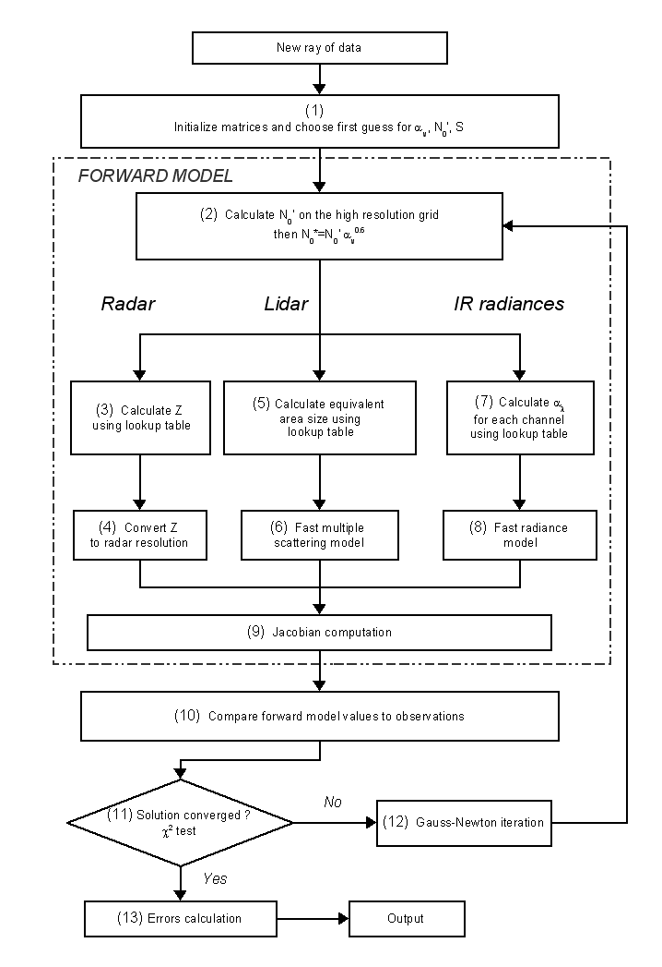
Figure 5-1: Flowchart showing the sequence of operations performed by the retrieval scheme

Algorithm Definition

Overview of the variational scheme
We assume that all instruments have been calibrated, that the nature of the random errors in the measurements is known. Profiles are analyzed in turn, and the procedures undertaken for each are summarized in Figure 5-1. The retrieval is then applied to the parts of the profile containing ice cloud. This is achieved using the target classification (currently provided in the merged file, but in future to be provided by a dedicated target classification product for EarthCARE), which identifies pixels containing ice and/or liquid. There are two cases when ice clouds are present but the measurements from a particular instrument are unreliable:
- Mixed-phase clouds, typically consist of a layer of liquid water cloud beneath which ice particles are falling. In this situation, the lidar has a large return from the liquid droplets, but is then rapidly extinguished. Since liquid clouds are not currently represented in the state vector or the lidar forward model, in this situation we don’t use the lidar pixels within and below the first pixel containing liquid water. Therefore, the ice information within and below the first liquid water layer will originate entirely from the radar. It should be noted that we are neglecting the attenuation of the radar signal by the liquid water cloud, but for supercooled clouds this is generally small. This problem will be overcome in future in a “unified” ice/liquid/precipitation retrieval, in which the liquid water path will be estimated simultaneously, and hence the contribution to radar attenuation can be included. A further possible error to document is that there is some evidence (Hogan et al. 2006a) that when supercooled liquid is present, the ice particles tend to grow more by vapour deposition and riming than by aggregation, leading to them having a higher density for a given size. This could have an impact on the ice water content retrievals, as yet not fully characterized. However, it should be noted that in these situations the liquid water is believed to dominate the radiative properties of the cloud (Hogan et al. 2003) and so the resulting radiative error may not be too significant. Certainly further work is required in this area.
- When liquid clouds are present at any height in the profile (either warm or supercooled), the infrared radiometer observations will contain a contribution from the liquid water that is not represented in the forward model, so cannot be used. Therefore in this situation the radar-lidar-radiometer ACM-Ice-Reading algorithm will revert to the behaviour of the radar-lidar AC-Ice Reading algorithm.
In a variational scheme, one must decide what variables to use to describe the system being observed. These variables will be retrieved and are represented as the state vector, x. In the case of ice clouds, the visible extinction coefficient, α_{v}, has the advantage that, in the geometric optics limit, it is directly linked to the both the lidar measurements and to the optical depth of the cloud. For example, in the single-scattering limit and in the absence of molecular scattering, the apparent lidar backscatter at range r from the instrument can be expressed as
(1)
where is “true” lidar backscatter coefficient, assumed proportional to α_{v} via the extinction-to-backscatter ratio, S:
(2)
Hence the second variable to be added to the state vector is S. In practice, (1) is replaced by a formulation including molecular and multiple scattering, as described in section 5.5.1. S is usually assumed constant in radar-lidar algorithms (e.g. [Donovan et al. (2005), Tinel et al. (2005)]). However this strong constraint can be relaxed when the number of independent measurements allows it, for instance when an independent measurement of α_{v} is available such as from a high spectral resolution lidar, then we have some information on S height dependence. In section 5.4.3, we will describe several possibilities for retrieving S using the high spectral resolution capability.
In order to relate α_{v} to other moments of the size distribution such as radar reflectivity factor (Z) or ice water content (IWC), it needs to be supplemented in the state vector by another intensive or extensive variable, such as a measure of particle size or number concentration. This additional variable should ideally have two key properties. Firstly, a good a priori estimate of it should be available as a function of temperature. This ensures that in regions where only the radar or the lidar is available, the scheme will tend towards existing empirical relationships involving temperature, such as the formulae for IWC as a function of Z and temperature (e.g. Liu and Illingworth 2000, Hogan et al. 2006a, Protat et al. 2007).
It was demonstrated by Hogan et al. (2006a) that the temperature dependence in these relationships must arise via the temperature dependence of the number concentration parameter of a size distribution, commonly referred to as N₀. Secondly, it should be easy to combine this additional variable with α_{v} to estimate any other property of the size distribution. A good candidate is the ice “normalized number concentration parameter”, N₀*. For a full description of the properties of this variable (including to what it is normalized), the reader is referred to Delanoë et al. (2005), but for our purposes, the key property that we exploit is that for any intensive variable y and extensive variable Y there is a near-unique relationship between the ratio α_{v} / N₀* and both y and the ratio Y / N₀*.
Given these requirements, the last variable we add to the state vector is N₀’, defined as
(3)
In Figure 5-3 of section 5.4.7.2, it is shown that this mathematical combination of variables has the useful property of being independent of ice water content; unfortunately we do not currently have a good physical reason why this is the case. As shown in section 5.4.7.2, this variable is found to have a strong temperature dependence. Furthermore, N₀* can easily be derived from the combination of α_{v} and N₀’, which then enables any intensive or extensive variable to be estimated (see section 5.4.7.2).
To improve the computational efficiency, we seek to reduce the number of elements in x. Naturally, α_{v} is only retrieved at the n ranges where ice cloud is detected by either the radar or the lidar. This is achieved using the “cloud_phase” (equal to 1), cloud_mask_rad and cloud_mask_lid variables (greater or equal to 1) defined in section 4.1.2. An additional efficiency is obtained by not retrieving N₀’ directly at each gate, but rather representing it by reduced set of m basis functions, N_{b}, such that smooth variation in range is guaranteed. The same approach was used by Hogan (2007) to retrieve an analogous variable for polarization radar measurements in rain. Consequently, the state vector for a single profile is
(4)
Note that we use the logarithm of the entities α_{v}, N_{b} and S, not the entities themselves, to avoid the unphysical possibility of retrieving negative values. In section 5.4.4, we describe the S retrieval assumptions, however for the sake of convenience we express the state vector with lnS with an index varying between 1 and g.
With the state vector now defined, we turn to the observation vector, y. This contains the measurements Z (the radar reflectivity factor), β (the apparent lidar backscatter for Mie and Rayleigh channels), I_{λ} (the infrared radiance at wavelength λ) and ΔI (the difference between two infrared radiances). Currently the default is to use the combination 10.85 and 11.85 microns, but the optimum pair has yet to be rigorously found by experiment with ECSIM. Radiances measured in the infrared atmospheric window provide information on the extinction of the cloud within the nearest one or two optical depths, provided that the temperature profile is well known. The difference between two infrared radiances provides information on ice particle size [Chiriaco et al. (2004), Cooper et al. (2003)].
Hence, the observation vector can be written as
(5)
Note that β_{mie}, β_{ray} (respectively Mie and Rayleigh channels) and Z have different indices p, p’ and q, since the radar and lidar usually do not sample exactly the same part of the cloud. The lidar signal is more sensitive to the concentration of the particles but can be extinguished when the cloud becomes too thick (typically when optical depth is greater than 3). The radar is more sensitive to the size of the particles and therefore does not always detect very optically thin clouds. The reason why p and p’ can be different is due to the lower signal-to-noise ratio for the molecular signal, leading to p’ being often less than p. When instrument noise is subtracted (something that occurs at Level 1), the signal may be negative, which means that it is not usable in the algorithm. Moreover, in the case of the Rayleigh signal it is advantageous to include in y any gates beyond the far end of the cloud, in which case p’ can be greater than p. This enables any molecular return measured here to be used automatically as a constraint on optical depth [Cadet et al.(2005)].
When liquid is detected within the profile, the lidar signal is not used in the retrieval below this liquid pixel even if there is ice, because in this ice-cloud algorithm liquid is not represented in the state vector or the forward model, and so it is not possible to correctly interpret the lidar measurements in such a situation. Therefore in this situation, the radar alone is used to retrieved ice cloud properties. If measurements are missing they are simply excluded from y. As in the state vector, the logarithms of the entities β_{mie}, β_{ray} and Z are used because of the large dynamic range that they can span in a single profile. It is also found that the use of logarithms in x and y results in much faster convergence to the correct solution.
The slowest part of the radar-lidar-radiometer retrieval is currently in the forward model for the radiometer. Therefore, in practice, the retrieval is performed in two parts: the first in which the I_{λ} and ΔI elements are omitted from y, and a radar-lidar retrieval is iterated until convergence. The retrieved ice cloud properties are then used as the first guess for a second part in which the I_{λ} and ΔI elements are reintroduced into y, and the iterations are continued but including forward modelling of the radiance quantities. In practice it is found that only a few further iterations are necessary at this point, since the radar-lidar combination usually derives a profile very close to the final profile from all three instruments. In producing the “AC-I Ice cloud properties” product, we simply stop the retrieval after the first part and report the ice cloud properties retrieved only by the radar-lidar combination. By default, we use the 10.85 micron channel for I_{λ} and the 10.85 and 11.85 combination for ΔI, although it is straightforward to change this. The reason for using ΔI rather than two radiances I_{10.86} and I_{11.85} independently is that the forward modelling of the radiances is subject to errors in the temperature profile, and both radiances will be affected in the same way. This has the effect of introducing an observational error correlation between these two measurements, but unfortunately that is very difficult to characterise and indeed no observational error correlations are included in the formulation of the retrieval (i.e. the observational error covariance matrix R is diagonal). This problem can be overcome to some extent by taking the difference between two radiances ΔI.

Optimal estimation formulation
The essence of the technique is to start with a first guess of the state vector and use a forward model (represented by the dot-dashed box in Figure 5-1) to predict each element of the observation vector. This prediction is compared to the actual observations (box 10 of Figure 5-1) and the difference is used to calculate a refined state vector that is fed back into the forward model. This process is repeated until convergence. The aim is to find the state vector that minimizes the difference between the observations and the forward model in a least-squares sense. This is achieved by minimizing a cost function :
(6)
The first five elements on the right hand side of (6) represent the deviation of the observations ln Z, ln β_{mie}, ln β_{ray}, I_{λ} and ΔI, from the values predicted by the forward model ln Z’, ln β_{mie}’, ln β_{ray}’, I_{λ}' and ΔI’, with the root-mean-squared (RMS) observational errors represented by σ_{lnZ}, σ_{lnβmie}, σ_{lnβray}, σ_{Iλ} and σ_{ΔI}. In practice these include forward-model errors as discussed in sections 5.4.6 and 5.4.7.4
The last summation in (6) represents the deviation of the elements of the state vector from some a priori estimate, xª (referred to as the “background” in data assimilation). This term assists in the stability of the algorithm and ensures that if radar or lidar observations are missing then the retrieval will tend towards the behavior of existing empirical algorithms in the literature. In most cases, an a priori is only required for N₀’ (see section 5.4.7.2) and S, not for α_{v} since this variable is well constrained by both radar and lidar. Note that although the natural logarithm of several quantities is taken in (6), this should not lead to small deviations being weighted incorrectly with respect to large deviations, because each deviation is normalized by its error variance, which is rigorously calculated in each case.
However, it is found to be useful to use for α_{v} but with a large error, as this ensures the stability of the retrieval in a very small fraction of cases where this is necessary, but without significantly affecting the results in the vast majority of cases. A wide range of values of S have been reported in the literature; following the evidence of Platt et al. (1987) and Chen et al. (2002) of typically varying between 20 sr and 50 sr, we assume an a priori of lnS=3.5±0.5 sr.
Table 5-9: First guess and a-priori for the state vector
Variable | Description | First guess and a-priori | A-priori error | Unit
ln S | Extinction-to-backscatter ratio | 3.5 | 0.5 | ln(sr)
ln α_{v} | Extinction coefficient; an a priori is usually not required but is used to stabilize the retrieval in a very small fraction of cases, so we set a large error to the a priori. | ln(10⁻⁶) | 5.0 | ln(m⁻¹)
ln N0’ | The a-priori for this variable is defined as ln(N0’) = ln(N0*/extinction^{0.6}) =A +B*T, where temperature T is in degree Celsius. | A =22.46316  B=-0.089317 | 1 | ln(m^{-3.4})

In order to incorporate error correlations and smoothness constraints, it is convenient to rewrite (6) in matrix notation:
(7)
where δy=y-H(x), δx_{a}=x-xª, H(x) is the forward model operator, and R and B are the error covariance matrices of the observations and the a priori, respectively. In this application we assume that R is diagonal, i.e. that the errors in the observations are not spatially correlated. By contrast, the off-diagonal components of B play an important role in extending information on N₀’ in the vertical, as will be described in section 5.4.5.
Unfortunately, the lidar (and to a lesser extent the radar) measurements may be noisy, which can contaminate the retrieved α_{v}, as shown by Hogan et al. (2006b). For HSRL lidar, the same problem can lead to a noisy retrieved lidar-ratio S profile. Therefore, we add a smoothness constraint to the retrieved extinction and lidar-ratio, represented by the final term in (7), in which T is a “Twomey-Tikhov” matrix (Rogers 2000, Ansmann and Muller 2005). This matrix penalizes the second derivative of the lnα_{v} and lnS profiles, resulting in a smoother profile that is able to closely forward model the lidar backscatter without reproducing any of its random measurement noise. T is of size (n+m+g) × (n+m+g), and for n = 6, the top-left n × n elements of the matrix (i.e. those that correspond to the α_{v} elements of x) are given by
(8)
It may not be immediately obvious to the reader where these numbers come from, but they can be derived by writing the last term of the cost function in (7) as the sum of the square of the finite-difference form of the second derivatives of a column of values in the state vector. So if we have the column vector x=[x₁, x₂, …, x_{n}], then this quantity will be x^{T}Tx/κ=(x₁-2x₂+x₃)² + (x₂-2x₃+x₄)² + …+ (x_{n-2}-2x_{n-1}+x_{n})². By multiplying out all the squared terms, it can be shown that the matrix T has the form given by (8).
Note that if multiple cloud layers are present in the profile then the α_{v} element corresponding to the lowest level of one cloud layer will be adjacent in the state vector to the element corresponding to the highest level of the cloud layer below. The elements of T are therefore set independently for each cloud layer, to avoid artificially smoothing between non-adjacent layers. A similar submatrix is used for those parts of T that correspond to the lidar-ratio profile. Since the smoothing is only applied to these two variables, the other elements of T are set to zero. The coefficient κ controls the degree of smoothing and in practice needs to be chosen subjectively depending on the magnitude of the random errors in the lidar signal and the vertical resolution. It is typically different for lnα_{v} and lnS, since the noisier Rayleigh channel means that the lidar ratio needs more smoothing than the extinction; we use a value of 100 for lnα_{v} and 200 for lnS. These values are appropriate for a lidar vertical resolution of 100 m.
The cost function cannot be minimized in one step because of the presence of the non-linear forward model operator H(x), so we use the Gauss-Newton method [Rodgers (2000)] in which a linearized version of the cost function is minimized iteratively. At iteration k we have an estimate of the state vector, x_{k}, and the corresponding forward-model estimate of the observations, H(x_{k}). The linearized cost function J_{L} is obtained by replacing H(x) in (7) by H(x_{k})+H×(x-x_{k}), where H is the Jacobian, a matrix containing the partial derivative of each observation with each respect to each element of the state vector. In this case H is a (p+p’+q+2) × (n+m+g) matrix given by

(9)
and is calculated at the same time as the forward model, as will be described in section 3. In order to improve the readability of H, we have not displayed the logarithm of the variables β_{ray}, β_{mie}, Z, α_{v}, N_{b} and S, or the primes on any of the forward-modeled variables. The lower two rows are omitted for producing the “AC-I Ice cloud properties” product.
By setting the derivative of J_{L} with respect to each element of x to zero and rearranging, an expression for the state vector at the minimum of J_{L} is obtained:
(10)
where the symmetric matrix A is known as the Hessian and is given by
(11)
For efficiency A is not inverted but rather kept on the left hand side of (10) and the matrix problem is solved by Cholesky decomposition, box 12 in Figure 5-1
Since we are using an iterative process, a first guess is required for the state vector, x₀. For those variables with an a priori (N_{b} and S), the a priori value is used, while for α_{v}, a constant value of 10⁻⁶ m⁻¹ is used. The process is repeated until convergence (box 11 in Figure 5-1), as determined by a χ² convergence test. χ² is defined as:

(12)
Or more simply it may be written as . The iterations are stopped if χ² is less than 0.01 or when its value has converged. Convergence is determined to have occurred when the value of χ² increases from its value at the previous iteration for the third time. The state vector at the iteration with the minimum value of χ² is taken to be the solution. As described earlier, the radar-lidar-radiometer retrieval is performed in two parts: first using only the radar and lidar measurements, and then using this as a first guess of a few more iterations in which the radiance elements are added to the measurement vector. The same convergence criteria are used in each case.

Use of cubic spline basis functions for smoothing N₀’
As mentioned previously, N₀’ is represented by a reduced set of m basis functions, which ensures a shorter computation time as well as achieving a certain degree of smoothness in the retrieved N₀’. However the forward model described in section 5.4.7 works on the lidar range grid, so at the beginning of each iteration, the m amplitudes of the basis functions N_{b}, within the state vector, have to be converted to n values of N₀’. We treat this as a transformation from the state vector x to a high-resolution state vector , which is the same as defined in (4) but with the m values of N_{b} replaced by n values of N₀’. This step is indicated by box 2 in Figure 5-1, and is achieved using an (n+m+g)×(2n+g) matrix W:
. (13)
The top-left (n+g)×(n+g) elements of W correspond to the α_{v} and S elements of x that are unchanged by the transformation, so are represented in W by an identity matrix. The bottom-right n×m elements of W contain the basis functions. Following Hogan (2007), we use cubic spline basis functions, resulting in the retrieved N₀’ being continuous in itself and its first and second derivatives. Details of how to set these elements of W may be found in the appendix of Hogan (2007). The Jacobian that is output from the forward model, Ĥ, is also on the lidar range grid, i.e. it consists of derivatives with respect to N₀’ rather the corresponding basis function amplitudes N_{b}. We convert this high resolution Jacobian to the standard Jacobian used at the basis function resolution by simply post-multiplying by W:
(14)

Retrieving extinction-to-backscatter ratio
When the high spectral resolution is available as explained in section 5.4.1, extinction-to-backscatter ratio does not have to be assumed constant with height. Therefore S can be retrieved at each lidar gate if Mie and Rayleigh channel are usable. However it can be contaminated by noise in the lidar signal. In order to smooth the retrieved we could proceed as we do for N₀’, and use cubic spline basis functions. In that case the index g would no longer be the number of lidar gates, but the number of basis functions.
Note that the resulting reduction in the number of state variables would also have the advantage of reducing the computation time. Therefore we have 3 different ways to retrieve S: assuming S is constant, using basis functions, or retrieving S at every range gate. By default for EarthCare we use S at full resolution, i.e we retrieve S at each range gate. This is coupled to a smoothness constraint using the T matrix defined earlier.

Use of a priori error covariances for spreading of number concentration information in height
As described in section 5.4.7.2, an N₀’-temperature relationship is used as an a priori constraint on N₀’. Physically, this can be thought of as expressing the fact that lower down in a cloud (i.e. at warmer temperatures), the process of aggregation leads to a smaller number of larger particles. Algorithmically, this ensures that the N₀’ retrieved by the scheme tends toward a physical value when only one instrument is available. In the simplest case, the B matrix is diagonal and the diagonal elements are the error variances of the a priori estimate xª, i.e. B_{i,i}=σ_{a} ² (see Table 5-9 for the value used).
Very often in spaceborne radar-lidar retrievals, within a single profile we have a region of cloud detected by both radar and lidar, above which is a region detected by lidar alone and below which is a region detected by radar alone. In this case, if B is diagonal, the retrieved N₀’ would be determined closely by the radar and lidar in the region where both detect the cloud, but within the height span of a single basis function, would switch back to a value much closer to the a priori in the regions detected by just one instrument.
A more realistic retrieval takes account of the fact that, if in the radar-lidar region the retrieved N₀’ is higher than the a priori estimate, then we would expect it to be higher in the radar-only and lidar-only regions as well. This tendency is implemented via the off-diagonal elements of B, which express the fact that the difference between the actual value of N₀’ and the a priori value is spatially correlated. Following Hogan (2007), if we assume that the correlation coefficient between two basis-function coefficients centered at heights z_{i} and z_{j} decreases as an inverse exponential with the separation distance, then the off-diagonal covariance terms of B are given by
(15)
where z₀ is the decorrelation distance and it has been assumed that σ_{a} ² is constant with height.
Table 5-10: Constants
Variable | Description | Value | Unit
z₀ | decorrelation distance | 1 | km

Note that an a priori is used for N₀’, so (15) is applied to the N₀’ part of B. As yet, there is no observational data to choose a particularly value of z₀, a problem common to many areas of data assimilation Daley (1991).

Calculation of the retrieval error
After the solution has converged, the error covariance matrix, S_{x}, of the retrieved variables held in the state vector is simply given by the inverse of the Hessian matrix (box 13 Figure 5-1), i.e. S_{x} = A⁻¹ [Rodgers (2000)]. Hence, the first n diagonal terms of S_{x} represent the error variances in ln α_{v}, with the remainder representing error variances in ln S and ln N_{b}. The error covariance matrix of the high-resolution transformation of the state vector defined in (13) is given by pre- and post-multiplying by the weighting function matrix W:
(17)
The final n diagonal elements of represent the error variances of N₀’ at the same resolution as α_{v}. Errors in any other microphysical variables derived from α_{v} and N₀’ (in particular IWC and r_{e}) may be calculated from , as described in section 5.4.8
It should be stressed that the retrieval errors obtained in this way depend strongly on the observational errors that are assigned in (6). For the retrieval error to be realistic it is important that the observational errors include the error in the forward model. Formally we may write that the observation error covariance matrix is given by R=O+M, where O is the error covariance solely due to instrumental error and M is the forward model error. Discussion of the error associated with each component of the forward model is given in section 5.4.7.4.

Forward model
In this section, the forward model H(x) used in the scheme is described. As stated before, the forward model produces an estimate of the observations y from the state vector x, and is represented in Figure 5-1 by the dot-dashed box. In addition to the information held within the state vector, ancillary information is required for each of the components of the forward model. This includes the thermodynamic state of the atmosphere (in particular, profiles of temperature, pressure, humidity and ozone concentration), the properties of the surface (skin temperature and emissivity at the radiometer wavelengths), as well as the properties of the instruments themselves (in particular the lidar field-of-view to calculate the contribution from multiple scattering as listed in section 4.2). Such information can be obtained with adequate accuracy from standard analysis and forecast products.

The normalized concentration parameter N₀* and the look-up tables
Nearly all components of the forward model require the ability to predict arbitrary intensive and extensive variables from the combination of α_{v} and N₀’. This is achieved by first calculating N₀* using (3), then using one-dimensional look-up tables to relate the ratio α_{v}/ N₀* to either an intensive variable y, or to Y/ N₀*, where Y is an extensive variable. In this section it will be shown how these look-up tables are generated.
First, we need to decide on a microphysical model, describing the shape of the particle size distribution and the relationships between particle mass, cross-sectional area and size. The distributions are formulated in terms of the maximum particle dimension, D. The ice particle mass is assumed to follow the Brown and Francis (1995) density-D relationship:
(18)
where D is in cm and ρ(D) in g cm⁻³, which was found by Hogan et al. (2006a), to be accurate when calculating Z from aircraft data in mid-latitude ice clouds. The density assumption is encapsulated in the relationships in the look-up table, and so can be changed by recreating the look-up tables with a different assumption. The corresponding area-size relationship
(19)
where D is in cm and A(D) in cm², is taken from Francis et al. (1998), who used the same aircraft dataset as Brown and Francis (1995). Note that density and area are set to those for solid ice spheres for small D when the implied density from (18) exceeds that for solid ice (0.92 g cm⁻³).
Adopting the formalism of Delanoë et al. (2005), we describe the size distribution as
(20)
where N₀* is the normalized number concentration parameter, given by
(21)
and M_{n} is the n^{th} moment of the ice particle size distribution (the superscripts represent powers of 4 and 5 in the normal way). Particle size in (20) is normalized by D₀*, a measure of the mean size of the distribution and defined as
(22)
The function F in (20) is the “unified” size distribution shape given by Delanoë et al. (2005), and has been found to fit measured size distributions when they are appropriately normalized (i.e. F fits N / N₀* versus D / D₀*).
To generate the look-up tables, we cycle through a wide range of values of D₀* and for each calculate α_{v} / N₀*, y and Y / N₀* (where y and Y represent all intensive and extensive variables of interest). Geometric optics is used to calculate α_{v} via the area-size relationship discussed above. In the case when Y represents radar reflectivity factor Z, Mie theory is applied assuming the particles to be homogeneous ice-air spheres of diameter D and mass m. Similarly, the ice water content, IWC, is simply the integrated particle mass across the size distribution. The intensive variable effective radius, r_{e}, is derived using Foot (1988):
(23)
where ρ_{i} is the density of solid ice. Other variables are derived in a similar fashion, as detailed in Table 5-11
Table 5-11: lookup tables
Variable | Derived from | Comments | Used for
r_{e} | α_{v} / N₀* | Effective radius: directly retrieved | Cloud parameter
IWC | α_{v} / N₀* | First we retrieve IWC/ N₀*, then using N₀* we derive IWC | Cloud parameter
r_{a} | α_{v} / N₀* | Mean equivalent-area radius | Lidar model
Z | α_{v} / N₀* | We use Mie theory (radar at 94GHz) to derive Z/ N₀*. First we calculate Z/ N₀*, then using N₀* we derive Z | Radar model
α_{8.85} | α_{v} / N₀* | We use Mie theory to derive the extinction coefficient at 8.85 microns for size distributions described in the text, and store the results in the form of a look-up table of α_{8.85}/ N₀* versus α_{v} / N₀*. In the algorithm we then using α_{v} / N₀* from the state vector to calculate α_{8.85}/ N₀*, then using N₀* we derive α_{8.85}. | Radiative model
α_{10.85} | α_{v} / N₀* | We use Mie theory to derive the extinction at 10.85 um. Using α_{v} / N₀* we calculate α_{10.85}/ N₀*, then using N₀* we derive α_{10.85} | Radiative model
α_{11.85} | α_{v} / N₀* | We use Mie theory to derive the extinction at 11.85 um. Using α_{v} / N₀* we calculate α_{11.85}/ N₀*, then using N₀* we derive α_{11.85} | Radiative model
 | α_{v} / N₀* | We use Mie theory to derive the single-scatter albedo at 8.85 um. In the algorithm we use α_{v} / N₀* to calculate . | Radiative model
 | α_{v} / N₀* | We use Mie theory to derive the single-scatter albedo at 10.85 um. Using α_{v} / N₀* we calculate . | Radiative model
 | α_{v} / N₀* | We use Mie theory to derive the single-scatter albedo at 11.85 um. Using α_{v} / N₀* we calculate . | Radiative model
g_{8.85} | α_{v} / N₀* | We use Mie theory to derive the asymmetry factor at 8.85 um. Using α_{v} / N₀* we calculate g_{8.85} | Radiative model
g_{10.85} | α_{v} / N₀* | We use Mie theory to derive the asymmetry factor at 10.85 um. Using α_{v} / N₀* we calculate g_{10.85} | Radiative model

To demonstrate this approach, Figure 5-2 (a) shows α_{v} as a function of 94-GHz Z derived from the same large in situ aircraft database used by Delanoë et al. (2005) and Protat et al. (2007). There is clearly no unique relationship between the two variables, but Figure 5-2 shows that when both are normalized by N₀*, the points collapse on to a much tighter curve. These observations are well fitted by the gray line, which indicates the look-up table derived using using the unified size distribution shape discussed above. The same behavior is exhibited for all other extensive variables.
Hence this can be used to predict Z and an other microphysical variables required in the forward model from the combination of α_{v} and N₀* using one-dimensional look-up tables. In principle, any other pair of moments could be used to generate the required variables, but if one of them was not N₀* then the lookup tables would have to be two-dimensional.
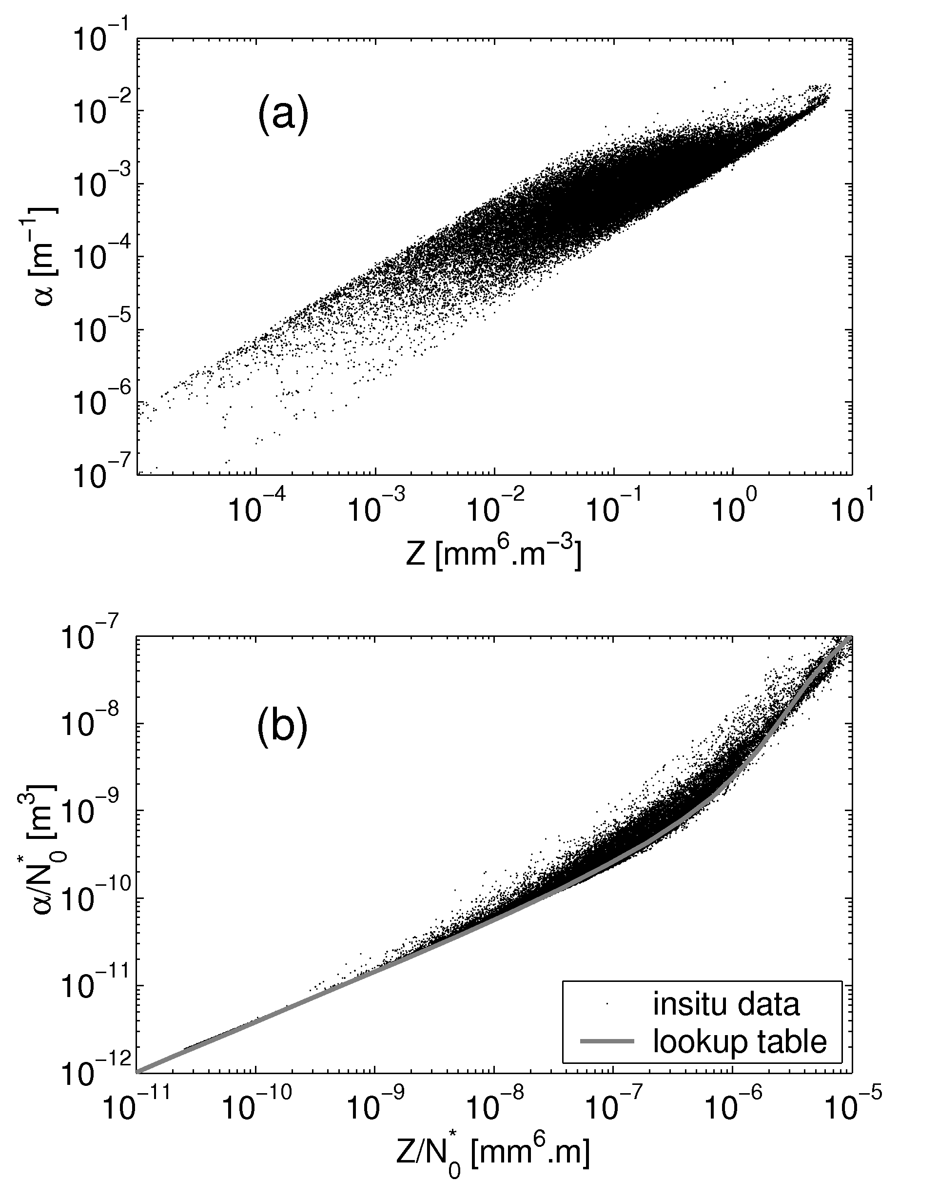
Figure 5-2: (a) Visible extinction coefficient av as a function of 94-GHz radar reflectivity factor Z for the large in situ aircraft database of Delanoë et al. (2005). (b) The same but after dividing both variables by the normalized number concentration parameter N0*. The gray line corresponds to the fit calculated using the unified size distribution shape. The curved shape in the relationship is due to the transition between Rayleigh scattering at small particle sizes to Mie scattering at larger sizes.

A priori of the normalized concentration parameter N₀*
As discussed in section 5.4.1, a desirable property of at least one of the state variables is that we have a good a priori estimate of it from temperature (T), in order that when only the radar or the lidar are available, the retrieval is at least as accurate as existing empirical relationships based on temperature in the literature (e.g. Hogan et al. 2006a).
Figure 5-3 (a) shows the temperature dependence of N₀* using the same in situ database as used in, Figure 5-2. It can be seen that, although there is such a relationship, it is not IWC independent. For both this reason, and in order to reduce the scatter, we divide it by a power of the visible extinction coefficient.
A range of powers has been tested and it is found that the best results are found for a power of 0.6; Figure 5-3 (b) clearly shows that there is an IWC-independent relationship between N₀*/α_{v}^{0.6} and temperature. Hereafter this ratio will be represented by N₀’. Because a good a priori is available for N₀’, it is used in the state vector rather than N₀*, but N₀* needs to still be calculated as the first step in the forward model (box 2 in Figure 5-1) before all the other variables can be calculated. The spread of the points in Fig. 3b indicates that ln N₀’ has a variance of 1.0 (Table 5-9), so this is the value used for the a priori error variance B_{i,j} discussed in section 5.3.5.
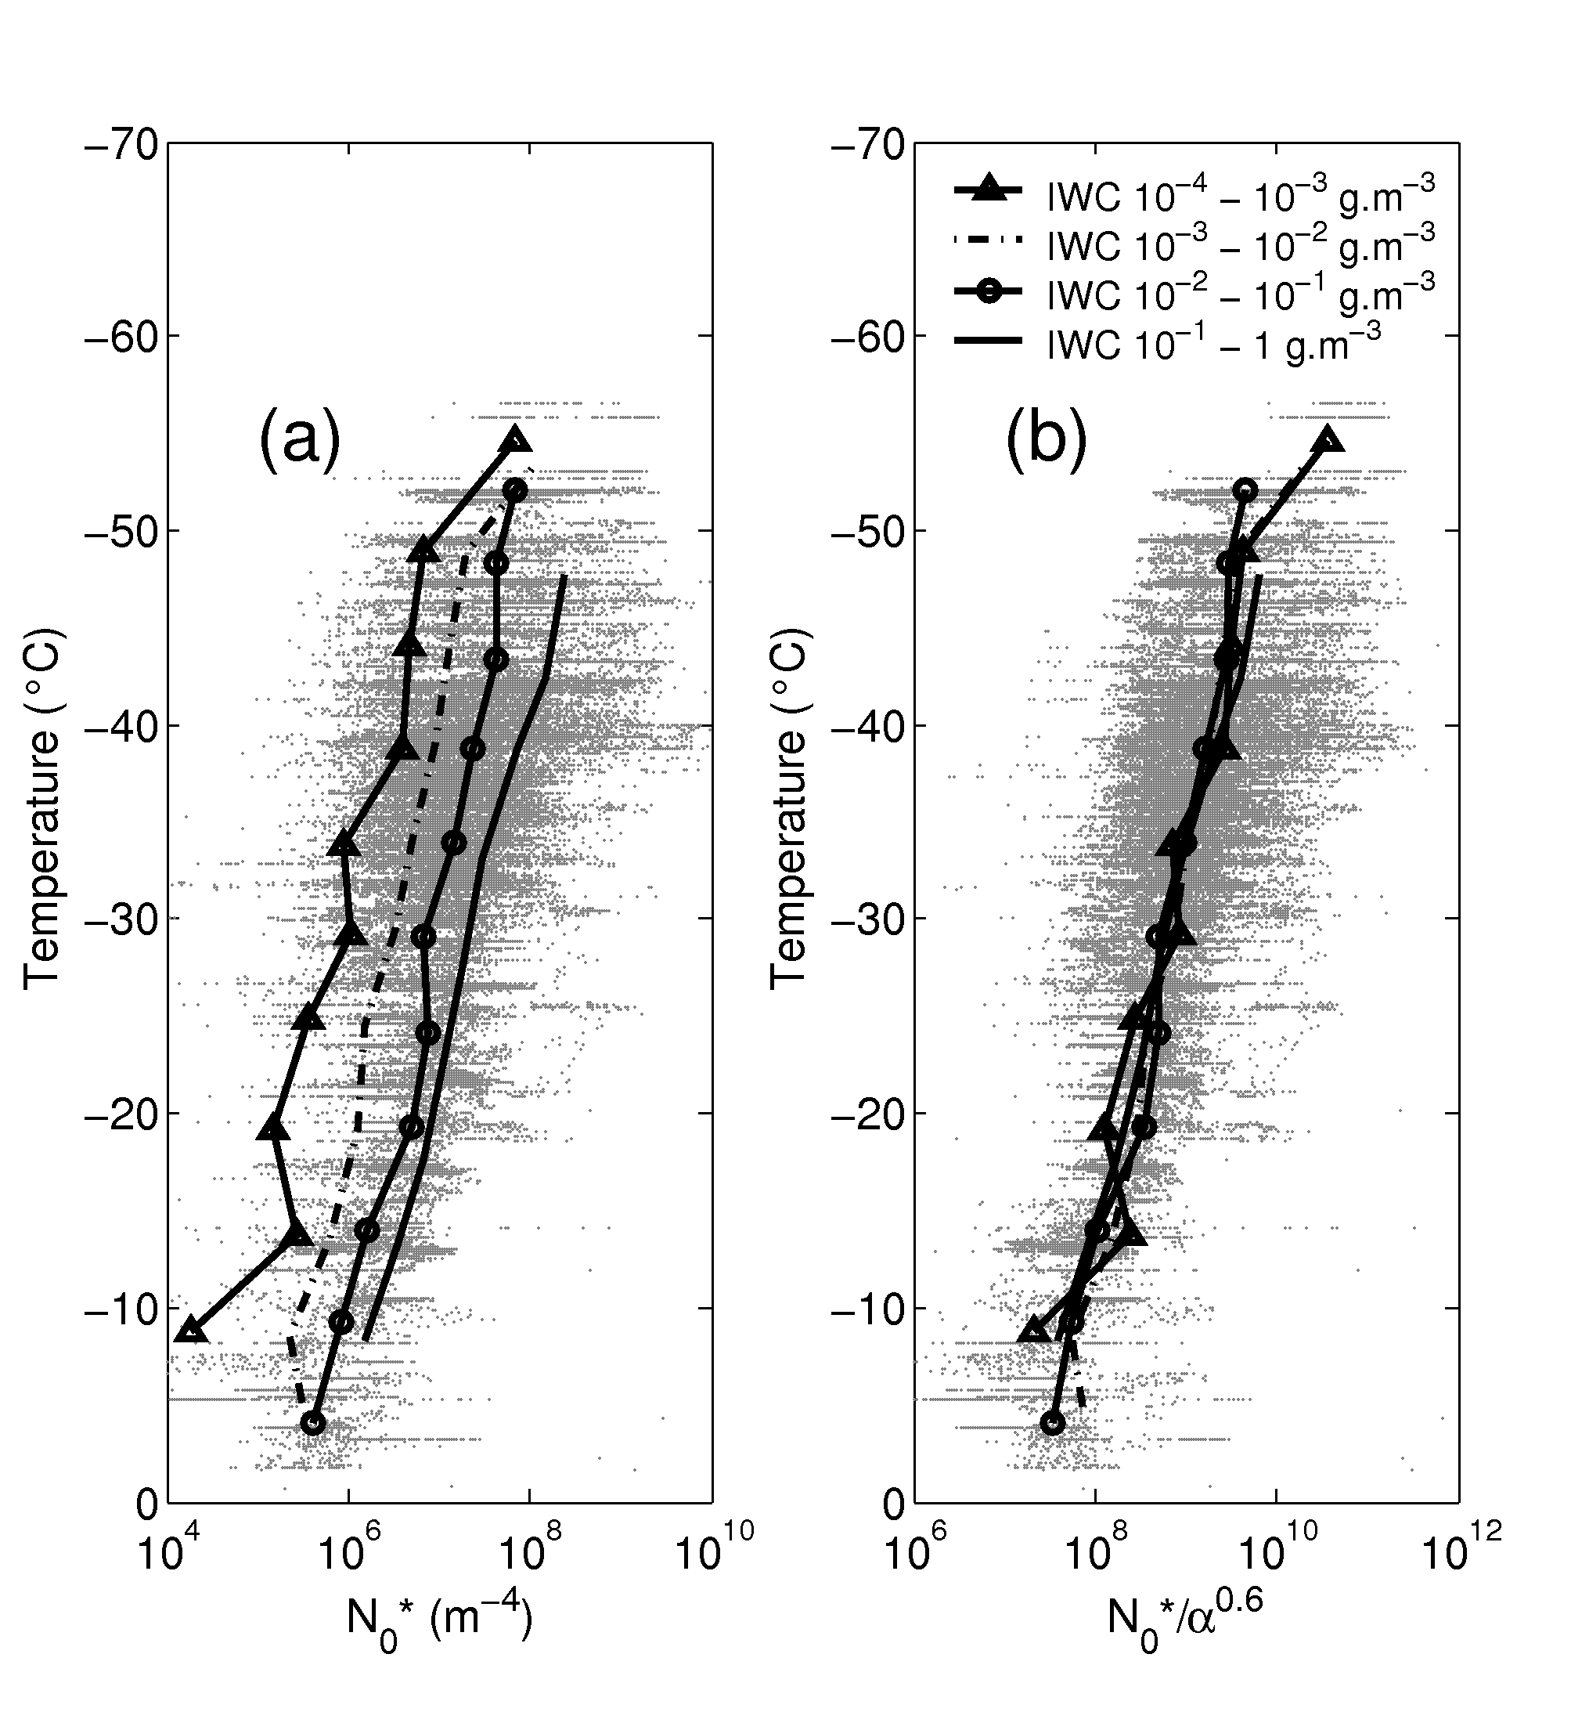
Figure 5-3: (a) The temperature dependence of N₀* for each size distribution within the large in situ database of Delanoë et al. (2005) (dots), superimposed by the mean N₀* in 5C temperature ranges and various ranges of ice water content IWC (lines and symbols). (b) The same but for the variable N₀’ = N₀*/α_{v}^{0.6}

Radar forward model
The look-up tables calculated in section 5.4.7.1 are used in the forward model to derive Z from α_{v} and N₀*, using the relationship between Z / N₀* and α_{v} / N₀* shown in Fig. 2, and represented by box 3 in Figure 5-1. Gaseous attenuation at the radar wavelength is calculated using the look-up tables generated from the line-by-line model of Liebe (1985), coupled to estimated profiles of temperature, pressure and humidity as part of the ancillary data if it has not been already done in the merged file. Note that Liebe (1985) may not still be state-of-the-art, but it would be straightforward to use an alternative model. Ice attenuation is believed to be small enough to be neglected (e.g. Hogan and Illingworth 1999, although they specifically considered 79 GHz which is very close to 94 GHz in terms of the extinction due to ice particles). Note that it would be straightforward to relax this assumption by including attenuation in the radar forward model.
The Jacobian of the radar forward model, i.e. the partial derivatives of ln Z at each gate with respect to ln α_{v} and ln N₀’, may be calculated efficiently using the gradient of the relevant look-up tables.
The second part of the radar forward model is the calculation of the part of the high resolution Jacobian Ĥ (mentioned in section 5.4.3) that contains the partial derivatives of ln Z with respect to each element of the state vector x. This is represented (for all instruments) by box 9 in Figure 5-1. The derivative of ln Z at high-resolution gate i with respect to the logarithm α_{v} at gate i, keeping N₀* constant, is:
(24)
The derivative is derived directly from the lookup-table by computing the slope of the relationship between the logarithms of Z / N₀* and α_{v} / N₀*. If we neglect attenuation in ice cloud then Z at gate i does not depend on α_{v} at any other gate j, so
(25)
The partial derivative with respect to N₀’ is derived in a similar fashion
(26)
while the off-diagonal terms are again zero:
(27)
Since the reflectivity factor is totally independent of the lidar extinction-to-backscatter ratio S, the partial derivative with respect to S is equal to zero.

Forward model error
As discussed in section 5.4.6, it is important to include the contribution of forward-model error to the observation error covariance matrix R. In the case of the radar model, the leading source of error is due to the representation of the size distribution by a unique modified gamma shape (see 5.4.7.1 for more details). The spread of points in the in situ microphysical data set cannot be represented in the lookup tables, which contributes to a root-mean-squared random error in Z. Additional errors are associated with the approximation of ice particles by homogeneous ice-air spheres, which is required for Mie theory to be applied. This approximation leads us to assume a density-diameter relationship, which is used to calculate the ice fraction of the homogeneous ice-air spheres. We consider a random error in Z due to microphysical assumptions (particle size distribution and density) of ΔZ_{micro}= 0.8 dB. This comes from a combination of the spread of points in the x-direction in Fig. 5-2b (the contribution from uncertainty in the particle size distribution), and from the degree of agreement found between aircraft and radar scans by Hogan et al. (2006a) (the contribution from uncertainty in the density). Forward lidar model error is mainly due to the error in extinction-to-backscatter ratio and multiple scattering effects so we assign an error of 0.6 to lnβ, although it is admitted that this value is somewhat arbitrary and may need to be revised in light of future work.
Table 5-12: Forward model error values
Variable | Value | Unit
Z_{error} | 0.8 | dB
ln β_{error} | 0.6 | none

The error in the forward modelled radiance is little more complicated, since it depends on cloud thickness, surface temperature and error in meteorological parameters such as the temperature profile. The infrared radiance forward model used here is described in section 5.5.2 (and more detailed in Delanoë and Hogan, 2008), where each individual radiance calculations employs the “two-stream source function technique”. Comparisons with the 16-stream DISORT code demonstrated that for zenith radiances our code is accurate to better than 1% (see Delanoë and Hogan 2008), thereby justifying the use of only two streams. However this study did not include uncertainties in the input parameters. In the literature, different sources of uncertainties have been explored, including the error in modelling infrared radiances I_{λ} and the radiance difference ΔI due to different particle habit assumptions and errors in humidity and ozone profiles. However these errors are negligible compared to errors due to other input parameters; skin temperature, emissivity and temperature errors.
Skin temperature and emissivity errors have an effect on observed top-of-atmosphere radiances that is dependent on the optical depth of the intervening cloud, and consequently need to be considered carefully. Our radiative model uses a two-stream calculation to estimate the upwelling and downwelling monochromatic fluxes F± , which are then used as the source function in a radiance calculation for the radiance measured by the MSI. Unfortunately, this model is too complicated to rigorously work out the radiance error associated with a particular skin temperature error. Therefore, a much simpler model of infrared radiative transfer is assumed for the purpose of calculating error propagation, although we stress that in the subsequent forward modelling of radiances, the full two-stream model is used.
For estimating the first-order contributions of the surface and the cloud to the measured radiance, it is valid to neglect scattering (which is weak in the infrared) and gaseous absorption (which is weak in the window region of the spectrum); therefore, assuming a single layer of physically thin cloud overlying a surface with an emissivity of unity, we may write the radiance measured by MSI as
(28)
where ε_{c} is the emissivity of the cloud, B is the Planck function, and T_{c} and T_{s} are respectively cloud and surface temperatures. Of course, (28) is not accurate enough to use as a complete forward model, but since errors only need to be estimated to one significant figure, it is sufficiently accurate to estiamate errors, which is our purpose here. For a radiance in the zenith direction, cloud emissivity can be estimated from the infrared absorption optical depth (τ_{λ}):
. (29)
Infrared optical depth can be well approximated as the half of visible optical depth and the cloud emissivity becomes:
. (30)
Since the radiances are only introduced into the retrieval after the radar-lidar part of the algorithm has been run to convergence, we may use the visible optical depth derived by radar-lidar here. In practice it is found that the radar and lidar provide an optical depth that is close to the value using all three instruments, and therefore the use of this optical depth does not introduce substantial uncertainty in the calculation of the error in I_{λ}..
We take the partial derivative of (28) with respect to ε_{c}, T_{c} and T_{s}, and by assuming each error is independent may sum the squares of the results to obtain the error variance of the radiance:
(31)
where ΔT_{s} is the error in surface temperature, which is assumed 3 K for ECMWF forecasts according to Morcrette (2001). ΔT_{c} is the error in cloud temperature; we use a value of 0.6 K, which was the estimated error of ECMWF temperature forecasts by Benedetti (2005). This value does seem rather low, but unfortunately the Benedetti (2005) reference is the only one that we have been able to get hold of. Certainly it would be straightforward to change the assumption in light of future work and communication with ECMWF. An additional consideration is that we require the temperature at a 1-km horizontal scale, but the ECMWF value will be the average over a 25-km model gridbox. It is expected that when EarthCARE flies, ECMWF will provide the instantaneous random errors in their temperature and humidity products. Note that if this number is increased from the current value of 0.6 K, then it means that the infrared radiance will contribute proportionately less to the retrieval. Future work ought to include a sensitivity test to investigate the impact of errors in temperature in interpretting infrared radiances. If the errors are genuinely large, then including infrared radiances in a retrieval (that is already tightly constrained by HSRL lidar) will only have the effect of degrading it. The final point to note is that the ECMWF temperatures will be provided on a pressure grid, and there will be a small amount of error in interpolation due to the model’s pressure error. However, this is believed to be less than the absolute temperature error.
The gradients of the Planck function are straightforward to calculate at the temperature of the surface and the temperature of the cloud (taken to be the cloud-top temperature as detected by the lidar). The random error in cloud emissivity, Δε_{c}, could be derived from visible optical depth, but it needs to be remembered that we are calculating the error in radiance due to parameters in the forward model that are held constant during the subsequent retrieval process. Since the cloud optical depth, and hence the cloud emissivity, will be varied in order to better match the observed radiance in the subsequent retrieval, this component of the error in (31) is set to zero.
It is clear that the errors in radiance will be strongly dependent on the visible optical depth retrieved in the first part of the algorithm: optically thin clouds will let through a substantial amount of radiation from the surface, and therefore the surface temperature error contributes significantly to the error in the radiance forward model. For optically thick clouds, ε_{c} is close to unity, almost all the measured radiation was emitted by the cloud, and hence the errors in forward modelling the radiance arise entirely from the error in the temperature profile. Errors in ΔI are estimated by combining the errors for the two contributing radiances.

Computing the retrieval error in ice water content and effective radius
As outlined in section 5.4.6, S_{x} contains the error variances and covariances of the retrieved ln α_{v}, ln S and ln N₀’, with ln α_{v} and ln N₀’ both having n elements. In this section we describe how the errors and error covariances in IWC and r_{e} may be derived rigorously and in a way that may be easily extended to any other extensive or intensive variable. Note that all calculations here are done with the matrices transformed such that all variables are held on the high resolution grid of the observations, rather than being in the form of basis function coefficients. However, for simplicity the “hats” used in section 5.4.6 have been omitted from S_{x} and x.
Defining column vector m as:
(32)
the task is to compute the corresponding error covariance matrix, S_{m}. As described in section 5.4.7.1, the look-up tables can provide any variable in terms of N₀* and the ratio α_{v} / N₀*. It is therefore convenient to consider an intermediate column vector u that contains these entities:
(33)
This may be obtained from x using u = Ux, where the matrix U describes how the elements of x are transformed to the elements of u. From (3) we derive and . Therefore, for the case of n = 2 and for S represented by a single number, the matrix U would be
(34)
where the column of zeros in the middle corresponds to the central element of x that contains ln S; this is not represented in u. Following (17), the error covariance matrix for u is given by . The last step is to define the matrix M such that we can write . This matrix is similar to a Jacobian in the sense that it contains the partial derivatives of each element of m with respect to each element of u. The look-up tables are of the form , or equivalently , where f_{IWC} represents the look-up table for IWC. Hence for n = 2 we have
(35)
where the partial derivatives are simply the gradients of the look-up tables. Bringing the preceding analysis together, the error covariance of m may be derived directly from the error covariance of the state vector using .

Miscellaneous
In deep convective clouds observed by spaceborne radar, it has been shown that multiple scattering can be important [Battaglia et al. (2007)]. In such situations, a number of the assumptions made in this retrieval scheme would become inappropriate, particularly the use of the Brown and Francis (1995) mass-size relationship, which is suitable for low-density aggregates. However, in principle a fast radar multiple scattering model, such as the one of Hogan and Battaglia (2007), could be incorporated. At present a fast method to calculate the Jacobian is not available for this model.

External models

Lidar multiple-scattering forward model (Hogan 2006)
To include molecular scattering and multiple scattering, we use the fast multiple-scattering model of Hogan (2006), which has been found to be as accurate as the widely-used Eloranta (1998) model when taken to 5th order scattering, but is over 3 orders of magnitude faster for a 50-point profile. The model is represented by box 6 of Figure 5-1 and takes as input the lidar ratio S, profiles of α_{v} and the “equivalent-area radius” r_{a}, i.e. the radius of a sphere with the same cross-sectional area as the mean area of the entire size distribution. A look-up table is used to convert α_{v} / N₀* to r_{a} (box 5 of Figure 5-1).
In order to estimate the molecular return, the profile of atmospheric density is required. The model produces an estimate of the profile of apparent backscatter β, the separate returns from the cloud and the molecules (β^{mie} and β^{ray}, corresponding to Mie and Rayleigh channel respectively), as well as the top-left p × n part of the Jacobian H in (9) that contains . An alternative faster method to calculate the Jacobian was provided by Hogan (2008). Note that is lower-triangular in the sense that β_{i} only depends on values of α_{v,i} earlier in the profile, so values corresponding to j > i are zero.
We also require the elements of the Jacobian corresponding to the other terms in the state vector. The Jacobian with respect to the cloud extinction-to-backscatter ratio S, when molecular scattering is included, we assume that the molecular extinction-to-backscatter ratio has a fixed value of 8π/3 sr, and the Jacobian is expressed as . The derivative of molecular return with respect to S is equal to 0 since independent on S, then .
The Jacobian with respect to N₀* arises due to the particle-size dependence of multiple scattering. Since this is relatively weak, we assume for both channels (Mie and Rayleigh) that
(36)
due to the fact that in practice β is primarily dependent on α_{v} and only weakly dependent on particle size and N₀*.
Regarding the partial derivative of β (Rayleigh and Mie) with respect to the visible extinction parameter, the upper diagonal is always equal to zero since the lidar signal at i^{th} gate is not affected by the further i+1th gate:
. (37)
The lidar model gives us and as described in Delanoe and Hogan (2008).

Infrared radiance forward model
For each infrared radiometer channel, the radiance forward model takes as input the relevant cloud variables from the state vector (profiles of visible extinction coefficient α_{v} and N₀’) and estimates of other variables (profiles of temperature, pressure, humidity, O₃ and CO₂ concentrations, as well as skin temperature and emissivity). It produces an estimate of the radiance measured by the instrument as well as the Jacobian with respect to each of the cloud variables from the state vector.
The scattering and absorption properties of ice are taken from the database of Baran (2003), which assumes aggregates. At each radiometer wavelength λ, the ice particle distributions described in section 5.4.7.1 have been used to create look-up tables such that from an input profile of α_{v} and N₀*, profiles can be calculated of extinction coefficient α_{λ}, single-scatter albedo and asymmetry factor g_{λ}. This is illustrated by box 7 of Figure 5-1.
The forward model was described more fully by Delanoe and Hogan (2006), and therefore, as it is treated as an external module, only a brief overview will be provided here. Gaseous absorption is represented using the correlated-k-distribution method similar to that described by Fu and Liou (1993); the radiance code is essentially run multiple times to represent the variation of absorption coefficient within the wavelength band of a particular channel. Line-by-line calculations using the code of Kato et al. (1999) have been performed to determine the number of quadrature points required and to produce the necessary look-up tables for each satellite channel of interest. The spectral features of different gases within a channel are assumed to overlap randomly, i.e. the wavelengths of the peaks and troughs in the absorption spectrum of one gas are uncorrelated to the wavelengths of the peaks and troughs for the other gases. For example, for the EarthCARE multi-spectral imager (MSI) channel 5 at 8.85 μm, numerical integration over the spectral region requires 6 quadrature points for the H₂O absorption spectrum and 2 quadrature points for the O₃ spectrum, resulting in 12 independent radiative transfer calculations. The cloud properties are kept constant in each calculation. The final radiance and Jacobian are computed as a weighted average of the radiances and Jacobians from each individual calculation, using Gaussian Quadrature.
The individual radiance calculations employ the “two-stream source function technique” of Toon et al. (1989), which is very fast but still represents scattering with sufficient accuracy to be used in the infrared when clouds are present. This is illustrated by box 8 in Figure 5-1. The method used here is described in Delanoe and Hogan (2008). The radiance model takes as inputs the variables α_{8.85}, α_{10.85,} α_{11.85,} ,,, g_{8.85,} g_{10.85} and g_{11.85} (although in practice only two wavelengths are used, by default 10.85 and 11.85 μm) deduced from visible extinction and N₀*. The model computes the infrared radiances at 8.85, 10.85 and 11.85nm and for the Jacobian dI_{λ}/dα_{v} and dI_{λ}/dN₀*.
Although monochromatic calculations with the infrared radiance forward model have been validated against DISORT (reported by Delanoe and Hogan 2008), verifying that the “two-stream source function” approach is appropriate, there is still a need to validate the ability of the model to represent the gaseous absorption spectrum by comparison with independent calculations. One such approach would be to use the RTTOV model (Saunders et al. 1999), which is widely used for assimilating satellite sounder data (e.g. in the Met Office and ECMWF). Indeed, it is also worth investigating the speed of different forward models and whether RTTOV would be a more suitable forward model than the one used here. It should be noted that the correlated-k tables are actually the same ones used within ECSIM, even though the radative transfer model is Monte Carlo.

Required Computational Accuracies
In determining the required computational accuracies of the retrieved products, it is necessary to go back to the [MRD] where the aim is to retrieve a cloud profile sufficient to calculate the radiative flux to 10 W m⁻². Some discussion of the necessary accuracy in ice water content to achieve this goal was presented by Brown et al. (1995), although they considered more the ability to minimize long-term biases in ice water content. Without performing a large number of sensitivity studies using a radiation code, it is difficult to state the required computational accuracies in the variables retrieved by this (or any) algorithm. Therefore we instead present the a rough estimate of the errors we anticipate from this retrieval (largely based on the findings of Hogan et al. 2006b), and leave it for a future study to determine whether it allows the mission requirements to be met. The key variable for understanding the radiative properties of the clouds is the extinction coefficient, and we believe that we retrieve this to 20%, but often better than 10% in the cloud-top regions where the HSRL channels are sensitive. The ice water content is used to evaluate the values held in numerical models of the atmosphere, and a larger error can be tolerated (in any case, it was shown by Hogan et al. (2006b) that errors in ice water content from radar-lidar retrievals are typically larger than those for extinction). We anticipate a 30% accuracy for retrieved ice water content.

ALGORITHM PERFORMANCE

Performance of the Algorithm
A very similar algorithm to this one has been applied successfully to a large volume of CloudSat and CALIPSO data (Delanoe, Hogan and Stein, document in preparation), and the algorithm has been found to be stable and reliable. With the additional information coming from the HSRL lidar channel to constrain the extinction, we are confident that the algorithm will perform well on EarthCARE data.

Error Propagation of Input Data Errors
As shown by equations 10 and 11, the errors in both the observations are treated rigorously in the retrievals via the observation error covariance matrix R. This contains errors due not only random measurements, but also due to forward model errors. These are described in depth in section 5.4.7. These propagate to errors in the retrieved state variables, and are reported as part of the data product. The propagation of errors in the state variables to the other retrieved microphysical variables IWC and r_{e} is described in section 5.4.8. Hogan et al. (2006b) conducted a detailed study of the propagation of errors in both the Donovan et al. (2001) and Tinel et al. (2005) radar-lidar retrieval algorithms for ice clouds, which can each be considered as precursors to the one considered here. Therefore, many of their results are also applicable to the AC-Ice-Reading algorithm (perhaps less to the ACM-Ice-Reading algorithm, i.e. the version in which infrared radiances are included). Table 6-1 lists the sensitivities of the three key retrieved variables to various errors in input parameters that are still applicable here (at least, they are applicable to the retrieval in the part of the cloud detected by both the radar and the lidar). It can be seen that in general the extinction is very insensitive to many possible sources of error in the inputs. This is because it is retrieved before the key microphysical assumptions (e.g. on the mass-size, or density relationship) need to be made. The other two variables, on the other hand, do show some sensitivity to these assumptions.
Hogan et al. (2006b) also considered sources of error which are not necessarily applicable here, but which are useful to report anyway; these are given in Table 6-2.

Table 6-1: Error sensitivities reported by Hogan et al. (2006b) that are applicable to the AC-Ice-Reading algorithm: the first column presents a hypothetical source of error and the remaining three columns report the effect on the three main retrieved ice cloud properties.
Source of error | Extinction | Eff. Radius r_{e} | IWC
Any error in lidar calibration | No effect | No effect | No effect
Radar calibration a factor of 2 too high (+3 dB) | No effect | +5 μm | +10%
Any change in absolute value of S | No effect | No effect | No effect
Uncertainties in the representation of small crystals | No effect | ±15% | ±15%
Uncertainties in mass–size relationship | No effect | ±30% | ±30%
Difference in radar and lidar footprints | ±8% | ±1 μm | ±8%

Table 6-2: As Table 6-1, but for errors that are not always directly applicable to the AC-Ice-Reading algorithm, but which are nonetheless useful to document.
Source of error | Extinction | Eff. Radius | IWC
S varying by ±25% in a profile for a radar-lidar combination in which the lidar does NOT have HSRL capability. Note that these errors are fluctuations around the true value, and so they may largely cancel when vertically integrated quantities (such as optical depth and ice water path) are calculated. | ±25% | ±2.5 μm | ±25%
Non-Rayleigh radar scattering: true r_{e} greater than 100 μm: this result is for very large particles which undergo non-Rayleigh radar scattering (an effect represented in the radar forward model) to an extend that the ratio of radar reflectivity to lidar extinction is no longer uniquely related to particle size. This result needs to be tested further, and to see whether the additional information (e.g. from radiances) can help. | No effect | ~-70 μm | -40%
Neglecting lidar multiple scattering (in practice lidar multiple scattering IS forward modelled of course). | -35% | +3 μm | -35%

One potential source of error is the correction of the radar reflectivity for gaseous attenuation. It was shown by Hogan et al. (1999) that in the tropics, the two-way 94-GHz attenuation from space down to the melting level is likely to be around 0.5 dB, but decreasing to 0.3 dB in mid-latitude regions. If the model humidity is wrong by 20% then at most the error in reflectivity will be 0.1 dB. This is equivalent to a calibration error of 0.1 dB, and it is clear from the second column of Table 6-1 that this will have a negligible impact on the retrievals.
A remaining consideration is that in the cores of convective clouds, the assumptions of no radar attenuation and the Brown-Francis density function are no longer valid. Therefore it would be desirable to have a flag in the target classification product, which would be read in by this algorithm, to highlight regions where the retrieved ice properties are unreliable. In future, it would be desirable for such a flag to be used to change the microphysical assumptions used in the retrieval such that it accounted for higher density particles, radar attenuation and radar multiple scattering.
Clearly there is considerable further work to characterise rigorously the error propagation, and this should be part of any future project to develop this algorithm to the state when it can be applied to actual EarthCARE data.

VERIFICATION / VALIDATION STATUS

How the Algorithm has been Verified / Validated
Note: this chapter will evolve in the future as additional observational datasets become available and are used to validate the algorithm. For the time being, evaluation of the ACM-Ice-Reading algorithm has been performed on two sets of data: the simulated profiles used in the “blind-test” study of Hogan et al. (2006b), and profiles generated by the EarthCARE simulator ECSIM.

Blind test profiles
To test the algorithm, it is first applied to synthetic profiles of radar reflectivity factor and apparent lidar backscatter in the Mie and Rayleigh channels. Using the same methodology as “Blind test 2” in Hogan et al. (2006b), radar and lidar profiles are simulated from the aircraft size spectra obtained during the European Cloud Radiation Experiment (EUCREX) and effects such as lidar attenuation, multiple scattering and instrument noise are included. All profiles used by Hogan et al. (2006b) have been tested, but for brevity only one (their profile 7) is shown here. This has been chosen as it demonstrates many of the strengths and weaknesses of the method.
The calculation of N₀*, r_{e}, IWC and radar reflectivity factor is done assuming the mass- relationship of Brown and Francis (1995), while α_{v} is obtained directly from the in situ measurements of ice particle cross-sectional area using the geometric optics approximation. All processing is the same as that done by Hogan et al. (2006b), except for the lidar multiple scattering, which is calculated with the Hogan (2006) rather than Eloranta (1998) code. Rayleigh and Mie attenuated backscatter values are calculated assuming an extinction backscatter ratio varying with height between 30 and 60 sr in a way that is totally unknown to the subsequent retrieval algorithm.
The radiance for each infrared window radiometer channel of the MSI radiometer is computed using the radiance forward model previously described in section 5.5.2. In this case, the radiance model takes as input the relevant cloud variables (profiles of α_{v} and N₀*) from the in situ measurements, and other variables from the US Standard Atmosphere [McClatchey et al. (1972)]. A random 1% measurement error has been added to the simulated radiances.

ECSIM
ECSIM is the EarthCARE simulator which simulates radar-lidar-radiometer measurements. As mentioned earlier in section 4.1, we use a merged file containing all the required variables to apply the algorithm.

Results and Overall Assessment

Validation using Hogan et al 2006 blind test profile 7
Figure 7-4 demonstrates the application of three different versions of the retrieval algorithm to profile 7 of Hogan et al. (2006b). The thin lines in the first panel show the simulated measurements by the two HSRL lidar channels. It can be seen that the Rayleigh channel is noisier than the Mie channel due to the lower signal to noise ratio, and that it also loses signal sooner than the Mie channel. The gray line in the second panel shows the simulated measurements of radar reflectivity factor. Random errors have been added but are much smaller than for the lidar. The three versions of the algorithm that have been added are
- AC-I Ice cloud properties (radar and lidar only): red lines
- ACM-I Ice cloud properties (all three instruments): black lines
- A version in which the radar and radiometer measurements have been omitted so that the information comes only from the HSRL lidar only: blue lines. This is merely to demonstrate the capabilities of the underlying algorithm rather than necessarily being a product that would be officially used for EarthCARE.
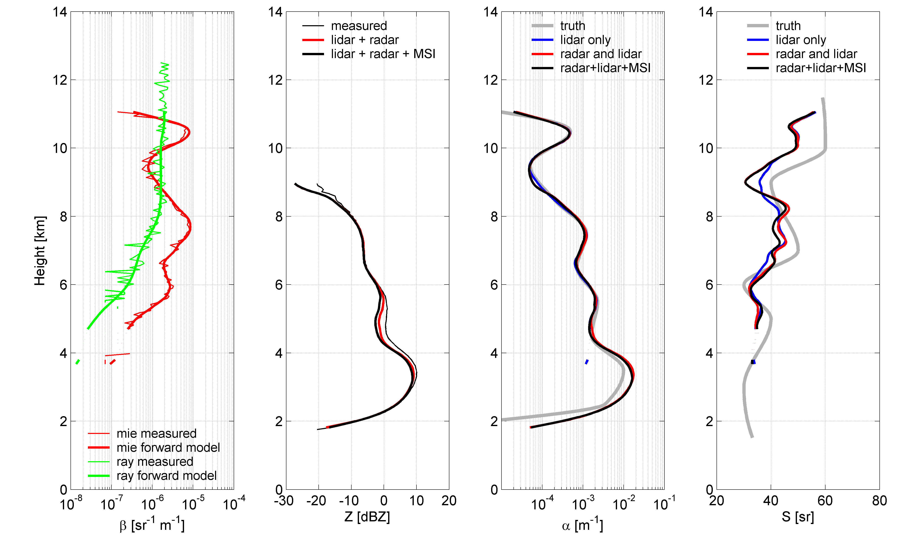
Figure 7-4: Results when algorithm is applied to the blind test, including true and forward-modelled reflectivity and attenuated backscatter (left two panels) and also true and retrieved extinction and extinction-to-backscatter profiles (right two panels). Three different configurations are used: lidar only (blue lines), radar and lidar (red lines) and radar-lidar-MSI (black lines)
The forward modelled values within the algorithm are shown by the thick lines in the first panel and the red and black lines in the second panel. The agreement with the observations confirms that the algorithm has successfully converged to the measurements.
The right two panels of Figure 7-4 compare the retrieved extinction and lidar ratio with the observations. It can be seen that all algorithms retrieve extinction with remarkable accuracy. There is some deviation at the base of the cloud, which is due to the fact that here the lidar signal has been completely extinguished and so the information is coming entirely from the radar. Note that there is no retrieval at cloud base by the lidar-only version of the algorithm for this reason. There is little to say which version of the algorithm is better; it is notable that the inclusion of radiances makes little difference to the accuracy of the extinction in this case. The rightmost panel shows that the features of the lidar-ratio profile are captured by all algorithms, although perhaps with slightly more accuracy by the lidar-only algorithm.
Figure 7-5 compares the other microphysical retrievals to the “truth”. Effective radius is retrieved best by the algorithms using both the radar and lidar, and through most of the depth the error is only a few microns.
The lidar-only retrieval is poorer since it must assume the a-priori value for N0*. Ice water content is retrieved almost as well as extinction in this case, with no significant difference between the three algorithms in terms of accuracy. N0* is retrieved somewhat less well, although as for effective radius, the radar and lidar combination performs better than lidar-only. The final panel shows the retrieved N0’ variable, and compares it to the temperature-dependent a-priori value (note that this is not “truth” like the grey lines in the other plots). There is a slight difference between the retrieval using the MSI radiances and the radar-lidar only, although the main thing to note is that the lidar-only retrieval has to use the a-priori value, which feeds through to errors in the other parameters.
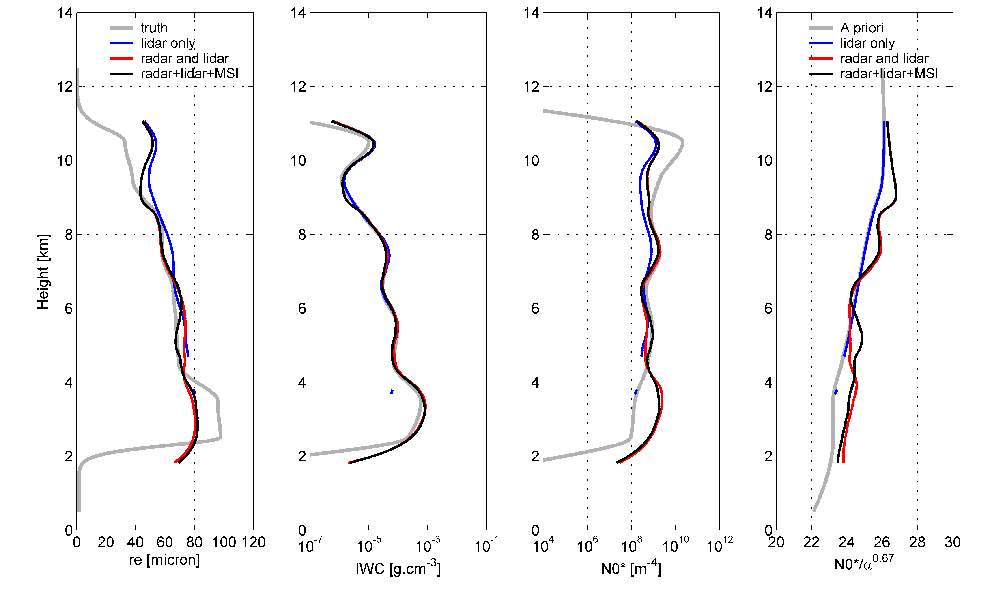
Figure 7-5: Results when algorithm applied to the blind test, true and retrieved effective radius, ice water content, N0* and a priori. The three different algorithm configurations are lidar only (blue), radar and lidar (red) and radar-lidar-MSI (black).

Validation using ECSIM
This example demonstrates the performance of the algorithm using an ECSIM case consisting of a “fractal” ice cloud case generated using the Hogan and Kew (2005) model, and with the extinction retrievals compared to the “true” values. This case contains no liquid clouds, and therefore the task of accurately classifying the profile is sidestepped; moreover, the infrared radiances can be used with confidence.

Radar and lidar
The results for retrievals only using radar and lidar are shown in Figure 7-6. The forward modelled radar, lidar Mie and lidar Rayleigh are again shown to agree with the measurements but without reproducing the instrument error. Note that the Rayleigh scattering contribution has not been forward modelled outside the cloud. As a diagnostic, the off-line radiance calculations are compared to the ECSIM observations in the lower right panel. There are large differences for most of the case, which appears to indicate the forward-modelled radiances to be generally too large, implying that the retrieved cloud is too optically thin. The comparison with the infrared radiances is discussed further in the next section, in which we use them actively within the retrieval.
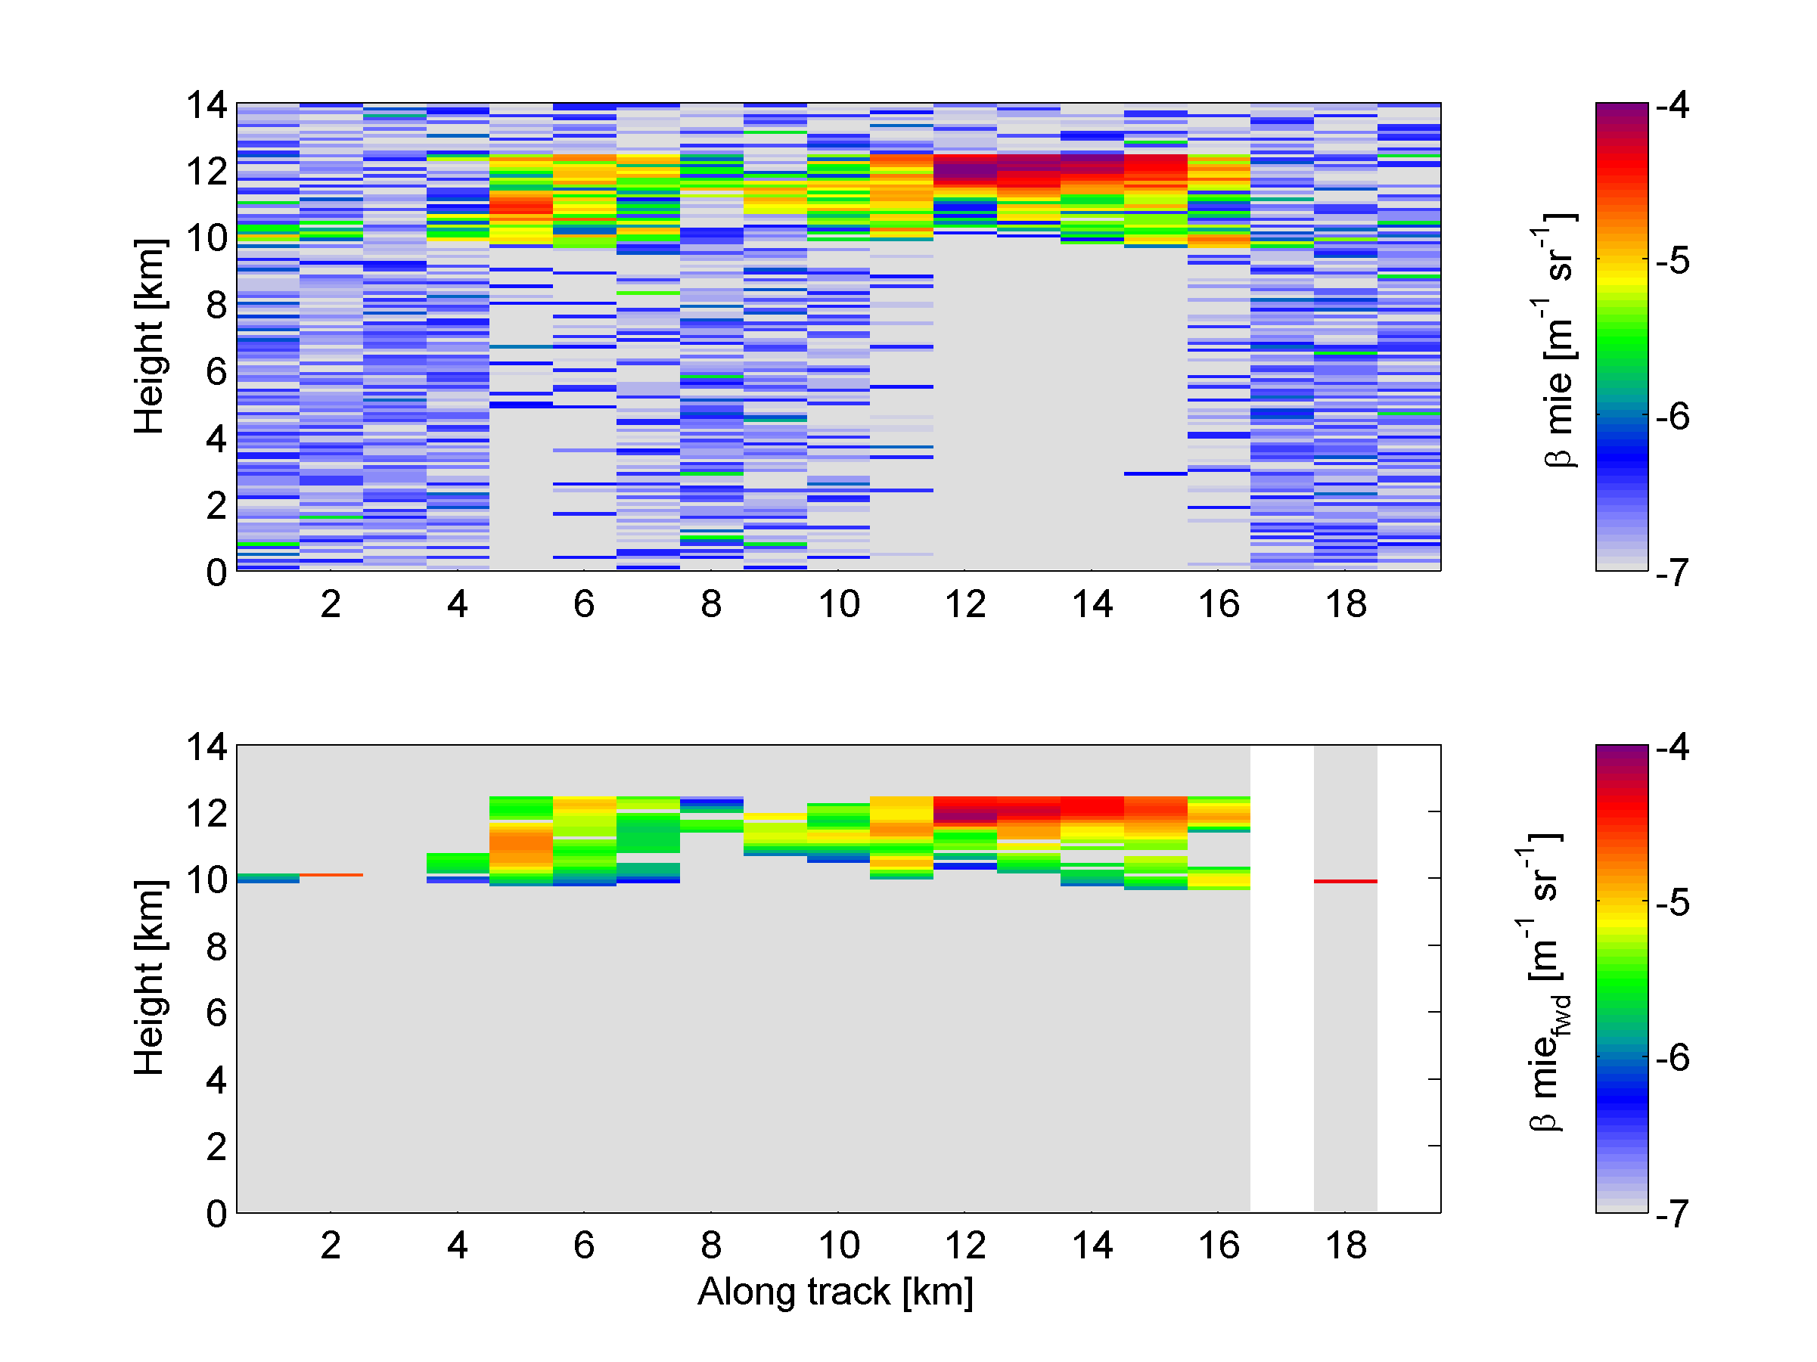
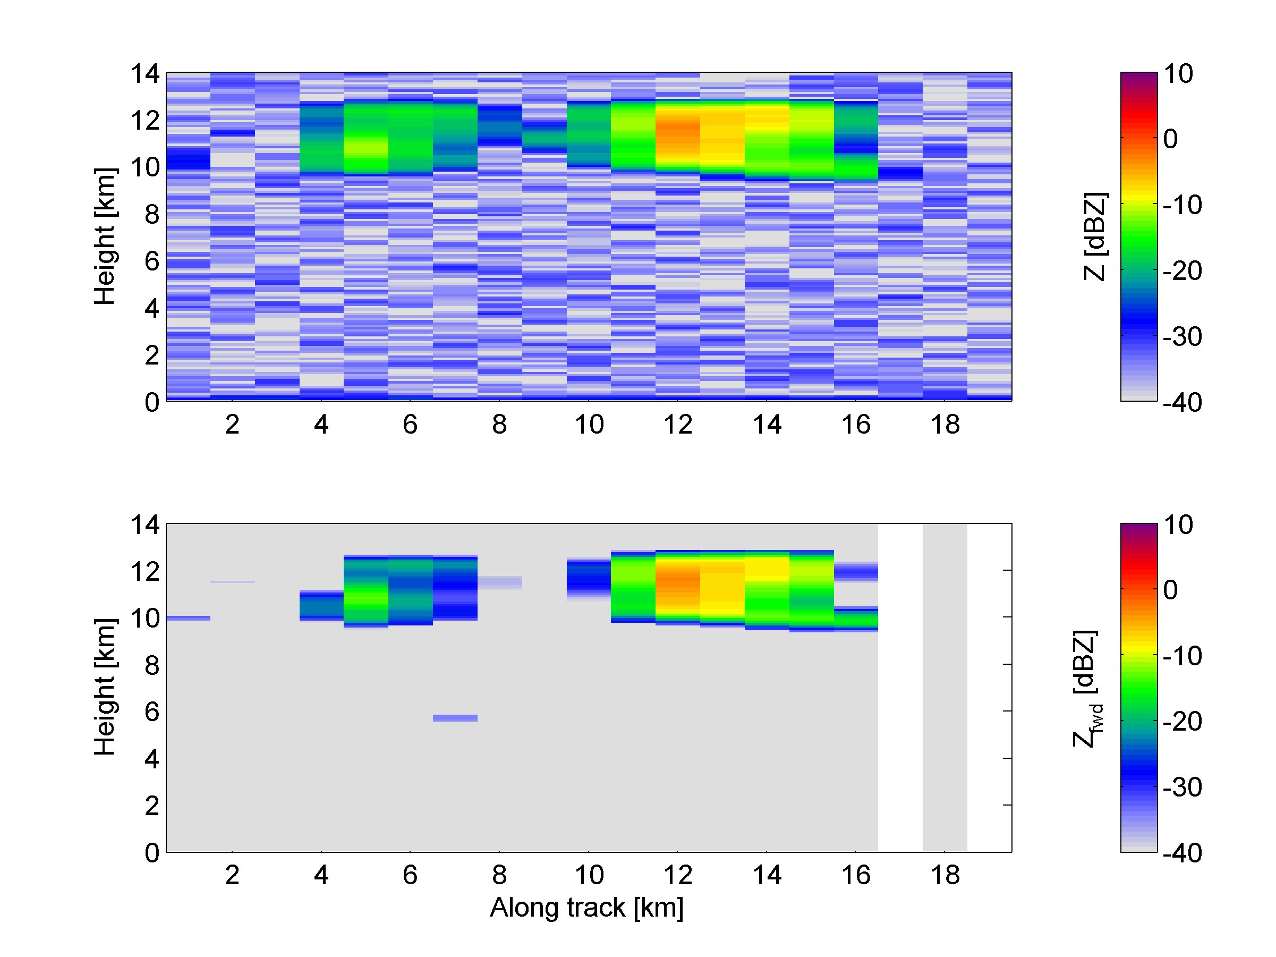
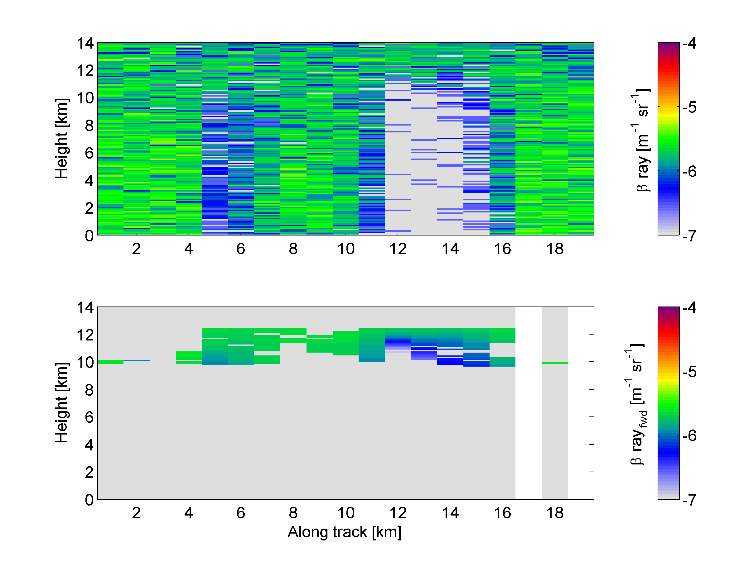
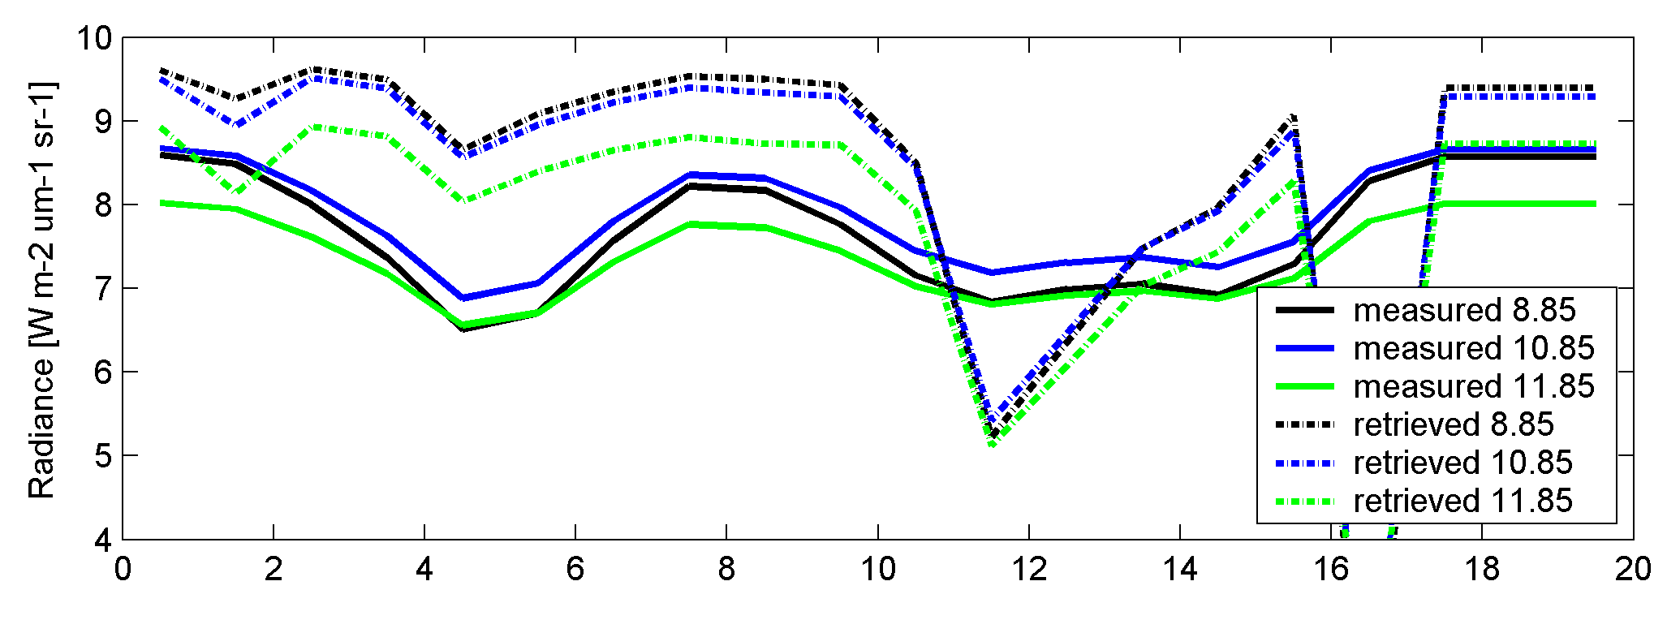
Figure 7-6: (Top row) The ECSIM-simulated observations of (left) HSRL Mie backscatter and (right) HSRL Rayleigh backscatter; (second row) the corresponding “forward modelled” HSRL observations at the final iteration of the “AC-Ice-Reading” radar-lidar version of the algorithm; (third row left) ECSIM radar reflectivity factor; (fourth row left) forward modelled radar reflectivity at the final iteration of the algorithm; (bottom right) the ECSIM (“measured”) and the forward modelled (“retrieved”) radiances in the three infrared window channels of MSI. NOTE: the measurements were not used by the retrieval, so are rather intended to be used diagnostically to assess the quality of the radar-lidar retrieval.
The retrieved extinction is compared with the “truth” in Fig. 7-4 and appears to agree reasonably well. The corresponding retrieved effective radius and ice water content are shown in the lower row in this figure.
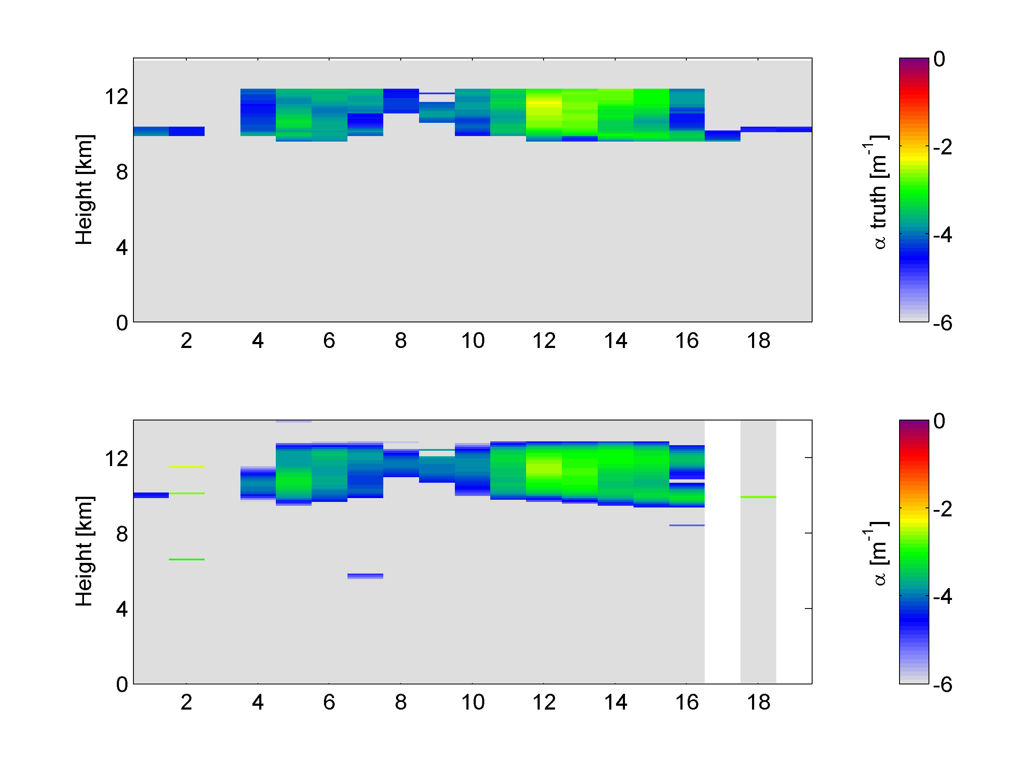 | 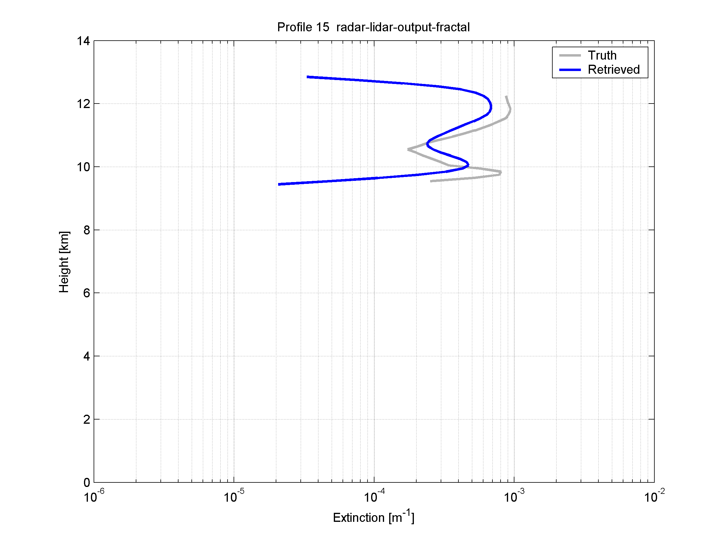
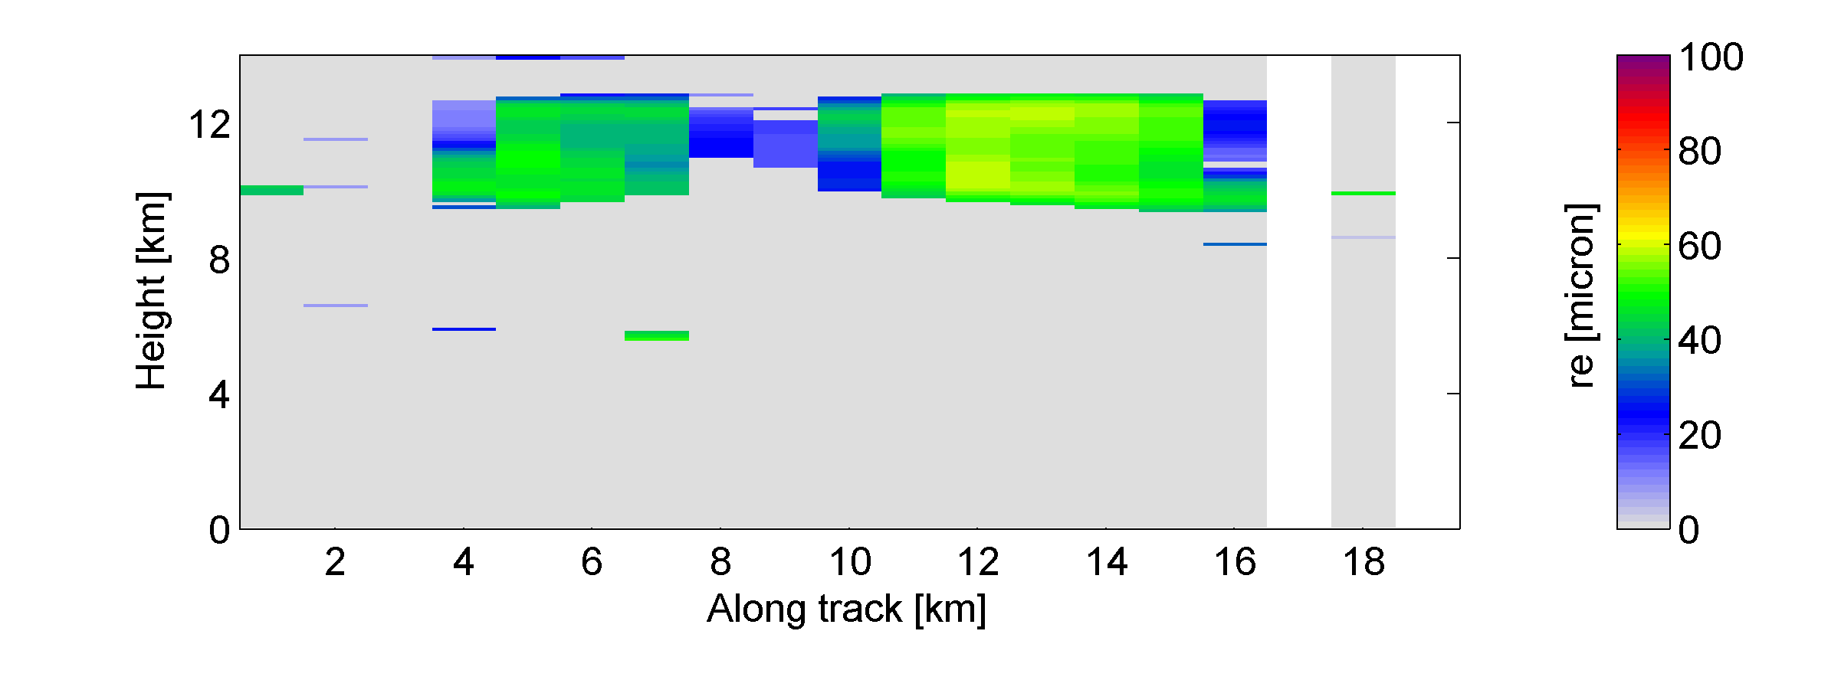 | 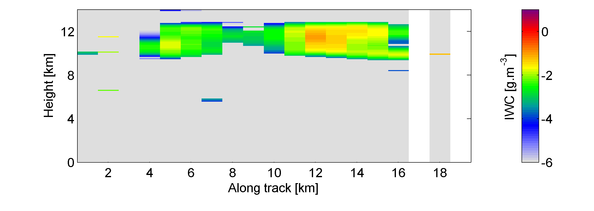
Figure 7-4: Retrievals corresponding to the data shown in Fig. 7-3. (Top left panels) The “true” extinction from ECSIM; (below this) the corresponding retrieved extinction; (top right) a profile comparison of extinction; (bottom left) retrieved effective radius; (bottom right) retrieved ice water content.

Radar, lidar and MSI
Finally we demonstrate the current performance of the three-instrument version of the algorithm (ACM-Ice-Reading) on the same ECSIM case. This time better agreement with the MSI radiances is achieved (lower right panel of Figure 7-5), and the other forward modelled quantities still agree well with the observations.
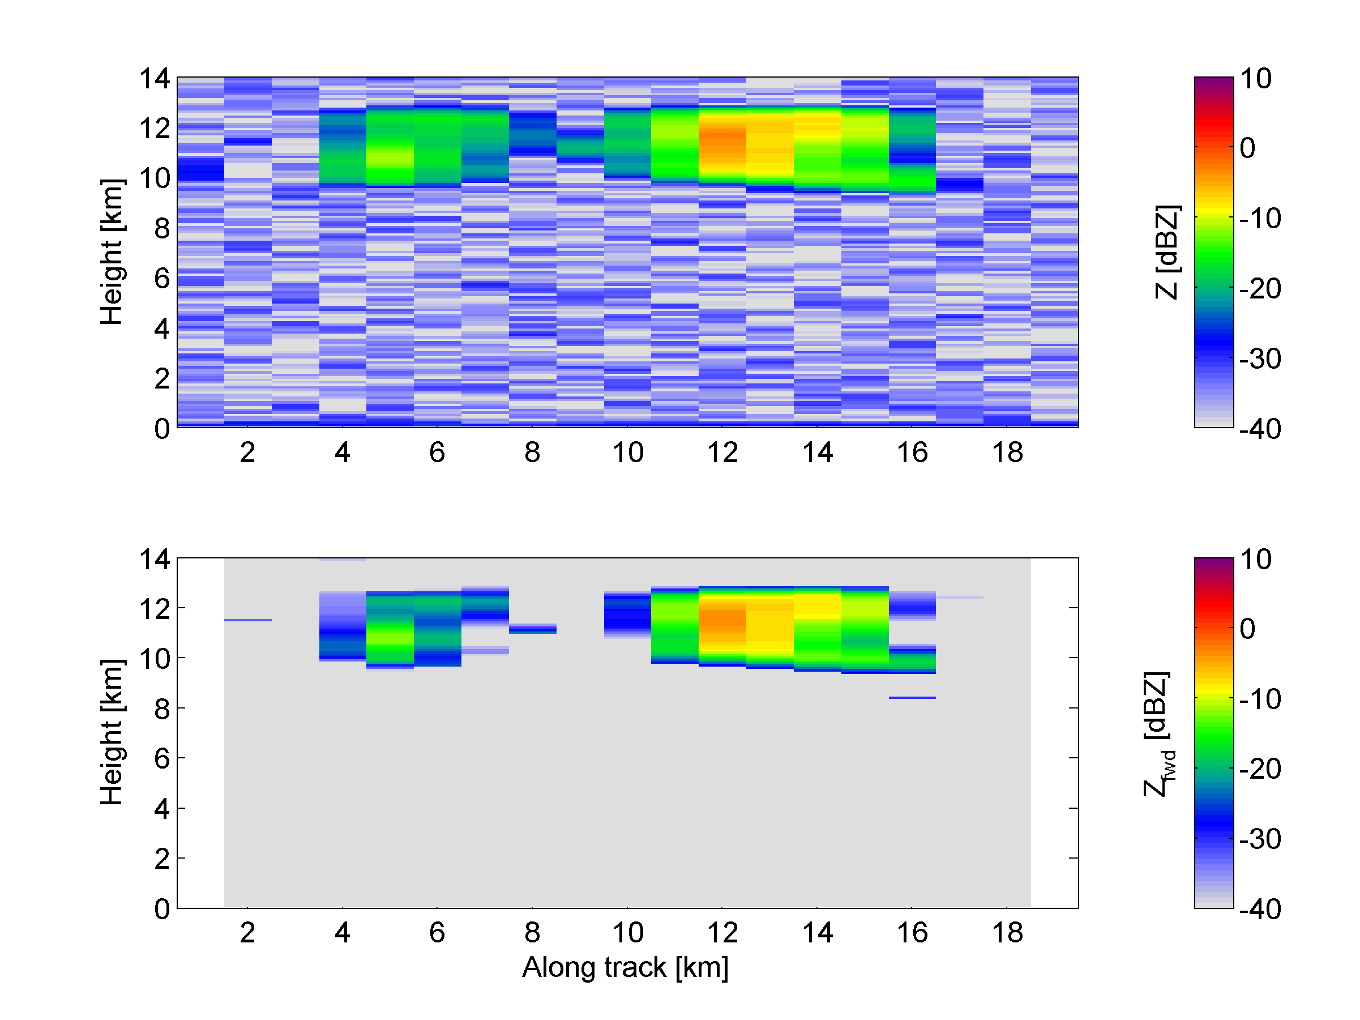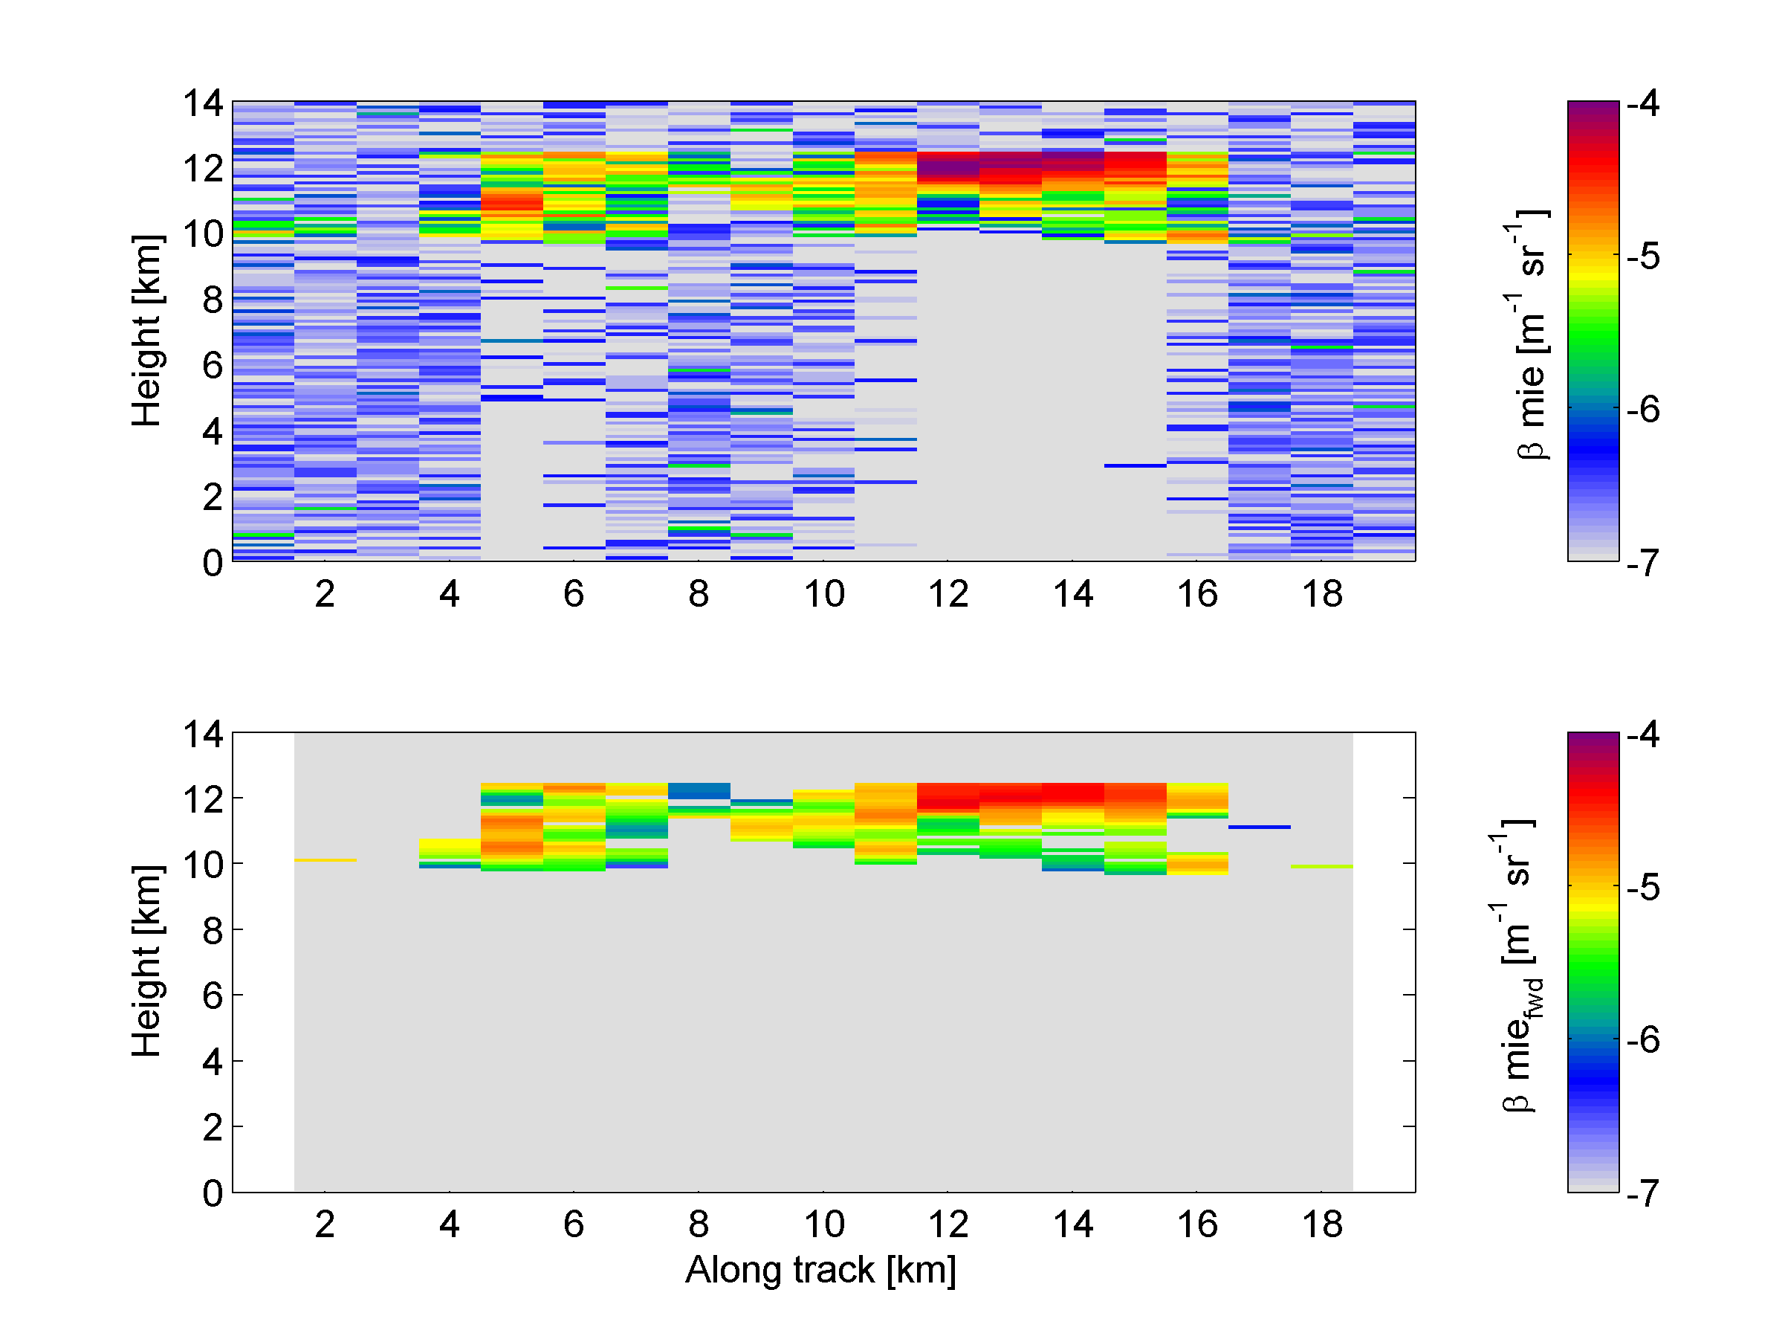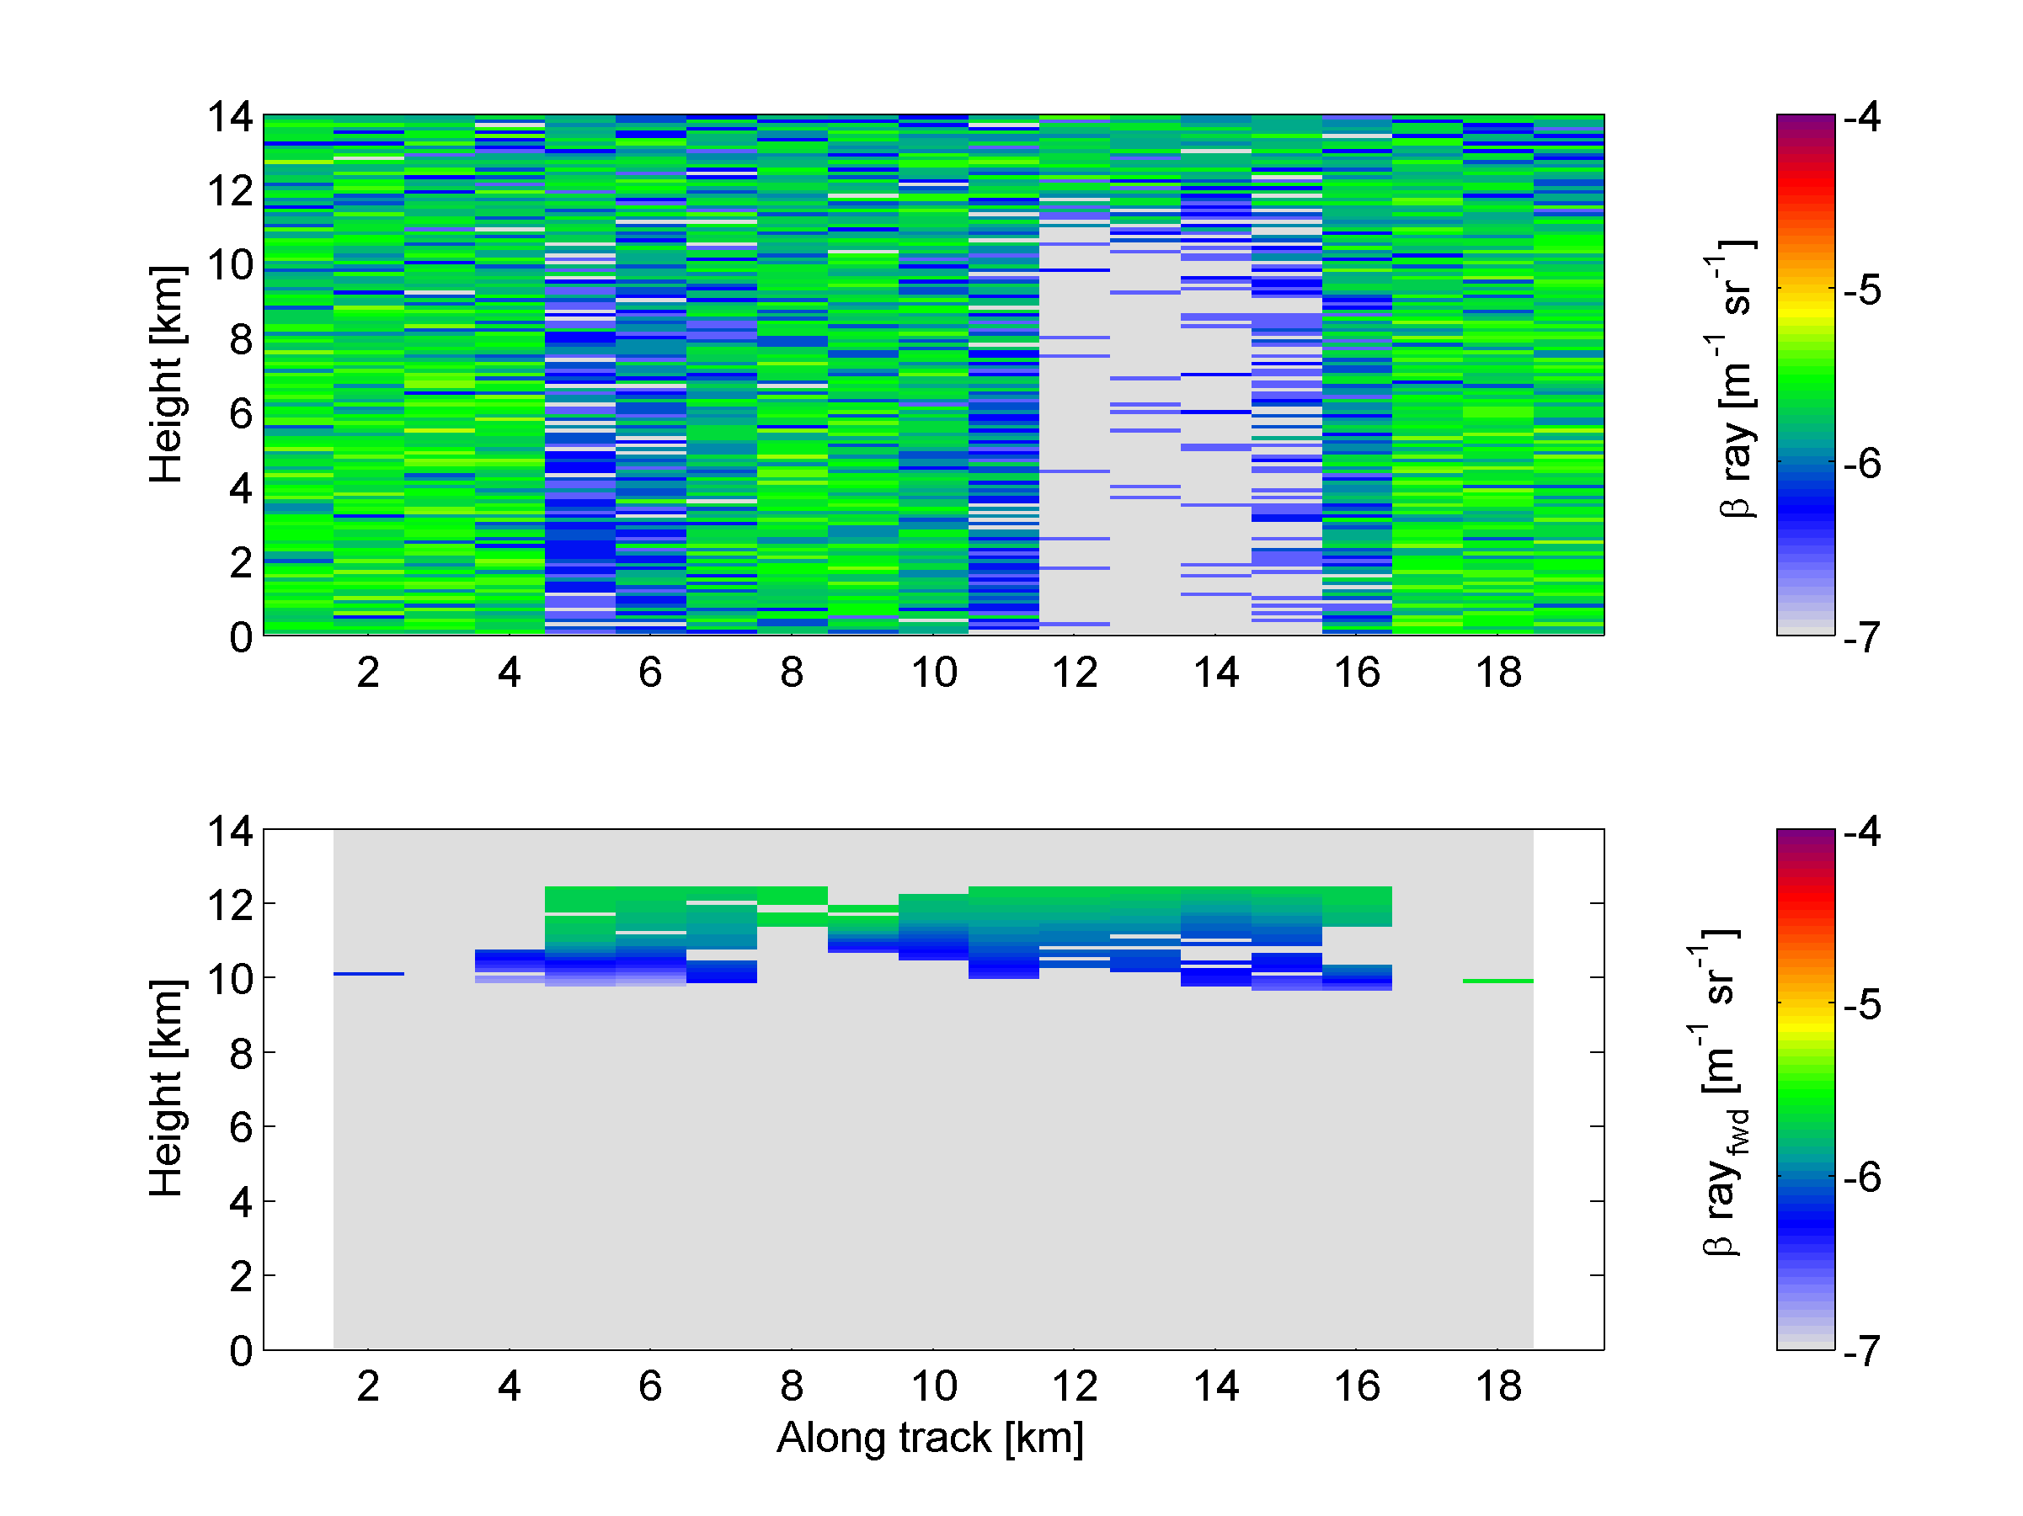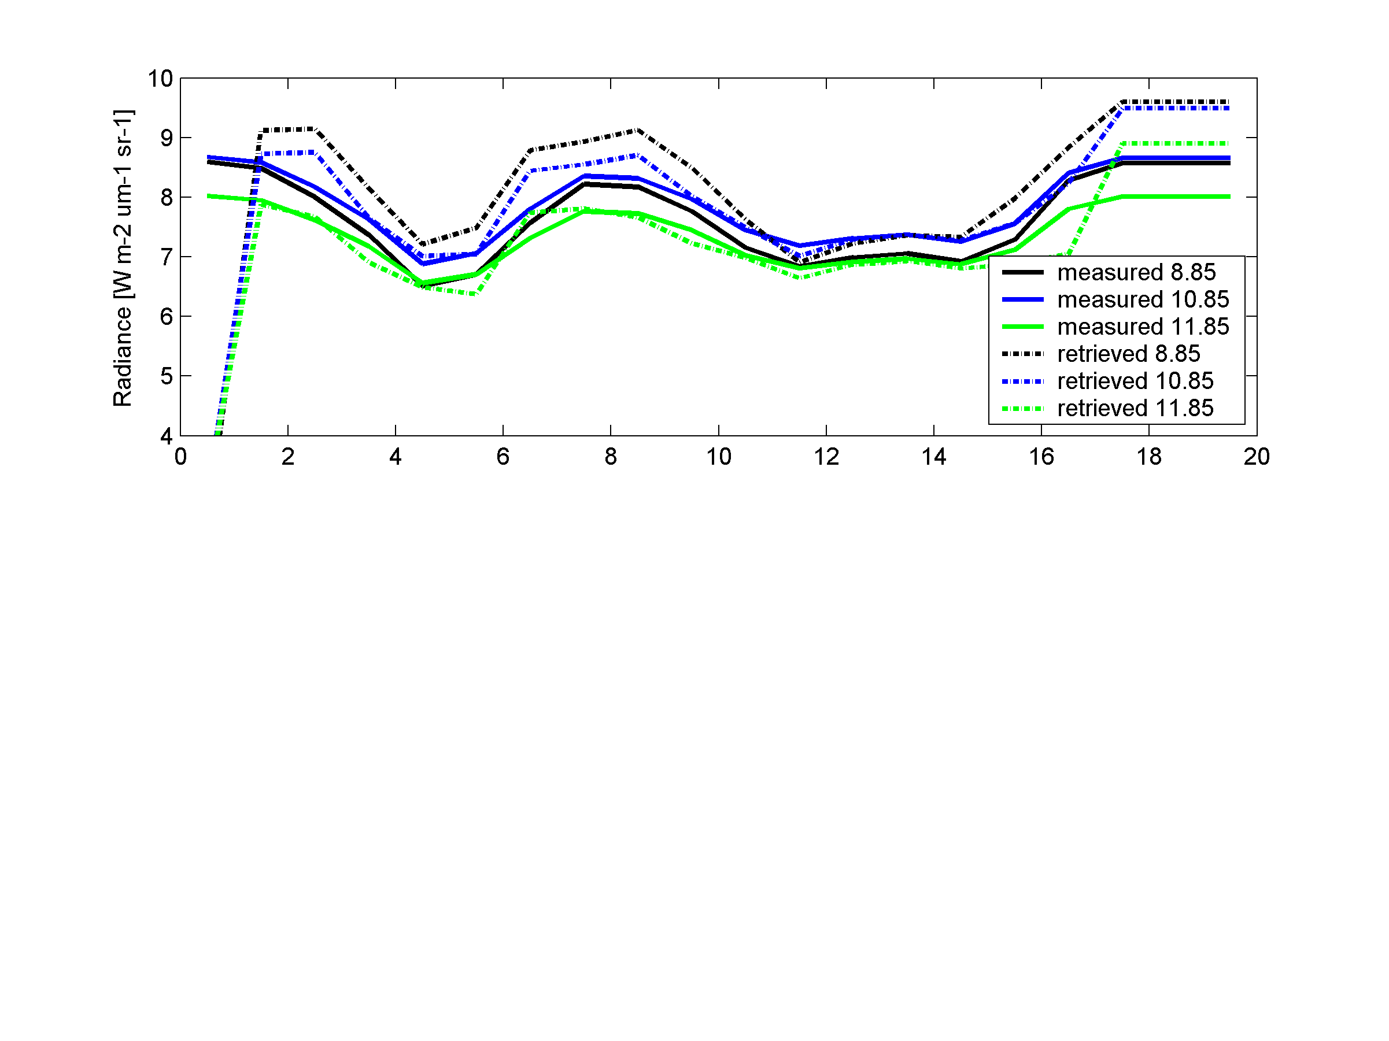
Figure 7-5: As Fig. 7-3, but with the MSI radiances (shown in the bottom-right figure) now being used within the retrieval, i.e. the “ACM-Ice-Reading” version of the algorithm.
The comparison of the retrieved values with the ECSIM “truth” is shown in Fig. 7-6. It can be seen that in the central part, which formerly resulted in too low an infrared radiance, has now had its extinction coefficient reduced, resulting in a better match to the radiances in the lower-right panel of Fig. 7-5 at an along-track distance of 11 km. Conversely, the regions of cloud to either side have had their extinctions increased relative to the radar-lidar version of the algorithm, which counters the previous overestimate of the radiances that had been evident in Fig. 7-3.
However, overall the extinction appears to match the truth less well for the radar-lidar-radiometer case in Fig. 7-6 compared to the radar-lidar case in Fig. 7-4. A particular area for concern is that Fig. 7-5 shows that in the clear-sky region at the far end of the profile (along-track distance of 18 km), the forward modelled radiances using the two-stream source function method do not well match the ECSIM values, which were generated using a Monte Carlo approach. This deserves further study, particularly since exactly the same treatment of gaseous absorption is used. Therefore, further work should include a careful comparison of the infrared forward model in the algorithm with both the one used by ECSIM, and an independent model, such as RTTOV.
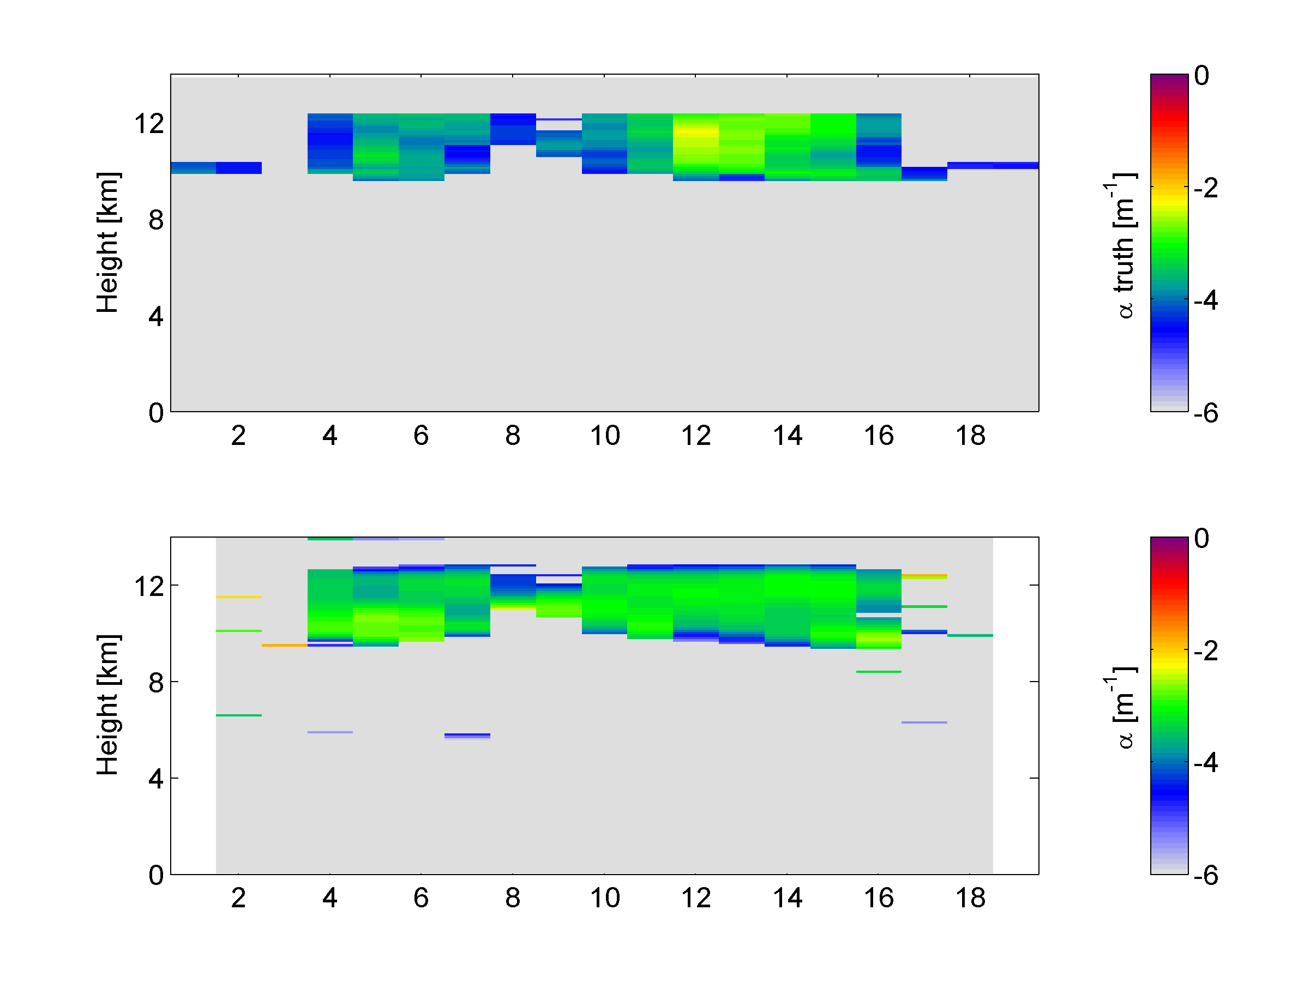 | 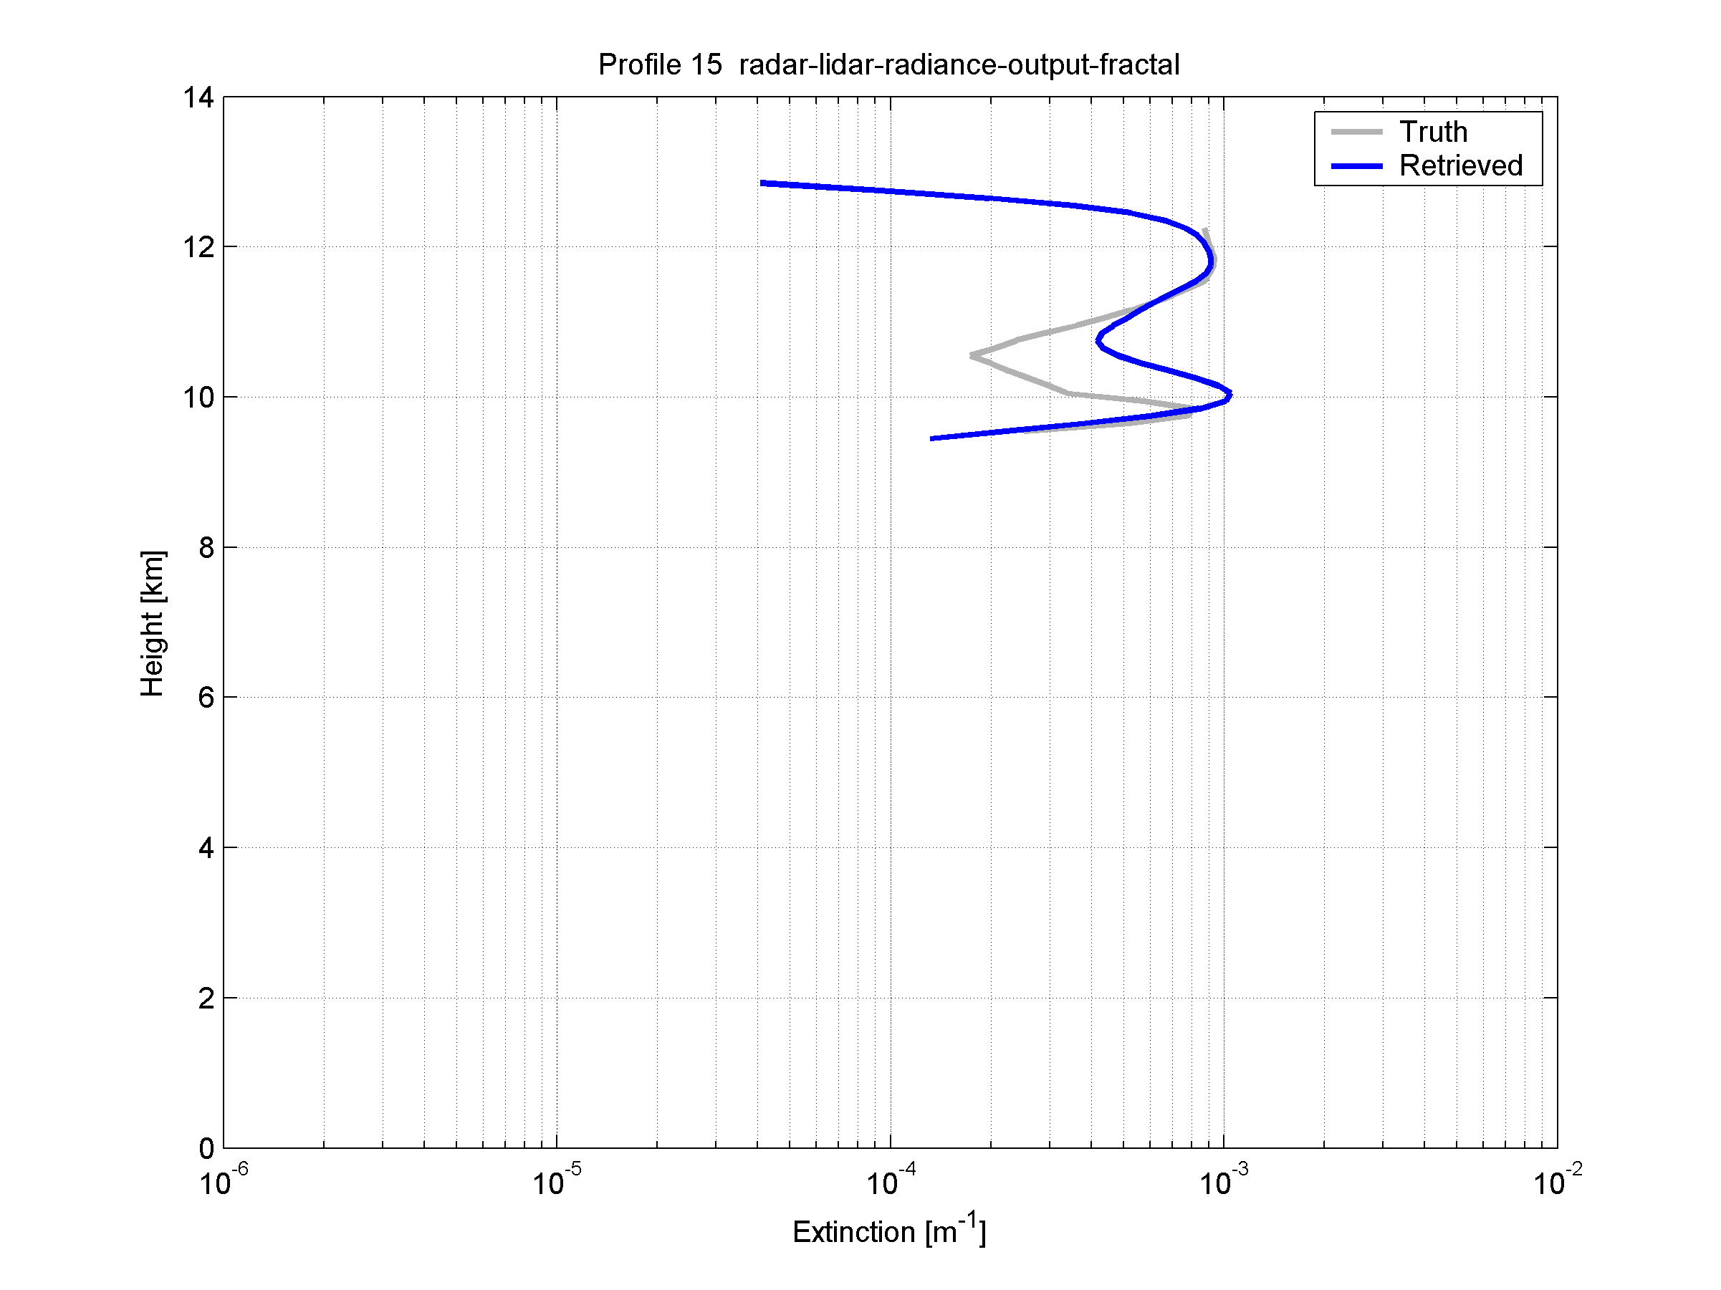
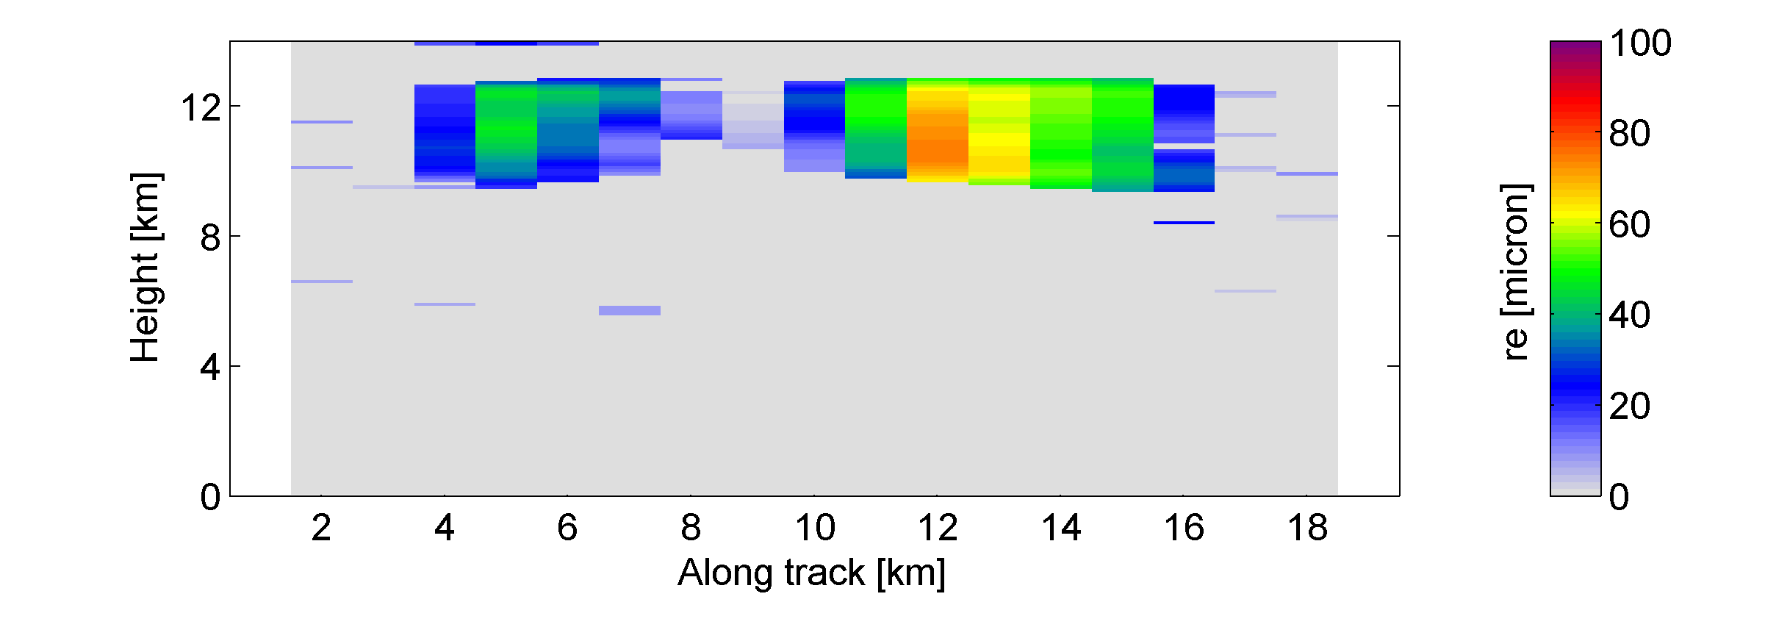 | 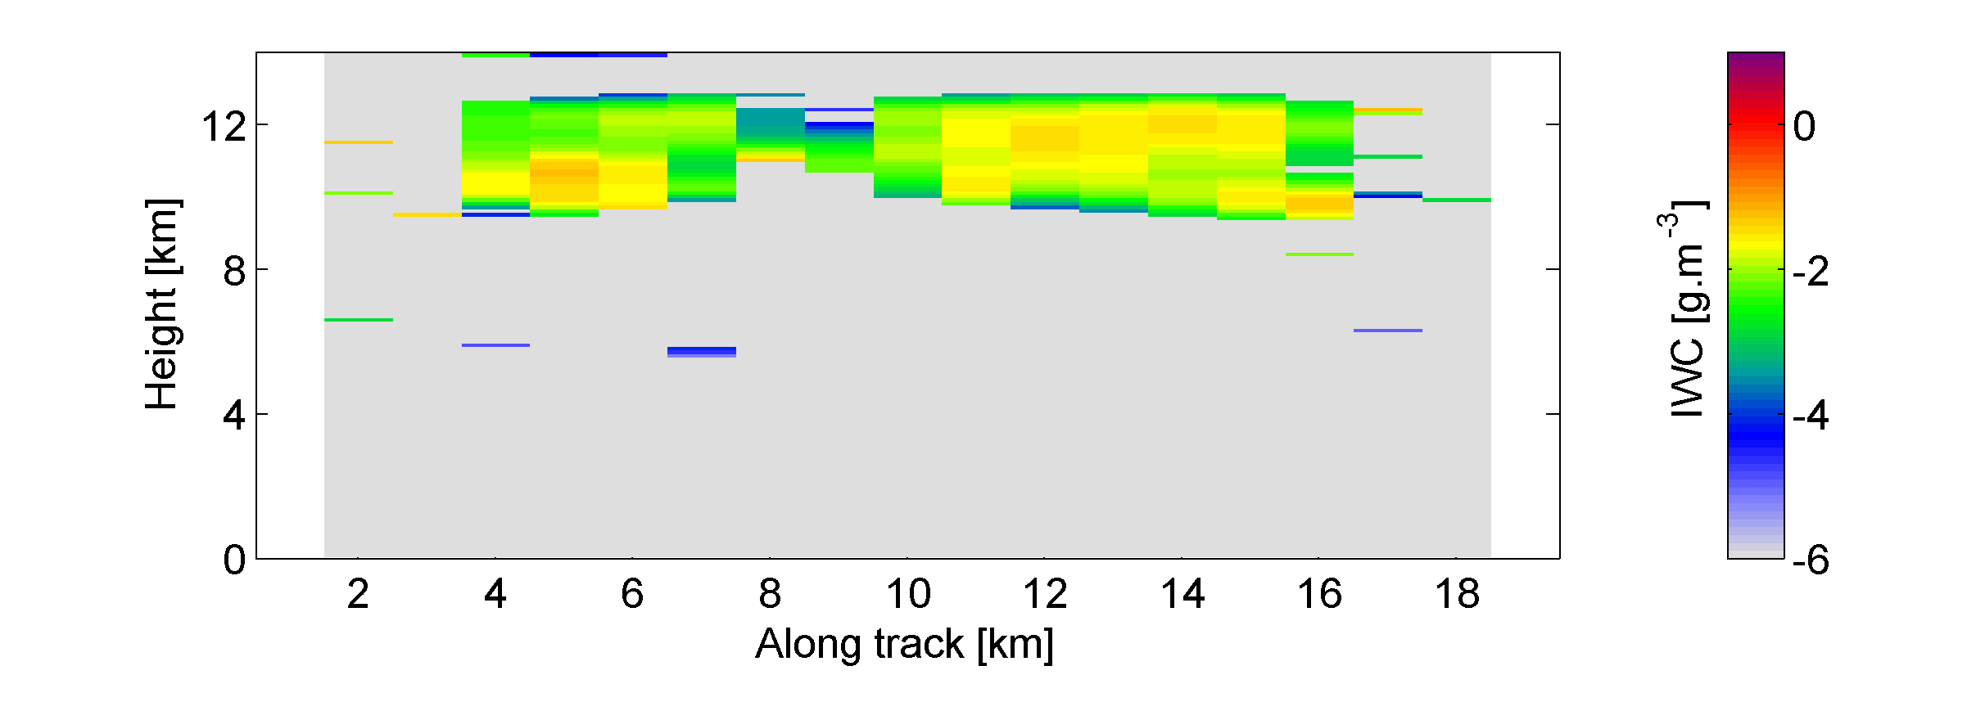
Figure 7-6: As Fig. 7-4, but for the “ACM-Ice-Reading” version of the algorithm.
As a final point, it is clear that the “validation” presented in this section is just a first step; clearly a key part of future studies will be to perform comparisons with “truth” over a much wider range of cases. In addition to using other ECSIM cases, there is a need to make use of coordinated aircraft campaigns in the real atmosphere, in which airborne radar-lidar-radiometer observations are coincidently sampled with an aircraft carrying a full array of microphysical probes.

REFERENCES
Keyword | Reference
Ansmann and Müller (2005) | Ansmann, A., and D. Müller (2005), Lidar and atmospheric aerosol particles, in Lidar range-resolved optical remote sensing of the atmosphere, edited by C. Weitkamp, Springer.
Battaglia et al. (2007) | Battaglia, A., M. O. Ajewole, and C. Simmer (2007), Evaluation of radar multiple scattering effects in Cloudsat configuration, Atmos. Chem. Phys., 7, 1719--1730.
Benedetti (2005) | Benedetti, A. CloudSat AN-ECMWF ancillary data interface control document. 2005. Technical document, CloudSat Data Processing Cent., Fort Collins, Colo., 16 July. (Available at http://cloudsat.cira.colostate.edu/ICD/AN-ECMWF/AN-ECMWF_doc_v4.pdf).
Brown and Francis (1995) | Brown, P. R. A., and P. N. Francis (1995), Improved measurements of the ice water content in cirrus using a total-water probe, J. Atmos Oceanic. Technol., 12, 410-414.
Brown et al. (1995) | Brown, P. R. A., A. J. Illingworth, A. J. Heymsfield, G. M. McFarquhar, K. A. Browning and M. Gosset, 1995: The role of spaceborne millimeter-wave radar in the global monitoring of ice cloud. J. Appl. Meteorol., 34, 2346-2366.
Cadet et al.(2005) | Cadet, B., V. Giraud, M. Haeffelin, P. Keckhut, A. Rechou, and S. Baldy (2005), Improved retrievals of the optical properties of cirrus clouds by a combination of lidar methods, Appl. Opt., 44, 1726--1734.
Cooper et al. (2003) | Cooper, S. J., T. S. L'Ecuyer, and G. L. Stephens (2003), The impact of explicit cloud boundary information on ice cloud microphysical property retrievals from infrared radiances, J. Geophys. Res., 108, 4107--4123.
Chen et al. (2002) | Chen, W.-N., C.-W. Chiang, and J.-B. Nee (2002), Lidar ratio and depolarization ratio for cirrus clouds, Appl. Opt., 41, 6470--6476.
Chiriaco et al. (2004) | Chiriaco, M., H. Chepfer, V. Noel, A. Delaval, M. Haeffelin, P. Dubuisson, and P. Yang (2004), Improving retrievals of cirrus cloud particle size coupling lidar and three-channel radiometric techniques, Mon Weath. Rev., 132, 1684--1700.
Delanoë et al. (2005) | Delanoë, J., A. Protat, J. Testud, D. Bouniol, A. J. Heymsfield, A. Bansemer, P. R. A. Brown, and R. M. Forbes (2005), Statistical properties of the normalized ice particle size distribution, J. Geophys. Res., 110, 10201, doi:10.1029/2004JD005405 .
Delanoë and Hogan (2008) | Delanoë, J., and R. J. Hogan (2008), A variational scheme for retrieving ice cloud properties from combined radar, lidar, and infrared radiometer, J. Geophys. Res., 113, D07204, doi:10.1029/2007JD009000.
Daley (1991) | Daley, R. (1991), Atmospheric data analysis, 457 pp., Cambridge.
Donovan et al. (2001) | Donovan, D. P., A. C. A. P. van Lammeren, H. W. J. Russchenberg, A. Apituley, R. J. Hogan, P. N. Francis, J. Testud, J. Pelon, M. Quante, and J. W. F. Goddard (2001), Cloud effective particles size and water content profile retrievals using ombined radar and lidar observations - 2. Comparison with IR radiometer and in-situ measurements of ice clouds, J. Geophys. Res., 106, 27,449--27,464.
Eloranta, E. W. (1998) | Eloranta, E. W. (1998), A practical model for the calculation of multiply scattered lidar returns, Appl. Optics, 37, 2464--2472.
McClatchey et al. (1972) | McClatchey, R. A., R. W. Fenn, J. E. A. Selby, F. E. Volz, and J. S. Garing (1972), Optical properties of the atmosphere (3rd ed.), Air Force Cambridge Research Laboratories, Rep. No. AFCRL72-0497, L. G. Hanscom Field.
Foot (1988) | Foot, J. S. (1988), Some observations of the optical properties of clouds - 2. Cirrus, Quart. J. Roy Meteorol. Soc., 114, 145--1647.
Francis et al. (1998) | Francis, P. N., P. Hignett, and A. Macke (1998), The retrieval of cirrus cloud properties from aircraft multi-spectral reflectance measurements during EUCREX'93, Quart. J. Roy Meteorol. Soc., 124, 1273-1291.
Fu and Liou (1993) | Fu, Q., and K. N. Liou (1993), Parameterization of the radiative properties of cirrus clouds, J. Atmos. Sci., 50, 2008– 2025.
Hogan (2006) | Hogan, R. J. (2006): Fast approximate calculation of multiply scattered lidar returns. Applied Optics, 45, 5984-5992.
Hogan (2007) | Hogan, R. J., (2007): A variational scheme for retrieving rainfall rate and hail reflectivity fraction from polarization radar. J. Appl. Meteorol. Climatology, 46, 1544-1564.
Hogan (2008) | Hogan, R. J., (2008): Fast lidar and radar multiple-scattering models – 1. Small-angle scattering using the photon variance-covariance method.  J. Atmos. Sci., in press.
Hogan and Illingworth (1999) | Hogan, R. J., and A. J. Illingworth (1999), The potential of spaceborne dual-wavelength radar to make global measurements of cirrus clouds, J. Atmos Oceanic. Technol., 16, 518--531.
Hogan and Kew (2005) | Hogan, R. J., and S. F. Kew (2005), A 3D stochastic cloud model for investigating the radiative properties of inhomogeneous cirrus clouds. Q. J. R. Meteorol. Soc., 131, 2585-2608.
Hogan et al. (2003) | Hogan, R. J., P. N. Francis, H. Flentje, A. J. Illingworth, M. Quante and J. Pelon (2003), Characteristics of mixed-phase clouds – 1. Lidar, radar and aircraft observations from CLARE'98. Quart. J. Roy. Meteorol. Soc., 129, 2089-2116.
Hogan et al. (2006a) | Hogan, R. J., M. P. Mittermaier, and A. J. Illingworth (2006a), The retrieval of ice water content from radar reflectivity factor and temperature and its use in the evaluation of a mesoscale model, J. Appl. Meteorol. Climatology, 45, 301-317.
Hogan et al. (2006b) | Hogan, R. J., D. P. Donovan, C. Tinel, M. A. Brooks, A. J. Illingworth, and J. P. V. Poiares Baptista (2006b), Independent evaluation of the ability of spaceborne radar and lidar to retrieve the microphysical and radiative properties of ice clouds, J. Atmos Oceanic. Technol., 23, 211-227.
Hogan and Battaglia (2008) | Hogan, R. J., and A. Battaglia (2008), Fast lidar and radar multiple-scattering models - 2. Wide-angle scattering using the time-dependent two-stream approximation, J. Atmos. Sci., in press.
Hollingsworth and Lönnberg (1986) | Hollingsworth, A., and P. Lönnberg (1986), The statistical structure of short-range forecast errors as determined from radiosonde data. Part I: The wind field, Tellus, 38A, 111--136.
Kato et al. (1999) | Kato, S., T. P. Ackerman, J. H. Mather, and E. E. Clothiaux (1999), The  k-distribution method and correlated-k approximation for a shortwave  radiative transfer model, J. Quant. Spectrosc. Radiat. Transfer, 62, 109– 121.
[Liebe (1985) | Liebe, H. J. (1985), An updated model for millimeter-wave propagation in moist air, Radio Science, 20, 1069--1089.
Liu and Illingworth (2000) | Liu, C. L., and A. J. Illingworth (2000), Towards more accurate retrievals of ice water content from radar measurement of clouds, J. Appl. Meteorol., 39, 1130--1146.
Morcrette (2001) | Morcrette, J.-J. (2001), Accessment of the ECMWF model cloudiness and surface radiation fields at the ARM-SGP site. ECMWF technical memorandum.
Platt et al. (1987) | Platt, C. M. R., S. C. Scott, and A. C. Dilley (1987), Remote sounding of high clouds - 4. Optical properties of midlatitude and tropical cirrus, J. Atmos. Sci., 44, 729--747.
Protat et al. (2007) | Protat, A., J. Delanoë, D. Bouniol, A. J. Heymsfield, A. Bansemer, and P. R. A. Brown (2007), Evaluation of ice water content retrievals from cloud radar reflectivity and temperature using a large airborne in-situ microphysical database, J. Appl. Meteorol., 46, 5, 557--572.
Rodgers (2000) | Rodgers, C. D. (2000), Inverse methods for atmospheric sounding: Theory and practice, 238 pp., World Scientific.
Saunders et al. (1999) | Saunders, R., M. Matricardi, and P. Brunel, 1999: An improved fast radiative transfer model for assimilation of satellite radiance observations. Quart. J. Roy. Meteorol. So., 125, 1407-1425.
Tinel et al. (2005) | Tinel, C., J. Testud, R. J. Hogan, A. Protat, J. Delanoë, and D. Bouniol (2005), The retrieval of ice cloud properties from cloud radar and lidar synergy, J. App. Meteorol., 44, 860--875.
Toon et al. (1989) | Toon, O. B., C. P. McKay, T. P. Ackerman, and K. Santhanam (1989), Rapid calculation of radiative heating rates and photodissociation rates in inhomogeneous multiple scattering atmospheres, J. Geophys. Res., 94, 16,287– 16,301.

