**Cloud Banding and Winds in Intense European Cyclones –Results from the DIAMET Project**

G. Vaughan1, J. Methven4, D. Anderson11, B. Antonescu2 , L. Baker4, T. Baker7, S. P. Ballard9, R.N. Bannister5, A.M. Blyth6, K.N. Bower2, P.R.A. Brown10, J. Chagnon3, T.W. Choularton2, J. Chylik8, P.J. Connolly2, P.A. Cook8, R.J. Cotton10 , J. Crosier1, C. Dearden2, J. R. Dorsey1, P. R. Field10, T. H. A. Frame3, M. W. Gallagher2, M. Goodliff4, B. J. Harvey4, S. L. Gray4, P. Knippertz12, H. W. Lean9, G. Lloyd2, O. Martinez –Alvarado4, S. Migliorini5, J. Nicol3, J. Norris2, E. Öström10, J. Owen7, D. J. Parker7, R. S. Plant4, I. A. Renfrew8, N. M. Roberts9, P. Rosenberg7, A. C. Rudd4, D. M. Schultz2, R. Swinbank10, J. P.Taylor10, T. Trzeciak7, R. Tubbs9, A. K. Vance10, P.J. van Leeuwen5, A. Wellpott11, A. Woolley11

**AFFILIATIONS:**

1 National Centre for Atmospheric Science (NCAS) , University of Manchester, Manchester, UK

2 Centre for Atmospheric Science, University of Manchester, Manchester, UK

3 NCAS, University of Reading, Reading, UK

4 Department of Meteorology, University of Reading, Reading, UK

5 National Centre for Earth Observation (NCEO), University of Reading, Reading, UK

6 NCAS, University of Leeds, Leeds, UK

7 School of Earth and Environment,University of Leeds, Leeds, UK

8 School of Environmental Science, University of East Anglia, Norwich, UK

9 Met Office, University of Reading, Reading, UK

10 Met Office, Exeter, UK

11 Facility for Airborne Atmospheric Measurement, Cranfield, UK

12 KIT, Karlsruhe, Germany

Version 4.0. 13 Dec 2013

**Abstract**

The DIAMET (DIAbatic influences on Mesoscale structures in ExTratropical storms) project aims to improve forecasts of high-impact weather in extratropical cyclones, using field measurements, high-resolution numerical modeling, and improved design of ensemble forecasting and data assimilation systems. This article introduces DIAMET and presents some of the first results. Four field campaigns were conducted by the project, one of which, in late 2011, coincided with an exceptionally stormy period marked by a succession of severe windstorms in northwest Europe. For example, December 2011 had the highest monthly North Atlantic Oscillation index (2.52) of any December in the last 60 years, meaning an unusually active North Atlantic jet stream. Detailed observations of several of these storms were gathered using the UK’s BAe146 research aircraft and intensive ground-based measurements. As an example of the results obtained during the campaign we present observations of cyclone Friedhelm on 8 December 2011, when surface winds with gusts exceeding 30 m s-1 crossed central Scotland, leading to widespread disruption. Friedhelm was a storm that deepened 44 hPa in 24 hours and developed a pronounced bent-back front wrapping around the storm center. We focus on the belt of strongest winds in the southern quadrant of the storm, finding that the strongest winds at 850 hPa and the surface occurred between bands of showers. High-resolution ensemble forecasts from the Met Office showed similar features, with the strongest winds aligned in linear swaths between the bands, suggesting that this phenomenon is in principle predictable.

**Capsule:** New aircraft measurements, together with high-resolution modeling, reveal fine-scale wind structure in a severe extratropical windstorm.

1. **Introduction**

Extratropical cyclones approaching Western Europe along the North Atlantic stormtrack are a major cause of damaging winds and heavy precipitation. A particular problem in forecasting these cyclones is that the highest-impact weather within them arises from mesoscale structures such as fronts and bands of strong winds. These structures are influenced by diabatic processes (those which add or remove heat from the air) such as latent heating and cooling associated with phase changes of water, fluxes of heat and moisture from the Earth’s surface, and radiative flux convergence. Key elements in diabatic processes are turbulence, convection and cloud physics – small-scale phenomena which cannot be represented explicitly in numerical weather prediction models. They must therefore be parameterised, introducing a source of systematic uncertainty in the models. Detailed observations of real events are needed to test the models and ultimately to improve the parameterisation of small-scale processes.

Here we report on initial results from the DIAMET (DIAbatic influences on Mesoscale structures in ExTratropical storms) project, which aims to improve our understanding and predictions of mesoscale structures within extratropical cyclones by means of field measurements, high-resolution modeling and improved design of ensemble forecasting and data assimilation systems. The project includes evaluation of Met Office high-resolution ensemble forecasts, the skill in probability forecasts of mesoscale structures, the stochastic physics scheme used in the ensemble and the ability of the model to represent the structures that bring high impact weather.

One of the DIAMET field campaigns was conducted during a period of particularly intense storm activity in the North Atlantic sector, which we discuss further in section 3. As an example of an intense storm, and to illustrate the results obtained by DIAMET, we present a more detailed study in Section 4 of Cyclone Friedhelm on 8 December 2011. The strongest low-level winds in this storm occurred on its southern and southwestern flanks. We concentrate in this paper on the prominent cloud banding often found in the southern quadrant of this type of cyclone, where our observations reveal a relation between the wind strength and the cloud bands. A similar relation appears in an experimental trial of the Met Office high-resolution ensemble forecast system, which we discuss further in section 7.

1. **The DIAMET project**

The DIAMET project is one of the three components of the UK Natural Environment Research Council’s Storm Risk Mitigation Programme (<http://www.bgs.ac.uk/stormrm/home.html>), and is a collaboration between British academic groups and the Met Office. The key scientific questions for DIAMET concern the effect of diabatic processes on the distribution of potential vorticity (PV) and its consequences for the evolution of weather systems. PV combines the vertical stability of the atmosphere with the horizontal shear and rotation of the wind field, and is conserved in the absence of diabatic and frictional processes. It is a local measure of circulation about a point whose distribution is fundamental to our understanding of Rossby waves and the evolution of cyclones (e.g. Hoskins et al. 1985). Cyclone development typically arises through interaction between a Rossby wave on the tropopause and large-scale horizontal waves in temperature near the ground, with the surface cyclone center positioned to the east of the upper-level PV maximum (trough). This process is well understood, but the effects of PV anomalies produced by diabatic processes are much less clear. It is possible to attribute diabatically-generated PV anomalies to the processes that produce them in a forecast model (e.g. Chagnon et al. 2013) but these diagnostics need to be tested by comparison with observations. A main goal of DIAMET is to use detailed measurements of dynamics, cloud physics and air-sea fluxes to calculate diabatic heating rates in cyclones and thereby evaluate how well the diabatic production and removal of PV anomalies are represented in models.

## From September 2011 to August 2012, DIAMET conducted four field campaigns lasting several weeks each to examine cyclones around the UK and Ireland. The primary measurement platform was the BAe146 aircraft of the UK’s Facility for Airborne Atmospheric Measurements (FAAM, <http://www.faam.ac.uk/>) carrying instrumentation to measure winds, thermodynamic parameters, microphysics and chemical tracers. A summary of the relevant instrumentation for DIAMET is shown in Table 1. The FAAM aircraft can operate up to an altitude of 10 km with an endurance of around 5 hours (see Renfrew et al. 2008 for more details and flight examples). In several DIAMET cases, double flights were conducted, with a break for refuelling mid-mission. For three of the four campaigns, the aircraft was based in Cranfield, north of London, but in the winter campaign of November–December 2011 it was based at Exeter, near to the Met Office headquarters (see Fig. 5 for locations). Ground-based measurements were also a crucial part of DIAMET: 3D precipitation radar measurements from the Chilbolton Facility for Atmospheric and Radio Research (Browning et al. 2007); precipitation maps from the Met Office’s operational weather radar network (as presented in Fig. 3b); continuous measurements from wind profilers, especially the UK Mesosphere-Stratosphere-Troposphere VHF profiler at Aberystwyth in Wales (Vaughan 2002); and surface data from the Met Office’s network of around 270 automatic weather stations (AWS). Additional radiosonde launches were made from selected stations on intensive observation period (IOP) days.

There were fifteen flying days (Table 2) covering fourteen DIAMET IOPs (flights into the same meteorological system on successive days are grouped into the same IOP). Nine of these IOPs were in 2011 and five in 2012 and all but one involved the FAAM aircraft. The exception, IOP 10, was declared a DIAMET IOP because of the passage of a mesoscale convective system over the Chilbolton radar which led to widespread flooding in the largest UK catchment (River Severn). Three flights are also listed from the T-NAWDEX (THORPEX-North Atlantic Waveguide and Downstream impact Experiment) Pilot campaign in November 2009. They were conducted by the DIAMET team as a preliminary investigation, and have been analysed as part of the DIAMET project (labelled TNP1-3 in Table 2).

1. **The North Atlantic weather regime of early winter 2011/12**

The second DIAMET aircraft campaign (24 November - 14 December 2011) fell within an extremely active period characterized by a strong zonal jet stream across the North Atlantic and a quick succession of intense cyclones, many of which crossed northwest Europe. One way to assess the large-scale situation over the North Atlantic during this period is to examine the North Atlantic Oscillation (NAO) index, a normalized measure of the pressure difference between Iceland and the Azores. Positive values of the NAO are associated with stormy weather over northwest Europe, with milder temperatures and greater precipitation than the negative phase. Daily NAO index values are provided by the Climate Prediction Center for the period January 1950 to June 2012[1]. Remarkably, 30 November and 3 and 6 December 2011, all within the DIAMET campaign period, appear in the top 0.4% of daily values of this long time series (22,825 days). December 2011 had the highest monthly NAO index (2.52) of any December and the third highest for all months of the entire time series.

Further insight into the storminess of this period is provided by the Eady index (a measure of the potential for rapid cyclone growth, see Box 1) averaged over the North Atlantic, obtained from 6-hourly ERA-Interim re-analysis data (Dee et al. 2011). Values of the index between 1 November 2011 and 31 January 2012 are shown in Fig. 1a together with the climatological mean and standard deviation for this time of year. The Eady index was exceptionally high during the DIAMET campaign with values more than one standard deviation above the long-term mean for most of the period and more than two standard deviations for some of it. These high values were the result of a very strong, zonal jet stream across the North Atlantic at tropopause level and much weaker westerlies at low levels. Comparison of the probability density function of the Eady index during the 21 days of the DIAMET campaign with that during the three-month period November 2011 – January 2012 and the corresponding ERA-Interim climatology (Fig. 1b) further underlines the anomalous conditions during this period.

Between 22 November and 10 January the Free University of Berlin named 29 significant cyclones affecting Europe as part of their Adopt-A-Vortex scheme, corresponding to one new storm forming every 1.7 day. All but one of these storms passed over or near the UK or affected the UK with their frontal systems. Many of the stronger storm developments are reflected by *decreases* in the Eady index, which seems counterintuitive at first since high Eady index is associated with rapid cyclone growth. This is true in the early stages of explosive cyclogenesis but the index then decreases as the Rossby waves at tropopause level reach large amplitudes and break, causing the jet stream to split, with weaker average flow in the 40-60°N band. Several significant dips in the index are associated with intense cyclonic storms:

* Zafer (1 December, DIAMET IOP6) was a small-scale intense low north of Scotland.
* Friedhelm (7–8 December, IOP8) was the explosively deepening cyclone discussed in Section 4.
* Hergen (11–12 December, IOP9) passed north of Scotland extending an active warm front across the UK.
* Joachim (15–16 December) was fast moving and tracked directly into central Europe causing widespread gales and heavy rain associated with some damage in southern Germany.
* Patrick (25 December) and Robert (28 December) followed similar tracks across northern Scotland.
* Ulli and Andrea (03–05 January) again brought very high winds to Scotland and northern England.

In contrast, the dips to relatively low values on 18–19 December 2011 and around 12 January 2012 were associated with ridge-building not linked to a preceding cyclone.

We now present a more detailed study of cyclone Friedhelm, the subject of DIAMET IOP8.

1. **DIAMET IOP8 – Flight into the Center of Cyclone Friedhelm**

The passage of extratropical cyclone Friedhelm resulted in considerable disruption to transport and some damage to infrastructure over the central belt of Scotland. Friedhelm started as a shallow wave on a trailing cold front over Newfoundland at 1200 UTC on 6 December 2011. As it crossed the Atlantic the storm crossed the axis of the polar jet stream and deepened spectacularly – by 44 hPa between mid-day on 7 December and mid-day on the 8th, easily qualifying as a meteorological ‘bomb’ (Sanders and Gyakum 1980). Structurally, Friedhelm resembled the archetype of a Shapiro-Keyser cyclone (Shapiro and Keyser 1990) with a frontal fracture (weakening of the northern part of the cold front near the warm front) followed by wrapping of cold air at low levels around the northern flank of a warmer cyclone center. By the time Friedhelm reached western Scotland early on 8 December the storm was in a mature phase with a central pressure of 957 hPa (Fig. 2), well to the west of the intersection of the cold and warm fronts, and a bent-back front wrapping around the low, corresponding to the mass of cloud curling westward around Scotland in the satellite image (Fig. 3a). Southwest of the cyclone center, bands of low cloud extended eastwards towards Scotland from beneath the mid-level cloud deck. Corresponding banding was observed in light precipitation over the sea to the west of Scotland by the Met Office radar network (Fig. 3b). At this time bands were also seen across central Scotland (labelled A-D) moving east-southeastwards. The storm continued to move eastward towards Scandinavia, with the strongest winds crossing to the east side of Scotland by early evening. The precipitation bands crossed Scotland with the storm and were especially prominent at around 1800 UTC over central Scotland (Fig. 4a). The cyclone also wrapped up further with the strongest winds moving into the southern and then southeastern side of the low pressure center.

Figure 4b shows the maximum wind gusts measured on 10 m masts at selected AWS across the northern UK during 8 December. The numbers are coloured by the time of maximum gust to illustrate the eastward progression of the high winds associated with the storm. Maxima of around 30 m s-1 (67 mph) occur over a wide area of Scotland, notably in the highly populated region between Glasgow and Edinburgh. The previous day the Met Office issued its first ever red alert[2] for winds in the UK, allowing precautions to be taken, including the closure of schools, roads and bridges in the threatened areas. Over some of the Scottish mountains much higher winds were recorded – the highest being 74 m s-1 (165 mph) reported on the summit of Cairn Gorm (1237m), around 100 km north-northwest of Leuchars.

The FAAM aircraft was tasked on this day with investigating the region of strongest winds to the south and southwest of the cyclone center. Such winds are often associated with a *cold conveyor belt* (CCB), a low-level airstream which wraps around a cyclone as it develops (Carlson 1980). In addition, some Shapiro-Keyser cyclones develop *sting jets* – cores of very strong low-level winds associated with descending airstreams ahead of the mid-level cloud head (Browning 2004; Clark et al. 2005) - indeed, evidence for such features during the passage of Cyclone Ulli on 3January 2012 was presented by Smart and Browning (2013). There have been other aircraft flights through intense extratropical cyclones – for example Neiman and Shapiro (1993) and Neiman *et al* (1993) presented observations of an extremely rapidly developing cyclone (named ERICA IOP4) which had similar bent-back frontal structure to Friedhelm and prominent rainbands in the same sector of the storm (their Fig. 19). However, they did not measure the wind structure associated with precipitation bands or the cloud microphysical properties, both of which we were able to do in IOP8.

The aircraft took off at 1048 UTC from Exeter, timed to intercept the cyclone center before it had traversed Scotland. Baker et al. (2013b) described the thrill of the flight and showed photographs taken from within the cyclone center looking across the curving cloud bands, and also the sea state in the high wind region. The first leg of the flight, at an altitude of 7 km, launched ten dropsondes along the west coast of Scotland, reaching the cyclone center at 1234 UTC (Fig. 5), to measure the thermodynamic and wind structure along a transect through the storm to the north of the cold front.

Figure 6 shows relative humidity with respect to ice (RHi), potential temperature and horizontal winds along the dropsonde section. The sloping temperature gradient between 2 and 6 km in the southern part of the section separated dry air above it from the moister air below (northwest of the cold front). The wind speed cross-section shows the upper-level jetstream between 54° and 55.5°N, exceeding 60 m s-1 at 6 km altitude above a layer of pronounced wind shear. On the northern flank of the jet, ozone measurements and shear indicated that the aircraft crossed two thin tropopause folds before crossing the tropopause at 56.5oN (ozone exceeding 150 ppbv). Ozone concentrations at 7 km remained stratospheric throughout the cyclone core.

A second, weaker temperature gradient is shown below 4 km, north of 57°N. Here, temperature increased with latitude (Fig. 6), associated with the bent-back warm front which had wrapped round to the south side of the cyclone. The pool of warmer air at low levels near the core of this kind of cyclone is called a seclusion (Shapiro and Keyser 1990). The low-level wind maximum that was the focus of this mission lay on the southern flank of this front. An L-shaped wind maximum extended from 4 down to 1.5 km at 56.3°N, with an extension northward to 57.1°N below 2.5 km; a low level zonal wind maximum is expected from approximate thermal wind balance with the poleward increase in potential temperature. Martinez-Alvarado et al. (2013) found that the air entering the strong wind region south of the cyclone center in this storm comprised three air streams with distinct trajectory origins and observed tracer composition. Two airstreams were associated with the cold conveyor belt – the air was cloudy and back-trajectories stayed at low levels wrapping around the cyclone core – while the third resembled a sting jet which left the tip of the cloud head to the west of the cyclone and descended towards the ESE. In Fig. 6, the strongest winds, measured by sondes 4-7, coincided with relative humidity values > 80% beneath the sloping isentropes, suggesting that the cold conveyor belt dominated the low-level winds along this section.

After executing the first two dropsonde sections (Fig. 5) the aircraft descended to make *in-situ* measurements at lower altitudes. Of particular interest for this paper are the low-level legs to the west of Scotland at around 1500 UTC, through the region of strongest low-level winds, which are discussed in the next section. Further low-level work was conducted after refuelling in Teesside, by which time the strongest winds had moved to the east of Scotland. Here the relative humidity (with respect to ice) of the fastest-moving air was around 42%, suggesting descent of around 150 hPa from saturation. Turbulent mixing was intense at low levels on this flight – the aircraft becoming coated in sea salt even when flying at 500 m above sea level. On this boundary-layer leg (lasting 30 minutes), the gradient in potential temperature was almost uniform with values decreasing towards the south while wind speed increased to an average of 47 m s-1 at the southern end (not shown). Both west and east of Scotland therefore the aircraft was able to make detailed measurements of the wind field, thermodynamic variables and composition in the region of maximum wind speed to the south of the cyclone center.

1. **Banding in Cloud, Precipitation and Winds on the Southern Flank of the Cyclone**

We now turn to the question of how the cloud and precipitation bands (Fig.3) were linked to the severe surface winds (Fig.4b), concentrating on the low-level legs measured around 1500 UTC as the aircraft flew from Islay northwards towards Tiree (Fig. 7) in a region of banded precipitation (Fig. 8) within the cold conveyor belt airstream of the cyclone. The bands in fig 8 are numbered from south to north and fall in two groups – the northern group (B) intersected by the aircraft and a southern group, with a more anticlockwise orientation. As the progression from white lines (position at 1500 UTC) to yellow lines (1515 UTC) shows, the bands were moving quickly south-southeastwards. The aircraft section crossed B0, B1 and B2 but passed through a gap in the (much larger) B3 band.

Figure 7a shows the relative humidity from the aircraft overlain with surface precipitation rate estimated from the radar network (red). The flight leg crossed three cloud bands (RH ≥ 100%,), identified as bands B1-B3 in Fig. 8, with B1 and B2 clearly precipitating at the time of crossing (no cloud was encountered at aircraft altitude during the passage of B0). Note how the wind speed is lower in the bands than in the clearer air in between (Fig. 7b). The aircraft turned around at 1516 UTC and crossed B3 again at 1517 UTC heading southwards, experiencing a sharp drop in wind speed. The maximum wind speed measured at 650 m altitude on the northern flank of B3 was 46 m s-1 (103 mph); the aircraft was then immediately east of Tiree where the maximum 10 m gust was 36 m s-1 (80 mph).

Panels 7c and 7d show measurements of liquid and ice number concentrations across the bands, from the Cloud Droplet Probe (CDP) and CIP-100 respectively. The clouds contained mixed liquid and ice, with relatively high concentrations of ice particles, images of which (Fig. 9a) reveal the presence of columnar crystals characteristic of secondary ice formed by the Hallett-Mossop process. Significant ice concentrations were also found in regions sub-saturated with respect to ice. One of the main objectives of DIAMET was to quantify diabatic heating and cooling rates using the observed microphysics, to compare with and improve model simulations. As an example of this, a Lagrangian parcel model based on that used in Connolly et al (2012) was initialised along this section of the flight with the observed ice particle size distributions, along with the relative humidity calculated using measurements from the WVSS-II tunable diode laser hygrometer. Ice particle size distributions, from 0.1 to 6 mm diameter, were taken from the CIP-100 probe, which agreed well with other probes in the size range below 1 mm (Fig. 9b). The parcel model was run over a ten second period from each point along the flight at 1 s intervals, to compute rates of change of ice mass, which were then converted into an instantaneous temperature increment, equivalent to a diabatic heating/cooling rate (Fig. 7e). These calculations assumed spherical particles and fitted negative exponential functions to the observed particle size distributions, the same assumptions as in many bulk microphysical parameterization schemes used in operational numerical weather prediction models, including that of the Met Office (Wilson and Ballard, 1999). Further details of this method are given in Dearden et al (2013) who show that these assumptions introduce an error in the heating rate calculations of up to a factor of two when compared with those using an explicit bin-resolved calculation taking into account ice crystal habit and the observed size distribution.

The regions of diabatic heating between 1510 and 1511 UTC, and between 1513 and 1514 UTC both coincide with decreases in wind speed, consistent with transport of lower-momentum air from below in convective plumes. By contrast, the large instantaneous cooling rates in the clear air in between coincide with both minima (1512) and maxima (1516) in wind speed. This raises the question of whether the cloud and precipitation bands are instrumental in mixing (or transporting) high-momentum air down towards the surface. We now examine surface wind observations during the passage of the bands.

1. **Surface Wind observations**

Figure 10 shows the position of rainbands with time along a straight line section joining AWS sites on the islands of Tiree and Islay (Fig. 8). Distance is measured from north-northwest to south-southeast. The precipitation rate at 5 minute intervals estimated by the radar network has been interpolated to the section to create the time-distance progression of rainfall rate. Wind gust strength (5-minute running median to be consistent with the radar update interval) is overlain for both AWS sites, after subtracting a 90-minute running median to remove the larger-scale variation. White curves indicate the progression of rainbands along the section, identified using animations of the radar images. Band B1 moves from Tiree (point T) at 1445 UTC to Islay (I) at 1610 UTC and was intercepted by the aircraft at point A (1510 UTC). Note the variability in the precipitation rate of this rainband as it moved along the section – as well as moving south-southeastward the cloud bands changed morphology noticeably between 5 minute radar images. One rainband appeared to split into two at around 1500 UTC: band B1 propagated towards the ESE while B2 was more stationary, curving almost parallel to the bent-back front (Fig. 8). The rain reaching Tiree at 1515 UTC (seen on Fig. 8) was at the tip of a much broader precipitation feature advancing rapidly from the WNW along the bent-back front. The aircraft intercepted cloud band B3 in the non-precipitating air ahead of this feature. At about 1615 UTC another precipitation band, B4, emerged between band B2 and the bent-back front.

Consistent with the aircraft observations at 840 hPa, the surface wind speed is lower in the core of rainband B1 and immediately after it (at T and I) than in the clear air either side. Similar dips in wind speed occurred during the passage of band B2 across Islay (1715 UTC) and also the earlier bands S1 and S2. To generalise this result, data from all 13 AWS sites across central Scotland were examined for this day. The mode of wind speed within the rainbands was 1.5 m s-1 lower than between them while locally the peak to trough variation in surface gust strength associated with bands was as much as 10 m s-1. In summary, both at aircraft altitude and at the surface there is evidence that the wind speed tends to dip during the passage of a rainband, and to be higher in the clear air in between. Given the linear nature of the rainbands and their tendency to align along the mean wind, this suggests that the strongest surface winds (and therefore damage) will be arranged in linear swathes. We now examine forecast model predictions of the storm to see how well the Met Office Unified Model simulated these features.

1. **Ensemble Prediction of Banding in the High Wind Region**

DIAMET IOP8 provided an ideal test case for the new MOGREPS (Met Office Global and Regional Ensemble Prediction System) convection-permitting forecast for the UK prior to its implementation. The MOGREPS-UK ensemble is now run routinely and consists of 12 forecasts run every 6 hours with the Met Office Unified Model, on a limited area spanning the UK with a horizontal grid spacing of 2.2 km. For this test each ensemble member took its initial and boundary conditions from the corresponding regional MOGREPS-R member. Figure 11 shows a snapshot at 1600 UTC from the first four MOGREPS-UK members, zooming in on Scotland. The colour shading is the wind speed at 850 hPa and lines have been drawn to indicate the axes of wind speed maxima. Figure 12 overlays the same lines on the model precipitation rates at the same time. The high wind cores generally lie along the clear slots between the rainbands. The same is true of the deterministic Met Office 1.5 km (UKV) model forecast (not shown). This structure and magnitude of variation is consistent with the *in-situ* aircraft observations presented in Fig. 7.

Although each of the 12 ensemble forecasts exhibited some form of precipitation and wind banding, it is clearly relevant to ask how well the observed banding was represented. Roberts and Lean (2008) and Roberts (2008) introduced a measure of the similarity of a forecast pattern of precipitation rate to the radar-derived rate called the Fractions Skill Score (FSS), which is used to measure the length scale above which a rainfall forecast resembles the observations (assuming that smaller scales are harder to capture). The FSS is computed by dividing the region (here Scotland) into square neighbourhoods of length L and in each neighbourhood calculating the fraction of grid pixels where the radar rain rate exceeds a certain threshold. The fractions are calculated in the same way from the forecast data. If the precipitation fraction in the forecast matches the observed fraction in every neighbourhood square, the FSS equals 1. The lowest possible score is zero and a score of 0.5 indicates a minimum level of satisfactory spatial agreement (the forecast pattern is correct more often than it is wrong). The FSS is then calculated for a range of neighbourhood scales. Figure 13 shows the FSS versus scale, averaged over forecast lead times of 4-24 hours (for a rain rate threshold of 2 mm hr-1). The yellow shading indicates the range of the ensemble scores with the three best ensemble members drawn individually. The FSS increases with scale and exceeds 0.5 for scales greater than 25 km for the best ensemble member. The precipitation pattern is very dependent upon initial conditions, with the worst ensemble member having FSS < 0.5 even for the 110 km scale, associated with a displacement error in the cyclone. The characteristic spacing between the cloud bands in this cyclone ranged from 20 to 50 km, so the statistics indicate that the model has skill in capturing the spatial pattern of the banding structure.

1. **Conclusions**

The second DIAMET campaign took place at a time of exceptionally strong flow across the North Atlantic and vigorous cyclone activity over northwestern Europe, both in terms of storm frequency and intensity. The DIAMET flights were the first aircraft missions with comprehensive cloud instrumentation to sample the strong wind region south of a cyclone center. IOP8 took the investigators into the extreme winds of extratropical cyclone Friedhelm, which had a T-bone frontal structure with bent-back warm front. A phenomenon of particular interest was the cloud and precipitation banding in the strong wind (southern) quadrant of the storm.

The FAAM aircraft traversed this region between 2000 and 700 m altitude crossing three cloud bands, two of which were precipitating at the time. The clouds were found to be of mixed phase with high number concentrations of secondary ice crystals in the form of columns, consistent with ice multiplication by the Hallett-Mossop (splintering) process. Between the bands, sublimating ice particles were found in places which gave instantaneous diabatic cooling rates of up to 4 K hr-1, in a region where (according to dropsonde 4) the atmosphere was close to neutral convective stability below 800 hPa (2 km)*.*

The horizontal wind speed was lower within the cloud bands than in the clear air between. At 840 hPa, diabatic heating (deduced from the microphysical measurements) occurs where the wind speed dips, indicating that saturated updrafts are transporting lower momentum air from the boundary layer below. However, wind measurements from automatic weather stations at the ground also show a dip in wind speed as rainbands pass overhead. Thus a link exists between precipitation banding and wind speed throughout the lowest 2 km. Further work is under way to understand the dynamical reasons for the bands and their characteristic spacing.

The DIAMET IOP8 case was one of several used to examine the behaviour of a 2.2 km ensemble prior to the implementation of the Met Office MOGREPS-UK ensemble forecast system. The forecasts indicated banding structure in winds and precipitation with the highest wind speeds in the clear slots. The best member (the control) matched the structure in precipitation rates observed by radar for length scales of 25 km and above, and this degree of match was sustained throughout the forecast. This length scale corresponded with the rainband spacing, indicating that the model was capable of forecasting the rainbands and associated wind structures to some extent. However, this is only one case and ensemble forecasts from many cases are required to quantify the skill in probability forecasts of mesoscale features.

Cloud and precipitation banding is often observed in satellite and radar imagery in the southern quadrant of intense extratropical storms. The finding that the precipitation bands are associated with structure in the wind with gusts up to a few m s-1 higher in the cloud free slots, even at the surface, is important for predicting the local impact of cyclonic windstorms. For example, in simple environmental risk models, wind damage scales with the third power of wind speed, so even small wind speed enhancements of order 1 m s-1 are significant. In IOP8 the rainbands were aligned approximately with the large-scale winds, so the highest wind gusts would have been concentrated along linear swathes. This coherent structure of the wind fields is important for nowcasting, and also for short-range forecasting where there is potential skill in predicting wind band structure using high resolution models.

**Acknowledgments**

DIAMET is funded by the Natural Environment Research Council (NERC) as part of the Storm Risk Mitigation Programme (NE/I005234/1) in collaboration with the Met Office. The BAe-146 Atmospheric Research Aircraft is flown by Directflight Ltd and managed by the Facility for Airborne Atmospheric Measurements (FAAM) on behalf of NERC and the Met Office. We would particularly thank Captain Alan Foster and Co-Pilot Ian Ramsay-Rae for flying in such severe conditions and working hard to find an airport that would let us land for refuelling during the storm. Figure 3a was supplied by the Dundee satellite receiving station.

**Box 1: the Eady parameter**

The Eady index arises in the simplest theories of baroclinic instability (Eady 1949; Charney 1947) as the maximum growth rate of a baroclinic wave – characterized by a chain of low and high pressure centers. It is defined by the equation *EI=0.31fΛ/N* where *f* is the Coriolis parameter, *N* is the static stability parameter and *Λ* is the vertical shear in the wind. It is a robust indicator of the potential for rapid cyclone growth in storm tracks (Hoskins and Valdes 1990) even though the developing systems are far from the simple conditions imposed by the original theories. Here the vertical shear and static stability are calculated by finite difference between data at 400 and 850 hPa (the upper and lower troposphere) using a log-pressure vertical coordinate. The results are averaged between 40-60°N and 10-60°W. The climatology was obtained from the entire ERA-Interim dataset 1979–2010 by calculating the mean and standard deviation of each calendar date across all years and then smoothing the resulting series with a 7-day running mean.

**Box 2: Educational resources**

A research project on storms presents an excellent opportunity for outreach activities and in DIAMET we collaborated with an award-winning educational consultant (a former broadcast meteorologist) to develop a package of educational resources related to our key science aims. These included two short professionally-filmed videos on “Forecasting the weather” and “Studying severe storms around the UK” as well as four sets of exercises comprising information for the pupils and activities or worksheets. Topics covered included: change of state; latent heat; the electromagnetic spectrum and using observational data. The videos and worksheets are available on the NCAS project website, <http://www.ncas.ac.uk/index.php/en/diamet-schools>, and are being actively promoted via project partners like the Royal Meteorological Society, the Institute of Physics and Education Scotland.

The material is aimed at 12-14 years olds taking science, in particular physics. The topics were chosen to fit broadly into the secondary-school physics curriculum and provide alternative contexts for the “uses of physics” to the more common examples like X-rays in medical physics or heating solid stearic acid to demonstrate latent heat. This topic choice was deliberate. Firstly because the topics fitted neatly with the project’s focus on diabatic processes and the use of a research aircraft. Secondly because all too often weather and climate only feature in geography at school level, in contrast to university teaching and, more importantly, the skills usually required for a career in the field, where a physics background can be vital.

**References**

Baker, L. H., S. L. Gray and P. A. Clark, 2013b: Idealised simulations of sting-jet cyclones. *Quart. J. Roy. Meteorol. Soc..* doi: 10.1002/qj.2131

Baker L., O. Martinez-Alvarado, J. Methven, and P. Knippertz, 2013a: Flying through extratropical cyclone Friedhelm. *Weather* **68**, 9-11.

Browning, K., 2004: The sting at the end of the tail: Damaging winds associated with extratropical cyclones. *Quart. J. Roy. Meteorol. Soc.,* **130**, 375-399.

Browning, K., A. M. Blyth, P. Clark, U. Corsmeier, C. Morcrette, J. Agnew, D. Bamber, C. Barthlott, L. Bennett, K. Beswick, M. Bitter, K. Bozier, B. Brooks, C. Collier, C. Cook, F. Davies, B. Deny, M. Engelhardt, T. Feuerle, R. Forbes, C. Gaffard, M. Gray, R. Hankers, T. Hewison, R. Huckle, N. Kalthoff, S. Khodayar, M. Kohler, S. Kraut, M. Kunz, D. Ladd, J. Lenfant, J. Marsham, J. McGregor, J. Nicol, E. Norton, D. Parker, F. Perry, M. Ramatschi, H. Ricketts, N. Roberts, A. Russell, H. Schulz, E. Slack, G. Vaughan, J. Waight, D. Wareing, R. Watson, A. Webb, A. Wieser, and K. Zink, 2007: The Convective Storm Initiation project. *Bull Amer. Met. Soc*., **88**, 1939–1955.

Carlson, T. N., 1980: Airflow through midlatitude cyclones and the comma cloud pattern. *Mon Wea. Rev*. **108**, 1498-1509.

Chagnon, J., S. L. Gray, and J. Methven, 2013: [Diabatic processes modifying potential vorticity](http://onlinelibrary.wiley.com/doi/10.1002/qj.2037/abstract) [in a North Atlantic cyclone.](http://onlinelibrary.wiley.com/doi/10.1002/qj.2037/abstract) *Quart. J. Roy. Meteorol. Soc.,* **139**, 1270-1282.

Charney, J. G. , 1947: The dynamics of long waves in a baroclinic westerly current. *J. Meteorol.,* **4**, 135-162.

Clark, P. A., K. A. Browning and C. Wang, 2005: The sting at the end of the tail: Model diagnostics of fine-scale 3-D structure of the cloud head. *Quart. J. Roy. Meteorol. Soc.,* **131**, 2263-2292.

Connolly, P. J., C. Emersic and P. R. Field, 2012: A laboratory investigation into the aggregation efficiency of small ice crystals. *Atmos. Chem. Phys*., **12**, 2055-2076.

Dearden, C., P. J. Connolly, T. W. Choularton, G. Lloyd, K. Bower, J. Crosier and G. Vaughan, 2013: A preliminary validation of diabatic heating and cooling rates from in-situ microphysics measurements: A case study of a wintertime UK cold front. In preparation for submission to *Mon Wea Rev*.

Dee, D. P., S. M. Uppala, A. J. Simmons, P. Berrisford, P. Poli, S. Kobayashi, U. Andrae, M. A. Balmaseda, G. Balsamo, P. Bauer, P. Bechtold, A. C. M. Beljaars, L. van de Berg, J. Bidlot, N. Bormann, C. Delsol, R. Dragani, M. Fuentes, A. J. Geer, L. Haimberger, S. B. Healy, H. Hersbach, E. V. Holm, L. Isaksen, P. Kallberg, M. Koehler, M. Matricardi, A. P. Mcnally, B. M. Monge-sanz, J. -. Morcrette, B. -. Park, C. Peubey, P. de Rosnay, C. Tavolato, J. -. Thepaut, F. Vitart, 2011: The Era-Interim reanalysis: configuration and performance of the data assimilation system. *Quart. J. Roy. Meteorol. Soc*., **137**, 553-597.

# Eady, E. T. , 1949: Long Waves and Cyclone Waves. *Tellus*, 1, 33-52.

Hoskins, B. J., M. E. McIntyre, and A. W. Robertson, 1985: On the use and significance of isentropic potential vorticity maps. *Quart. J. Roy. Meteorol. Soc.,* **111**, 887–946.

Hoskins, B. J. and P. J Valdes, 1990: On the existence of stormtracks. *J. Atmos. Sci.,* **47**, 1854-1864.

Martínez-Alvarado, O., L. H. Baker, S. L. Gray, J. Methven and R. S. Plant, 2014: Distinguishing the cold conveyor belt and sting jet air streams in an intense extratropical cyclone. Submitted to *Mon Wea. Rev*.

Neiman, P. and M. Shapiro, 1993: The life-cycle of an extratropical marine cyclone 1. Frontal-cyclone evolution and thermodynamic air-sea interaction. *Mon. Wea. Rev*., **121**, 2153-2176.

Neiman, P., M. Shapiro and L. Fedor, 1993: The life-cycle of an extratropical marine cyclone 2. Mesoscale structure and diagnostics. *Mon. Wea. Rev*., **121**, 2177-2199.

Renfrew, I.A., G.W.K. Moore, J.E. Kristjánsson, H. Ólafsson, S.L. Gray, G.N. Petersen, K. Bovis, P.R.A. Brown, I. Føre, T. Haine, C. Hay, E.A. Irvine, A. Lawrence, T. Ohigashi, S. Outten, R.S. Pickart, M. Shapiro, D. Sproson, R. Swinbank, A. Woolley, S. Zhang, 2008: The Greenland Flow Distortion experiment, *Bull. Amer. Meteorol. Soc.,* **89,** 1307-1324.

Roberts, N., 2008: Assessing the spatial and temporal variation in the skill of precipitation forecasts from an NWP model. *Met. Apps.,* **15**, 163-169.

Roberts, N., and H. W. Lean, 2008: Scale-selective Verification of Rainfall Accumulations from High-Resolution Forecasts of Convective Events. *Mon Wea. Rev*.,**136**, 78-97.

# Sanders, F. and J. R Gyakum, 1980: Synoptic-Dynamic Climatology of the “Bomb”. *Mon. Wea. Rev.*, 108, 1589–1606.

Shapiro, M. A., and D. A. Keyser, 1990: Fronts, jet streams and the tropopause. Extratropical Cyclones, The Erik Palmén Memorial Volume, C. W. Newton and E. O. Holopainen, Eds., Amer. Meteor. Soc., 167–191.

Smart, D. J. and K.A. Browning, 2013: Attribution of strong winds to a cold conveyor belt and sting

Jet. Submitted to *Quart. J. Roy Meteorol. Soc*.

Vaughan, G., 2002: The UK MST radar. *Weather*, **57**, 67-73.

Wilson. D. R., and S. P. Ballard, 1999: A microphysically based precipitation scheme for the UK Meteorological Office Unified Model. *Quart. J. Roy. Meteor. Soc*., **125** (557, A), 1607-1636.

Table 1: Instruments carried on the FAAM aircraft for DIAMET

|  |  |  |
| --- | --- | --- |
| Measurement | Instrument | Key parameters |
| Temperature | Platinum resistance thermometer | 32 Hz, ±0.3°C |
| Water Vapor | General Eastern 1011B (-25 - +50°C)  Buck CR2 (-60 - +30°C)  Spectra Sensors WVSS –II | 4 Hz, ±0.1 - 1 °C in dew/frost pt  1 Hz, ±0.1 - 0.5°C  0.4 Hz |
| Winds and turbulence | FAAM 5-hole probe | 32 Hz, 0.25 m s-1 |
| Profiles below the aircraft  Pressure, temperature, humidity  Winds  Cloud top | Vaisala AVAPS RD94 dropsondes  GPS tracking of dropsonde  Leosphere ALS450 backscatter lidar | 2 Hz, ±0.4 hPa, ±0.2°C, ±2% RH  4 Hz  5 - 30 s (along-track) , 1.5 m (vertical resolution) |
| Liquid Water | Johnson-Williams hot wire  Nevzorov total water probe | 4 Hz, ±0.3 g m-3  8 Hz, ±10% |
| Cloud and aerosol particles | DMT CIP-15 imaging probe  DMT CIP-100 imaging probe  DMT CDP scattering probe  DMT Cloud, Aerosol and Precipitation Spectrometer with Depolarisation (CAPS-DPOL)  SPEC 2D-S shadow probe  SPEC CPI V1.5 imaging probe  DMT Passive Cavity Aerosol Spectrometer Probe (PCASP) | 1 Hz, 15 < D < 960 µm  1 Hz, 100 < D < 6400 µm  10 Hz, 3 < D < 50 µm  1 Hz, 15 < D < 1000 µm  100 Hz, 10 < D < 1280 µm  40 Hz, 5 < D < 1000 µm  1 Hz, 0.6 < D < 50 µm |
| Chemical species  Ozone  Carbon Monoxide  Greenhouse Gases | TECO 49C UV analyser  Aerolaser AL5002 fluorescence  Los Gatos Cavity Enhanced Absorption FGGA  CO2  CH4 | 10 – 30 s, ±2 ppbv  1 Hz, ±4 ppbv  1 Hz, ±0.17 ppmv  1 Hz, ±1.3 ppbv |
| Upwelling infrared radiation | Heimann KT-19.82 sensor  ARIES Fourier Transform Spectrometer | 1 Hz, ±0.3 K brightness temperature  4 Hz, 3 – 18 µm, ±0.2 K brightness temperature |

Table 2 DIAMET and T-NAWDEX Pilot Intensive Observation Periods

|  |  |  |  |  |  |
| --- | --- | --- | --- | --- | --- |
| IOP | Date | Flight | Duration, hours | Drop sondes | Scientific Objective |
|  |  |  |  |  |  |
| IOP1 | 16-Sep-11 | B647 | 4.67 | 9 | Convective rainband ahead of upper-level trough |
| IOP2 | 20-Sep-11 | B648 (D) | 7.35 | 15 | Mesoscale waves running along trailing cold front – good coverage from Chilbolton |
| IOP3 | 23-Sep-11 | B650 (D) | 7.52 | 18 | Rainband developing in diabatic Rossby wave beneath a warm conveyor belt |
|  |  |  |  |  |  |
| IOP4 | 26-Nov-11 | B652 | 5.12 | 1 | Surface fluxes in cold airstream approaching Scotland from the northwest |
| IOP5a | 28-Nov-11 | B654 | 4.75 | 15 | Dropsonde profile across double front approaching from the Atlantic |
| IOP5b | 29-Nov-11 | B655 (D) | 7.03 | 13 | Intense cold front crossing UK from the west, giving rise to tornados on landfall |
| IOP6 | 01-Dec-11 | B656 | 5.40 | 10 | Small-scale cyclone Zafer near Shetland; measuring surface fluxes in high winds |
| IOP7 | 05-Dec-11 | B657 | 3.13 | 0 | Organised convection west of Scotland |
| IOP8 | 08-Dec-11 | B658 (D) | 9.00 | 21 | Severe winter cyclone Friedhelm; Sting jet case |
| IOP9 | 12-Dec-11 | B662 | 4.83 | 17 | Warm front approaching from the west, bringing South coast gales and rainfall |
|  |  |  |  |  |  |
| IOP10 | 30-Apr-12 |  |  |  | Slow moving cyclone bringing floods; overnight observations from Chilbolton radar |
| IOP11a | 09-May-12 | B694 | 4.60 | 8 | Warm front of a frontal wave cyclone approaching from the southwest |
| IOP11b | 10-May-12 | B695 | 5.15 | 19 | Warm front of same frontal cyclone over Scotland plus surface fluxes |
|  |  |  |  |  |  |
| IOP12 | 10-Jul-12 | B712 | 4.27 | 9 | Convective rainbands north of a mesoscale PV anomaly |
| IOP13 | 18-Jul-12 | B715 | 4.60 | 11 | Stationary warm conveyor belt over Scotland, bringing flooding |
| IOP14 | 15-Aug-12 | B728 | 4.50 | 8 | Bent-back front of strong summer cyclone over Ireland |
|  |  |  |  |  |  |
| TNP1 | 03-Nov-09 | B483 | 4.65 | 11 | Cold front capped by tropopause fold. Later developed tornados across S. England |
| TNP2 | 13-Nov-09 | B486 | 4.70 | 17 | Warm front at leading edge of frontal wave cyclone |
| TNP3 | 24-Nov-09 | B488 | 5.23 | 7 | Circuit around surface cold front over ocean and survey of warm conveyor belt |

Note: flights marked (D) were double flights where the aircraft landed for refuelling mid-mission.

**Figures**

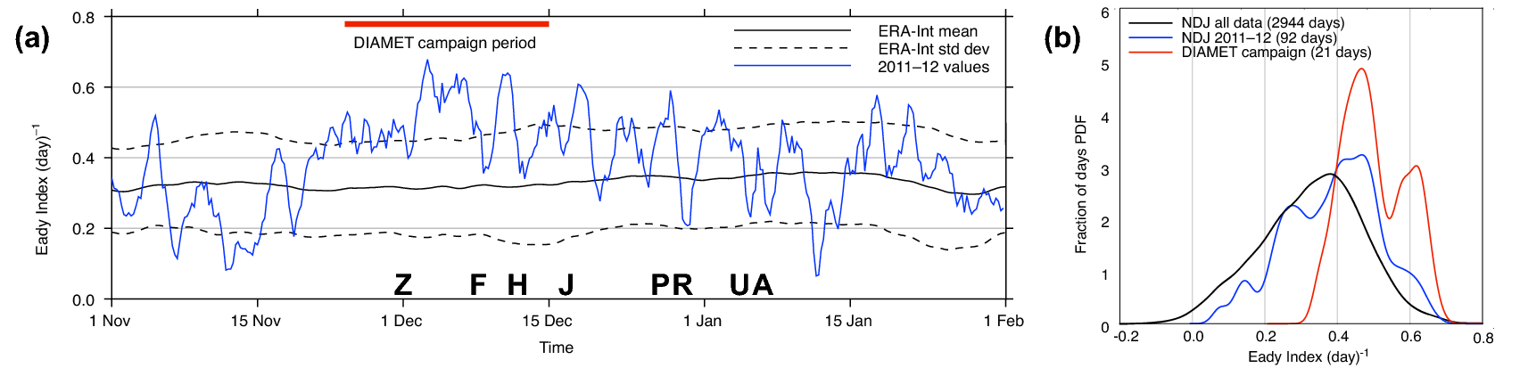

Fig. 1: Evolution of jet stream strength, as indicated by the Eady index averaged over the North Atlantic (see box). (a) Time series from 1 November to 31 January showing 2011-2012 values in blue from ERA-Interim, with the climatological mean (1979-2010) and standard deviation in black (smoothed with a running 7-day mean). The DIAMET campaign period is marked. The letters refer to the strongest cyclones passing over the UK (see text). (b) Probability density function of Eady index for the DIAMET campaign (red), November 2011 to January 2012 (blue), and the Nov-Dec-Jan for the whole ERA-Interim period 1979-2010 (black). Estimated from 6-hourly data using Gaussian kernel smoothing.

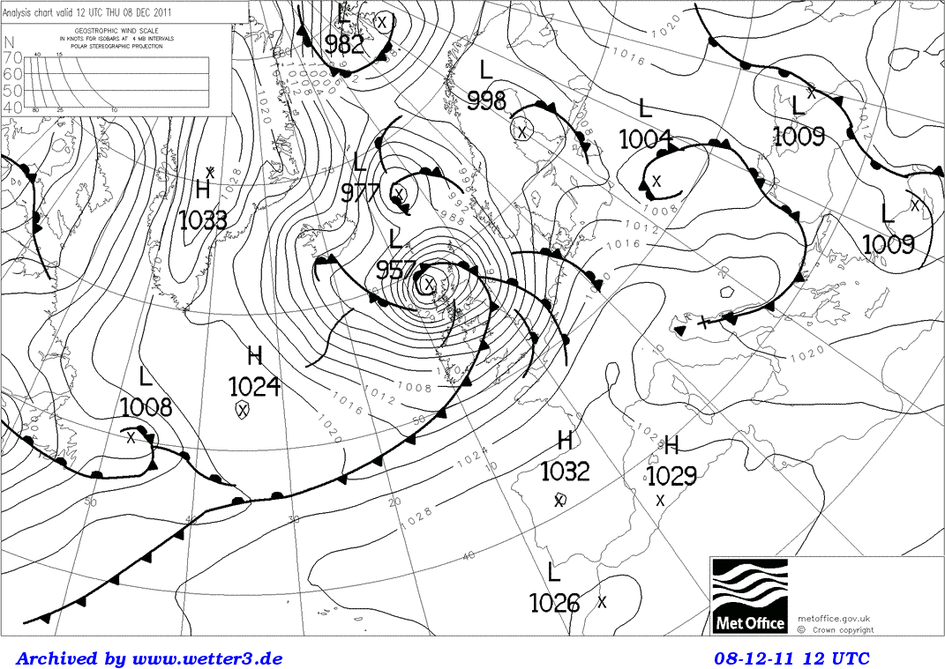

Fig. 2. Met Office surface analysis for 12 UTC on 8 December 2011

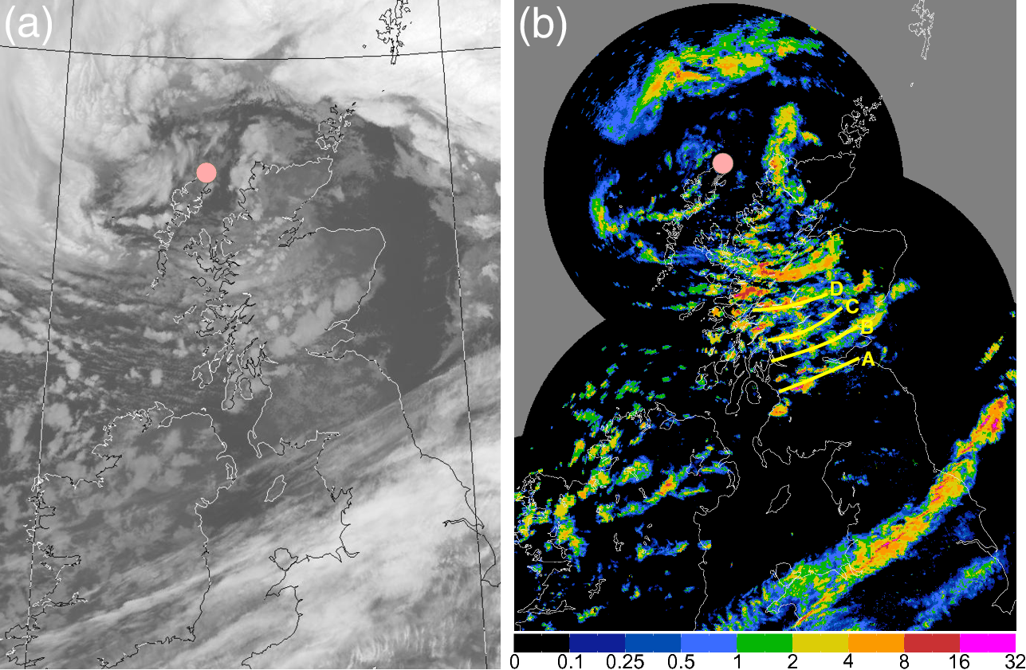

Fig. 3: a) Infra-red image from the AVHRR instrument on NOAA-19, 1235 UTC 8 December 2011. b) Rain rate (mm hr-1)at 1300 UTC estimated by the Met Office radar network (1 km resolution). At 1234 UTC the FAAM aircraft reached the storm center (pink dot). A-D indicate rainbands which propagated towards ESE.

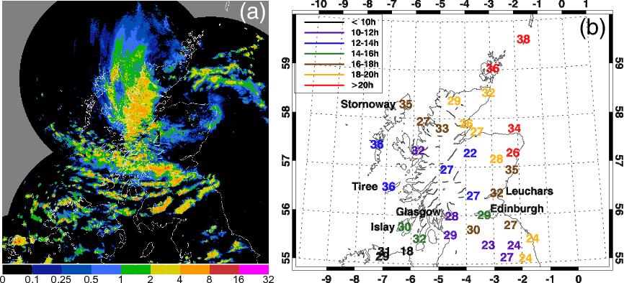

Fig. 4: a) Radar-derived precipitation rate (mm hr-1) at 1800 UTC 8 December 2011 when the cyclone center had crossed to northeastern Scotland and the banding to the south was most prominent. b) Maximum 1-minute gusts at surface stations over central Scotland during 8 December 2011, filtered using a 10-minute median. Gust strength (ms-1) is colored by the time of occurrence.

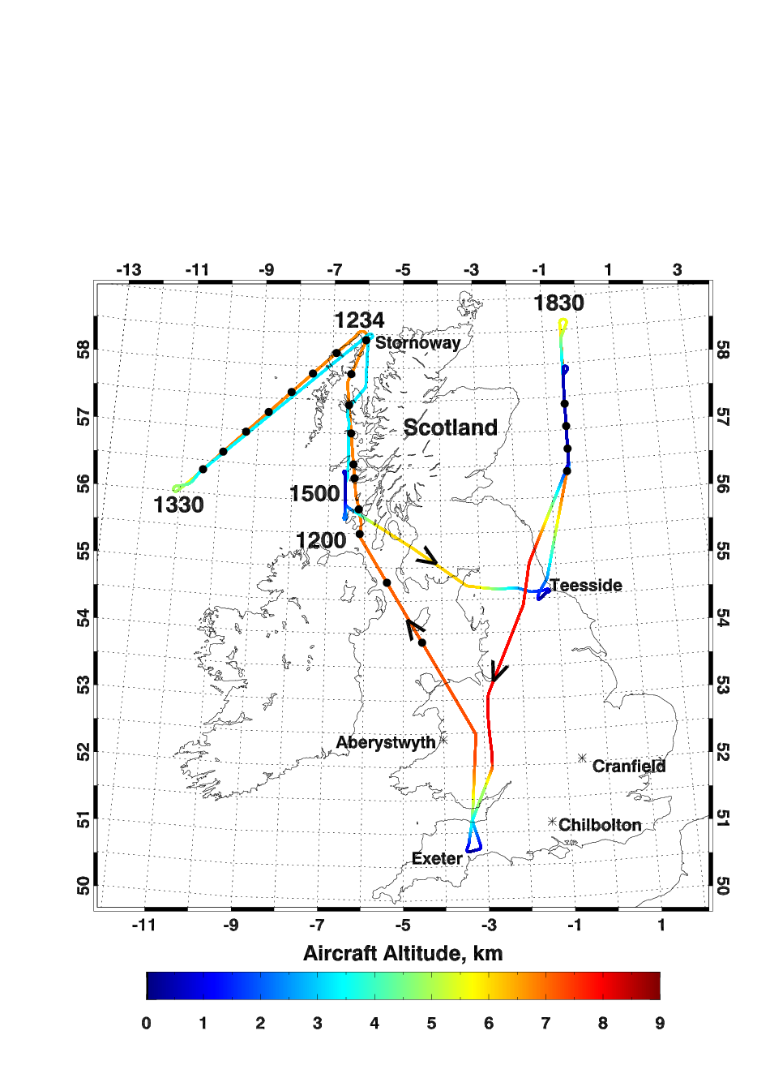

Fig. 5: Path of the FAAM aircraft on 8 December 2011, with the track coloured according to altitude. Black dots indicate dropsonde launches. The flight took off from Exeter at 1048 UTC, landed for refuelling in Teesside on the east coast of England at 1607 UTC, took off again at 1729 and returned to Exeter at 2110 UTC. The aircraft was at low levels within the strongest winds at around 1500 UTC and again at 1900 UTC.

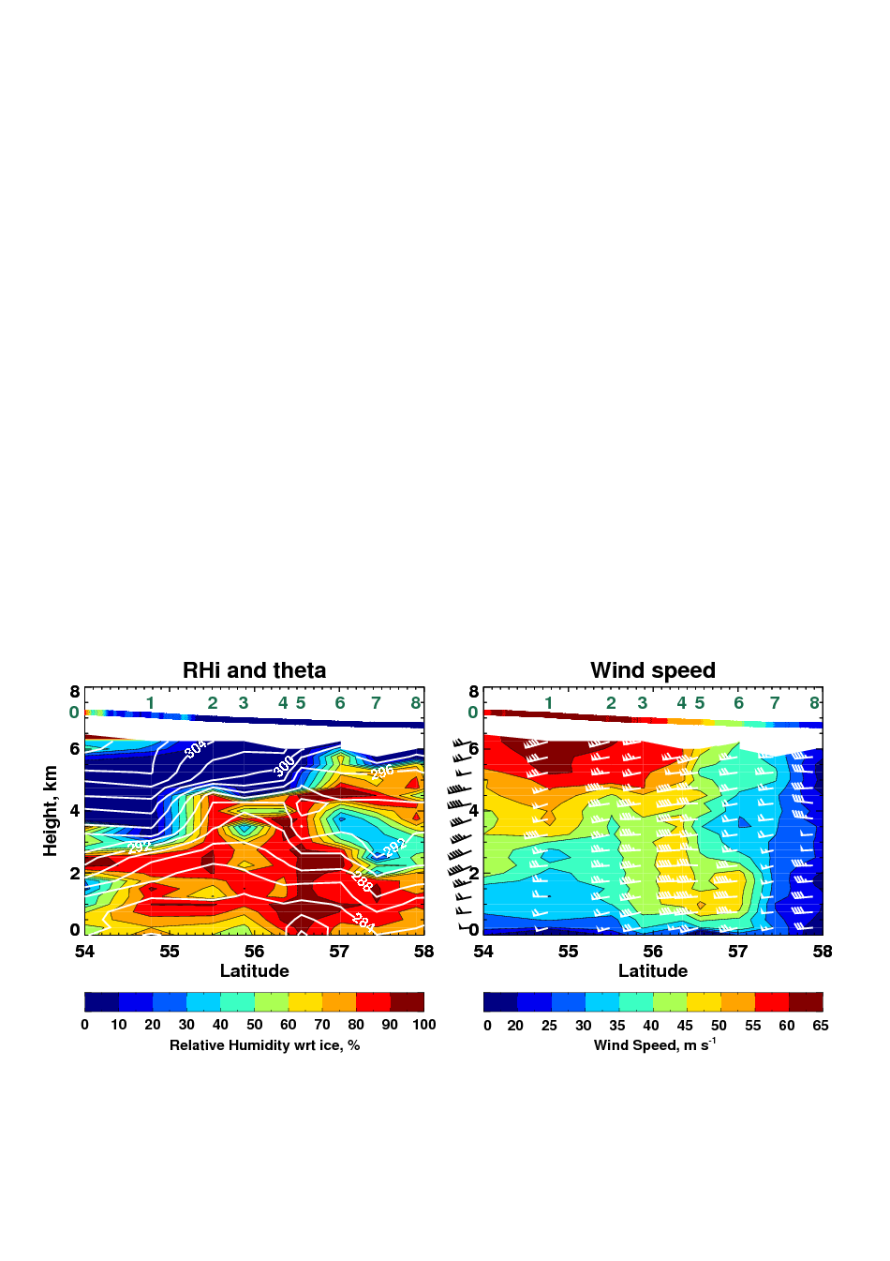

Fig. 6: Cross-sections of relative humidity with respect to ice, potential temperature (white contours) and wind speed (ms-1) derived from the first nine dropsondes released along the first leg from 1130 to 1228 UTC. Numbers in green denote the locations where the sondes were dropped. The wind barbs use the usual convention for wind strength in knots. *In-situ* measurements from the aircraft, flying at a constant pressure of 390 hPa, are shown in the strip at the top.

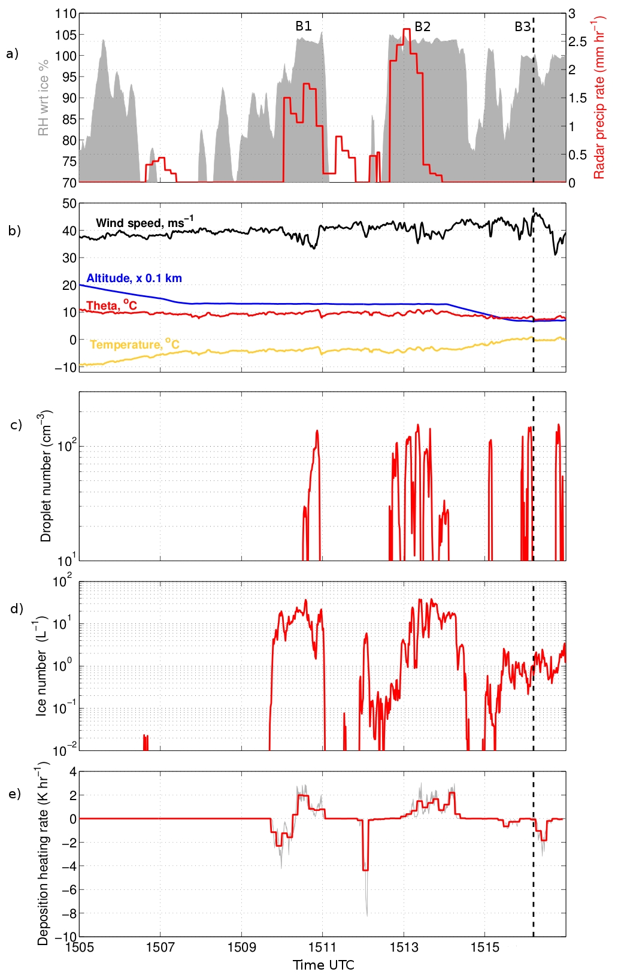

B0

Fig. 7: Measurements from the FAAM aircraft as it flew northwards from Islay to Tiree through the strongest low level winds and three cloud bands. The aircraft reversed its heading at 1516, shown by the vertical dashed line, and so sampled band B3 twice. a) Relative humidity with respect to ice along the flight track, computed using WVSS-II data (shading) against rain rate (red line) derived from the radar network (interpolated to the flight track). b) Wind speed (m s-1, black), radar altitude (x0.01 m, blue), temperature (°C, yellow) and potential temperature (°C, red). c) Droplet number concentration (cm-3), as measured by the Cloud Droplet Probe. d) Ice particle number concentration (l-1) as measured by the CIP-100 probe. e) Diabatic heating and cooling rates associated with deposition and sublimation of ice crystals. The black line shows 1 Hz values; the bold red line shows the mean value calculated over 8 second intervals, equivalent to a distance of approximately 1km. Wind speed is shown again, with an expanded scale.

Chris, please:

1. Annotate the red blob at 1507 with B0
2. Show wind speed again on the fourth panel, with an expanded scale (30 – 50 m/s)

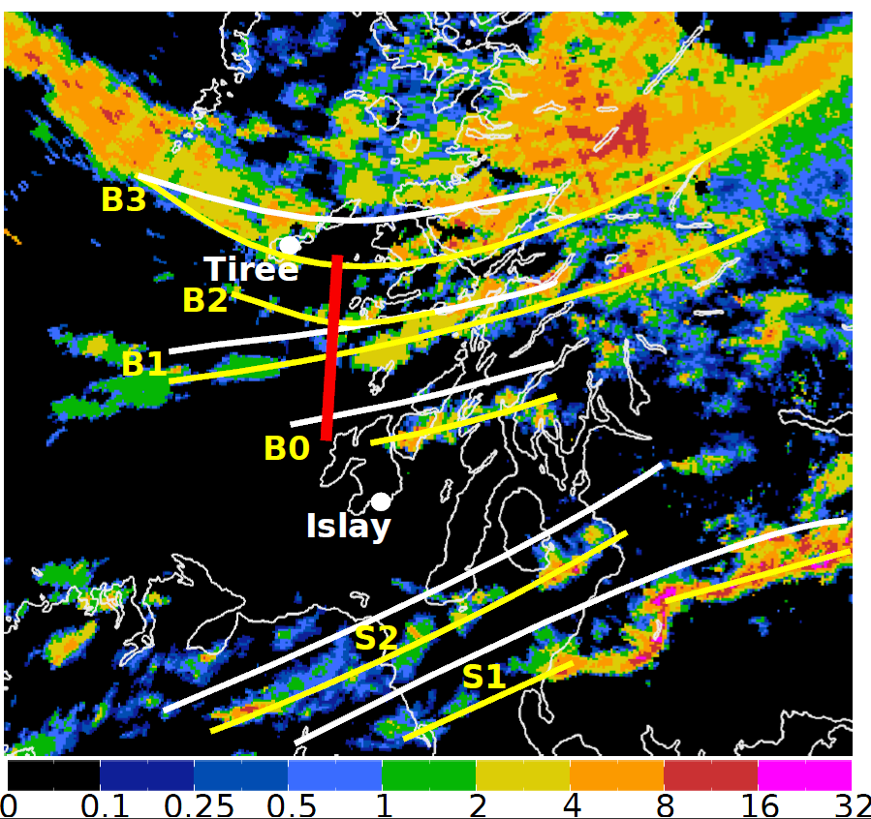

Fig. 8: Precipitation radar image for 1515 UTC showing the bands intercepted by the aircraft between 1505 and 1517. White lines: bands at 1500 UTC corresponding to the labels in Fig. 7a (B3 from shape of clouds where precipitation is absent). Yellow lines: positions of the bands on the 1515 image, showing the southeastward progression of the bands. Note that the southern bands S1 and S2 were not intercepted by the aircraft. Colour scale is mm hr-1. White dots on Tiree and Islay denote position of automatic weather stations.

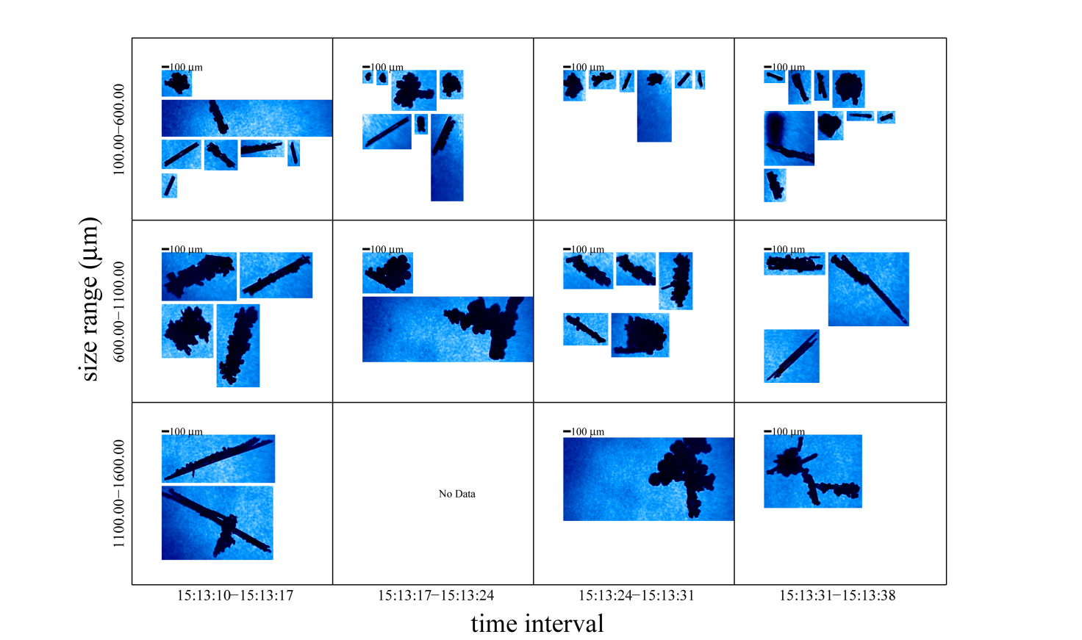

Fig. 9a: Images of ice crystals captured by the Cloud Particle Imager (CPI) over a few seconds in the middle of cloud band B2 at a time with very high number concentrations of small columnar crystals.

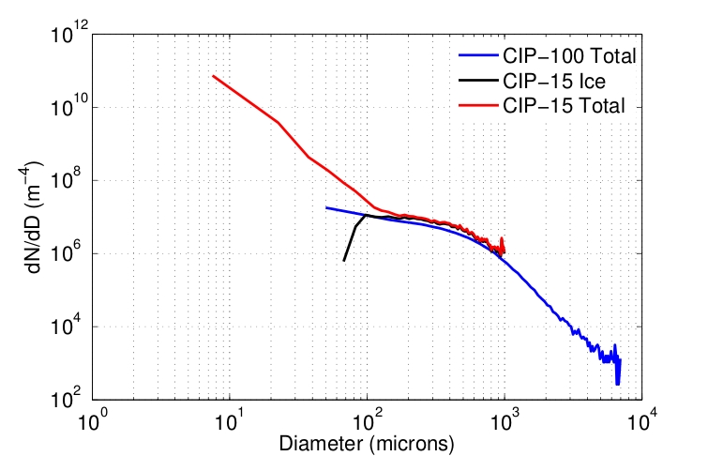

Fig. 9b: Comparison of particle size distributions from the CIP-15 and CIP-100 probes, averaged between 1504 UTC and 1516 UTC. The CIP-15 has a bin width of 15 microns and can measure cloud particles up to 1 mm diameter. The CIP-100 has a bin width of 100 μm and can measure precipitation-sized particles up to 6 mm diameter.

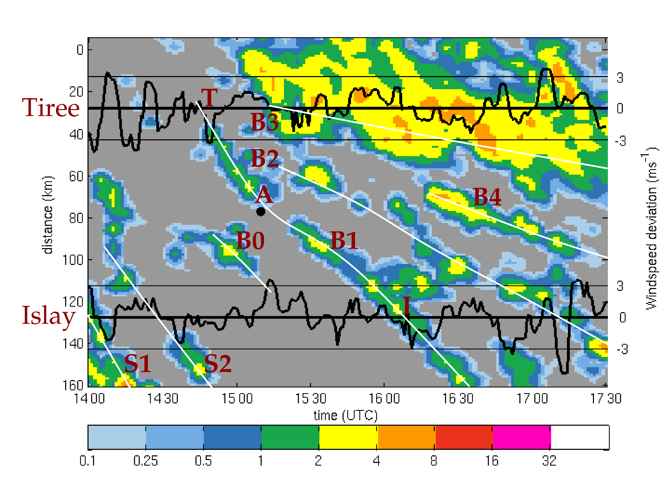

Fig. 10: A time-distance plot of radar-derived precipitation rate (mm hr-1) interpolated from the Met Office radar composite to a line connecting observation sites at Tiree and Islay. Distance increases along the section from north-northwest to south-southeast. Labels T and I identify the passage of rainband B1 over Tiree and Islay and point A indicates the crossing of this section by the aircraft. The time series of wind gusts measured at both AWS sites is overlain at the corresponding distance along the section. A 90-minute running median has been removed from the winds to emphasise the bands. The white curves indicate the progression of rainbands along the section (see Fig 8). Color scale is in mm hr-1.

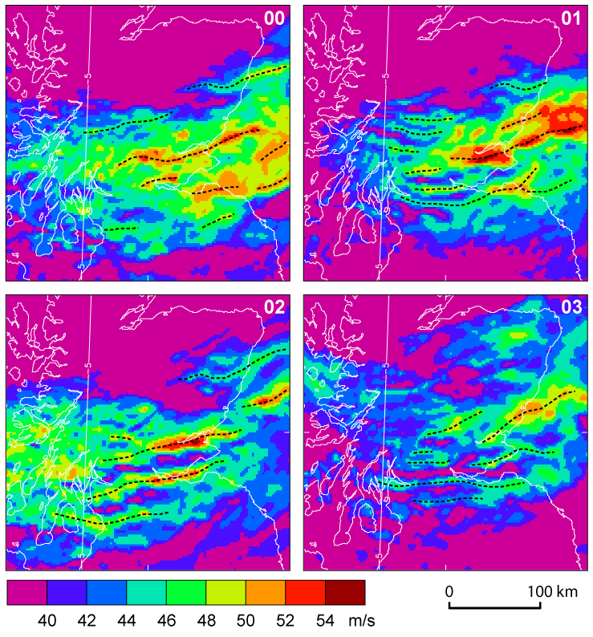Fig. 11: Wind speed (m s-1) at the 850 hPa level from the first 4 members of the MOGREPS-UK trial forecast. Shown at 1600 UTC, 7 hours into the forecast. Dashed lines indicate the axes of the wind maxima.

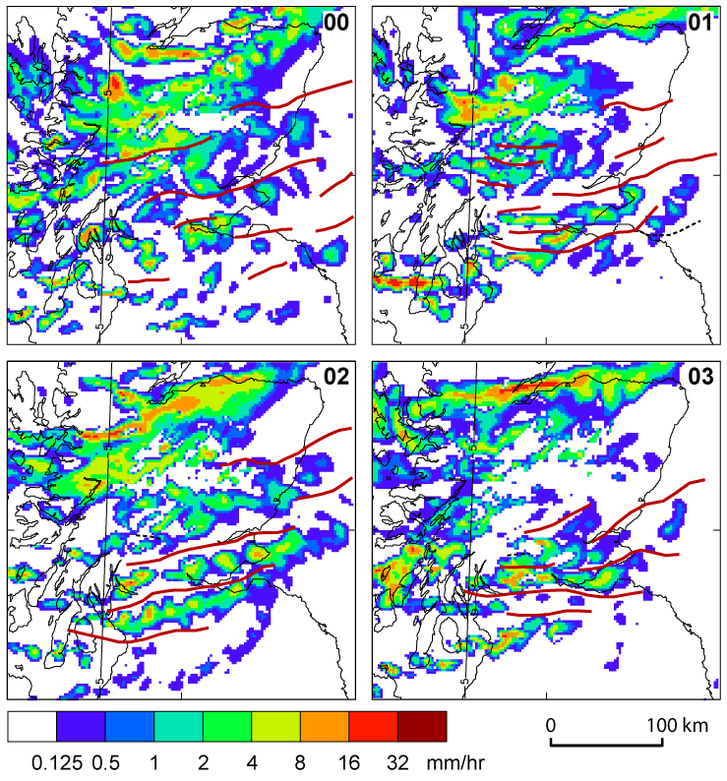

Fig. 12: Rainrate at 1600 UTC 8 December 2011 from the first 4 members of the trial MOGREPS-UK ensemble forecast. The red lines follow the low level wind maxima (see Fig. 9).

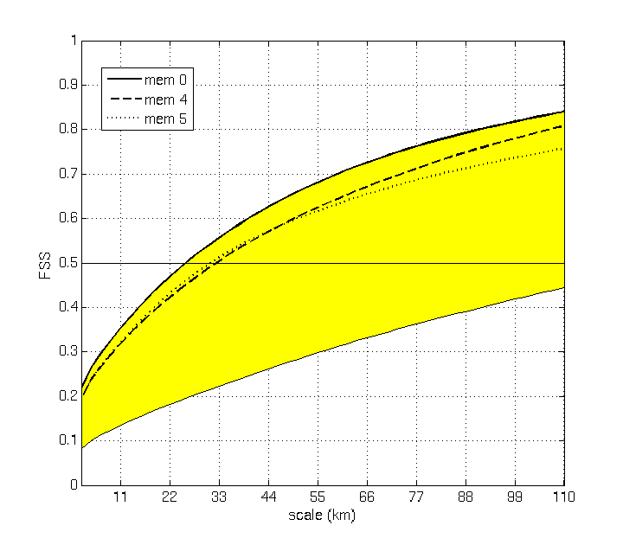

Fig. 13: Fractional skill score (FSS) measuring the degree of fit between the rain rate pattern in each forecast and the radar data versus horizontal scale, averaged over forecast lead times 4-24 hours. The yellow shading indicates the full range of results from the 12-member ensemble and the members 0, 4 and 5 are also indicated. The best ensemble member has skill (FSS > 0.5) for scales greater than 25 km. FSS is calculated over Scotland (54.6-59.3oN, -8.1-0.4oE).

1. http://www.cpc.ncep.noaa.gov/products/precip/CWlink/pna/nao.shtml
2. Warning the public to take action