Practical 3: A plume dispersion model

Objectives
To gain an understanding of how pollutants disperse in the boundary layer under a range of meteorological conditions using a Gaussian plume model, which forms the basis of several commercially available atmospheric dispersion models (e.g. ADMS).
The model may be run from http://www.met.rdg.ac.uk/courses/MTMG49/

1. Background to the Model
Pollutants are emitted into the atmosphere from two main classes of source: (i) diffuse area emissions, e.g. from a city, and (ii) point sources, e.g. from a factory or power plant. A Gaussian plume model is used to simulate dispersion from a point source, such as a stack emitting at some height H above the ground. Pollutant emitted from a stack is advected in the direction of the prevailing wind (the “along wind” direction). Small-scale turbulent eddying motions disperse the pollutant vertically and horizontally in the “across plume” direction. These dispersion processes determine pollutant concentrations at the ground.

Meteorological conditions play an important role in governing the dispersion. If there is a strong wind, the pollutants will be spread over a large area, yielding relatively low concentrations, while if the wind is light the pollutant will remain in the vicinity of the stack with high concentrations. Atmospheric stability also plays an important role. The schematic below (from Oke 1987) shows the coordinate system used in the model.
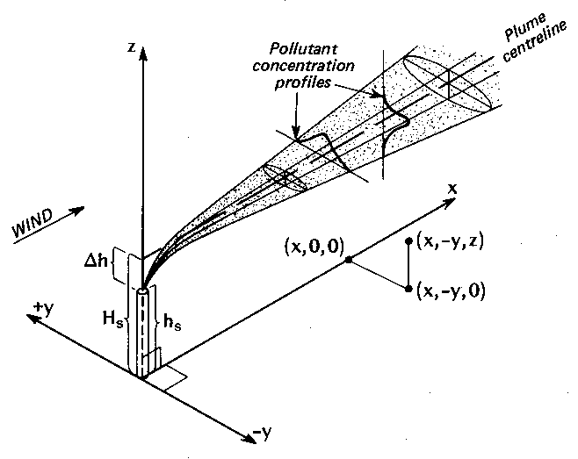
The rate of change of the mean concentration C of the pollutant at a particular point is the sum of advection and turbulent mixing effects:
$$\begin{aligned}\frac{∂C}{∂t}=−u\frac{∂C}{∂x}−v\frac{∂C}{∂y}−w\frac{∂C}{∂z}+K_{c}\left(\frac{∂^{2}C}{∂x^{2}}+\frac{∂^{2}C}{∂y^{2}}+\frac{∂^{2}C}{∂z^{2}}\right) \\ \begin{matrix} & \end{matrix}=−\vec{u}\text{.}∇C+K_{c}∇^{2}C\end{aligned}$$
This advection term shows that the concentration is increased if the wind, u, blows in high pollutant concentrations. The turbulent mixing is parameterized in a Gaussian plume model as a diffusive process (not a particularly good parameterization when the atmosphere is convecting), with diffusion coefficient K_{c}.

It can be shown that if the turbulence is stationary and homogeneous the concentration of pollutant at position x resulting from emissions from the stack located at x = 0, y = 0, z = 0 has a Gaussian shaped variation with distance across the plume (y) and with height (z). This solution is written mathematically as
$C(x,y,z,t)=\frac{Q}{2{\text{πσ}}_{x}σ_{y}u}\text{exp}\left(−\frac{y^{2}}{2σ_{y}^{2}}−\frac{z^{2}}{2σ_{z}^{2}}\right)$.
Here Q is the release rate of the pollutant, and u is the wind speed in the along wind direction (x). This expression needs to be modified slightly if the stack is at a height H. The coefficients σ_{y} and σ_{z} are related to the eddy diffusion coefficients, K_{c}, by
$σ_{y}^{2}=2K_{c}t$,
where t is the time downwind of the stack. These coefficients vary because the turbulent diffusivity (i) increases with increasing distance from the ground, (ii) increases with increasing surface roughness and (iii) varies with atmospheric stability.

In the present formulation, the atmospheric stability is represented by the Pasquill stability class. This scheme classifies the boundary layer into 6 stability classes that can be determined by routine surface observations. The stability class is determined by the surface wind speed, and by day by the amount of incident solar radiation, and by night by the amount of cloud cover, using the following table

Wind at 10m height | Solar Radiation |  |  | Night time cloud cover
 | Strong | Moderate | Slight | >=4/8 | <=3/8
<2 | A | A-B | B
2-3 | A-B | B | C | E | F
3-5 | B | B-C | C | D | E
5-6 | C | C-D | D | D | D
>6 | C | D | D | D | D

The classes A-F determine the stability is as follows:
A: Extremely unstable | D: neutral
B: moderately unstable | E: slightly stable
C: slightly unstable | F: moderately stable
Solar radiation is reckoned strong if the solar insolation exceeds 700 W m-2, moderate if the solar insolation is between 350 and 700 W m-2, and slight if less than 350 W m-2. Under unstable conditions the Gaussian plume model predicts the mean concentration, averaged over the meandering plume, so that the actual concentrations will be underestimated.

2. Running the model
The Gaussian plume model is run by entering the parameter values into the form and then clicking on the submit button. The parameters are as follows:

Parameter | Unit | Notes
Release rate | g s-1 OR g | Can either be a release rate OR a total amount – see Release duration
Wind speed | m s-1 | Measured at 10 m above the ground
Roughness length | m
Release duration | hours | If pollutant release given as a total amount this should be set to 1, otherwise enter time over which release takes place
Effective release height | m
Stability category |  | Select category from drop down list
Calculation range: Define the volume over which concentrations are to be calculated
X - Minimum, maximum and step size | m | Minimum must be greater than zero
Y - Minimum, maximum and step size | m | To see the symmetric shape of the plume set  Ymin = -Ymax.  Recommend that Ystep chosen so that Y=0.0 is calculated.
Z - Minimum, maximum and step size | m | Minimum must be greater then or equal to zero

Notes:
- Values for the concentration are calculated at all points on the specified three-dimensional grid system.
- You can plot the variation of concentration along one direction by specifying fixed values for the other two directions, e.g. for concentration values along x (the along wind direction) select x and specify values for y and z.
- You can obtain a contour plot of concentration in a specified plane. For example, in the vertical (z) plane: select “z” and specify the value of z at which the plane lies.
- The concentration values are guaranteed to remain on the system for an hour, and may be retained for up to two hours, depending on the time of creation. After this period of time values will need to be recalculated.
- Some contour plots may look a little odd at first sight. This is a real effect. Ten contours are linearly spaced across the range of concentrations. However, close to the emission point the concentration drops away much faster and so the contours will be clustered closely together.

3. Analysis
      - Estimate the input parameters that would be appropriate for the current meteorological conditions (wind speed and stability class), and choose a roughness length appropriate to rural terrain. Run the model, and view the output in several different ways, until you are confident that you can interpret the x-y and contour plots of output.
      - The surface roughness length, z₀, and the atmospheric stability govern the dispersion of the plume. Keeping other input parameters fixed, vary these two parameters in turn to determine which parameter has the strongest effect on plume dispersion in the vertical and in the across-plume direction. Hence determine the meteorological conditions that lead to highest ground level pollutant concentrations.
      - Using the meteorological conditions that gave the highest ground level concentrations, determine how stack height controls ground level pollutant concentrations.
      - In what ways and what conditions is the model likely to be too simplistic in its representation of pollution dispersion?

Reference
Oke, T. R., 1987: Boundary Layer Climates, Second Edition, Routledge.

