4.2 Photochemical smog and ozone

1. Introduction
A major concern in recent years is pollution from vehicles; urban areas produce a complex soup of chemicals with a multitude of reactions downstream of the car. This forms the modern “photochemical smog”, often known as “Los Angeles smog” where it is most severe. Of particular interest are nitrogen dioxide (NO₂) and ozone (O₃), both of which exacerbate respiratory conditions.
Ozone is a major regional pollutant in Europe and North America, with a lifetime of days and a typical mixing ratio of 30-40 ppbv (parts per billion by volume) in rural areas. The UK target is for less than 50 ppbv as an 8-hour average but this is often exceeded.

2. Sources of tropospheric ozone
i. Synoptic dynamics
Stratosphere-troposphere exchange can bring the high ozone concentrations in the stratosphere into the troposphere, via dynamical features such as a tropopause fold associated with a cold front. This occurs more often in winter than in summer.

ii. Photochemistry
In an unpolluted (e.g. rural) atmosphere, we have naturally occurring NOx (NO+NO₂). In daylight the following fast cycle occurs:

- 1. Ozone production:

- 2. Ozone destruction:

In this cycle there is no net source of ozone.

In a polluted environment cars emit NO, reactive hydrocarbons RH, and various other muck. RH is basically unburned fuel, and may be methane (R=CH₃), ethane (R=C₂H₅), propane and so on.
- What is the immediate effect on ozone concentrations?

However, RH is oxidised by OH to form a peroxy radical RO₂, which in a high NOx environment leads to NO₂ production:

- 3. RH oxidation:

- 4. NO₂ production:

The RO produced then reacts in numerous ways to form more stable “hydrocarbon by-products” (HC) including aldehydes and ketones. Note that reactions 3 and 4 have a much longer timescale (hours to days) than 1 and 2, so become important some distance downstream of the pollution source.
- What is the consequence for ozone concentrations of additional conversion from NO to NO₂?

→ Sketch 1: Contrast between urban and surrounding rural ozone concentrations.

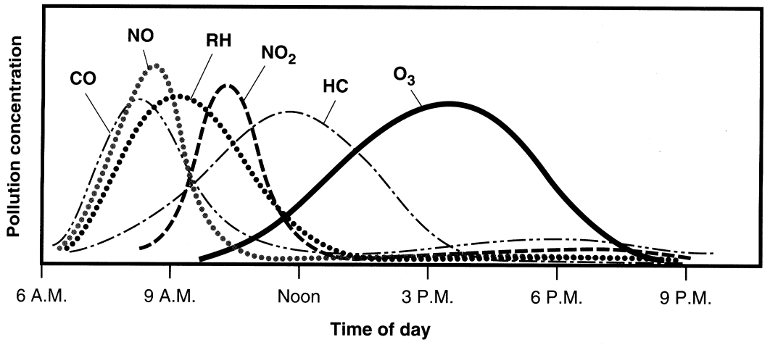
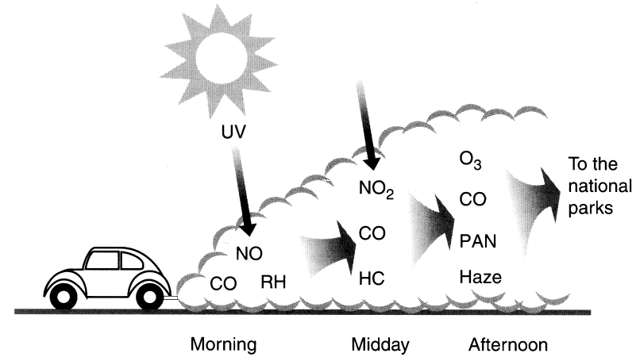
Figure 1. The time evolution of the principal chemical components of photochemical smog in a typical smoggy city following the morning rush-hour. Note that HC represents “hydrocarbon by-products”. From Turco (1997).

3. Sinks of ozone
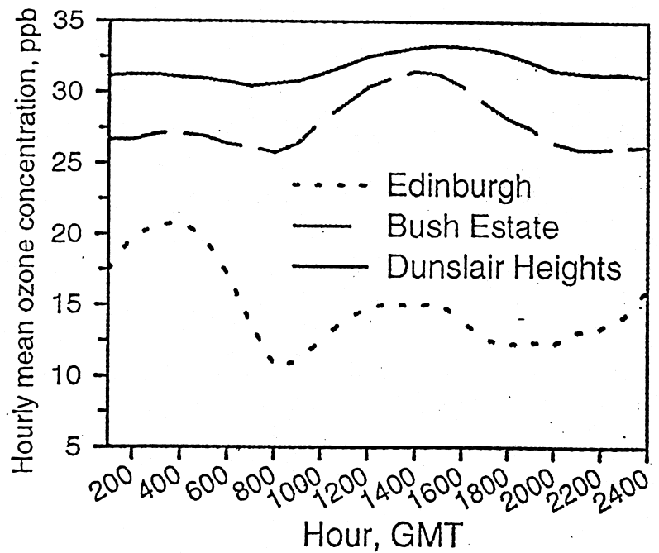
i. Photolysis of ozone
In the day, one sink of ozone is photolysis, which leads to the production of two OH radicals per ozone molecule. However, this is slow compared to the other sources and sinks.

ii. Dry deposition
A more rapid loss mechanism near the ground is dry deposition to soils and plants. The dry deposition velocity is the effective speed at which the molecules of a gas move towards a surface as the gas is removed, and for ozone over land it is 0.1-0.5 cm s⁻¹ (over the sea it is smaller). In a convective daytime boundary layer, vertical mixing can rapidly replenish from above the ozone deposited at the surface. At night, however, the mixing is weak and dry deposition can significantly deplete the ozone in around 100 m of air above the surface. The result is that ozone concentrations typically increase with height (see Figure 2).
Figure 2. Diurnal cycle of ozone at 3 sites in the vicinity of Edinburgh: the city centre (near sea level), the Bush Estate (180 m altitude, downwind) and Dunslair Heights (600 m).

→ Sketch 2: The effect of dry deposition at night and in the day.

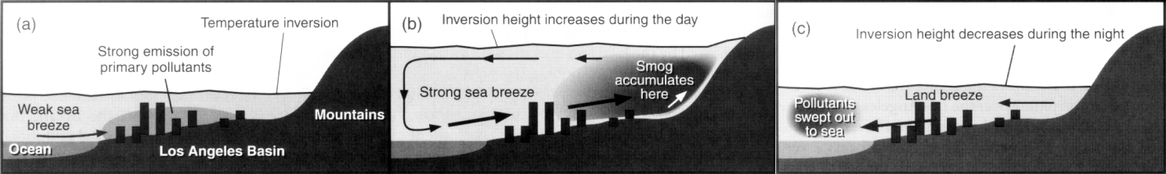
Figure 3. Near Los Angeles ozone pollution is exacerbated by the strong sea breeze, which carries the pollution inland where it is trapped by the mountains.

4. Annual variation of ozone
Ozone concentrations peak in late spring to early summer:
- In winter there are more cyclones, leading to more stratosphere/troposphere exchange and an increase in tropospheric ozone.
- In summer when the sun is at its highest the increased photochemistry increases ozone concentrations. However, the warmer surface also leads to a deeper boundary layer (e.g. Carson’s model) diluting the ozone and tending to reduce surface concentrations.
High ozone episodes in the UK can occur
- Under a persistent anticyclone (bright sunshine, strong capping inversion to trap the pollutants and no rain or fronts to sweep the pollution out or up).
- In polluted air flow from continental Europe.

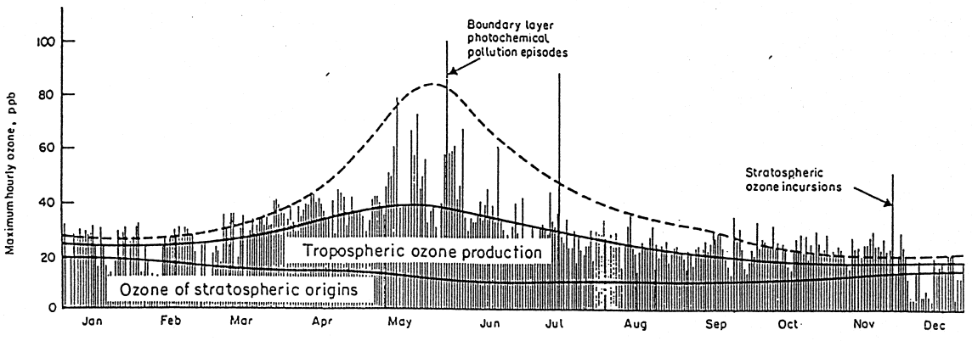
Figure 4. Observations of daily maximum ozone concentrations at a rural site.

→ Further reading: Oke p281-284.
→ See also “Transboundary air pollution” 2001 report at http://www.nbu.ac.uk/negtap/finalreport.htm, and documents at http://www.airquality.co.uk/archive/reports/reports.php?action=category&section_id=12.

