4.1 Boundary Layer Air Pollution

1. Introduction
We are concerned about boundary layer air pollution for a number of reasons:
- Damage to health: can lead to respiratory problems (e.g. ozone, aerosols) or cancer (e.g. benzene).
- Damage to vegetation: crop yields decrease if ozone levels are sufficiently high; acid rain damages trees.
- Damage to ecosystems: acid rain acidifies lakes, which can kill plants and animals.
- Damage to materials: ozone weakens rubber and acid rain damages buildings.
In addition, long-lived chemicals such as carbon dioxide and methane act as green-house gases, CFCs can deplete the ozone layer and aerosols can affect the radiative properties of clouds by increasing the number concentration of cloud condensation nuclei and hence the number of droplets.
Pollutants are classified as primary (emitted directly) or secondary (formed by chemical reactions in the atmosphere). The table on page 2 lists the eight main pollutants harmful to human health in the UK.

2. London Smog
In December 1952, up to 12000 people were killed by polluted fog, known as smog (smoke + fog) in London. The causes were:
- Sulphur dioxide (SO₂) from coal-fired power stations in the city (e.g. Battersea power station) and from low quality coal (i.e. more sulphur content) used to heat homes.
- Fog droplets which reacted with the SO₂ to form a sulphuric acid mist.
- Aerosol particles from diesel buses acted as hydroscopic nuclei, causing the fog to have a much higher droplet number concentration and hence a much lower visibility than fogs in clean air.
- A stable nocturnal inversion resulted in the smog being trapped near the surface.
This led to the UK Clean Air Act, enforcing a minimum height for chimney stacks and promoting low-sulphur fuels.

The dispersion of pollution from a chimney is dependent on the eddy diffusivity of the boundary layer, which is affected by stability and other factors, and certain meteorological conditions can enhance the ability of the pollution to reach the ground. Figure 1 shows typical instantaneous plume patterns for a number of different scenarios. The Gaussian plume model (used in Practical 3) uses K-theory to provide an approximate description of the time-averaged dispersion of pollution from a chimney.

Under the 1996 UK National Air Quality Strategy (NAQS), standards have been set for the concentrations of eight pollutants that are harmful to human health:
Pollutant | Source in UK | Health effect | Mechanism and timescale for removal | Specific Objective | Prospects
Benzene | Vehicle emissions (unburnt fuel). | Carcinogen (notably leukaemia). | Around a week by reaction with OH. | 5 ppbv by 2005 | Reduction expected due to new legislation on vehicle emissions.
1,3-butadiene | Mainly vehicle emissions. | Carcinogen. | Hours, by reaction with OH or O₃. | 1 ppbv by 2005 | Significant reduction due to 3-way catalytic converters.
Carbon Monoxide (CO) | Incomplete combustion of fossil fuels. Two thirds from road transport. | Inhibits oxygen supply around the body. | Around a month, by reaction with OH. | 10 ppmv by 2005 | Decrease due to catalytic converters.
Lead | Industry (battery manufacture, piping etc). Enters atmosphere as salts (e.g. PbBrCl) in the form of sub-micron particles. | Lead is a cumulative poison to the central nervous system and is particularly detrimental to the mental development of children. | Wet and dry deposition. | 0.5 μg/m³ by 2005 | Drastic reduction now that leaded petrol is banned in the UK.
Sulphur Dioxide (SO₂) | Mainly power stations. | Short-term exposure to high levels of sulphur dioxide may cause coughing, tightening of the chest and irritation of the lungs and is estimated to bring forward 3500 deaths annually in the UK. | Wet deposition; timescale for oxidation in clouds around an hour. Can lead to acid rain. | 100 ppbv at the 99.9th percentile by 2005 | Good due to demise of coal industry and desulphurisation techniques.
Nitrogen Dioxide (NO₂) | Combustion produces Nitric Oxide (NO), rapid conversion to NO₂; together referred to as NOx. Half from road transport, half from electricity and other industries. | Nitrogen Dioxide gas irritates and inflames the airways of the lungs. This irritation causes a worsening of symptoms of those with lung or respiratory diseases. | Oxidation into nitric acid then rainout (wet deposition); can lead to acid rain. | 104.6 ppbv at the 99.9th percentile by 2005 | Decrease expected due to catalytic converters, but then continued rise due to increasing numbers of vehicles.
Ozone (O₃) | Secondary pollutant produced from reactions involving oxides of nitrogen and halocarbons. Found downstream of polluted cities. | Like NO₂, a high level of ozone can irritate and inflame the lungs and is responsible for the early death of between 700 to 12500 people a year in the UK. It can also cause eye irritation, migraine and coughing. Ozone affects plants and also damages materials such as rubber and paints. | Days, via dry deposition, photolysis or reaction with OH. Rapid reaction with NO in the vicinity of roads. | 50 ppbv at the 97th percentile by 2005 | Depends on NOx concentrations.
Particulate Matter (aerosols) smaller than 10 microns (PM10) | Road transport, particularly diesel vehicles. Also power industry, mining, domestic emissions (coal burning fires), natural sources. | Fine particles (<10 micron) can be breathed deeply into the lungs and thus are more likely to have a toxic effect than larger dust particles. Particles are associated with increased risk of heart and lung disease and may carry surface-absorbed carcinogenic compounds into the lungs. Expert opinion is that there is no threshold concentration below which particulates have no effect on health. | Wet and dry deposition. | 50 μg/m³ at the 99th percentile by 2005 | Depends on road transport.
→ Revision tip: you don’t need to memorise this table.

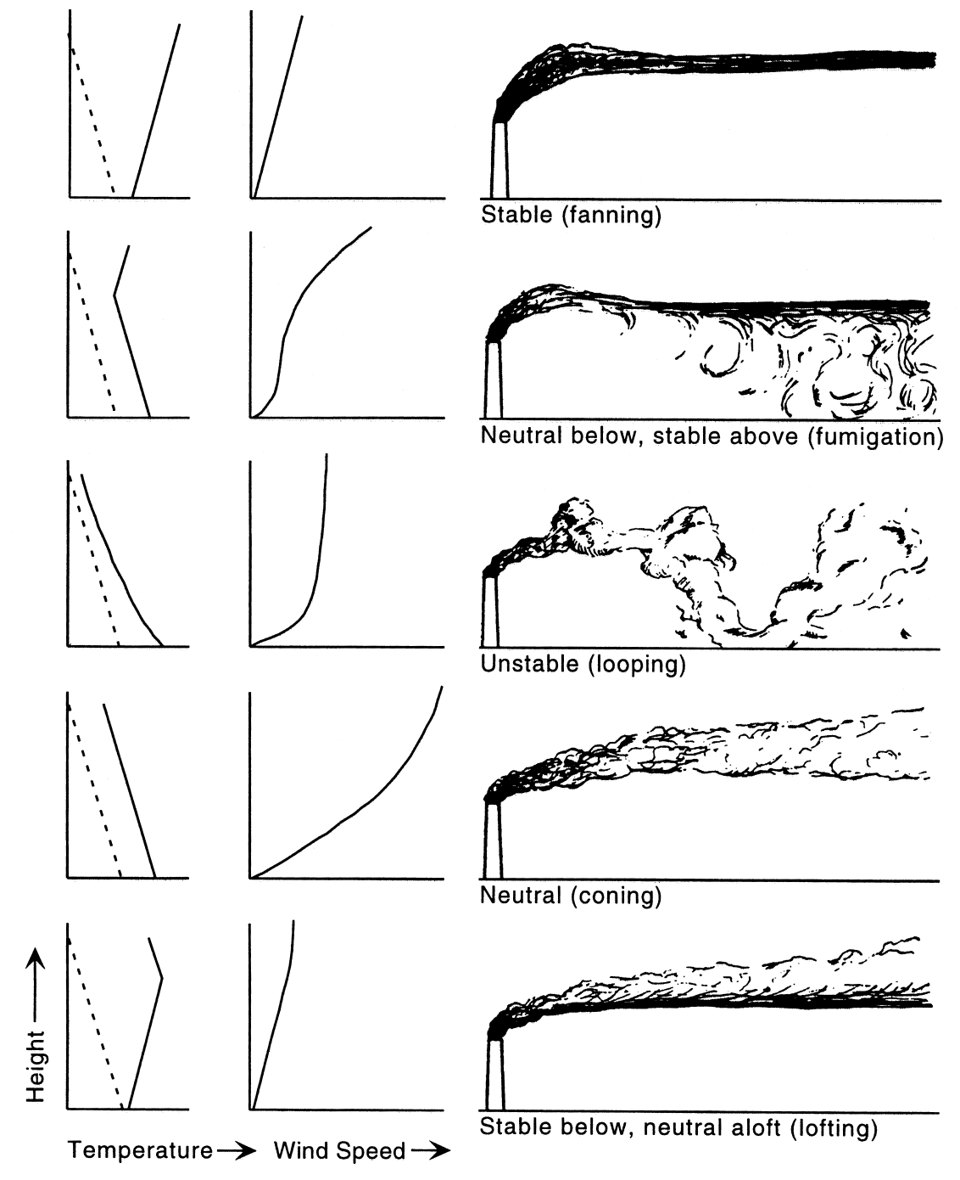
Figure 1. Schematic depictions of instantaneous plume patterns in the vertical and the corresponding wind speed and temperature profiles. The dashed lines on the temperature panels indicate the slope of a dry adiabat.

3. Oxidation and the hydroxyl radical
Most gaseous pollutants (notably not CFCs) are removed by reaction with the hydroxyl radical OH. A radical is very reactive due to the presence of an unpaired electron, which is often symbolised by a dot, i.e. •OH.
- During the day the hydroxyl radical may be formed by photolysis of ozone:

OH reacts so rapidly that each radical has a lifetime of only around 1 second, so OH is virtually absent after sunset. However, at night the less reactive NO₃ radical can play a similar role to that played by OH in the day. Reaction with these radicals is known as oxidation and results in more soluble species that are susceptible to wet deposition (rainout). For this reason, OH is sometimes referred to as the “cleaner of the atmosphere”.

4. Acid rain
While high chimneys help reduce the maximum concentrations experienced at the ground, pollutants may be carried long distances on the wind. In the case of SO₂ (emitted by coal power stations) and nitrogen dioxide NO₂ (a secondary pollutant rapidly produced from NO in vehicle exhausts), oxidation results in the formation of acids, which can then dissolve in water droplets and be deposited a long distance downwind as acid rain.
- The following gas phase reaction produces nitric acid:

SO₂ is only slowly oxidised in the gas phase by reaction with OH, but in aqueous solution (i.e. when dissolved in cloud droplets) it reacts with ozone or hydrogen peroxide on timescales of around 1 hour to produce sulphuric acid solution. Acidity is measured by the pH scale:
$\text{pH}=−{\text{log}}_{\text{10}}[H_{(\text{aq})}^{+}]$,
where the square brackets denote concentration. Natural rain is not neutral (pH=7) but slightly acidic (pH=5.6) due to CO₂ in the air dissolving to form weak carbonic acid. In Europe, forests have been damaged by acid rain, but SO₂ concentrations have decreased significantly in the last few decades and acid rain is less of an environmental concern. However, it is still a significant problem in parts of North America and is becoming so in parts of Asia. The average pH of rain in the North-Eastern US and Eastern Canada is 4.3 (20 times more acidic than natural rain), but much greater acidities have been measured. If the pH of a lake falls below 5 then fish and other animals will die and plant growth will be stunted. Acid rain also damages stonework.

→ Further reading: Arya p73-74, Oke.
→ See also Royal Society of Chemistry web site: http://www.rsc.org/lap/educatio/eic/2002/heal_jul02.htm.

