2.4 Cloud-Topped and Marine Boundary Layers
A significant fraction of boundary layers contain cloud, particularly over the ocean where there is an abundant supply of water vapour. Boundary layer clouds are important for a number of reasons:
- They strongly reflect solar radiation and so are climatically important. As is apparent from satellite images, the albedo of boundary layer clouds (0.4-0.8) is far more than that of the sea surface (0.05-0.1), while they emit only a little less infrared radiation to space than the slightly warmer surface. They therefore have a net cooling effect on climate. A modest change in the distribution or properties of low clouds (e.g. due to changes in aerosol concentration) could act to oppose or amplify global warming.
- They are often difficult to forecast, particularly anticyclonic stratocumulus, which impacts surface temperature, and fog, which is important for airports and road safety.
- Trade cumuli play an important role in enhancing the evaporation and upward transport of moisture in the subtropics and tropics, important for convection and the strength of the tropical circulation.
Due to the high heat capacity of the ocean, the diurnal cycle is weak in both surface temperature and the properties of the overlying boundary layer. Except near coasts, the air tends to be slightly cooler (~1 K) than the underlying sea surface due to radiative cooling of the air. This results in a slightly unstable surface layer but with surface sensible heat fluxes small, typically less than 30 W m⁻².

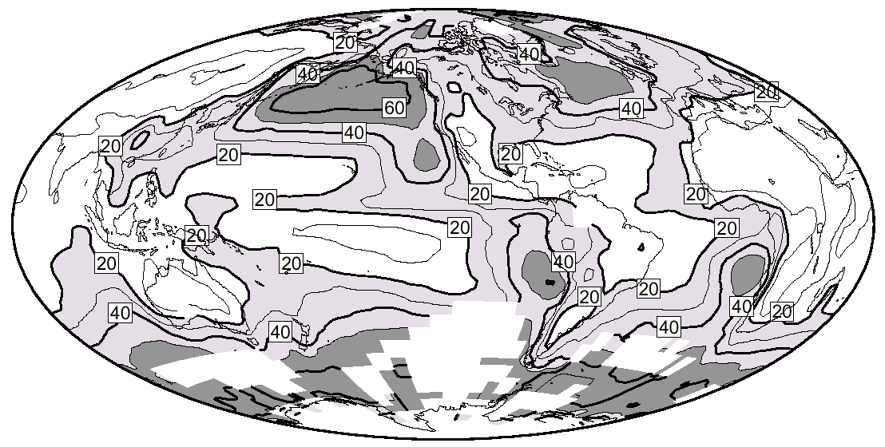
1. Types of boundary-layer cloud
There are four main types of boundary-layer cloud:
- Fog: Radiation fog occurs at night when long-wave cooling of the ground causes temperatures to fall below the dew point resulting in condensation of water droplets. Advection fog occurs when warm moist air is cooled to its dew point by being advected over a cold surface. Both tend to dissipate when the sun rises.
- Stratocumulus: The most common cloud type globally, forming extensive sheets in the persistent anticyclonic conditions over subtropical oceans. Stratocumulus is convective in nature, the overturning driven mainly by long-wave radiative cooling at cloud top and resulting in a cellular structure.
- Stratus: When buoyancy forces are weak, cellular structure is less evident and layer clouds are classified as stratus rather than stratocumulus. The average stratus cover over parts of the summer Arctic Ocean can exceed 90%.
- Cumulus: Ubiquitous in the trade-wind regions of oceans, but common elsewhere, these clouds rarely exceed a cloud cover of 0.25 but are important for their moisture and momentum transport and can act as precursors to thunderstorms.
Figure 1. Annual-mean stratocumulus and stratus amount derived from surface observations by Klein and Hartmann (1993).
The global occurrence of stratocumulus and stratus is shown in Figure 1.

2. The stratocumulus-topped mixed layer
As discussed previously, convective boundary layers consist of a well-mixed layer topped by a capping inversion. If the lifting condensation level (LCL) is lower than the capping inversion then a layer of cloud will lie at the top of the well-mixed layer. Over oceans the higher humidity results in a lower LCL, so a greater fraction of boundary layers contain cloud. However, the properties of the cloud profoundly affect the nature of the boundary layer.
→ Sketch 1: Schematic of a stratocumulus-topped mixed layer.

Above cloud base the temperature profile follows a moist rather than a dry adiabat. Because the saturation vapour pressure drops with temperature, liquid water is steadily condensed out as the air parcel rises, and in the absence of precipitation the cloud liquid water mixing ratio q_{l} increases approximately linearly with height above cloud base.
→ Sketch 2: Thermodynamic trajectories of potential temperature and liquid water mixing ratio.

The liquid water droplets interact strongly with both long-wave and short-wave radiation. In the long-wave, the cloud behaves as a black body, emitting radiation both out to space and towards the ground (with a flux given by σT⁴). Around 50-100 W m⁻² less long-wave radiation is received back from above (depending on the vapour content of the column above the cloud), resulting in a strong cooling of several K hr⁻¹ in the upper 50 m of the cloud. More radiation is received back from the surface than is emitted downwards, resulting in a radiative warming at cloud base, but this is small as the surface is not much warmer than the cloud base.
→ Sketch 3: Typical long-wave and short-wave heating-rate profile in marine stratocumulus.

The shielding of the surface from solar radiation by the cloud, and the high heat capacity of the sea surface, means that turbulent mixing is driven much more by cloud-top radiative cooling than surface heating. Narrow negatively buoyant thermals are generated at cloud top that sink down all the way to the surface. This can be thought of as an upside-down version of what happens in a dry convective boundary layer. The radiative and evaporative cooling at cloud top strengthens the inversion, with inversion strengths typically between 5 and 15 K.
Dryer tropospheric air is entrained into the descending thermals, causing partial evaporation and a higher cloud base on the descent. The air is moistened as it passes over the ocean surface, such that a steady state in humidity is attained. Similarly, the process of entrainment results in a growth of the boundary layer into the free troposphere above at rate given by the entrainment velocity w_{e} (typically 0.5 cm s⁻¹), but this tends to be in balance with the descent at the boundary layer top associated with the anticyclonic conditions.

3. Diurnal decoupling and transition from stratocumulus to cumulus
In the day the cloud is heated by short-wave radiation from the sun. This acts to oppose the long-wave cooling but is spread over a much greater depth of the cloud. Negatively buoyant thermals are still initiated at cloud top, but are no longer vigorous enough to reach the surface. The boundary layer becomes decoupled, with a weakly stable transition layer now separating an upper mixed layer (topped by the stratocumulus) from a cooler lower mixed layer. The transition layer inhibits vertical transport of water vapour, so as the day progresses:
- The upper layer dries by the continued entrainment of dry air, leading to a thinning of the cloud layer.
- The lower layer moistens by evaporation at the surface, and cumuli may form at the transition layer. Those clouds able to penetrate the transition layer can then rise freely into the dry-adiabatic upper layer.
Late in the afternoon, short-wave heating decreases and the long-wave cooling dominates once again. The more vigorous descending thermals are able to reach the surface and the two layers become reconnected. Figure 2 shows a numerical simulation of this effect over a diurnal cycle. If conditions are such that the stratocumulus breaks up completely in the day then it is unlikely to reform overnight and a cumulus regime will be preferred.
- What are the conditions that will lead to a preference for cumulus rather than stratocumulus?

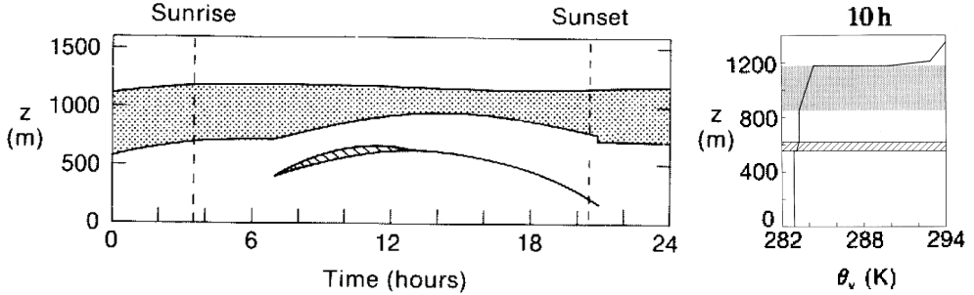
Figure 2. Simulation of diurnal decoupling and the associated thinning of the stratocumulus layer. The 10h potential-temperature profile on the right shows the weak inversion at the transition layer. From Turton and Nicholls (1987).

4. Boundary layer cumulus
The shallow-cumulus topped boundary layer can be understood by considering its component layers in turn:
- Sub-cloud layer: Characterised by dry (i.e. unsaturated) convection driven by sensible heat flux from the slightly warmer ocean surface. This layer is much shallower over oceans than over land.
- Transition layer: Weakly stable (temperature increasing by 0.2-0.5 K) and at the same height as the LCL. Only a few of the updrafts have enough energy to penetrate the layer and form cumulus. The natural tendency for the sub-cloud layer to grow upwards past the LCL (e.g. via Carson’s model) is balanced by the fact that the associated increase in cumulus would lead to more compensating subsidence between the clouds, bringing down higher θ air. This would lower and strengthen the transition inversion.
- Conditionally unstable layer: Cumulus clouds rise rapidly (1-5 m s⁻¹) through the conditionally unstable layer. Entrainment of dry air through the sides of the clouds mean that many of the smaller ones may not reach the top of the layer. The air between the clouds slowly descends (1-2 cm s⁻¹) to balance the updrafts, and radiative cooling maintains its temperature profile between a dry and a moist adiabat.
- Capping inversion: The cumulus layer is capped by an inversion maintained by subsidence in the mid-troposphere. In the trade-wind regions this is known as the trade inversion, and the subsidence is associated with the descending branches of the Hadley and Walker circulations.
→ Sketch 4: Schematic of a cumulus-topped mixed layer.
→ Sketch 5: Thermodynamic trajectory of potential temperature.

Figure 3 summarises the typical regimes that are found as a function of sea surface temperature. However, over large regions of the ocean both cumulus- and stratocumulus-topped boundary layers can exist as an equilibrium state. The large difference in planetary albedo associated with each state makes this a major source of uncertainty in global climate models, which tend to have a poor representation of boundary layer clouds.
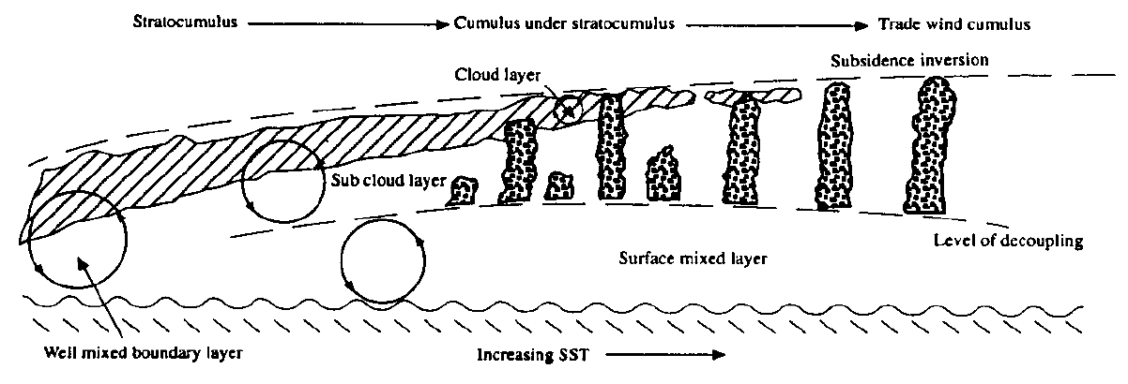
Figure 3. Schematic illustrating the transition from stratocumulus to trade-wind cumulus with increasing sea surface temperature (SST). From Albrecht et al. (1995, Bull. Am. Met. Soc., 76, 889-904).
→ Further reading: Garratt chapter 7, Stull chapter 13, Cotton and Anthes: Cloud Dynamics.

