2.3 The Nocturnal Boundary Layer (NBL)
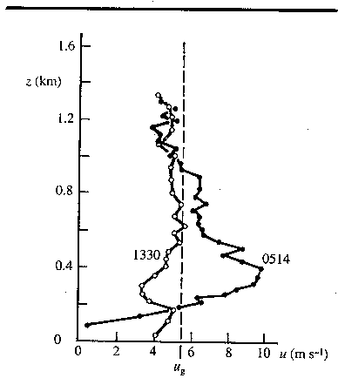Figure 1. Observed wind profile in the NBL showing the occurrence of the nocturnal jet (from Alan Thorpe’s PhD thesis).

1. Transition to Nocturnal Boundary Layer
After sunset, solar heating ceases and so too does the generation of convective plumes. Turbulence decays in around ½–1 hour (the lifetime of the largest eddies being around half an hour). The ground now cools by emission of infrared radiation, so in the surface energy balance equation:
$R_{n}−G=H+λE$, (1)

R_{n} is negative (proportional to –εσT⁴). The ground heat flux G is usually small and slow to respond (resulting in a decrease of ground temperature), and evaporation E is usually close to zero at night, so the sensible heat flux H is typically negative to balance R_{n}, i.e. air near the surface loses heat to the ground. This leads to the formation of the Nocturnal Boundary Layer (NBL), or nocturnal inversion, where temperatures increase with height. Note that the air also emits infrared radiation leading to a further 1-2 K cooling per night.
- What synoptic conditions maximise this effect?

→ Sketch 1: Typical profiles of potential temperature in the convective and nocturnal boundary layers.

2. Nature of the Nocturnal Boundary Layer
The increase of θ with height in the NBL means that it is stable, i.e. a lifted parcel will find itself colder than its surroundings and tend to return to its initial position. The stable stratification in the NBL therefore suppresses turbulence and vertical mixing, with the timescale for mixing throughout the depth of the NBL being typically between 6 and 30 hours. This has several consequences:
- Cool air near the surface remains near the surface, so the NBL remains thin (typically 100-200 m by the end of the night). It therefore does not reach up to the top of the daytime boundary layer, and a well-mixed residual layer remains, disconnected from the surface. However, the absence of large rising plumes after nightfall means that the strong daytime capping inversion is gradually eroded.
- High momentum air from aloft is not mixed right down to low levels so surface winds at night are often much lower than during the day. The reduced turbulence means that surface winds also tend to be less gusty.
- What implications does the stable stratification have for pollution dispersion in the boundary layer?

Turbulence is not completely absent from the NBL due to the additional effect of wind shear, but it does tend to be patchy and sporadic. This can be understood by considering the Gradient Richardson Number:
$\text{Ri}=\frac{\frac{g}{\bar{θ}}\frac{d\bar{θ}}{\text{dz}}}{{\left(\frac{d\bar{u}}{\text{dz}}\right)}^{2}}$, (2)
(where the mean wind is aligned in the x direction).
- Surface cooling leads to increasingly stable stratification (i.e. large $d{\bar{θ}}/{\text{dz}}$), which causes Ri to increase above 1 and the flow becomes laminar (i.e. non turbulent).
- Low turbulence leads to low vertical mixing, so wind shear ( $d{\bar{u}}/{\text{dz}}$) builds up and Ri decreases.
- When Ri falls below 0.25, turbulence is triggered (first by the formation of Kelvin-Helmholtz waves).
- The associated mixing reduces the gradient in both wind and potential temperature, but because Ri is related to the square of the wind shear, Ri increases and the flow becomes laminar again.
This is far from a regular cycle, but explains the intermittent nature of turbulence in the NBL. The situation is made more complicated by the presence of gravity waves, the shear associated with drainage currents and the flow around obstacles such as trees and buildings.
We now consider how the wind profile evolves in the nocturnal boundary layer.

3. The Nocturnal Jet
→ Sketch 2: Formation of the Nocturnal Jet.

As shown in Figure 1, a low level jet is often observed in the nocturnal boundary layer, where the wind speed has a maximum 100-300 m above the ground and can be greater than the geostrophic wind speed. The main cause of a supergeostrophic jet is inertial oscillations. As in the Ekman model, we consider the equations governing the momentum of air in the boundary layer, when for simplicity the geostrophic wind is aligned in the x direction
$\frac{∂\bar{u}}{∂t}=f\bar{v}−\frac{∂\overline{u'w'}}{∂z}$; $\frac{∂\bar{v}}{∂t}=−f(\bar{u}−u_{g})−\frac{∂\overline{v'w'}}{∂z}$. (3)
Note that we have made the assumption that the wind changes very slowly in the horizontal, and hence that the advection terms can be neglected. During the day, turbulent fluxes are large, and the wind will reach a steady state (i.e. no acceleration of the wind):
${\bar{u}}_{\text{day}}=u_{g}−\frac{1}{f}\frac{∂\overline{v'w'}}{∂z}$; ${\bar{v}}_{\text{day}}=\frac{1}{f}\frac{∂\overline{u'w'}}{∂z}$. (4)
Thus turbulent mixing (i.e. friction) is responsible for the departure of the winds from geostrophic. This departure is largest near the ground, and may be predicted reasonably well using the Ekman model. Once night falls, turbulent mixing is effectively switched off, except near the surface. Now the winds are not in equilibrium and the acceleration terms must be reintroduced:
$\frac{∂\bar{u}}{∂t}=f\bar{v}$; (5)
$\frac{∂\bar{v}}{∂t}=f(u_{g}−\bar{u})$, (6)
with the initial conditions on $\bar{u}$ and $\bar{v}$ given in (4). If we differentiate (5) with respect to time and substitute the resulting expression for $∂{\bar{v}}/∂t$ into (6) we obtain
$\frac{∂^{2}\bar{u}}{∂t^{2}}=−f^{2}\left(\bar{u}−u_{g}\right)$, (7)
which is essentially the equation of simple harmonic motion and, when the initial conditions are taken into account, has the solution
${\bar{u}}_{\text{night}}=u_{g}+{\bar{v}}_{\text{day}}\text{sin}(\text{ft})+\left({\bar{u}}_{\text{day}}−u_{g}\right)\text{cos}\left(\text{ft}\right)$. (8)
Similarly
${\bar{v}}_{\text{night}}={\bar{v}}_{\text{day}}\text{cos}(\text{ft})−\left({\bar{u}}_{\text{day}}−u_{g}\right)\text{sin}\left(\text{ft}\right)$. (9)
Thus the ageostrophic component of the wind rotates in a clockwise direction about the geostrophic wind with a period T given by
$T=2π/f$. (10)
The amplitude of this oscillation is proportional to the departure of the winds from geostrophic during the previous day. The low level wind is supergeostrophic for a significant part of the night when this oscillation leads to $\bar{u}>u_{g}$: this is called the nocturnal jet. See Figure 2 for a 3D plot of (8) and (9).
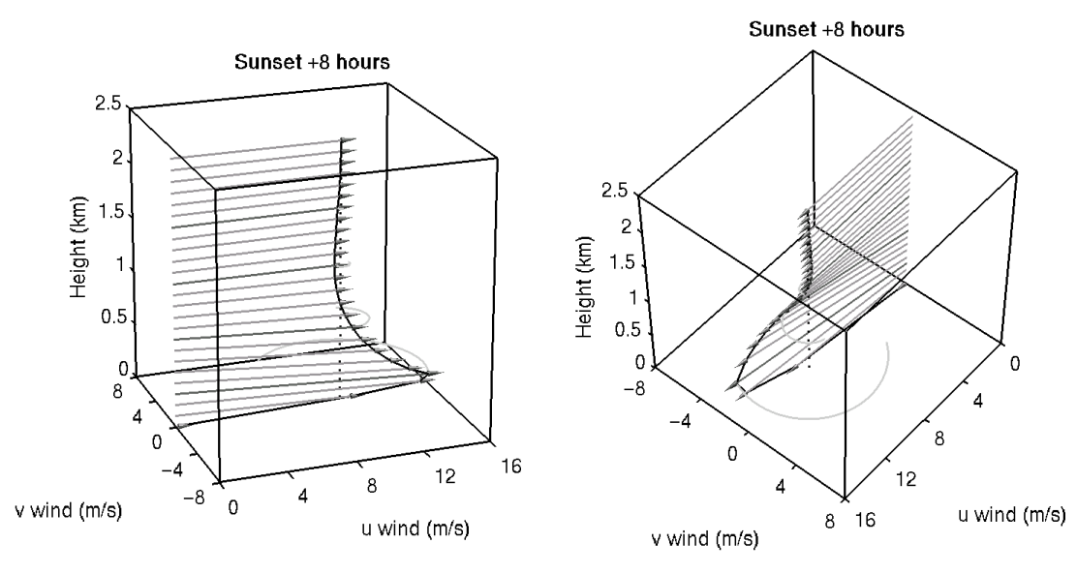
Figure 2. Visualization of the nocturnal jet. This is the predicted evolution of the wind profile shown in Fig. 2 of the previous lecture’s notes, but 8 hours after sunset. Friction has been retained in the lowest 300 m.

- Why is the nocturnal jet not observed near the ground or in the free troposphere?

→ Further reading: Garratt p175-178, Stull p520-526.
→ See also the Nocturnal Jet animation at http://www.met.rdg.ac.uk/courses/MTMG49.
→ Revision tip: You do not need to memorise the mathematical solution given by (8) and (9).

