2.2 Neutral Boundary Layers
The boundary layer will tend to be near neutral if there is little heating or cooling at the surface – this leads to θ approximately constant with height. More precisely we regard a boundary layer as neutral if shear production of turbulent kinetic energy is much larger than buoyant production.
- What synoptic conditions maximise this effect?

1. Wind profile in the neutral boundary layer: The Ekman Wind Spiral
An important factor in the atmospheric boundary layer is that winds are turbulent. This acts as a frictional force in the momentum balance that affects the wind profile. In neutral conditions the problem is simpler to deal with, as we don’t need to consider the thermodynamic effects on the turbulence and friction. With suitable assumptions, the wind profile can be estimated through the entire boundary layer analytically. It is rare that this is possible with the equations of motion because of their non-linearity.
→ Sketch 1: How the forces on an air parcel affect the wind profile in the neutral boundary layer.

In 1905, Walfrid Ekman derived an expression for the velocity profile in a neutral boundary layer. In the boundary layer the equations governing the horizontally averaged wind can be written as
$\frac{D\bar{u}}{\text{Dt}}=f\bar{v}−\frac{1}{ρ}\frac{∂\bar{p}}{∂x}−\frac{∂\overline{u'w'}}{∂z}$ $\frac{D\bar{v}}{\text{Dt}}=−f\bar{u}−\frac{1}{ρ}\frac{∂\bar{p}}{∂y}−\frac{∂\overline{v'w'}}{∂z}$.
- Ekman then made the following assumptions:
The result was the following coupled second-order differential equations:
$f\bar{v}\text{=-}K_{m}\frac{¶^{2}\bar{u}}{¶ z^{2}}$ $f\left(\bar{u}−u_{g}\right)=K_{m}\frac{¶^{2}\bar{v}}{¶ z^{2}}$.
These equations are solved by writing the velocity as a complex number and solving the resulting constant-coefficient second order differential equation. The appropriate boundary conditions are
$$z=0\text{ \{}\bar{u}=\bar{v}=0$$
$$z→¥\text{ \{}\bar{u}→u_{g},\text{ \{}\bar{v}→0$$
The solutions of this system of equations are
$\begin{aligned}\left.\bar{u}=u_{g}\left[1−\text{exp}(−\text{az})\text{cos}\left(\text{az}\right)\right] | \right\}\end{aligned}\text{ where }a=\sqrt{\frac{f}{2K_{m}}}$.
The resulting wind profile is a spiral, called the Ekman spiral: see figures 1 and 2.
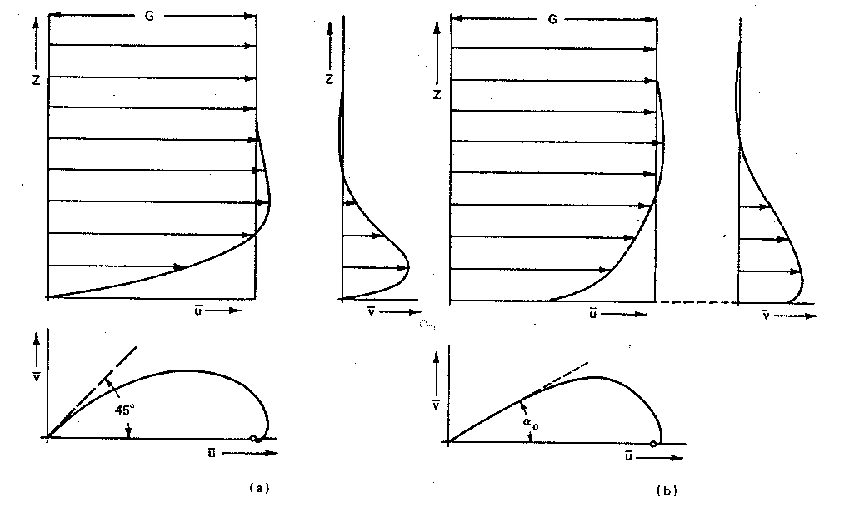
Figure 1. (a) The Ekman spiral in laminar flow, exact solution; (b) Typical example of the Ekman spiral in turbulent flow (from Prandtl 1965). Note that initially (in the surface layer) the wind speed increases markedly with altitude, but the direction of the wind doesn’t change much. Thus the assumption in Monin-Obukhov theory that rotation is unimportant in the surface layer appears to be reasonable. In the mixed layer, the wind speed increases only slowly with height, but most of the change in direction occurs here.
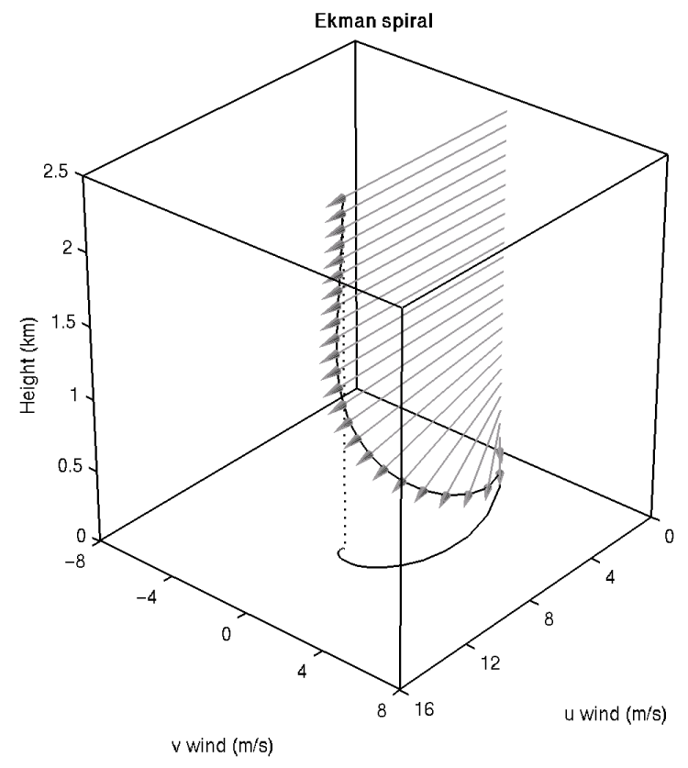
Figure 2. Visualization of the Ekman spiral for:
- Geostrophic wind = 10 m s⁻¹ in the x-direction. In the northern hemisphere this would correspond to low pressure to the north and high pressure to the south.
- Eddy diffusivity for momentum K_{m} = 10 m² s⁻¹.
- Coriolis parameter f = 10⁻⁴ s⁻¹.
- Ekman layer depth $h_{E}=π\sqrt{2{K_{m}}/f}$=1400 m.
Using L’Hopital’s rule, it is possible show that near the ground the wind is backed by 45° to the geostrophic wind. The top of the Ekman boundary layer is defined as the point where $\bar{v}$ is zero, i.e. when the spiral crosses the u axis. This occurs when sin(az)=0, i.e. when az=π or
$h_{E}=p\sqrt{\frac{2K_{m}}{f}}$.
If an Ekman boundary layer is observed to be around h_{E} = 1400 m deep, then for f=10⁻⁴ s⁻¹ this implies that K_{m} is around 10 m² s⁻¹.
- What does comparison of this value with the molecular viscosity of air say about the mechanism for the friction?

2. Comparison of the predictions of the Ekman model with observations
  - Addition of friction gives rise to a wind component towards low pressure. This is observed in neutral and unstable (convective) conditions, although the strong mixing in convective boundary layers below the capping inversion and the very low mixing above tends to produce a more constant wind profile than shown in Fig. 1, but which changes abruptly to the geostrophic value at the capping inversion. This behaviour is exhibited in Practical 2 “Evolution of the atmospheric boundary layer”.
  - Nearly linear wind profile near the surface. This is observed and agrees with Monin-Obukhov theory.
  - Supergeostrophic ($\bar{u}>u_{g}$) and cross-isobaric ($\bar{v}<0$) components at the top of the Ekman layer. Both have been observed in the real atmosphere.
  - The wind is 45° from geostrophic at the surface, independent of the magnitude of $u_{g}$, f or K_{m}. Observations tend to show a smaller angle at the surface (15-20°) and a faster near-surface wind speed than predicted.
- What causes this difference? What could we do to improve the model?

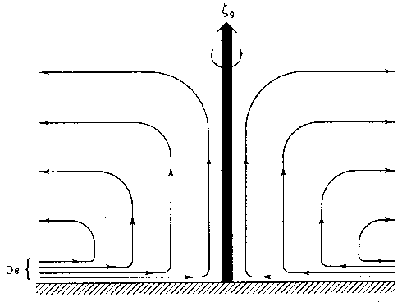
Figure 3. Streamlines of the secondary circulation forced by frictional convergence in the planetary boundary layer for a cyclonic vortex in a barotropic atmosphere. This is known as “Ekman pumping” and is responsible for the “spin down” of weather systems.

3. Ekman pumping (non-examinable)
The main prediction of the Ekman model is that air flows across the isobars in the direction from high to low pressure. By continuity, if air flows into a low-pressure region there must be compensating ascent (of the order of 1 or 2 cm s⁻¹), which is responsible for the formation of cloud and precipitation in cyclones. Similarly, air descends in an anticyclone and diverges in the boundary layer. These secondary circulations are known as Ekman pumping. The secondary circulation in a low pressure is shown below, where convergence occurs in the Ekman boundary layer and ascent and divergence occur throughout the rest of the troposphere. Air spiralling in to the centre of the low is slowed by friction. As this boundary layer air with a low angular momentum ascends and replaces the higher angular momentum air aloft the weather system “spins down” and decays. The timescale for this decay is around 4 days, and the transport of heat and momentum by deep convection also contributes to the decay of the cyclone. Molecular viscosity alone would take around 100 days to spin down a cyclone. Ekman pumping is also an important process in the ocean. The Ekman solution provides a reasonable qualitative description of boundary layer flows under neutral and unstable conditions.

→ Further reading: Stull p210-214, Holton p129-139.
→ Revision tip: You should know the assumptions made in the Ekman model but need not memorise the solution.

