2.1 The Convective Boundary Layer (CBL)
Solar heating during the day leads to sensible heat flux at the surface. This drives convection, which warms up and deepens the convective boundary layer.

1. Vertical structure of the CBL
The convective boundary layer can be divided into three regions:
- Surface layer: This layer is superadiabatic, i.e. $\bar{θ}$ decreases rapidly with height. Monin-Obukhov scaling applies, with both shear and buoyancy generating turbulence.
- Mixed-layer: Buoyancy dominates, with convective overturning and lots of turbulent mixing. This leads to $\bar{θ}$and most other variables approximately constant with height. Monin-Obukhov theory no longer applies because the friction velocity (a surface parameter) becomes unimportant in determining the nature of the turbulence. Strictly this occurs above a height of around |L|.
- Capping inversion: a large increase in $\bar{θ}$ marks the top of the CBL. Air from the free troposphere is entrained into the boundary layer.
→ Sketch 1: Vertical structure of the CBL.

Note that the fact that $\bar{θ}$ is constant with height in the mixed-layer does not mean that the layer is “neutrally stable”, because the layer beneath it still has a higher $\bar{θ}$. Hence buoyant parcels are rising through the mixed-layer and the whole boundary layer is “convectively unstable”. See Stull p169-171.

2. Turbulent structures in the CBL
Thermals originate in the surface layer due to surface inhomogeneities such as hills, or regions with a low surface albedo and high temperature: hotspots. In the mixed layer, these plumes can have a horizontal diameter of the same order as the depth of the boundary layer (around a kilometre). The updrafts in plumes depends on buoyancy production of turbulence (g/θ)(H/ρC_{p}) in m² s⁻³, and the depth of the boundary layer h in metres, so the convective velocity scale is given, on dimensional grounds, by

$w_{}=$

- What is the typical vertical velocity due to convection in the CBL?

- What is the typical mixing time?

Air rises in strong updrafts, which are surrounded by broader regions of gentle downdrafts, so the turbulent mixing is anisotropic (i.e. it isn’t the same in each direction) and it is non local – mixing isn’t determined by the Richardson number at a particular point in the atmosphere, because the plumes start at the surface and rise throughout the whole depth of the CBL.
The asymmetry between strong thermals and weak subsidence over a larger area has implications for pollutant dispersion. If a pollutant is emitted from a chimney near the ground it will gradually disperse upwards. If, however, the source is elevated, the bulk of the release will descend slowly, while a small fraction of the release will rise rapidly to the top of the boundary layer, causing the location of the maximum concentration to descend as you move downwind from the source. Contrast this behaviour with the simplified Gaussian plume model in experiment 3.
The growth of the boundary layer is due to two distinct mechanisms, encroachment and entrainment. We now consider them in turn.

3. Growth by encroachment
Encroachment is the simplest possible model of the growth of the CBL. It is a purely thermodynamic process and results from the warming of boundary layer air by continued input from the ground. We start by defining W as the total sensible heat provided to the atmosphere so far in a day:
$W=\int_{t_{0}}^{t_{1}}{\text{Hdt}}$, (J m⁻²)
where t₀ denotes sunrise and t₁ is the current time. We then make three assumptions:
- Assumption 1:

- Assumption 2:

- Assumption 3:

→ Sketch 2: Diagrammatic description of encroachment.
- By geometry we can derive an expression for the height of the CBL:

4. Growth by entrainment and Carson’s model
Encroachment is not the whole story – consider what happens to individual convective plumes:
- As they rise through they gain momentum.
- When they have the same potential temperature they are neutrally buoyant; in the encroachment-only model they would stop immediately.
- However, because of their upward momentum they continue to rise, overshooting their level of neutral buoyancy; this is known as penetrative convection.
- The boundary layer top can be visualised as a series of domes at the top of the rising thermals. The interface with the much warmer free troposphere air above is very sharp, possibly as thin as 10 m, but averaged over many thermals it is around 100 m thick.
- As the air sinks back into the mixed layer, it carries some with it some warmer air from the free troposphere. This is known as entrainment. The volume of air entrained per unit area, per unit time, is called the entrainment velocity w_{e}, and typically varies between 1 and 20 cm s⁻¹. This constitutes a sensible heat flux into the ABL, known as the entrainment heat flux. As it is heat input from above, it is negative.
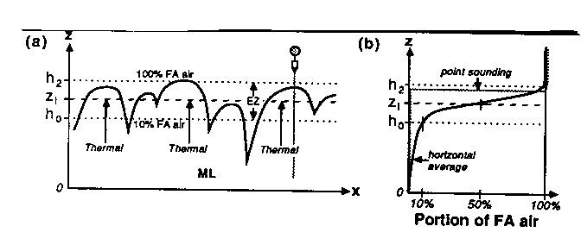
Figure1. Schematic of the buoyant plumes that rise through the mixed layer (ML) and entrain warmer air from the free atmosphere (FA). From Stull.

Wind speeds tend to be greater in the free atmosphere than in the boundary layer, which has several effects. First, airflow over the dome-like thermal is analogous to flow over a hill, and can be a source of gravity waves in the stably stratified free atmosphere. Also, the wind shear across the top of the thermal can cause Kelvin-Helmholtz billows to be generated, mixing air across the interface. However, it is thought that very little boundary layer air escapes into the free atmosphere in these overshooting plumes, an important consideration for the dispersion of pollutants emitted within the boundary layer.
How can we represent the effect of entrainment on the rate of growth of the boundary layer? Carson (1973) made one further assumption.
- Assumption 4:

→ Sketch 2: The thermodynamic profile assumed in Carson’s model.
→ Sketch 3: The sensible heat flux profile in the convective boundary layer.
Together with the previous three assumptions, and after some mathematical manipulation, the encroachment-only expression can be modified to include the effect of entrainment:
$h=\sqrt{\frac{2(1+2E)W}{{ρC}_{p}γ}}$.
This is known as Carson’s model for the growth of the convective boundary layer. It is a factor of $\sqrt{1+2E}$ larger than the entrainment-only model, i.e. 20-25%. It can be seen that the nature of the surface plays a crucial role in determining the height of the boundary layer above it: h is dependent on sensible heat flux, which in turn depends on the partitioning with latent heat flux according to surface water availability, as described by the Bowen ratio.
- How does this model compare to reality?

→ Further reading: Stull p441-446, Garratt p145-164.

