1.4 The dynamics of turbulence and the Richardson Number
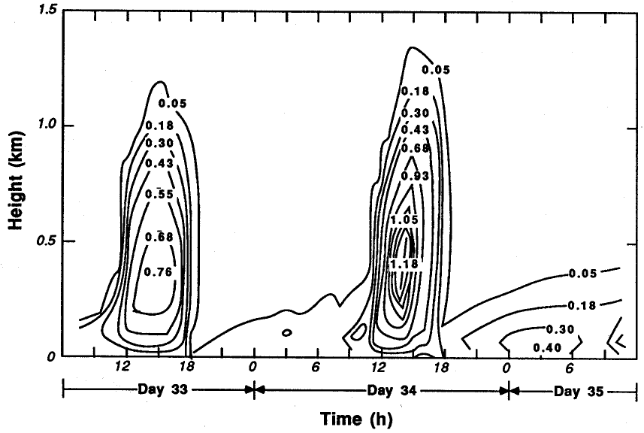
A key question is how turbulent mixing is affected by the stability of the atmosphere. On a sunny day the surface is heated and the boundary layer becomes unstable, promoting convective plumes and turbulent mixing. On a clear night the surface is cooled and the boundary layer becomes stable, suppressing vertical movement of air parcels (up or down). This will obviously affect turbulent fluxes (e.g. via eddy diffusivities) but how? We need to quantify what encourages turbulence and what suppresses it.

1. Turbulent kinetic energy
We consider the turbulent kinetic energy (TKE) per unit mass, e, defined as
$e=\frac{1}{2}\left(\overline{u'^{2}}+\overline{v'^{2}}+\overline{w'^{2}}\right)$ m² s⁻² or J kg⁻¹
This represents the kinetic energy in turbulent motions. Using Reynolds averaging leads to an equation for the rate of change of e with time:
$\frac{∂e}{∂t}=$ shear production + buoyancy production + transport – dissipation ε,
where for mean wind in the x direction:
- Shear production $=−\overline{u^{'}w^{'}}\frac{∂\bar{u}}{∂z}$
Figure 1. Diurnal evolution of turbulent kinetic energy per unit mass, e (m² s⁻²), simulated for the Wangara experiment. From Yamada and Mellor (1975).
- Buoyancy production $=\frac{g}{\bar{θ}}\overline{w^{'}θ^{'}}=\frac{g}{\bar{θ}}\frac{H}{{ρC}_{p}}$
“Transport” includes advection and turbulent fluxes but its exact form is not relevant here.

2. Richardson number
From the TKE equation, we can see that whether turbulence grows or decays depends on the relative magnitude of the shear and buoyancy terms. A very useful quantity is the Richardson Number:
- Flux Richardson Number $R_{f}=\frac{\frac{g}{\bar{θ}}\overline{w^{'}θ^{'}}}{\overline{u^{'}w^{'}}\frac{∂\bar{u}}{∂z}}$=
Hence we can write the TKE equation as
$\frac{∂e}{∂t}=$ shear production$(1−R_{f})−ε$,
A more common form is derived by applying first order closure:
$\overline{u'θ '}=−K_{h}\frac{∂\bar{θ}}{∂z}$ $\overline{u'w'}=−K_{m}\frac{∂\bar{u}}{∂z}$,
which leads to
- Gradient Richardson Number $R_{i}=\frac{\frac{g}{\bar{θ}}\frac{∂\bar{θ}}{∂z}}{{\left(\frac{∂\bar{u}}{∂z}\right)}^{2}}=\frac{K_{m}}{K_{h}}R_{f}=$
If this is applied over a finite layer it is referred to as Bulk Richardson Number, and if the mean wind is coming from any direction (rather than just the x direction) it is given by
- Bulk Richardson Number $R_{i}=\frac{\frac{g}{\bar{θ}}\frac{Δ\bar{θ}}{Δz}}{{\left(\frac{Δ\bar{u}}{Δz}\right)}^{2}+{\left(\frac{Δ\bar{v}}{Δz}\right)}^{2}}$.
The Richardson Number is useful because we can diagnose the onset of turbulence in statically stable but sheared flow. Clearly we have convective instability for R_{i} < 0, but theoretical and experimental studies show
- Non-turbulent flow becomes turbulent when R_{i} drops below the critical value R_{ic} of around 0.25.
- Turbulent flow becomes non-turbulent when R_{i} becomes larger than around 1.
Hence there is a hysteresis. When R_{i} drops below 0.25, the first appearance of turbulence is in the form of Kelvin-Helmholtz waves.

3. The dissipation term
The dissipation term in the TKE equation, ε (Greek letter “epsilon”), represents the fact that over time turbulent energy is dissipated into heat. This process arises due to the non-linear nature of the equations of motion and involves a cascade of energy to smaller scales: large eddies continually break up into smaller ones until all energy is in the form of molecular motions only, i.e. heat. The amount of heat produced is so small that it is rarely included as a source term in the thermodynamic equation. Richardson described this effect in a rhyme:
Big whorls have little whorls
That feed on their velocity,
And little whorls have lesser whorls
And so on to viscosity.
This will be described in much more detail in lecture 2.5.

→ Further reading: Stull p151-165.
→ More on Kelvin-Helmholtz instability: http://www-sccm.stanford.edu/Students/witting/kh.html
http://www.enseeiht.fr/hmf/travaux/CD0001/travaux/optmfn/hi/01pa/hyb72/kh/kh_theo.htm

