

Journal of Geophysical Research Atmosphere

Supporting Information for

Combining satellite observations and reanalysis energy transports to estimate global net surface energy fluxes 1985-2012

Chunlei Liu¹, Richard P. Allan^{1,2,3}, Paul Berrisford^{3,4}, Michael Mayer⁵, Patrick Hyder⁶, Norman Loeb⁷, Doug Smith⁶, Pier-Luigi Vidale^{1,3} and John M. Edwards⁶
¹ Department of Meteorology, University of Reading, Reading, UK
² National Centre for Earth Observation, UK
³ National Centre for Atmospheric Science, UK
⁴ ECMWF, Shinfield Park, Reading, UK
⁵ Department of Meteorology and Geophysics, University of Vienna, Austria.
⁶ Met Office, Exeter, UK
⁷ NASA Langley Research Centre, Hampton, Virginia, USA

Contents of this file

Tables S1 to S2

Figures S1 to S4

Table S1. Area mean change of net surface energy fluxes
(W/m², 2001-2008 minus 1986-2000)

 | Ocean + Land | Ocean | Land
$$F_{mass}$$ | 0.19 | 0.27 | 0.0
ERAINT | -1.00 | -1.3 | -0.21
ERA20C | 0.22 | 0.30 | 0.03
UPSCALE | 0.38 | 0.51 | 0.06
AMIP5 | 0.29 | 0.38 | 0.08

Table S2. Correlation coefficients (r) between different data sets over the global, (the global ocean) and [the global land]. Significant correlation coefficients (r) based on the two-tailed test using Pearson critical values at the level of 5% are marked in bold.

 | ERAINT | ERA20C | UPSCALE | AMIP5
$$F_{mass}$$ | -0.01  ( 0.02 )  [ 0.49 ] | 0.52  ( 0.52 )  [ 0.60 ] | 0.47  ( 0.45 )  [ 0.05 ] | 0.38  ( 0.33 )  [ 0.07 ]
$$ERAINT$$ |  | 0.33  ( 0.35 )  [ 0.56 ] | -0.25  ( -0.23 )  [ 0.00 ] | -0.11  ( -0.08 )  [ 0.13 ]
$$ERA20C$$ |  |  | 0.29  ( 0.29 )  [ 0.06 ] | 0.31  ( 0.28 )  [ 0.14 ]
UPSCALE |  |  |  | 0.60  ( 0.52 )  [ 0.19 ]

Fig. S1. Net land surface area mean energy flux anomaly time series from five UPSCALE models and reconstructions using relations between net fluxes and temperature changes at surface. r is the correlation coefficient from monthly anomaly time series and red values are the standard deviation ratio between reconstructed and modeled monthly flux anomalies. All lines are six month running means.

Fig. S2. Multi-annual (2001-2005) mean net downward energy fluxes (in W/m²) at surface from $F_{res},$ ERAINT, ERA20C, $F_{mass−MERRA},$ UPSCALE and AMIP5.

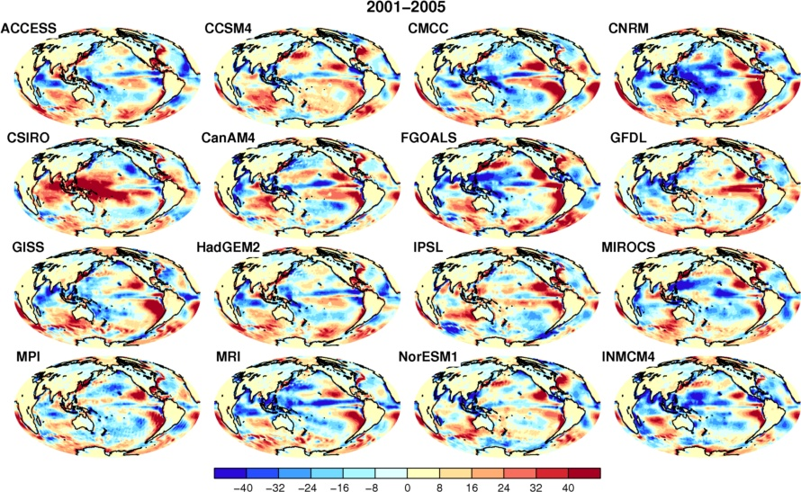

Fig. S3. Multi-annual mean (2001-2005) net surface energy flux (in W/m²) differences between AMIP5 member and $F_{mass}$. Names of AMIP5 models are at the up-left corner.

Fig. S4. Correlation coefficient of net downward energy flux anomaly time series (reference period 2001-2005) between $F_{mass}$ and (a) ERA20C, (b) 20thCR, (c) AMIP5 and (d) UPSCALE data sets.

