**Climate Change Worksheet**

Energy Budget

For any balanced budget, what comes in must equal what goes out. In the case of planets orbiting the Sun, this means that the absorbed fraction of the incoming solar radiation must equal the outgoing emitted radiation. Otherwise, the planet will either get hotter or cooler. Balancing the global energy budget is a fundamental aspect of the climate system.

Consider a beam of sunlight hitting the Earth at the equator as shown in [Figure 1](http://www.met.reading.ac.uk/~sgs02rpa/CONTED/cl-intro.html#fig1). The beam is approximately at right angles to the Earth's surface, so the amount of Earth it is spread over (area **a**), is the same as the width of the beam. Closer to the poles, a beam of the same width covers a much bigger amount of the Earth (area **b**), because it arrives at a different angle to the Earth's surface. This means that the surface of the Earth receives more energy in the tropics per unit area than it does at the poles. In a similar way, at midday, when the sun is highest in the sky, a sunbeam of a certain width illuminates an area smaller than the same sunbeam would illuminate at dawn or dusk, when the sun is lower in the sky. The sun therefore feels hottest at midday.

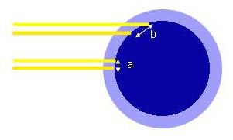 ***Figure 1.****Solar radiation arrives at a different angle to the Earth's surface at the poles than at the equator. In consequence, the area that the beam covers is smallest at the equator and gets larger towards the poles (area b is bigger than area a), so the Earth receives more heat per unit area at the equator than it does at the poles.*

Some of the incoming solar radiation (which is mainly ultraviolet, visible light and short wavelength infrared) is reflected or scattered directly back into space by the atmosphere and some is absorbed by the Earth and the atmosphere (see yellow arrows in [Figure 2](http://www.met.reading.ac.uk/~sgs02rpa/CONTED/cl-intro.html#fig2)). Once the radiation is absorbed, the Earth's surface (and atmosphere) re-emits this energy at a longer wavelength in the form of thermal (or infra-red) radiation.

[Figure 3](http://www.met.reading.ac.uk/~sgs02rpa/CONTED/cl-intro.html#fig3) shows how the distribution of incoming solar (shortwave) and outgoing (longwave) terrestrial radiation varies with latitude (a measure of distance from the equator). The tropics are net absorbers of energy as the amount of absorbed solar energy is greater than the amount of outgoing longwave radiation. Conversely, the poles are constantly losing heat. This should mean that the tropics are constantly heating up and the poles cooling down, but they're not. The Earth must therefore continuously pump heat from the tropics to the poles: it is a heat engine. The [circulation of the Earth's atmosphere](http://www.met.reading.ac.uk/~sgs02rpa/CONTED/cl-intro.html#atm_cir) and oceans is the dominant pumping mechanism. They carry approximately equal amounts of energy from the equator to the poles.

[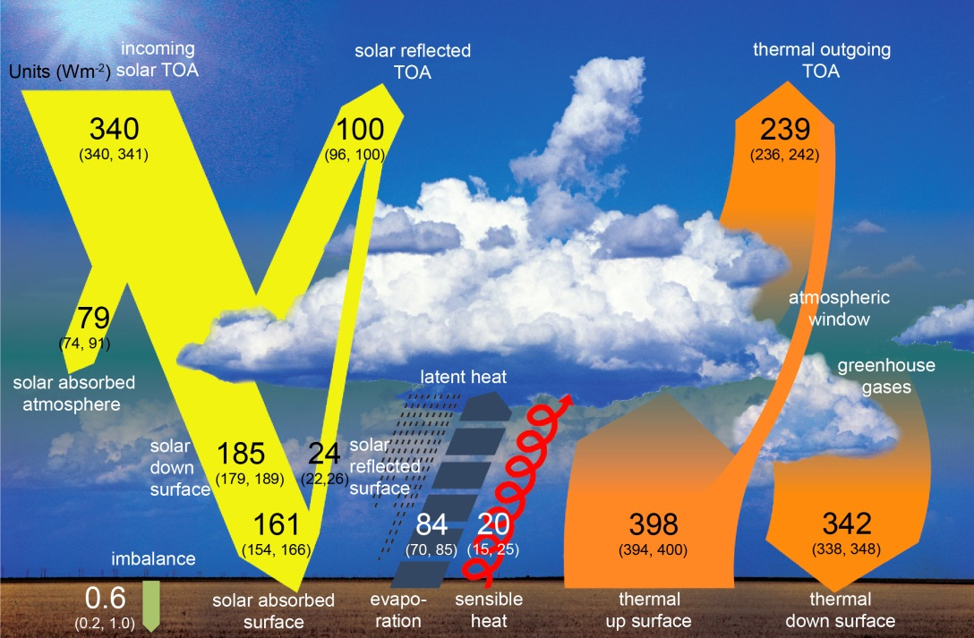](http://www.climatechange2013.org/images/figures/WGI_AR5_Fig2-11.jpg)

***Figure 2.****The Earth's global annual energy budget. The numbers are all in W/m2 (Watts per square metre), a measure of energy flux. Of the incoming radiation, 47% (161 divided by 340) is absorbed by the Earth's surface. That heat is returned to the atmosphere in a variety of forms (evaporation processes and thermal radiation, for example). Most of this upward flow of heat is absorbed by the atmosphere, which then re-emits it as thermal infra-red (longwave) radiation both up and down. Some is lost to space, and some stays in the Earth's climate system. The efficiency at which Earth can cool to space through thermal infra-red (long wavelength) radiation is determined by*[*the Greenhouse Effect*](http://www.met.reading.ac.uk/~sgs02rpa/CONTED/cl-intro.html#gnh_eff)*. The imbalance between absorbed sunlight and outgoing thermal radiation determines whether the planet heats up of cools down. The latest observations indicate an accumulation of heat by the Earth (primarily within the oceans) of 0.6 Wm-2. This may appear small but is currently what is driving global climate change. [Figure from IPCC 2013].*

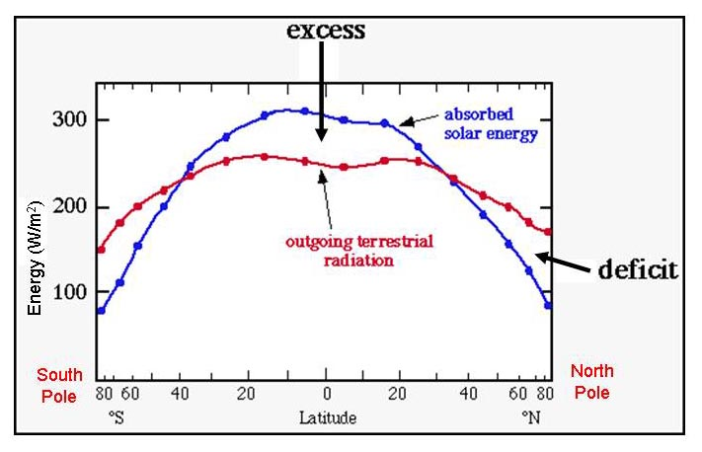***Figure 3.****Shortwave radiation (from the Sun) and longwave radiation (heat emitted by the Earth and its atmosphere) vary with latitude. The difference between the two shows that the Earth is a net absorber of energy (i.e. absorbed energy > outgoing energy) in the tropics, and a net emitter (outgoing energy > absorbed energy) in the polar regions. This is a plot of****zonal mean****radiation; that is, it shows how the radiation varies with latitude but not longitude. If you imagine a circle around the globe at each latitude, the radiation has been averaged around the circle, because in this case the variation with longitude is less interesting than the variation with latitude.*

Global Atmospheric Circulation

The circulation of the atmosphere is responsible for about 50% of the transport of energy from the tropics to the poles. The basic mechanism is very simple: hot air rises in the tropics (*convection*), reducing the pressure at the surface and increasing it higher up. This forces the air to spread away polewards at high levels, and to be drawn in at low levels. As the warm, polewards moving air comes into regions with less incoming solar radiation, it cools and sinks, thus completing the circulation.

If the Earth were not rotating, we would see this very simple pattern: hot air would rise in the tropics, move away from the equator, gradually cool, sink at high latitudes near the poles, and finally re-circulate near the surface towards the equator (see [Figure 4](http://www.met.reading.ac.uk/~sgs02rpa/CONTED/cl-intro.html#fig4)). However, the Earth's rotation and the distribution of mountains and oceans complicates matters and the atmospheric circulation is closer to that depicted in [Figure 5](http://www.met.reading.ac.uk/~sgs02rpa/CONTED/cl-intro.html#fig5).

On an non-rotating planet, air rises at the Equator, flows Polewards, sinks at the Poles,
    and flows back to the Equator ***Figure 4.****If the Earth were not rotating tropical air would rise, travel towards the pole, cool and sink before returning to the equator. The dominant flow at all heights would be along lines of longitude.*

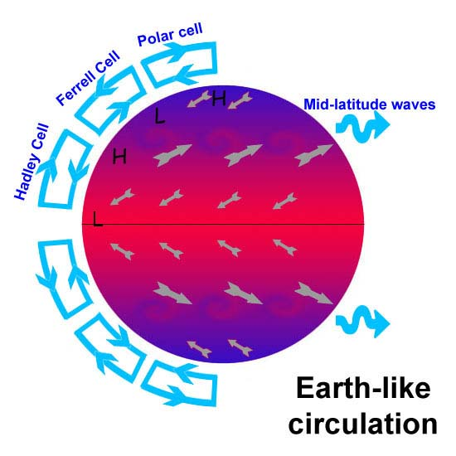***Figure 5.****Idealisation version of the Earth's atmospheric circulation. Air is heated and rises in the tropics, drifting north before sinking around 30o North and South in the Hadley Cell circulation. At the surface, air flow is easterly and is known as the trade winds. In the mid-latitudes (about 30oN-60oN) the circulation is dominated by large-scale wave activity and extra-tropical storms (the reason European weather is so unsettled!), which manifests itself as the Ferrell Cell. At high latitudes the simple, convection driven circulation returns and is called the Polar Cell. Regions of high and low surface pressure are marked ‘****H****’ and ‘****L****’, respectively.*

The Greenhouse Effect

In the nineteenth century various scientists (such as Joseph Fourier) explained that the atmosphere can, like an ordinary greenhouse, retain energy radiated into it from outside. The greenhouse analogy isn't very exact, but the name certainly stuck. In the 1860s John Tyndall explained that certain gases, including water vapour and carbon dioxide (CO2), don't affect visible light but absorb longer wavelength radiation (infrared). He suggested that these gases insulate the Earth.

The actual process works like this (see [Figure 2](http://www.met.reading.ac.uk/~sgs02rpa/CONTED/cl-intro.html#fig2)): visible incoming sunlight either gets reflected (for example by clouds or aerosol pollution), absorbed (for example by gaseous water vapour), or passes unhindered through the atmosphere, and gets absorbed by the surface of the Earth, thus heating it (a small fraction is reflected from the surface, particularly for bright surfaces such as fresh snow or deserts). The Earth radiates heat from the surface back into the atmosphere, where it can pass back into space, or, because it has now got a longer wavelength than before, it can get absorbed by the water vapour, carbon dioxide, methane and other greenhouse gases which are present in the atmosphere. As the water vapour/ methane/ carbon dioxide molecules absorb the longwave radiation, they heat up, and in turn re-radiate long wave radiation in all directions. Some is lost to space, but some of it also gets radiated back to the surface, again warming it.

This naturally occurring process helps keep the Earth warm enough for liquid water to exist. Without greenhouse gases, the average temperature at the Earth's surface would reach only -17oC, approximately 33oC colder than it actually is! Now, what if the concentrations of these insulating gases increase? We might expect the process described above to intensify. In fact, this is just what the Nobel Prize-winning Swedish chemist Svante Arrhenius did in 1896. By knowing how CO2 absorbs heat radiation from the surface of the Earth, he calculated what would happen if the amount of CO2 in the atmosphere were halved or doubled. He estimated that a doubling of CO2 would lead to an average global surface temperature increase of 2oC. This is consistent with modern predictions.

This approach, while still a handy first guess, considers the climate system in the absence of any **feedback processes** (although Arrhenius did consider the amplifying feedback effect from water vapour). Feedbacks are processes in which outputs from the process have an effect on the inputs to that same process. Sometimes feedback processes act to offset or inhibit a change (negative feedback), and sometimes they act to amplify a change (positive feedback). Examples of negative feedback include the maintenance of your body temperature: when you get too warm, you trigger various mechanisms (e.g. perspiration) to cool you down and vice versa. A common example of positive feedback is often associated with amplified music or speech, when the microphone is placed too close to a loudspeaker... someone speaks/ sings/ plays into the microphone, the noise is amplified, and comes out of the speaker. If some of this amplified noise goes back into the microphone, it gets amplified again etc. etc. and the end result is a deafening whine.

There are many examples of feedbacks in the climate system. If the atmosphere gets warmer, ice melts. Ice reflects a lot of incoming solar radiation, so if it melts, less gets reflected, more gets absorbed by the Earth and the atmosphere gets warmer; a positive feedback. On the other hand, if there is more carbon dioxide in the atmosphere, some plants grow faster, absorbing more carbon dioxide and eventually reducing its amount in the atmosphere; a negative feedback.

Because of the complexity of the climate system, due to the presence of feedbacks within it, we need to try to represent the whole system as thoroughly as possible in order to simulate the likely changes. We need to be able to understand how and where feedbacks act, and how large they are.

Carbon Dioxide and Climate Change

The climate of the Earth is constantly changing, in response to changes in the incoming solar radiation, the patterns of the continents, the amount of dust in the atmosphere, the chemical composition of the atmosphere and many other factors.

One of the factors which is thought to affect surface temperatures is the atmospheric concentration of carbon dioxide. Carbon dioxide is a ‘greenhouse gas’. This means that it does not reflect much incoming solar radiation, but it does strongly absorb outgoing, long wave, thermal radiation, re-emitting it back towards the surface and warming the atmosphere.

Atmospheric concentrations of carbon dioxide have been increasing in the past 200 years or so since the Industrial Revolution began. The source is mainly the burning of fossil fuels (coal, oil and gas) - for transport, industry, electricity or heat. The rest is due to land use change, such as deforestation. [Figure 6](http://www.met.reading.ac.uk/~sgs02rpa/CONTED/cl-intro.html#fig13) shows the atmospheric concentration of carbon dioxide in the past 800,000 years (data have come from ice cores, direct measurements in recent years etc., if you're interested in this, read ‘The two-mile time machine’ by Richard B. Alley) and various estimates of how carbon dioxide concentrations will behave over the coming decades, depending on how we react to legislation on carbon emissions.

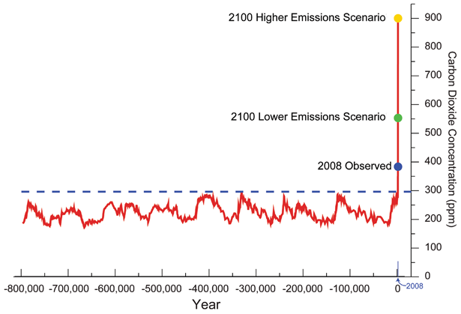***Figure 6.****The global atmospheric concentration of CO2 in parts per million (ppm) measured over the past 800,000 years from ice cores and instrumental records and estimated for 2100 using simulations. The dashed blue line shows "pre-industrial" concentrations of around 290ppm.*

[*Sources*](http://nca2009.globalchange.gov/references/footnote-2)*: [Luthi et al. (2008) Nature](http://www.nature.com/nature/journal/v453/n7193/full/nature06949.html);*[*Tans (2008)*](http://www.esrl.noaa.gov/gmd/ccgg/trends/)*;[IIASA 2008](http://www.iiasa.ac.at/web-apps/ggi/GgiDb/dsd?Action=htmlpage&page=series).*

Scientists are still uncertain exactly how the Earth-climate system will respond to such changes in carbon dioxide and other changes to the composition of the atmosphere. For example, how clouds respond to a warming is highly uncertain and it is not yet known whether they will amplify (positive feedback) or inhibit (negative feedback) the warming, or have little effect.

*For more details, see the Intergovernmental Panel on Climate Change assessment reports (*[*http://www.ipcc.ch/*](http://www.ipcc.ch/)*), the*[*climateprediction.net*](http://www.climateprediction.net/climate-science)*website, the Royal Society* [*https://royalsociety.org/policy/projects/climate-evidence-causes/*](https://royalsociety.org/policy/projects/climate-evidence-causes/)*and the UK Government site, "The Science of Climate Change" at:*[*http://www.dti.gov.uk/go-science/climatescience*](http://www.dti.gov.uk/go-science/climatescience)*.*

*This worksheet is based upon material from climateprediction.net*

***Questions***

*1) What would happen to Earth's temperature if the energy absorbed from the sun (solar radiation) was less than the emitted (thermal) energy leaving the Earth? (2)*

*2) Why is the tropical climate warmer than the climate at the north and south poles? (2)*

*3) In the tropics, the absorbed solar energy is greater than the emitted thermal radiation lost to space. The reverse is true at the poles. What stops the tropics getting hotter and hotter and the poles getting colder and colder? (2)*

*4) What factors influence the circulation of the Earth's atmosphere, thereby producing our weather? (3)*

*5) What are greenhouse gases? Give three examples (5)*

*6) What would the theoretical global average temperature be without the greenhouse effect? (2)*

*7) What effect does an increase in greenhouse gas concentration have on the energy budget of the Earth? (2)*

*8) Sea ice is highly reflective and causes less solar radiation to be absorbed compared to the darker ocean. Sea ice is likely to become less extensive as temperatures warm. Based on these considerations, will the effects of sea ice enhance warming or retard warming due to increased greenhouse gases? What is this process termed? (2)*

*9) List three factors that can cause climate to change. (3)*

*10) What is the pre-industrial concentration of carbon dioxide in parts per million (ppm)? What (approximately) is the current concentration? (2)*

*11) Why is the future climate response to increasing greenhouse gas concentrations uncertain? (3)*

*12) Will clouds enhance or diminish the warming due to future increases in greenhouse gases? (2)*

***Answers***

*1) What would happen to Earth's temperature if the energy absorbed from the sun (solar radiation) was less than the emitted (thermal) energy leaving the Earth? (2)*

*The Earth would cool down (1) until a new equilibrium was reached where absorbed solar energy equalled outgoing emitted energy (1)*

*2) Why is the tropical climate warmer than the climate at the north and south poles? (2)*

*The tropics receive a more direct beam of solar radiation and so absorbed solar radiation is larger over a year than at the poles (1). Additional factors are that ice at the poles reflects more sunlight than for ice-free regions and at lower sun angles, the solar beam travels through a greater atmospheric path with more absorption and scattering of sunlight. On the other hand, greater emission of longwave radiation to space in tropical regions and energy transport from the warm tropics to the cold poles reduces the temperature difference somewhat (any additional context, 1).*

*3) In the tropics, the absorbed solar energy is greater than the emitted thermal radiation lost to space. The reverse is true at the poles. What stops the tropics getting hotter and hotter and the poles getting colder and colder? (2)*

*Energy transport by the atmosphere (1) and oceans (1).*

*4) What factors influence the circulation of the Earth's atmosphere, thereby producing our weather? (3)*

*The distribution of land/ mountains and ocean (1), the rotation of the Earth (1) and the uneven heating of the Earth’s surface by sunlight (1). It is also acceptable to mention viscocity/composition of the atmosphere.*

*5) What are greenhouse gases? Give three examples (5)*

*Greenhouse gases absorb and emit longwave/thermal/infra-red radiation (1) and impede the loss of radiative energy emitted by the surface to space (1). Examples are water vapour, carbon dioxide, methane, nitrous oxide, CFCs/HCFCs; ozone is also acceptable (any 3).*

*6) What would the theoretical global average temperature be without the greenhouse effect? (2)*

*Around -18oC (-15 to -20oC is fine as is 255K) if all else is equal (2)*

*7) What effect does an increase in greenhouse gas concentration have on the energy budget of the Earth? (2)*

*It reduces the efficiency at which Earth can cool through emission of thermal radiation to space (1) by absorbing and re-emitting longwave/infra-red radiation (1).*

*8) Sea ice is highly reflective and causes less solar radiation to be absorbed compared to the darker ocean. Sea ice is likely to become less extensive as temperatures warm. Based on these considerations, will the effects of sea ice enhance warming or retard warming due to increased greenhouse gases? What is this process termed? (2)*

*Sea ice will increase the warming (1). It is termed a positive (amplifying or re-enforcing) feedback (1)*

*9) List three factors that can cause climate to change. (3)*

*Changes in the brightness of the sun, changes in Earth’s orbit around the sun, continental drift, evolution of Earth’s atmosphere over billions of years, volcanic eruptions, chaotic fluctuations of the ocean, human activity including land use change and emissions of greenhouse gases and aerosol pollution. (any 3)*

*10) What is the pre-industrial concentration of carbon dioxide in parts per million (ppm)? What (approximately) is the current concentration? (2)*

*290 ppmv (around 200-300 ppmv acceptable if considering glacial cycles) (1); 400 ppmv (1)*

*11) Why is the future climate response to increasing greenhouse gas concentrations uncertain? (3)*

*Emission of greenhouse gases are uncertain (socio-economic changes) (1); the sensitivity of climate to greenhouse gas concentrations are uncertain due to feedbacks, particularly cloud (2). Can also mention natural chaotic variability and hidden processes in the climate system.*

*12) Will clouds enhance or diminish the warming due to future increases in greenhouse gases? (2)*

Clouds both reflect sunlight and absorb thermal radiation and this depends upon cloud type and time of day (1) but we don’t know how clouds will respond to a warming climate (1).