Measurements for the CLARE 1998 campaign using the Chilbolton UV lidar

J. L. Agnew, A. J. Gibson and A. K. P. Marsh
Radio Communications Research Unit, CLRC Rutherford Appleton Laboratory
Chilton, Didcot, OX11 0QX, UK
Phone : +441235445770 Fax : +441235446140 Email: J.L.Agnew@rl.ac.uk

INTRODUCTION

The Chilbolton UV lidar was used during the CLARE campaign to make sensitive measurements of vertical cloud profiles above the Chilbolton site. Lidar and radar systems provide a remote sensing method for measuring a variety of atmospheric properties. The Chilbolton UV lidar system is designed to profile the temperature and humidity of the atmosphere and also detect the presence of clouds [1]. Cloud measurements represent a relatively straightforward operation for a lidar system such as this, as their presence is easily detected by elastic scattering of the laser radiation. These signals are several orders of magnitude stronger than the inelastically Raman scattered signals used to quantify other parameters such as temperature and humidity. The laser power used to achieve adequate returns for temperature and humidity measurements is high enough that cloud measurements can be made without the need for long signal integration times. At UV wavelengths the cross section for Rayleigh scattering is such that the elastically scattered returns from molecular species are comparable to those from larger atmospheric species such as aerosols and water droplets.

UV lidar data from 3 days during the campaign are presented and compared with results from an infrared ceilometer and (for one of these days) with a 94 GHz radar system. The strengths and weaknesses of the systems for detecting the presence of different cloud types are assessed.

THEORY

The lidar equation relates the measured signal from a given height to atmospheric and equipment parameters and can be written as

$C(h)=\frac{\text{KO}(h)}{h^{2}}T^{2}(h)B(h)$ , (1)

where C(h) is the detected signal from height h, K is a constant of the lidar system dependent on the transmitted laser power and the efficiency of the detection system, O(h) is the fractional overlap between the transmitted and received beams at height h, B(h) is the backscatter coefficient at height h and T(h) is the fraction of radiation transmitted to height h. B(h) and T(h) are dependent on the wavelength of the radiation.

T(h) is related to the attenuation coefficient of the atmosphere, α(h), by

$T(h)=\text{exp}\left(−\int_{0}^{h}{α(h)\text{dh}}\right)$ . (2)

In general, there are contributions to B(h) from both molecular scattering and scattering from larger particles, such as aerosols. The cross section for molecular scattering is well approximated by Rayleigh scattering which has an approximately λ⁻⁴ wavelength dependence. Hence for UV wavelengths there is appreciable Rayleigh scattering from atmospheric molecules. Scattering from larger spherical particles such as water droplets can be treated using Mie scattering theory and can be approximated as having a λ⁻¹ wavelength dependence. When the sky is clear, molecular Rayleigh scattering dominates and analytical expressions for B(h) and α(h) can be applied so that a value for KO(h) can be calculated.

B(h) for a species in the atmosphere is given by

$B(h)=n(h)\frac{dσ(π)}{dΩ}$ , (3)

where n(h) is the number density of the species at height h and $\frac{dσ(π)}{dΩ}$ is its cross-section for scattering through π radians (i.e. backscattering).

For Rayleigh scattering, $\frac{dσ(π)}{dΩ}$ is given by

$\frac{dσ(π)}{dΩ}=5\text{.}\text{45}×{\text{10}}^{−\text{24}}{\left[\frac{λ}{\text{550}}\right]}^{−4\text{.}\text{09}}$ m²sr⁻¹, (4)

and B_{R}(h) (for Rayleigh scattering) is related to α_{R}(h) by

$α_{R}\left(h\right)=\frac{4{πB}_{R}\left(h\right)}{1\text{.}5}$ . (5)
Hence it was possible to take a profile where scattering was predominantly molecular up to height h and substitute analytical values for B_{R}(h) and T(h) to calculate K. The value of K was then applied to all other profiles from the day. In the data analysis contained in this report, O(h) has been assumed to be equal to one for all heights as there was not sufficient clear sky data available to make a more accurate evaluation of O(h). In practice, O(h) was zero at low heights (less than around 1 km), then increased to a maximum value of 1 at around 4 km. The use of this assumption means that the returns from low altitudes are underestimated in the UV lidar plots. If scattering is not purely molecular Rayleigh, equations (3) to (5) do not apply and there is no analytical expression for T(h). It must then be deduced from the difference between the measured signal and that expected if only molecular Rayleigh scattering occurred. In the current work this has not been attempted and the UV lidar data are displayed using the product B(h)T²(h).

EXPERIMENTAL DETAILS

The parameters of the lidar system are shown in Table 1 and a diagram of the experimental layout is shown in Figure 1. The transmitter and receiver optics are arranged in a biaxial orientation. The beam is transmitted vertically and the orientation of the receiver mirror axis is inclined by a small angle from vertical so that its field of view overlaps the transmitted beam at the required height. Fine adjustments to this inclination are made by observing the returned signals.

Laser type | Pulsed Nd:YAG
Laser wavelength (nm) | 354.7
Energy per pulse (mJ) | 350
Pulse repetition frequency (Hz) | 50
Pulse duration (ns) | 7
Transmitted beam diameter (mm) | 120
Transmitted beam divergence (mr) | <0.5
Diameter of receiving mirror (m) | 0.45
Receiver field of view (mr) | 0.3
Detectors | Photomultiplier (bialkali cathode)
Table 1: Parameters of the UV lidar system

Figure 1: Layout of the lidar system

Since the elastically scattered signals obtained by the lidar are of relatively high intensity, the photomultiplier signal was measured in analog mode. After each laser pulse data were acquired over 4096 time bins at a frequency of 50 MHz, giving a profile with a vertical range of 12.3 km in steps of 3 m. The data from 1000 laser pulses (20 seconds) were averaged and stored, so that profiles were acquired at approximately 30 second intervals. The background signal resulting from the data acquisition electronics was calculated as the mean signal from the last 50 time bins and removed from each profile. The signals were range normalised and calibrated as described in the previous section.

During much of the campaign low cloud was present and under such conditions the UV lidar does not yield particularly useful data. The beam is highly attenuated by the cloud and only a large return from the lower levels of the cloud layer is seen. Also, several improvements were made to the sensitivity of the UV lidar system during the campaign. For these reasons, UV lidar data from 14/10/98, 19/10/98 and 20/10/98 are presented and compared with IR ceilometer data (available for all three days) and 94 GHz radar data (available for 20/10/98 only).

The IR ceilometer is a Vaisala CT75K system which uses an indium gallium arsenide diode laser operating at 905 nm as its source. It operates at a typical peak power of 16 W and a pulse rate of 5 kHz. Its transmitted beam divergence and receiver field of view are both approximately 0.7 mrad. The 94 GHz radar (Galileo) has a peak power of 2 kW and a pulse rate of 6250 Hz. It has an antenna diameter of 0.5 m and a beam divergence of 0.5°. Both the IR ceilometer and the 94 GHz radar system are on loan from ESTEC.

RESULTS AND DISCUSSION

Colour plots showing the results for each day from the available systems are shown in figure 2. The UV lidar data are shown as colour plots of the product B(h)T²(h) as a function of altitude and time. The IR ceilometer data are plotted using the backscattering coefficient B(h), a correction having been applied for the atmospheric transmittance T(h). The 94 GHz radar data are plotted using the reflectivity Z, converted to decibels. Z is equal to nD⁶, where n is the number density of the scattering particles and D is their diameter. Hence the 94 GHz radar data are effectively plotted on a logarithmic scale, whereas linear scales are used for the UV and IR data.

14/10/98 began with low cloud, typically at around 0 - 1 km. This was seen rather more clearly with the IR ceilometer, because the overlap function of the UV lidar is low at these altitudes. At some times, for example around 12:00, 2 distinct cloud layers at around 0.5 km and 1 km are visible with both systems. The low cloud cleared at around 13:00 and cirrus clouds at around 7 - 8 km became visible, with only occasional low cloud. The cirrus cloud is seen more clearly with the UV lidar, but altitude agreement between the 2 systems is good. In the IR system the return from cirrus is not present in every profile, even though there is no indication of low cloud. These differences are discussed further below. The ice crystals in cirrus clouds can be oriented so as to produce high specular reflectance for wavelengths smaller than the crystal size (as is the case for the UV and IR systems). Specular reflection and other effects due to non-spherical particles enhance the received signal over that expected for Mie scattering alone. Examples can be seen at 14:10 – 14:15 and 14:45 in the UV lidar plot of how the presence of low cloud causes attenuation of the beam and a subsequent reduction in the signal from the higher cirrus cloud. The backscattering coefficient of the low clouds causing the attenuation is underestimated by the UV lidar due to the low overlap function at altitudes of around 1 km, but they can be seen more clearly in the IR ceilometer data. A 95 GHz radar system operated by GKSS [2] which was present at Chilbolton during the campaign had the ability to detect higher level cirrus through low cloud. It indicated that cirrus cloud was also present during the period 10:00 to 11:00, then intermittently until 13:40. After this time the returns from the cirrus layer became much stronger. The clouds were in the altitude range 7 – 10 km. The intermittent signals seen in the UV data centred around 4 km between 13:00 and 14:00 are noise, related to changes in the gain of the detection system.

19/10/98 had intermittent cloud in the range 1-2 km between 10:30 and 15:00, which was seen more clearly by the IR ceilometer. Cirrus cloud became visible at around 15:00 at an altitude of 6.5 – 8 km and was seen more clearly with the UV system. The GKSS 95 GHz radar also began to detect the cirrus layer at around 15:00. The UV lidar returns from the cirrus show some descending band structure to the cirrus clouds and evidence of wind shear at around 15:30 which was also seen by the GKSS system.

Of the 3 days studied, 20/10/98 showed the most cloud, together with precipitation over the periods 12:30 to 13:00 and 15:00 to 15:40. For this day Chilbolton 94 GHz radar data are available over the period 13:55 to 15:35. The height agreement between the UV and IR systems is good, but again the IR system shows stronger signals from low cloud. In particular the precipitation is not detected by the UV lidar system. Examples of higher level cloud returns being obscured when lower level cloud is present are seen, particularly in the period 11:00 to 12:00. The 94 GHz data show similar trends to the two laser systems, but some differences can be seen. The layer at around 1.5 km which appears at around 14:30 in both laser systems is not seen so clearly by the radar system. This would occur if the droplets had a relatively small diameter (of the order of a few microns), as the ratio of radar reflectivity to lidar extinction increases rapidly with droplet size. Throughout its period of measurement the 94 GHz radar shows the layer centred around 4 km as being broader than that seen by the laser systems. This is probably due to the ability of the 94 GHz system to make measurements through thicker cloud layers and also a consequence of displaying the 94 GHz data using logarithmic units. It clearly shows the precipitation which began at around 15:00, together with a weaker signal from a melting layer at around 2 km. Due to the lower absorption of the 94 GHz signal by the rain cloud it continues to see the upper layer during the precipitation, whereas it is obscured in both laser systems. The ability of systems operating at around 94 GHz to see clouds to greater heights than shorter wavelength systems during periods of relatively high attenuation has been seen by other observers [3].

Figure 3 shows a sample of vertical profiles. The three profiles in each plot indicate changes in the returns over a 10 minute period. Figure 3a shows the UV lidar returns from the cirrus layer seen on 14/10/98. The measured values of B(h)T²(h) for this cirrus layer are typically ~ 50 times higher than the intermittent values of B(h) measured using the IR ceilometer. In contrast, figures 3b – 3d show vertical profiles recorded on 20/10/98 through a lower cloud layer. The IR ceilometer now shows a slightly stronger return than the UV lidar. The UV beam will be more strongly attenuated in reaching this layer in addition to having a different backscattering coefficient from it, so some differences are to be expected. The cause of the large difference in the relative responses of the UV and IR systems to the two cloud layers is not known. Specular reflection is known to enhance returns from cirrus layers, and this may be different at the two wavelengths. The strength of the specular return will depend on the shape of the crystals, their degree of alignment and the angle of the incident beam to the vertical. Different sizes of the crystals in the two cloud layers may also have an effect. Theoretical studies, both by geometric optics and the T-matrix approach, of lidar backscatter from cirrus are in progress to explain the enhanced UV response to cirrus [4,5]. All the UV lidar plots show a continuous background due to Rayleigh scattering. No such background is detectable in the IR ceilometer data as the IR radiation has a much smaller cross section for Rayleigh scattering (equation 4).

The 94 GHz radar has lower height resolution than the lidar systems. It shows the cloud layer at 4 km as being much broader and extending to higher altitudes. It also shows the peak signal from this layer as occurring at a slightly lower altitude than measured by the lidar systems. This effect has been observed previously and has been attributed to differing microphysical states within the cloud which produce a different response in the two wavelength ranges [3]. The signal at 0.5 km is noise resulting from the end of the transmitted pulse.

CONCLUSIONS

The UV lidar system at Chilbolton was successfully operated during the CLARE campaign to obtain cloud profiles using elastic scattering. The data obtained showed good overall agreement with that from other systems operating at lower frequencies. Due to its high sensitivity it was more useful on days with lesser amounts of cloud, as dense cloud causes large amounts of scattering of the transmitted beam. It showed high sensitivity to cirrus clouds, with much stronger returns than those from the IR ceilometer. The 94 GHz radar was capable of providing useful information through thicker cloud layers but without the sensitivity to finer structures which is available using lidar. The experiment also highlighted areas needing improvement in the UV lidar system and work is in progress to reduce the divergence of the transmitted beam, to increase the overlap function at low altitudes and to enable simultaneous measurements of Raman and elastic scattering.

REFERENCES

[1] A. J. Gibson, K. H. Craig and U. M. Yilmaz, “Remote Sensing of Radio Refractivity by Lidar”, Proceedings 10th International Conference on Antennas and Propagation, IEE Conference Publication No. 436, pp. 2.325 – 2.328, 1997

[2] M. Quante, O. Danne, H. Lemke, D. Milferstädt and E. Raschke, “The GKSS 95 GHz Cloud Radar: System Description and Potential Contributions in Support of the Earth Radiation Mission”, Proceedings Workshop on Synergy of Active Instruments in the Earth Radiation Mission, ESA EWP-1968, GKSS 98/E/10, pp. 75 – 80, 1997

[3] C. Weitkamp, O. Danne, H. Flint, W. Lahmann, M. Quante, E. Raschke and F. E. Theopold, “Lidars for Cloud Measurements at GKSS and first Radar – Lidar Comparisons”, Proceedings Workshop on Synergy of Active Instruments in the Earth Radiation Mission, ESA EWP-1968, GKSS 98/E/10, pp. 87 – 90, 1997

[4] A. Macke, “Scattering of Light by Polyhedral Ice Crystals”, Appl. Opt. Vol. 32 , pp. 2780 – 2788, 1993

[5] M. I. Mishchenko, D. J. Wielaard and B. E. Carlson, “T-matrix Computations of Zenith-Enhanced Lidar Backscatter from Horizontally Oriented Ice Plates”, Geophys. Res. Lett. Vol. 24, No. 7, pp. 771 – 774, 1997

UV lidar
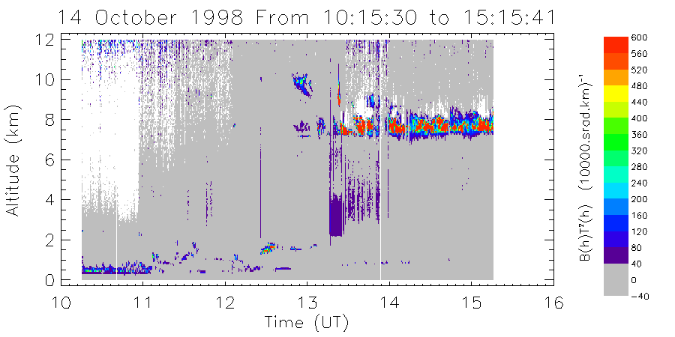

IR ceilometer
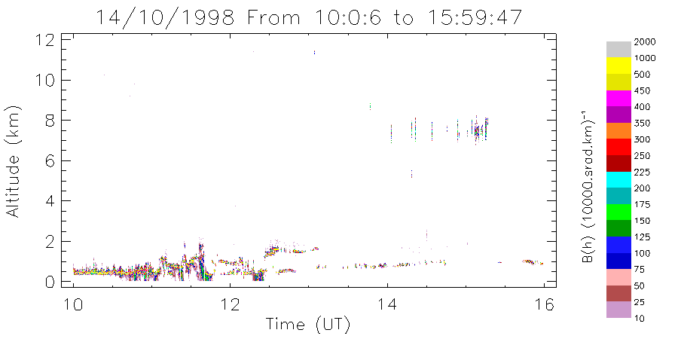

FIGURE 2a: UV lidar and IR ceilometer data from 14/10/98

UV lidar
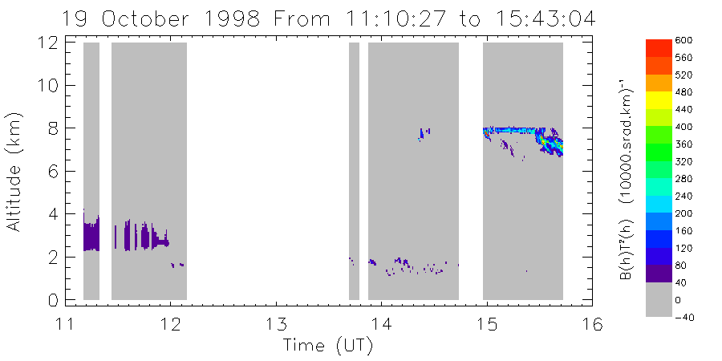

IR ceilometer
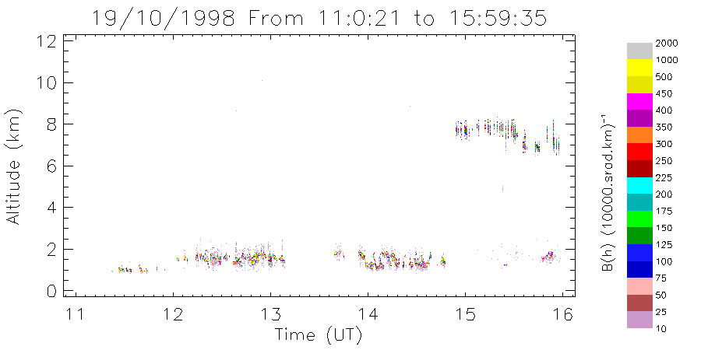

FIGURE 2b: UV lidar and ceilometer data from 19/10/98

UV lidar
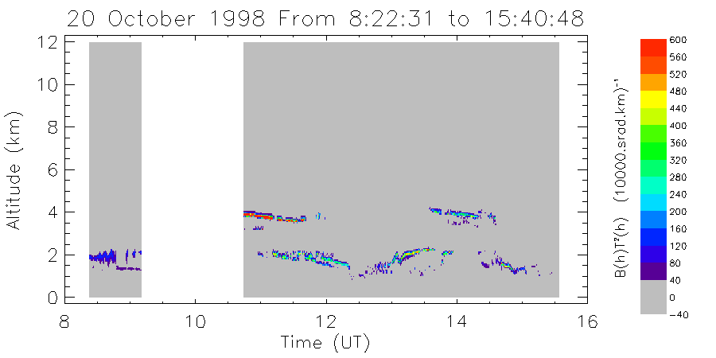

IR ceilometer
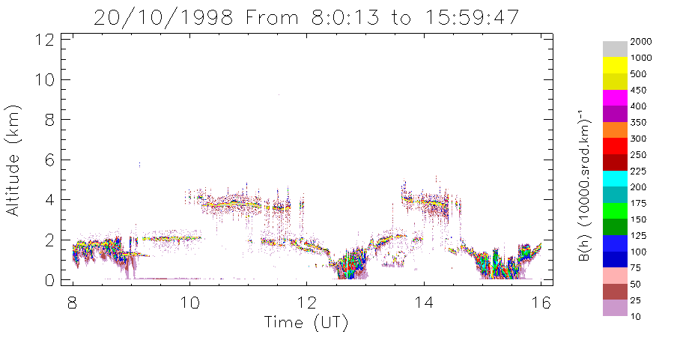

94 GHz radar
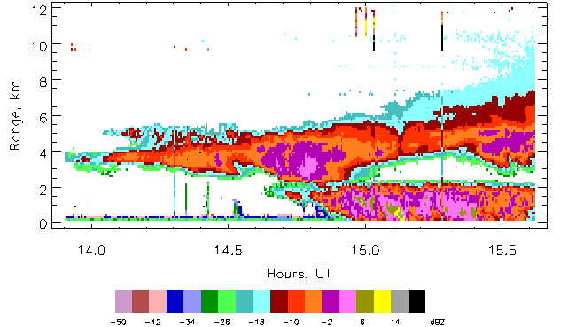

FIGURE 2c: UV lidar, ceilometer and 94 GHz radar data from 20/10/98
FIGURE 3a UV lidar 14/10/98 | FIGURE 3b UV lidar 20/10/98
FIGURE 3c IR ceilometer 20/10/98 | FIGURE 3d 94 GHz radar 20/10/98

FIGURE 3 Vertical profiles from 14/10/98 and 20/10/98 from the different measurement systems

