Non-Rayleigh scattering effects in mixed phase cloud observations

Nicolas Gaussiat*and Henri Sauvageot
Laboratoire d'Aérologie, Observatoire Midi-Pyrénées, Toulouse, France
*email: gaun@aero.obs-mip.fr

- INTRODUCTION
In most parts of the troposphere, temperature is negative. That is why, for a large fraction, the tropospheric clouds are mixed clouds. To correctly describe the radiation transferts in mixed clouds, the knowledge of both ice and liquid water profiles is required.

In mixed clouds, radar reflectivity is dominated by ice while liquid water is responsible for attenuation. Gosset and Sauvageot (1992) have proposed a dual-wavelength radar method for the remote sensing of the cloud profiles. In this algorithm, liquid water cloud M_{w} is deduced from the differential attenuation between the two wavelength and ice water content M_{i} is computed from the radar reflectivity. This method assumes that the size of the hydrometeors satisfies the Rayleigh approximation for both scattering and attenuation, because, in the presence of non-Rayleigh effects, an ambiguity appears on M_{w} and M_{i}.
The object of this paper is to discuss the effect of non-Rayleigh scattering on the performances of the dual-wavelength radar algorithm.

- THEORY
Let Zm_{α} be the radar reflectivity measured for the wavelength α, that is :
$$\begin{matrix}{\text{Zm}}_{α}={\text{Ze}}_{α}×{\text{10}}^{\text{-0}\text{.}1\int_{0}^{r}{A_{α}(r)\text{dr}}} & (1−1)\end{matrix},$$

where Ze is the unattenuated radar reflectivity factor, A is the attenuation factor and r the radar target distance. A, in dB km⁻¹, is the sum of Ag and Ah, the two-way attenuation factors for gas and hydrometeors respectively.
Ag is computed from the standard profile of temperature.
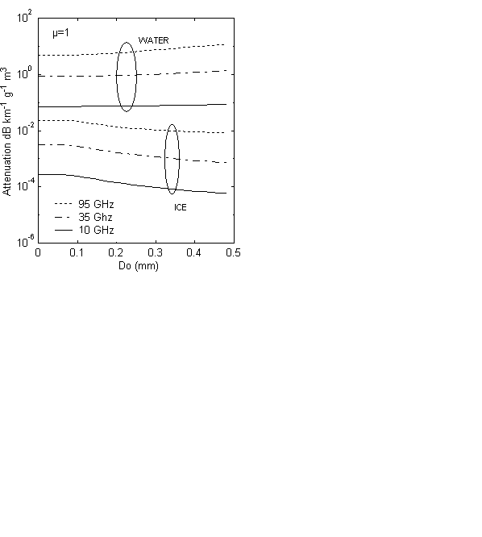
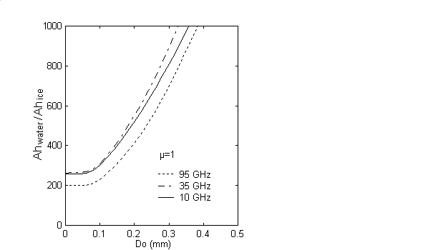
Fig.1 : Variation of the attenuation by ice and water clouds and ratio Ah_{w}/Ah_{i} as a function of Do, for the frequency 95, 35 and 10 GHz.

Ah is computed by the summation of the Mie attenuation cross-section Qe (D), where D is the equivalent spherical diameter, over the hydrometeors size distribution N(D).
The strong difference between ice and water cloud attenuation appears on figure 1, where Ah and Ah_{w}/Ah_{i}, as a function of Do, the mean volume diameter, are presented.

In the Rayleigh approximation conditions the attenuation factor for liquid water cloud droplets, and for frequency α, is:

$$\begin{matrix}A_{α}(r)=2C_{α}(r)M_{w}(r) & (1−2)\end{matrix},$$

where M_{w} is in g m⁻³ and C_{α} is the water cloud attenuation coefficient in dB km⁻¹ g⁻¹ m³ for one way.
Thus, for two frequencies having significantly different attenuation properties we can write:

$$\begin{matrix}M_{w}=\frac{A_{β}−A_{α}}{2(C_{β}−C_{α})}=\frac{\text{Ad}}{2(C_{β}−C_{α})} & (1−3)\end{matrix},$$

where α and β stand for the lower and higher frequency respectively and Ad is the differential attenuation.
The Dual wavelength ratio (DWR) is defined (Eccles and Muller, 1971) by:

$$\begin{matrix}Y_{α,β}=\text{10}\text{log}\left(\frac{{\text{Zm}}_{α}}{{\text{Zm}}_{β}}\right) & (1−4),\end{matrix}$$

where Zm is in mm⁶m⁻³. Using (1-1) in (1-4) gives

$$\begin{matrix}Y_{α,β}=\text{10}\text{log}\left(\frac{{\text{Ze}}_{α}}{{\text{Ze}}_{β}}\right)+\int_{0}^{r}{\text{Ad}(r)\text{dr}} & (1−5)\text{.}\end{matrix}$$

Taking the range derivative of (1-5), we found:

$$\begin{matrix}\text{Ad}=\frac{{\text{dY}}_{α,β}}{\text{dr}} & (1−6)\end{matrix}\text{.}$$

Then, with (1-3), the liquid water content for Rayleigh conditions is obtained:

$\begin{matrix}M_{w}=\frac{1}{2(C_{β}−C_{α})} & \frac{{\text{dY}}_{α,β}}{\text{dr}} & (1−7)\end{matrix}$.

It is assumed that N(D) can be represented by a modified gamma distribution :

$$\begin{matrix}N\left(D\right)=N_{o}×D^{μ}×e\text{xp}\left[−\left(3\text{.}\text{67}+μ\right)\frac{D}{D_{0}}\right] & (1−8),\end{matrix}$$

where No, µ, Do are the parameters and N_{T} =∫N(D)dD is the total number of hydrometeors by cubic meter.

For Mie scattering, Ze_{α} has to be rewritten (Lhermitte 1988, Sekelsky et al. 1996) :

$${\text{Ze}}_{α}=\frac{{\text{10}}^{\text{12}}λ_{α}^{4}N_{ο}}{4π^{4}{\left|K_{w}(λ_{α})\right|}^{2}}\int_{0}^{∞}{ξ_{b}\left(D,λ_{α},ρ\right)D^{2+μ}\text{exp}\left[−\left(3\text{.}\text{67}+μ\right)\frac{D}{D_{0}}\right]\text{dD}}$$
(1-9),

where Ze_{α} is in mm⁶m⁻³, λ is the wavelength,⏐K_{w}(λ_{α})⏐² is the dielectric factor for λ_{α} ,ρ is the hydrometeor density and ξ_{b}(D) is the back-scattering efficiency as a function of D.

Using (1-9) in (1-5) gives :

$Y_{α,β}=\text{10}\text{log}\left(\frac{{\left|K_{w}(λ_{β})\right|}^{2}λ_{α}^{4}\int_{0}^{∞}{ξ_{b,α}\left(D\right)D^{2+μ}\text{exp}\left[−\left(3\text{.}\text{67}+μ\right)\frac{D}{D_{0}}\right]\text{dD}}}{{\left|K_{w}(λ_{α})\right|}^{2}λ_{β}^{4}\int_{0}^{∞}{ξ_{b,β}\left(D\right)D^{2+μ}\text{exp}\left[−\left(3\text{.}\text{67}+μ\right)\frac{D}{D_{0}}\right]\text{dD}}}\right)+\int_{0}^{R}{A_{d}\left(r\right)}dr$(1-10),
with λ_{α} in cm and ρ=ρ(D).

Taking the derivative and inverting (1-10), we obtain :

$\begin{matrix}\text{Ad}=\frac{{dY}_{α,β}}{dr}−\frac{{dD}_{0}}{dr}×\text{Ec}\left(D_{0},μ\right) & (1−\text{11})\end{matrix}$,

with
$$\text{Ec}\left(D_{0},μ\right)=\frac{\text{10}(3\text{.}\text{67}+μ)}{D_{o}^{2}\text{Ln10}}\left\{\frac{\int_{0}^{∞}{ξ_{b,α}\left(D\right)D^{3}N(D)\text{dD}}}{\int_{0}^{∞}{ξ_{b,α}\left(D\right)D^{2}N(D)\text{dD}}}−\frac{\int_{0}^{∞}{ξ_{b,β}\left(D\right)D^{3}N(D)\text{dD}}}{\int_{0}^{∞}{ξ_{b,β}\left(D\right)D^{2}N(D)\text{dD}}}\right\}$$
(1-12).

Using (1-12), Ec(Do,μ) was computed for water and ice, with μ as a parameter, for the pair 35-95 GHz and 10-35 GHz. The results are presented on Fig 2.

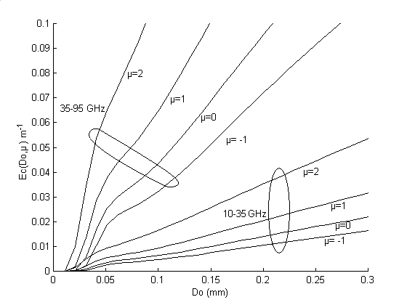

Fig 2 : Variation of Ec(Do,µ) as a function of Do with µ as a parameter for ice hydrometeor distribution and for the 35-95 GHz and 10-35 GHz pairs.

In non-Rayleigh conditions (1-7) becomes :

$\begin{matrix}M_{w}=\frac{1}{2(C_{β}−C_{α})}\left\{\frac{{dY}_{α,β}}{dr}−\text{nR}(D_{0},μ)\right\} & (1−\text{13})\end{matrix}$,

with
$\begin{matrix}\text{nR}\left(D_{0}\text{,μ}\right)=\frac{{\text{dD}}_{0}}{\text{dr}}×\text{Ec}\left(D_{0}\text{,μ}\right) & (1−\text{14})\end{matrix}$,

where nR(Do,μ) is in dB km⁻¹ .

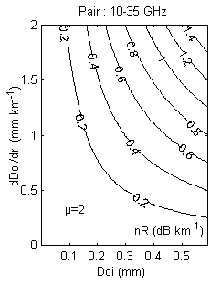
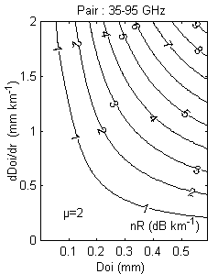
Fig 3 : Variation of nR(Do,µ) and dDoi/dr as function of Do for an ice hydrometeor distribution with µ as a parameter for the 35-95 GHz and the 10-35 GHz pairs.

Of course, neglecting the non-Rayleigh effects can lead to an error in the estimation of the liquid water content M_{w}.

- MIXED-CLOUD MICROPHYSICS.

In situ observation shows that mixed-clouds are typically made up of 1) a supercooled water cloud with No very large and Do not larger than about 30 μm and 2) a bimodal distribution of ice particles with a large number of crystals smaller than about 50 µm and a small number of particles with size between 100 and 400 µm (Heymsfield et al. 1991; Sassen 1991; Mitchel and al. 1996). The large ice particles, because their low terminal fall velocities, create slanted streamers with high reflectivity. Thus mixed-clouds can schematically be described as the addition of an attenuating, Rayleigh scattering water cloud and a non attenuating, non-Rayleigh scattering bimodal ice cloud.
In the present work dedicated to the study of the radar propagation, for sake of simplicity, we choose to ignore the small mode of the ice particle distribution.

- SIMULATION

Let N_{w}(D,z) and N_{i}(D,z) (eq. 1-9) be the water and ice cloud particle size distributions respectively.
For all simulated cases, we used N_{Tw}=4×10⁷m⁻³, µ_{w}=1 and Do_{w}(z) varying from the bottom to the cloud top following the polynomial curve presented in Fig 4.
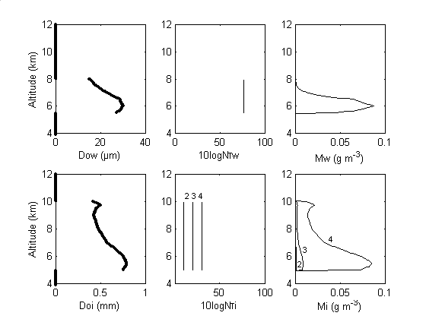
Fig 4 : Vertical profiles of Nw(D) and Ni(D) parameters and corresponding liquid water and ice water content.

For N_{i} (D, z), the parameter Do_{i} (z) has the same profile for the four simulated cases : a polynomial variation between the bottom and the top of the cloud (Fig. 4). N_{Ti} takes the values 0, 10¹ ,10² and 10³ for the four cases respectively, µ_{i} is constant and equal to 2

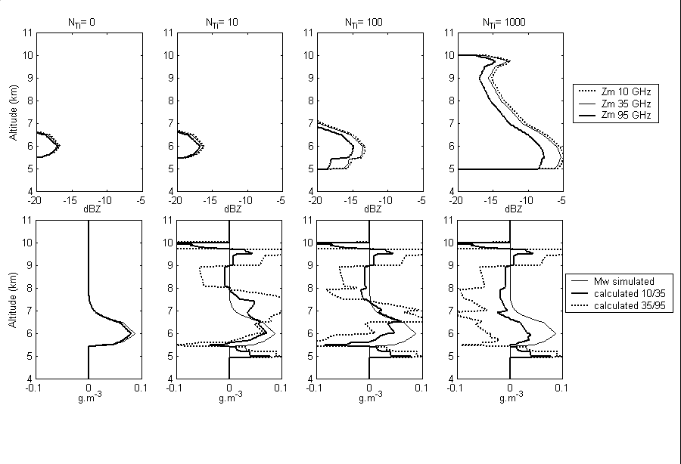
Fig 5 : Upper Row, reflectivities at 10, 35 and 95 GHz fo a mixed cloud. N_{Ti} is the number of large ice particles.
Lower Row, liquid water content simulated and retrieved from the wavelength pairs 10-35 GHz and 35-95 GHz.

- RESULTS

In the absence large ice particles (N_{Ti}=0), the dual wavelength method gives correct results for both wavelengh pair (See Fig 5, the first column of the simulation).
As the number of large ice particles increases, incorrect values of liquid water content appear. The errors are related to the Doi gradients.
These errors are larger for the 35-95 pair than for the 10-35 one, but in both cases, retrieved liquid water profiles are jeopardized.

- CONCLUSION

Simulations showed in the present work suggest that the dual wavelength radar method for liquid water content retrieval in the mixed cloud is very sensitive to the non-Rayleigh effect induced by large ice particles.

- REFERENCES

Eccles , P. J. and E. A. Mueller, 1971 : X-Band attenuation and liquid water content estimationby dual-wavelengh radar. J. Appl. Meteor 10, 1252-1259.
Gosset, M. and H. Sauvageot, 1992 : A Dual-Wavelengh Radar Method for Ice-Water Characterisation in Mixed-Phase Clouds. J.Atmos.Oceanic.Technol., 14., 256-272
Heymsfield, A. J., L. M. Miloshevich, A. Slingo, K Sassen and D. O'C Starr, 19991/ An observational and theoretical study of hightly supercooled altocummulus. J. Atmos. Sci., 48, 923-945.
Lhermitte, R. M., 1988 : Cloud and precipitation remote sensing at 94 GHz Trans. Geosci. Remote Sens 26, 207-216.
Mitchell, D.L., S.K. Chai, Y.Liu, A.J.Heymsfield and Y. Dong, 1996 : Modeling cirrus clouds. Part I : Treatment of bimodal size spectra and case study analysis. J. Atmos. Sci., 53, 2956-2966.
Sassen, K., 1991 : Aircraft-produced ice particles in a hightly supercooled altocummulus cloud. J. Applied Met., 30, 765-775.

