Development of retrieval algorithms of cloud parameters from radar
and lidar based on the CLARE data set

J.J.M. de Wit, R.J.P. Baedi, J.S. Erkelens, J.P.V. Poiares Baptista¹ and H.W.J. Russchenberg
IRCTR, International Research Centre on Telecommunications-transmission and Radar,
Department of Informational Technology and Systems, Delft University of Technology,
Mekelweg 4, 2628 CD Delft, The Netherlands, http://irctr.et.tudelft.nl/
Fax: +31 15 2784046 Email: H.W.J.Russchenberg@ITS.TUDelft.nl
¹European Space Research and Technology Centre

ABSTRACT

To measure the cloud liquid water content, time consuming in-situ aircraft measurements are needed. Radars on the other hand are capable of monitoring large volumes thus radar measurements are faster and cheaper than in-situ observations. Several Z-LWC relations have been proposed. However these relationships do not hold throughout a whole cloud because they ignore larger droplets. The effective radius is used to identify the parts of the cloud where the Z-LWC relations are not valid. Finally a procedure to obtain the effective radius with radar and lidar measurements is outlined.

INTRODUCTION

Clouds have a significant influence on the earth-atmosphere radiation budget. This influence is determined by their physical properties, e.g. the cloud liquid water content (LWC).
The LWC can be measured in-situ with a Johnson-Williams liquid water content sensor mounted on an aircraft [1]. The sample volume of the Johnson-Williams sensor is however very small. Hence to measure the LWC profile throughout a whole cloud a lot of flights have to be made. During the time needed to cover the whole cloud the cloud properties will alter. Next to that in-situ aircraft measurements are very expensive.
It would be less cumbersome if the LWC could be obtained with (ground-based) radars. The sample volume of ordinary radars is about 10⁵ times as large as the sample volume of the Johnson-Williams sensor. In order to obtain the LWC with a radar some relation between the radar reflectivity and the LWC must be found. Therefore radar and in-situ measurements have to be correlated.
A comprehensive measurement campaign of cloud parameters using several remote sensing techniques and in-situ aircraft measurements was carried out during the Cloud Lidar and Radar experiment (Clare). The Clare campaign took place in October 1998 near Chilbolton in the United Kingdom. During the campaign simultaneous in-situ aircraft measurements and co-located ground-based measurements were performed. The ground-based equipment consisted of radiometers, radars and lidars. The aircraft provided in-situ measurements of cloud droplet spectra, ice/liquid water content and radar and lidar measurements. The aircraft flew runs from and to the radar site. Although the aircraft had slightly different velocities they arrived at Chilbolton simultaneously. Each run is about 10 minutes long, that is 60 km. A more detailed description of the Clare ’98 campaign can be found in [2].

PARTICLE SIZE SPECTRA

The particle size spectra are measured by the Forward Scattering Spectrometer probe (FSSP) and the Two-Dimensional Cloud probe (2DC). The FSSP measures water droplets in the size range of 1.75 μm to 22.75 μm radius. The particles are sized in 15 radius bins of 1.5 μm each. The raw FSSP data are corrected so that the LWC from the particle size spectra is the same as that measured by the Johnson-Williams LWC-sensor. This correction is performed because the Johnson-Williams sensor is much more accurate than the FSSP [3].
The 2DC measures the larger drop sizes in the range of 12.5 μm to 400 μm radius. The measured particles are sized in 32 radius bins of 12.5 μm each. The 2DC data are not tuned to the Johnson-Williams measurements.
The particle probes produce a spectrum every 5 seconds. In order to obtain the complete particle size spectrum the spectra measured by the FSSP and the 2DC are merged. Detailed information on the particle probes and the merging technique can be found in [4] and [2] respectively.
The liquid water content from the particle size spectra is computed as:

$\text{LWC} = 43π⋅ρ_{w}⋅{\text{10}}^{−6} \sum_{i}{N_{i}r_{i}^{3}}$ [g/m³] (1)

Where ρ_{w} is density of water [kg/m³], r_{i} is the mid-radius of bin i [mm] and N_{i} is the number of particles measured in bin i [m⁻³]. The LWC is dominated by the smaller cloud particles, that is the FSSP-sized particles. The large

cloud droplets do not contribute much to the LWC because their concentrations are too low. Generally the contribution of the 2DC-sized droplets is 5% or less.
The radar reflectivity on the other hand is dominated by the 2DC-sized droplets. This is due to the r⁶ dependence if the Rayleigh approximation is valid:

$z = \text{64}\sum_{i}{N_{i} r_{i}^{6}}$ [mm⁶/m³] (2)

Where z is the radar reflectivity.

Z-LWC RELATIONSHIPS

To be able to determine the LWC with radar measurements some relationship between the reflectivity and the LWC must exist. Several empirical Z-LWC relations have been proposed. However most of these relations ignore the 2DC-sized droplets [5].
Figure 1 shows the Z-LWC relation for a run made on October 7th in a precipitating stratocumulus cloud at 2.0 km height. Figure 2 shows the Z-LWC relation for six consecutive runs of October 7th.
a) b)
Figure 1. Scatter plot of Z_{2DC+FSSP} versus LWC_{2DC+FSSP} (a) and the scatter plot of Z_{FSSP} versus LWC_{FSSP} (b) for run 51 made on October 7th. The relationship for only the FSSP data is Z_{FSSP} = 0.01⋅LWC^{0.95}. The correlation between Z_{FSSP} and LWC_{FSSP} is 0.93. If the 2DC data are also taken into account the relationship is Z_{2DC+FSSP} = 0.96⋅LWC^{1.83} and the correlation coefficient is 0.63.

a) b)
Figure 2. Scatter plot of Z_{2DC+FSSP} versus LWC_{2DC+FSSP} (a) and the scatter plot of Z_{FSSP} versus LWC_{FSSP} (b) for six succeeding runs made on October 7th. The Z-LWC relations are Z_{2DC+FSSP} = 0.84⋅LWC^{0.60} and Z_{FSSP} = 0.01⋅LWC^{1.03} respectively. If the 2DC data are taken into account the correlation coefficient is only 0.24.

These runs were all made in precipitating stratocumulus. The Z-LWC relations are found using a least-squares fit.
From figure 2b can be seen that the scatter is very small, if only FSSP data are taken into account. The scatter is much larger if the 2DC data are also taken into account, see figure 2a. The Z-LWC relation fitted on the FSSP data will therefore give a better estimate of the LWC. However radars do not discriminate between reflectivity due to FSSP-sized particles and reflectivity due to 2DC-sized particles.
If the 2DC data are taken into account the fit is not very good. In order to get a better fit the scatter has to be decreased. From figure 2a it is seen that most deviating data are data with high reflectivity and rather low LWC. That is, these spectra are heavily weighted towards the larger drop sizes.
The effective radius can be seen as a parameter that shows how many large, 2DC-sized drops occur relative to the smaller FSSP-sized droplets. Spectra that are heavily weighted towards the larger droplets have a large effective radius. The effective radius is defined as:

$r_{e} = r^{3}>\frac{}{r^{2}>}= \frac{\sum_{i}{N_{i}r^{3}}}{\sum_{i}{N_{i}r^{2}}}$ [μm] (3)

Indeed the spectra with high reflectivities and modest LWC have very large effective radii. See for example figure 3. This figure shows the reflectivity, the LWC and the effective radius from the spectra for a run also made in a precipitating stratocumulus cloud on October 7th. At the end of this run the LWC is very low while the reflectivity reaches values up to 20 dBZ. From the bottom figure it is seen that the effective radius is very large for those cases.
For the runs made on October 7th the limit for the effective radius is set to 10 μm. Figure 4 shows the Z-LWC scatter plot for the run shown in figure 3. The diamonds represent the spectra with r_{e} > 10 μm. It is easily seen that most deviating spectra have effective radii larger than 10 μm. If these spectra are filtered out the scatter will decrease significantly. Figure 5 shows the scatter plot if the spectra with r_{e} > 10 μm are filtered out. The correlation coefficient is 0.61 compared to 0.24 if no

filtering is applied (see figure 2a). A lower limit of r_{e} does not improve the results significantly.
This method to decrease the scatter is however only useful if the effective radius can be derived with radar and other remote sensing data. Otherwise the probe measurements would still be necessary.

Z/α - R_{E} RELATIONSHIPS

The effective radius may be obtained by combining a radar and lidar operating in the Rayleigh and Mie region respectively. As mentioned earlier, the 2DC-sized drops dominate the radar reflectivity when the Rayleigh approximation is valid (i.e. when the particles are small compared to the wavelength). The smaller FSSP-sized droplets on the other hand dominate the extinction of the lidar signal that is computed from the spectra as:

$α=2π\sum_{i}{N_{i}r_{i}^{2}}$ [m⁻¹] (4)

Where the optical approximation of 2 for the extinction efficiency is used; i is the bin number.
In order to show that a relation exists between the effective radius, the radar reflectivity and the lidar extinction, let’s first define the radar/lidar ratio as:

$\frac{z}{α}=\frac{\text{64}\int{N(r)r^{6}\text{dr}}}{2π\int{N(r)r^{2}\text{dr}}}$ (5)

Let’s also assume that the merged FSSP and 2DC spectrum can be approximated by the summation of two exponential functions:

$N(r)=N_{0,1}e^{−λ_{1}r}+N_{0,2}e^{−λ_{2}r}$ (6)

Where λ₁ and λ₂ are the slopes of the FSSP and 2DC distributions respectively, and N₀ is a scaling factor. If it is further assumed that
a)
b)
c)

Figure 3. The reflectivity (a), liquid water content (b) and the effective radius (c) from the spectra for run 71 made on October 7th.

Figure 4. The scatter plot of Z_{2DC+FSSP} versus the LWC_{2DC+FSSP} for run 71 of October 7th. The asterisks represent spectra with r_{e} ≤ 10 μm and the diamonds represent spectra with r_{e} > 10 μm. |  | Figure 5. The scatter plot of Z_{2DC+FSSP} versus LWC_{2DC+FSSP} for six succeeding runs of October 7th. The spectra with r_{e} > 10 μm are filtered out. The relation is Z_{2DC+FSSP} = 1.80⋅LWC^{1.70} and the correlation coefficient is 0.61. The relation is found using a least-squares fit.

Figure 6. Plot of the radar/lidar ratio vs effective radius. Note that the values are logarithmic. These values are computed with the assumption that the size spectra measured by the probes can be approximated with a summation of two exponential functions. The solid line shows the case where λ₂ varies as λ₁ is held constant (see eq. (6) and (7)). The dashed line is the case where λ₁ varies as λ₂ is set to zero.
Figure 7. Scatter plot of the radar/lidar ratio vs effective radius. Note that the values are logarithmic. The solid line is the least-squares-fit on the data which are computed using eq. (2), (3) and (4). The data are moving averaged on a 4 sample basis (20 seconds). The dashed line in figure 6 does not appear here, since this line represents a situation where FSSP-sized droplets dominate the distribution; these data have a very low radar reflectivity and are filtered out by the threshold set at Z=-35 dBZ.

the integrals in equation (5) are infinite, which is reasonable since they are usually zero for large radii, the k^{th} moment can be written as:

$\left\langle r^{k}\right\rangle =N_{0,1}{\left(λ_{1}^{−1}\right)}^{k+1}k!+N_{0,2}{\left(λ_{2}^{−1}\right)}^{k+1}k!$ (7)

Then the radar/lidar ratio can be written as (ignoring the constants):

$\frac{z}{α}=\frac{N_{0,1}λ_{1^{−7}}6!+N_{0,2}λ_{2^{−7}}6!}{N_{0,1}λ_{1^{−3}}2!+N_{0,2}λ_{2^{−3}}2!}$ (8)

and the effective radius can be written as:

$r_{e}=\frac{N_{0,1}λ_{1^{−4}}3!+N_{0,2}λ_{2^{−4}}3!}{N_{0,1}λ_{1^{−3}}2!+N_{0,2}λ_{2^{−3}}2!}$ (9)

Figure 6 shows the plot of the ratio vs r_{e}. The solid line shows the case where λ₁ and N₀ are held constant (λ₁ = 1) and λ₂ is varied between 0 and 1. It can be seen that when a lot of 2DC-sized drops are present (λ₂ is small), i.e. when the effective radius is relatively large, the curve converges to a r_{e}⁴ dependency. This can also be seen from equations (8) and (9). The dashed line shows the situation where λ₂ is set zero while varying λ₁. Again, the r_{e}⁴ dependency is clearly seen.
In figure 7 a scatter diagram of the radar/lidar ratio versus the effective radius is shown. These data are computed from the measured size spectra, moving averaged on a 4 sample basis (20 seconds), of eight runs made on October 7th 1998 and two runs made on October 13th 1998.
In calculating the scatter plot, a threshold of –35 dBZ has been set on the radar reflectivity since this is the sensitivity of a typical radar system. As a consequence, the dashed line in figure 6 does not appear in the scatter plot, since that line represents the situation where FSSP-sized droplets dominate the distribution, implying a very low radar reflectivity (generally lower than –35 dBZ). The solid line is the least-squares-fit on the data. The line shows the following relation between the ratio and the effective radius:

${\left(\frac{z}{α}\right)}_{\text{log}}=−\text{17}\text{.}\text{56}+\text{21}\text{.}\text{01}{\left(r_{e}\right)}_{\text{log}} {\left(\frac{z}{α}\right)}_{\text{log}}< 2\text{.}\text{33}$ (10)
${\left(\frac{z}{α}\right)}_{\text{log}}=0\text{.}\text{76}+1\text{.}\text{66}{\left(r_{e}\right)}_{\text{log}} {\left(\frac{z}{α}\right)}_{\text{log}}≥ 2\text{.}\text{33}$ (11)

In order to give an indication of the reliability of these fits, the standard deviation of the retrieved effective radius is computed. For (z/α)_{log} smaller than 2.33 (r_{e} < 8.85μm) the standard deviation is 0.894, whereas for (z/α)_{log} greater than 2.33 (r_{e} ≥ 8.85μm) the standard deviation is 29.13.

OBTAINING R_{E} FROM RADAR/LIDAR DATA

During Clare’98 a Fokker 27 ‘Arat’ carried the Kestrel radar operating at 94 GHz (wavelength=3.19mm), and the Leandre lidar with a wavelength of 532 nm to observe the cloud top. In this paper, only water clouds are considered,

a)
b)
Figure 8. Plot of extinction vs longitude using a moving average on a 4 sample basis. The solid line shows the extinction extracted from the lidar signal. The dashed-dotted line shows the extinction calculated from the size spectra. Note that the extinction from the Leandre is taken at an altitude that is about 200 metres higher than the height the C130 was flying. Figure a) displays data taken from October 7th run 51, and figure b) shows data from October 7th run 52.
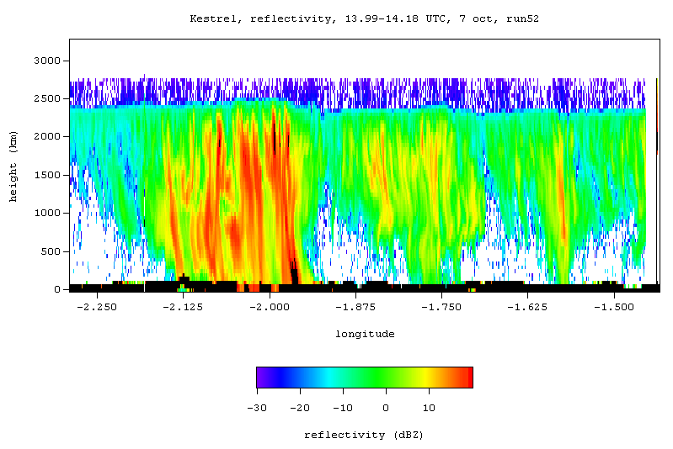
a)
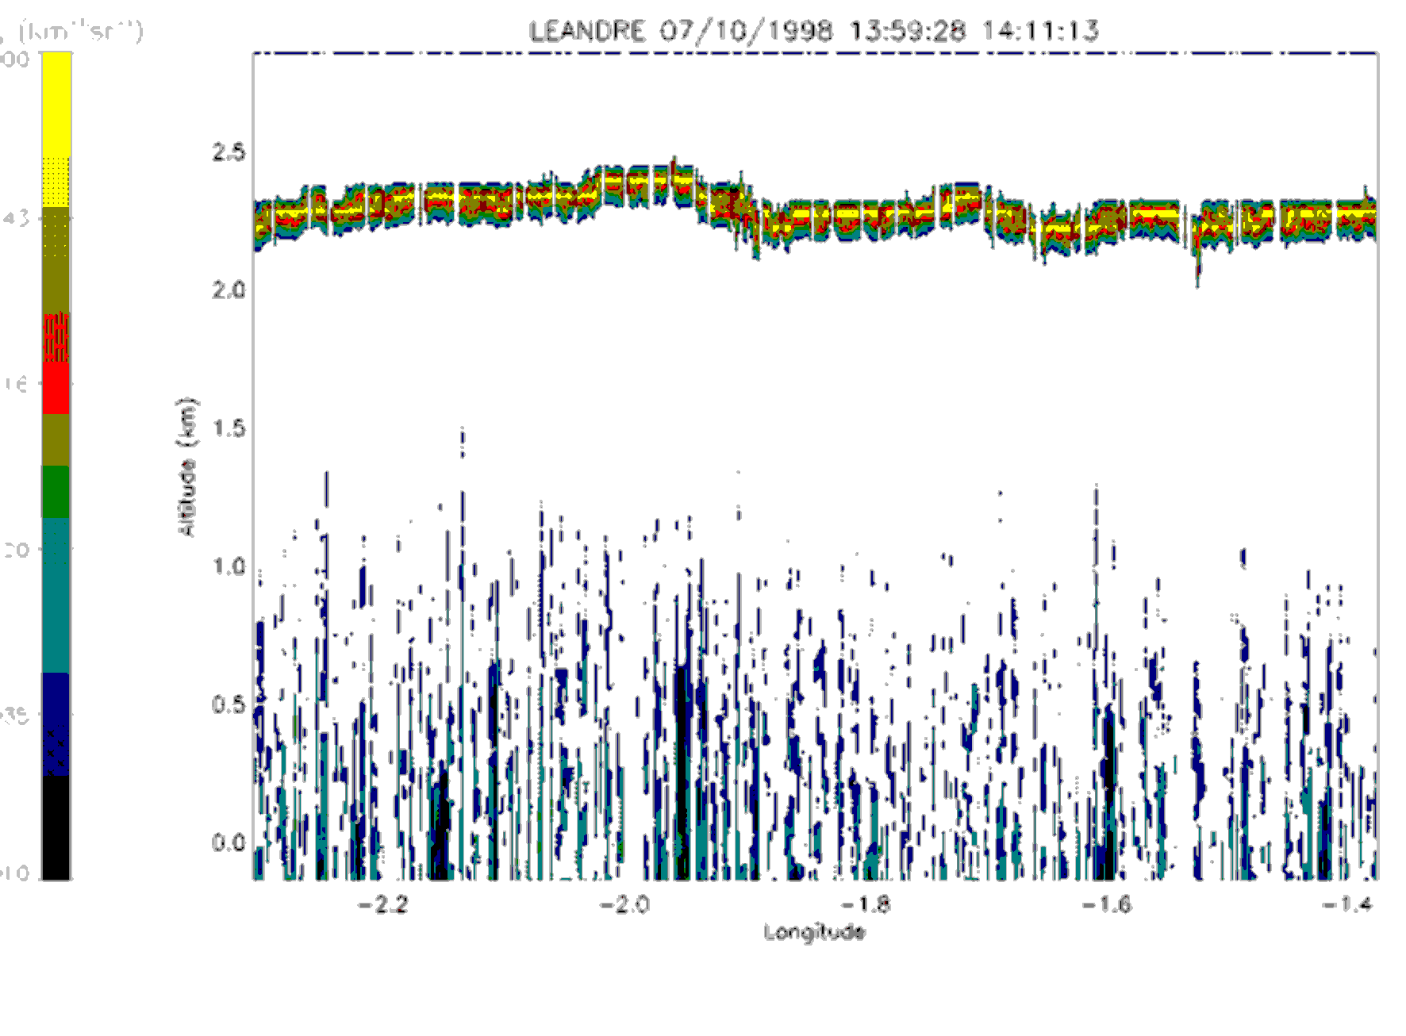 b)
Figure 9. The top figure displays the radar reflectivity measured by the 94 GHz Kestrel. Figure b) shows the lidar backscatter measured by the Leandre at a wavelength of 532 nm. The measurements were taken on October 7th run 52.

a)
b)
Figure 10. Plot of effective radius vs longitude using a moving average on a 4 sample basis.. The thin solid line shows r_{e} computed from relations (10) and (11), where the ratio is obtained from measurements of the Kestrel and the extracted extinction of the Leandre. The thick solid line shows r_{e} calculated from the size spectra. Figure a) also shows the r_{e} using k=0.5 and k=1.5. These are the dot-line and the circle-line respectively. Figure a) and b) show data from October 7th run 51 and 52 respectively.

and thus most particles encountered are very small compared to the radar wavelength, and very large relative to the lidar wavelength. Therefore, it may be assumed that in the radar and lidar point of view, the (spherical) particles encountered act as Rayleigh and Mie scatterers respectively.
The lidar extinction at a certain range R can be extracted from the lidar signal by using the inversion technique commonly known as the Klett algorithm [6]. This method assumes a power law relation between the backscatter β and the extinction of the form:

$β=\text{const}⋅α^{k}$ (12)

In this article, k=1 is used. An input boundary value α_{m} at some reference height R_{m} is also required. This reference height should be taken further away from the receiver than the height at which the extinction is to be calculated, yet at an altitude where the range corrected lidar signal is still above the noise level. The performance of the Klett-algorithm is dependent on several factors, two of which are the selection of the reference extinction value, and the value of k that is used in relation (12). In [7] some analysis is done on how sensitive the retrieved extinction is to the boundary value. It appears that estimations with an α_{m} that is 100% above and 50% below the correct value still converge to the correct profile if the distance between R and R_{m} is large enough. In this paper, only the effect of the choice of k on the effective radius is presented.
It is difficult to choose the correct height at which the extinction is to be calculated, since the Hercules C130, the aircraft carrying the particle probes, usually flew at a height where the lidar signal is completely attenuated. Therefore, the extinction is calculated about 200-300 metres above the height at which the Hercules had flown.
Two examples of the extracted lidar extinction and the extinction computed from the size spectra are shown in figure 8. From these figures it is seen that the extinction of the Leandre follows a similar pattern as the extinction that is calculated from the size distributions. However, the order of magnitude of the Leandre extinction lies roughly a factor 10 lower than the extinction from the spectra. The large difference seen in figure 8b) between about –2.05º and –1.95º longitude is a direct effect of the height difference. The lidar extinction is calculated at a height of 2.318 km, which is near the cloud top, whereas the Hercules flew near the cloud base, around 2.0 km. From figure 9 it is seen that during this interval of precipitation, both radar and lidar detect a slightly higher cloud top. Consequently there is no lidar signal at the height at which the extinction is calculated.
Figure 10 shows diagrams of the effective radius that is computed from relation (10) for (z/α)_{log} < 2.33 and from relation (11) for (z/α)_{log} ≥ 2.33. The reflectivity and the extinction are then the measurements of the Kestrel and the extracted extinction of the Leandre respectively (thin solid line). In figure 10a the effect of k on r_{e} is also seen; the dot-line results from using k=0.5 and the circle-line is the result for k=1.5. It shows that the value for k does not have a very large impact on the effective radius. In this figure, the results for k=1.5 are almost identical to the results for k=1. The thick solid line is the effective radius calculated from the size spectra. In overall, the thin solid line comes in good approximation with the thick solid line; the difference between the two lines is generally less than 1 micron. In figure 10b) the effective radius is very large around –2.0º, which is a direct consequence of the difference in altitude mentioned earlier.

NOTES

In the examples discussed in this paper, the height difference of the two aircraft does not have a disastrous consequence. However, these runs are not useful in showing the operation of the r_{e}-filter, since the effective radius does not exceed the threshold value of 10 μm discussed before. Next to the difference in altitude, the calibration of the Kestrel radar has to be taken into account in calculating the radar/lidar ratio. At this point, it is not certain exactly how much the radar has to be calibrated. For the results in this paper, a calibration of 8.5 dBZ had been used [8]. This calibration factor has a great influence on whether relation (10) or (11) is used in computing the effective radius. Another issue is that the data files of the Kestrel and the Leandre show different longitudes at the same time instances. Strangely enough, these instruments were on board the same aircraft.
These obstructing issues have to be resolved before other data can be analysed. Finally, the method described in this paper to derive the effective radius from radar and lidar data can only be reliably validated if data from the particle probes, the radar reflectivity, as well as the lidar extinction are available at the same location and altitude.

REFERENCES

[1] Johnson, D.A., A study of the Johnson-Williams liquid water content meter as fitted to the MRF Hercules, Meteorological Office, Met. O. 15 Internal report no.22, 1979

[2] Baedi, R.J.P., Wit, J.J.M. de, Poiares Baptista, J.P.V., Comparison of micro-physical and macro-physical measurements of clouds during the Cloud Lidar and Radar Experiment, Internal report ESTEC-European Space Agency, 1999

[3] Francis, P.N., Personal communication

[4] Moss, S.J., Brown, P.R.A., Johnson, D.W., Lauchlan, D.R., Martin, G.M., Pickering, M.A., Spice, A., Cloud microphysics measurements on the MRF C-130: Working Group Report, Meteorological Research Flight, MRF Technical note no.12, 1993

[5] Illingworth, A.J., Liu, C-L., Astin, I., Richards, B., Study of the critical requirements for a cloud radar, Internal report ESTEC-European Space Agency, 1997

[6] Klett, J.D., Stable analytical inversion solution for processing lidar returns, J. Applied Optics, Vol. 20, no.2, 211-220, 1981

[7] Fong, A.Y., Lammeren, A.C.A.P. van, Cloud Lidar research at the RNMI and KNMI2B2 version 2 Cloud Lidar analysis software documentation, Technical report TR-172 KNMI, 1994

[8] Guyot, A, Personal communication

