Cloud effective radius and water contents inferred from combined lidar and radar observations during CLARE’98.

David P. Donovan and A.C.A.P. Van Lammeren
Royal Netherlands Meteorological Institution (KNMI), Postbus, 201, DeBilt, 3730 AE,
The Netherlands, e-mail: donovan@knmi.nl

J. Goddard, Rutherford Appleton Laboratory. UK

Henri Sauvageot, Laboratoire d’Aerologie, Universite Paul Sabatier, Toulouse, France

R.J Hogan, Department of Meteorology, University of Reading, UK

Abstract
In principle, combined lidar and radar cloud soundings are capable of providing detailed height resolved information of the effective sizes of cloud particles. However, accounting for extinction at the lidar wavelength in an appropriate manner can be problematic. In this paper a recently developed procedure for estimating cloud effective particle radius and water content profiles is described. The procedure accounts for extinction in a self-consistent manner and has many advantages over conventional lidar or radar only procedures. The technique has been applied to a number of CLARE cases and some examples will be presented here.

INTRODUCTION

Cloud lidar and radar share many similarities. Both are active systems which acquire information about their targets (clouds) by launching pulses of electromagnetic radiation and then detecting the returned radiation as a function of time after each given pulse was emitted. Both types of systems are capable of providing height-resolved information with a high temporal and spatial resolution. The key difference between lidar and radar systems is, of course, the large difference in their associated wavelengths. Cloud lidars typically employ wavelengths in the range of 0.5-1.0 microns while radar systems employ wavelengths in the millimeter to centimeter range. This large difference in wavelength leads to a large difference in the response to a cloudy volume with a given effective particle size.

The relative strengths of the lidar and radar backscatters as a function of effective radius for three different gamma-type cloud particle distributions is shown in Fig.1. The calculations were performed using Mie theory and assuming gamma type distributions where $γ$was set to 3, 5, and 7 respectively. i.e.

$\frac{\text{dn}}{\text{dr}}=\frac{N_{o}}{R_{m}}\frac{1}{Γ(γ)}{\left(\frac{r}{R_{m}}\right)}^{γ−1}\text{exp}\left[−rR_{m}\right]$ (1)
where ${\text{dn}}/{\text{dr}}$ is the number of cloud droplets with radii between $r$ and $r+\text{dr}$, $R_{m}$is the mode parameter and $N_{0}$is the total number of particles.

Figure 1. Normalized backscatter per unit volume as a function of $R_{\text{eff}}$
$R_{\text{eff}}$in Fig 1. Is defined in the normal fashion,. i.e.
$R_{\text{eff}}\text{=<}r^{3}><r^{2}>$ (2)
where the braces denote averaging over the size distribution. It can be seen that, broadly speaking, the lidar will be sensitive to the presence of small particles while the radar will be most sensitive to the presence of larger droplets.

LIDAR/RADAR RATIO

Considering spherical scatters for the moment. Since cloud particles tend to be large compared to the lidar wavelength, the extinction and backscatter coefficients for a single particle will be approximately proportional to $r^{2}$. Since the same particles will be small compared to the radar wavelength, they will act approximately as a Rayleigh scatterers and the radar backscatter will for a single particle scale with $r^{6}$. Accordingly, the ratio of the radar backscatter to the lidar extinction is more usefully thought of as a function of
$R'_{\text{eff}}=[<r^{6}><r^{2}>]^{1/4}$ (3)
instead of $R_{\text{eff}}$. For a gamma type size distribution $R'_{\text{eff}}={\left[\frac{(γ+5)(γ+4)(γ+3)}{(γ+2)^{3}}\right]}^{1/4}R_{\text{eff}}$ (4)
The utility of using $R'_{\text{eff}}$ is illustrated in Fig 2.where the ratio of the radar reflectivity to lidar extinction computed using different values of gamma are shown both as functions of $R'_{\text{eff}}$ and $R_{\text{eff}}$ The radar reflectivity is related to the radar backscatter coefficient as

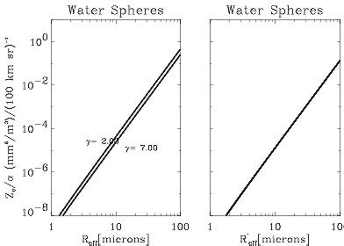
Figure 2. Reflectivity to extinction ratios for two values of gamma as a function of $R_{\text{eff}}$ (left) and $R'_{\text{eff}}$ (right).
$Z_{e}=\frac{λ_{\text{rad}}^{4}}{π^{5}}\frac{1}{K_{w}}β_{\text{rad}}$ (5).
It can be seen that plotting the ratios in terms of $R'_{\text{eff}}$ removes the variations with gamma. The same results could have been obtained using different types of size distributions. $R'_{\text{eff}}$ is the invariant size that will be measured using the lidar and radar signals. To infer other size measurements such as $R_{\text{eff}}$ or to estimate water content then assumptions about the cloud size distribution have to be invoked (such as fixing the value of gamma in Eqn.(1).)

Ice Clouds

The previous considerations may be approximately extended to the case of randomly orientated ice crystals. Since the lidar extinction will mainly depend on the cross-sectional area of the particles and the radar reflectivity will mainly depend on the square of the mass of the particles we will model ice clouds using distributions of equivalent $R'_{\text{eff}}$spheres. However, the definition of $R'_{\text{eff}}$ must be altered so that
$R'_{\text{eff}}=$ (6)
where, $D$ is the maximum ice crystal dimension, $M$ is the ice crystal mass, $ρ_{i}$ is the density of solid ice and Ac is the cross-sectional area of the particles. For spherical particles Eqn.(6) will reduce to Eqn.(3).

In order to interpret a measurement of $R'_{\text{eff}}$ in an ice cloud and to estimate its IWC it is necessary to know or assume both the form of the ice crystal particle size distribution (e.g. an appropriate value of gamma) and the crystal habit. The relationship between $R'_{\text{eff}}$ and $D_{v}\text{=<}6/π⋅\text{Vol}(D)>^{1/3}$is shown in Fig.3 for several types of crystal habits assuming a gamma-type particle size distribution in $D$. The area-vs$D$and mass-vs-$D$ relationships used here were taken from Mitchel et al. [1996] and Mitchell and Arnott [1994]. In Mitchell’s parameterization the volume and area vs $D$ relationships change for $D$ greater than around 50 microns this produces the shift seen in the non-spherical curves.
Figure 3. Relationship between $R'_{\text{eff}}$and $D_{v}$ for different crystal habits.

INVERSION PROCEDURE

Referring back to Fig. 2 it can be seen that there is a well-defined power law relationship between the lidar extinction and the radar reflectivity. So, in principle, if the lidar extinction profile and the radar reflectivity profile were known then $R'_{\text{eff}}$could be estimated. However, in most circumstances the lidar extinction must be extracted from the lidar signal. The lidar signal is a function of both the lidar backscatter and extinction i.e.
$P(z)z^{−2}=C_{\text{lid}}β_{\text{lid}}(z)\text{exp}[−2\int_{0}^{z}{α_{\text{lid}}(z')\text{dz}']}$ (7)
where z is altitude, P(z) is the power detected by the lidar originating from range z, $C_{\text{lid}}$ is an effective calibration constant, and $β_{\text{lid}}$is the backscatter coefficient.

In order to invert Eqn.(7) some relationship between the lidar backscatter coefficient and the lidar extinction coefficient must be imposed. Instead of assuming a direct relationship between the extinction and backscatter coefficients (i.e. $β_{\text{lid}}(z)={Cα}_{{\text{lid}}^{k}}(z)$ [Klett, 1981]), it is possible to parameterize the extinction and backscatter coefficients in terms of the radar reflectivity and their effective size. In particular, if we assume that

$α_{\text{lid}}(z)=B_{α}(z)Z_{e}(z)R'_{\text{eff}}^{A_{α}}(z)$ (8)
and that
$β_{\text{lid}}(z)=B_{β}(z)Z_{e}(z)R'_{\text{eff}}^{A_{β}}(z)$ (9)
then Eqn.(7) can be written as
$\begin{aligned}P(z)z^{−2}\frac{(B_{α}(z)Z_{e}(z))^{A}}{B_{β}(z)Z_{e}(z)}=C_{\text{lid}}α_{\text{lid}}^{A}(z)×\text{exp}[−2\int_{0}^{z}{α_{\text{lid}}(z')\text{dz}'}]\end{aligned}$ (10)
where $A≡{A_{β}}/{A_{α}}$ and the A’s and B’s are the results of fits to Mie calculations like those shown in Fig 2. In general the A’s are nearly the same for ice or water particles. However, the B’s change a fair bit between water and ice mainly due to the large difference in refractive index between water and ice at radar wavelengths.

If A can be considered to be constant with range then the solution to Eqn.(10) is
$α_{\text{lid}}(z)=\frac{{\left(S'(z)/S'(z_{m})\right)}^{1/A}}{\frac{1}{α_{\text{lid}}(z_{m})}+\frac{2}{A}\int_{z}^{z_{m}}{{\left(S(z')/S'(z_{m})\right)}^{1/A}\text{dz}'}}$ (11)
where $z_{m}$ is some normalization range and $S'(z)=P(z)z^{−2}\frac{(B_{β}(z)Z_{e}(z))^{A}}{B_{α}(z)Z_{e}(z)}$.
The treatment shown here is strictly applicable to the case where attenuation due to the cloud particles themselves at the radar wavelength can be neglected. However, attenuation at the radar wavelength could be taken into account using an iterative solution scheme.

Once the extinction profile is determined the $R'_{\text{eff}}$ profile can be determined using Eqn.(8). The effective particle size profile thus determined will be consistent with the assumptions and procedure used in accounting for the lidar extinction.

Eqn.(11) is similar in form to the well-known so-called Klett solution for the lidar equation, except here the effective relationship between the lidar backscatter and extinction is a function of the cloud particles effective radius. Another difference is that, in Eqn(11) the extinction boundary value can be estimated by estimating $R'_{\text{eff}}$ since
$α_{\text{lid}}(z_{m})=B_{α}(z_{m})Z_{e}(z_{m})R'_{\text{eff}}^{A_{α}}(z_{m})$ (12).
The solution of Eqn.(11) and the resulting $R'_{\text{eff}}$ profile depends on the choice of $z_{m}$ and $R'_{\text{eff}}(z_{m})$. Without the radar signal as a guide it is often difficult to choose an appropriate boundary value for use in a conventional Klett type inversion. In simple terms, supplying a useful extinction boundary value implies estimating both $R'_{\text{eff}}$ and the cloud particle number density at a given point while the scheme described here only requires an estimate of $R'_{\text{eff}}$

Choosing a value for $R'_{\text{eff}}(z_{m})$ implies a certain value of Clid in Eqn.(10). As described in more detail in Donovan et al.[1999], an automated procedure for determining an appropriate value of $R'_{\text{eff}}(z_{m})$ near the cloud top was developed. This procedure insures that a value of $R'_{\text{eff}}(z_{m})$ is chosen such that the inferred value of $C_{\text{lid}}$ is within a certain range and also that the gradient in $R'_{\text{eff}}$ around the normalization range is a minimum. Simulations have indicated that under a wide range of circumstances that this procedure finds a value of $R'_{\text{eff}}(z_{m})$ which is within 10-20% of the true value.

APPLICATION TO CLARE-98 DATA

During CLARE-98 a large number of simultaneous lidar and radar cloud observations were made. Here we will present some examples of effective size and water content retrievals using data from the 35GHz `Rabelais’ radar from the university of Toulouse together with the Vaisala CT-75K 905 nm lidar-celiometer operated by RAL.

35GHz Radar

The calibration of the 35GHz Radar has been described by Hogan and Goddard. [1999] The gasous attenuation at 35 GHz was calculated from the UKMO model parameters using the line-by-line model of Liebe et al.[1985] while the temperature dependence of $K_{w}$ was calculated using the approach of Liebe at al. [1989].

Attenuation of the radar beam due to scattering and absorption by the cloud particles themselves was ignored. In principle, this could be accounted for using an iterative approach. However, it is not too large an effect at 35GHz and, in general, the lidar attenuation is much more sever than the radar attenuation so that the lidar signal is usually completely extinguished long before the radar attenuation becomes significant.

Vaisala Lidars

During CLARA (in addition to other lidars) an automated
Vaisala CT75K lidar was operated close to the Delft radar. The CT75K operates at a wavelength of 905nm and has a range resolution of 15meters and a temporal resolution of 30 seconds. The field-of-view is small (around 0.5 mrad) so that multiple scattering is not a great concern.

Examples

An example retrieval taken from data obtained on October 14th, 1998 is shown in Fig.4. Here the normalization altitude was about 7.25 km and the errors shown were determined using a combination of the estimated uncertainties in the lidar and radar signals as well as assuming a 25% error in the value of $R'_{\text{eff}}(z_{m})$. Here the temperatures were below –15 ${}^{o}$C at the cloud altitudes so it was assumed that the cloud was comprised of ice particles. The derived particles sizes (between 25-30 microns) are also consistent with ice particles. The ice water content and normal effective radius was estimated from the reflectivity and the derived $R'_{\text{eff}}(z_{m})$profile using a complex-poly-crystal habit for the ice particles [Mitchell, 1996].

Figure 4 Lidar (Grey) and radar (thin Black) signal profiles for October 14, 1996 at 22.0 UTC (left). The middle panel shows the retrieved 905 nm extinction and IWC profile while the right panel shows the retrieved $R_{\text{eff}}$ profile and the UKMO temperature profile (upper -axis).

Figures 5-8 show, respectively, the radar reflectivity, the lidar signal, the estimated effective radius field and the estimated ice water content fields for 20-24 Hrs UTC for
November 14th, 1998. Here the estimated effective sizes are largely in the range of 25-30 microns. Although a region of smaller particles seems to be present near the cloud top from 23-24 Hrs.

In contrast to the previous case where only high ice clouds were present. Figures 9-12 show a case where both high level ice clouds along with low level water clouds were present. Here the large contrast in particle size between the lower level clouds and the high cloud present overhead between around 12.0-12.5 Hrs is clearly visible.

The contrast between the ice and water clouds can be seen in more detail in Figures 14-and 15. Similar to Figure 4, Fig. 14 shows the results of the retrieval at 12.29 Hrs UTC where the particle sizes are in the range of 50-70 microns while the particle sizes shown in figure 14 are much smaller (5-20 microns).

It is interesting to note that in Fig. 14, it appears that
a “drizzeling” cloud is present. The main cloud deck appears to have a small effective radius (5-8 microns) which produces a large lidar signal. Below this main layer the lidar return is reduced and a “somewhat strong” radar return is present. The retrieval estimates that the drizzle drops have an effective of around 2-30 microns.
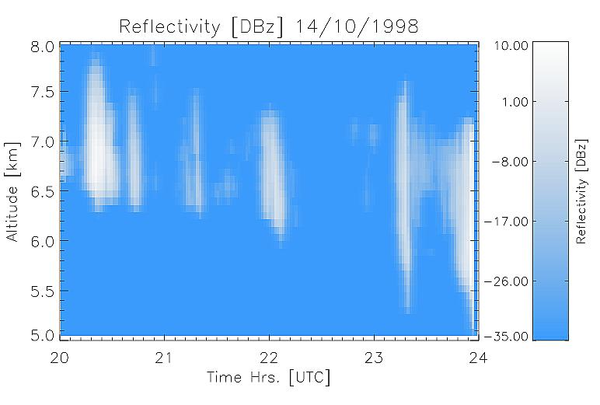
Figure 5. Effective reflectivity for October 14th, 1998.
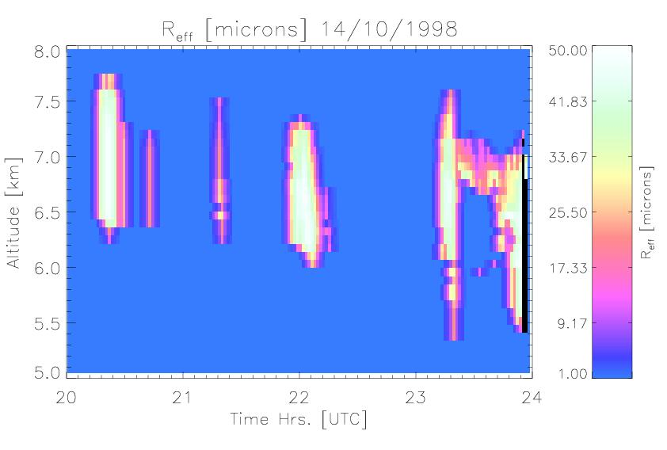
Figure 7. Effective radius field for October 14th, 1998.
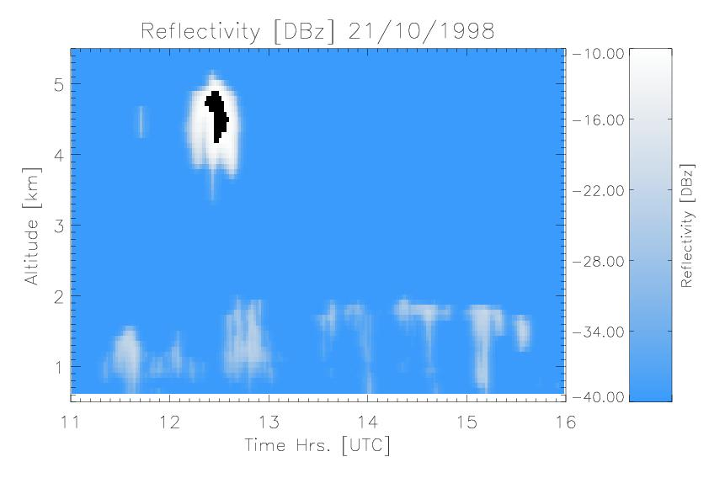
Figure 9. Effective reflectivity for October 21th.
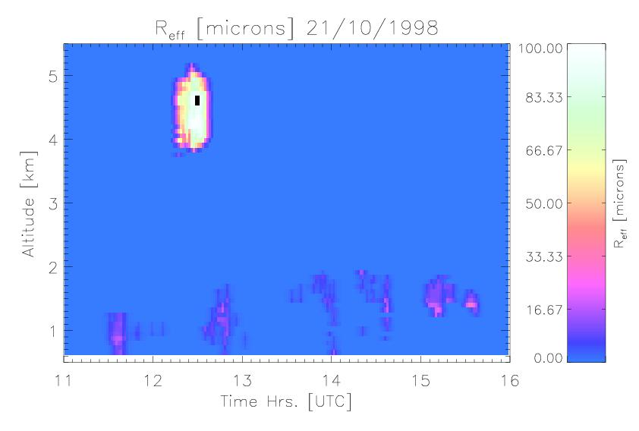
Figure 11. Effective radius field October 21th.
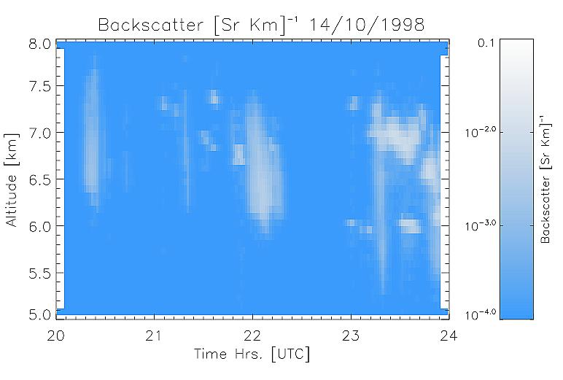
Figure 6. Uncorrected lidar backscatter for Oct. 14th.
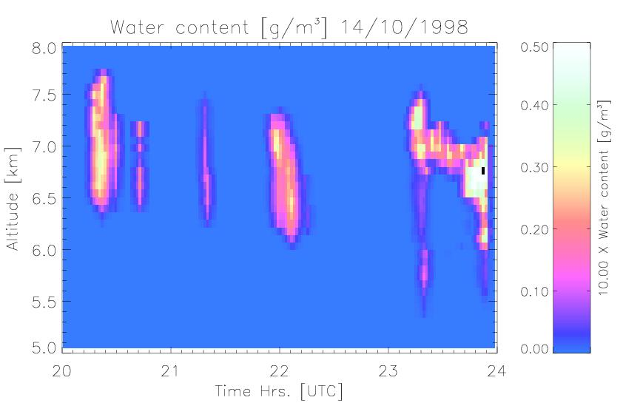
Figure 8. Water content for October 14th, 1998.
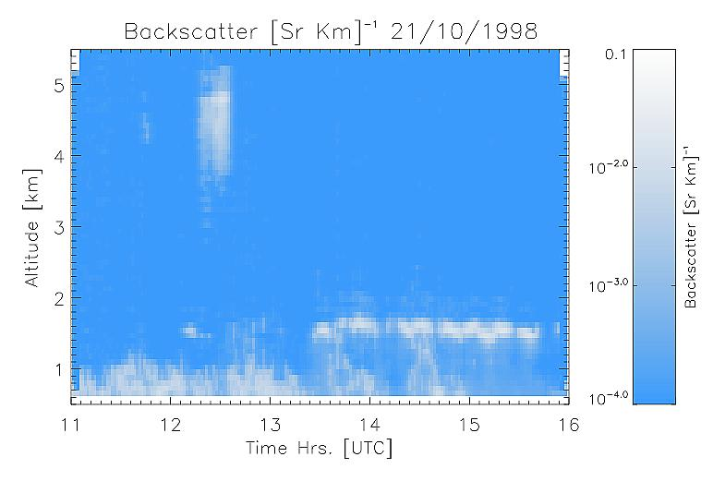
Figure 10. Uncorrected lidar backscatter for Oct. 21th.
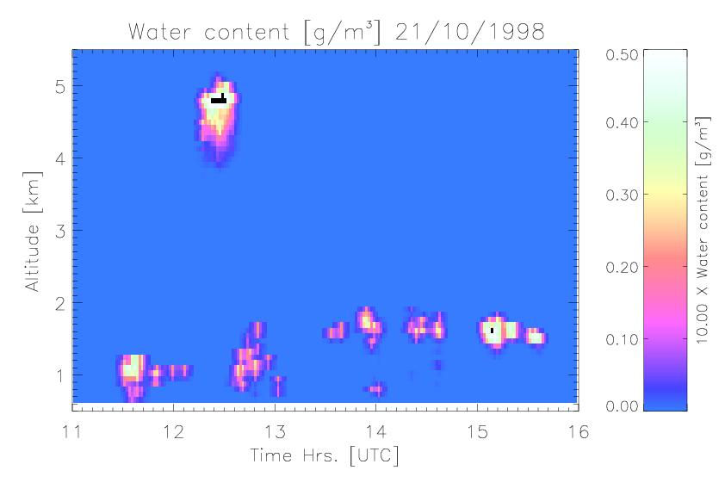
Figure 12. Water content for October 21th.
Figure 13 Lidar (Grey) and radar (thin Black) signal profiles for October 21, 1996 at 12.29 UTC (left). The middle panel shows the retrieved 905 nm extinction and ice-water content profile while the right panel shows the retrieved $R_{\text{eff}}$ profile and the UKMO temperature profile (upper -axis).
Figure 14 Lidar (Grey) and radar (thin Black) signal profiles for October 14, 1996 at 15.1 UTC (left). The middle panel shows the retrieved 905 nm extinction and water content profile while the right panel shows the retrieved $R_{\text{eff}}$ profile and the UKMO temperature profile (upper -axis).

SUMMARY

Using lidar and radar systems in a synergetic fashion has definite advantages when applied to cloud studies. In particular, it is possible to construct a synergetic inversion scheme, which overcomes many of the traditional difficulties of inverting the lidar signal in clouds while simultaneously estimating an effective cloud particle size.

As well as effective particle size estimates, height and time resolved estimates of cloud water contents are also possible. However, the method only works up to the point where the cloud optical depth is such that the lidar still detects usable signal levels. Also, especially when dealing with ice clouds, it is still necessary to know (or assume) the type of ice-crystals present and estimate the form of the particle size distribution.

Applied to real data, the algorithm appears to generate realistic values of particle sizes for both water and ice clouds. As of this time, no comparison of the results of this procedure with In-situ measurements has been preformed. However, it is hoped that this procedure will be soon validated using the results of aircraft-based measurements made during CLARE98.

REFERENCES

Donovan D.P. and A.C.A.P. van Lammeren, Combined lidar and radar cloud particle effective size retrievals made during CLARA, submitted to Physics and Chemistry of the Earth, (1999).

Hogan. R.J. and J.W.F Goddard, Calibration of the groud-based radars during CLARE’98, This issue.

Liebe, H.J., An updated model for millimeter wave propagation in moist air, Radio Sci., 20, 1069-1089, (1985)
.
Liebe, H.J. T. Manabe, and G. Hufford, Millimeter-Wave Attenuation and Delay Rates Due to Fog/Cloud Conditions, IEEE Trans. Ant. Prog., 37, 1617-1623, (1989).

Mitchell, D.L., A. Macke, and Y. Liu, Modeling Cirrus Clouds. Part II: Treatment of Radiative Properties, J. Atmos. Sci., 53, 2967-2988 (1996)

Mitchell, D.L., W.P. Arnott, A Model Prediction the Evolution of Ice Particle Size Spectra and Radiative Properties of Cirrus Clouds. PartII: Dependence of Absorption and Extinction on Ice Morphology, J. Atmos. Sci., 51, 817-832, (1994)

Klett, J.D., Stable analytical inversion solution for processing lidar returns, Appl. Opts., 20, 211-220, (1981)

Intrieri J.M., Stephens, G.L., Eberhard, W.L., and Uttal, T., A method for Determining Cirrus Cloud Particle Sizes Using Lidar and Radar Backscatter Technique J. Appl. Met. , 32 , 1074--1082, (1993)

