Estimation of cloud microphysical parameters from
radar, lidar and microwave radiometer during CLARE'98

J. Erkelens¹, S. Jongen², H. Russchenberg¹, M. Herben², P. Francis³, and M. Quante⁴

¹IRCTR, Delft University of Technology, The Netherlands. Email: j.s.erkelens@its.tudelft.nl
²Eindhoven University of Technology, The Netherlands
³United Kingdom Meteorological Office, Farnborough
⁴GKSS Institut für Atmosphärenphysik, Geesthacht, Germany

ABSTRACT

In October 1998, the CLARE measurement campaign took place in Chilbolton, England. A variety of collocated instruments performed measurements on the clouds. Among the instruments were a microwave radiometer, lidars and radars. Also, particle size measuring probes were operated during flights through the clouds. Estimates of the cloud microphysical properties may be made by combining the measurements from the different remote sensing instruments. In this paper, two methods to estimate cloud microphysical properties are applied to the CLARE'98 data. Comparison of the results of one of the methods with in-situ data from the size measuring probes for 22 October shows reasonable agreement.

1. INTRODUCTION

The radiative properties of clouds depend on the concentrations and sizes of the droplets. By combining different remote sensing instruments, estimates of these microphysical cloud properties can be made. For example, Frisch et al. [1] combine a K_{α}-radar and a microwave radiometer to estimate liquid-water content, modal radius and droplet concentration in stratus clouds. Boers et al. [2] combine a lidar, an S-band radar and a microwave radiometer to estimate the concentration of cloud droplets. Hogan et al. [3] use the difference in attenuation between ground-based 35 and 94 GHz radars to estimate the liquid water content. Guyot et al. [4] use a dual-beam 95 GHz airborne radar to estimate cloud microphysical properties. Donovan et al. [5] combine radar and lidar to estimate effective radius in water and ice clouds.
Erkelens et al. [6] have applied the methods of Frisch et al. [1] and Boers et al. [2] to two cases of the CLARE data and compared the retrievals of droplet concentration. They showed that the Frisch-method is very sensitive to the value of the width parameter in the assumed lognormal distribution of cloud droplet sizes. This method will not work properly when drizzle is present. The Boers-method is less sensitive to drizzle, but needs an accurate estimation of cloud thickness.
In this paper, the methods of Frisch et al. and Boers et al. will be applied to more cases and for one case the results of the Boers-method are compared to measurements performed with airborne particle sizing probes. The instruments that have been used in this study are the following: the microwave (21.3/31.7 GHz) radiometer of Eindhoven University of Tech-nology, the Netherlands (on loan from ESA/ESTEC), the Vaisala CT75 ceilometer and the 35 GHz 'Rabelais' radar of the Rutherford Appleton Laboratory, England (on loan from the Université Paul Sabatier, France), the 95 GHz 'Miracle' radar of GKSS, Germany [7], and the Forward Scattering Spectrometer Probe, the 2D-C probe and the Johnson-Williams liquid water content meter of the UK Meteorological Office.
The outline of the paper is as follows. In the next section the methods of Frisch et al. and of Boers et al. will be described. In section 3 examples of retrievals are shown and a comparison with in-situ data is made. A discussion of error sources is presented in section 4 and the paper finishes with some concluding remarks.

2. RETRIEVAL ALGORITHMS

Lognormal distribution

For both retrieval methods used in this paper the assumption is made that the cloud-droplet size distribution can be modeled by a lognormal distri-bution. The expression for the distribution and its moments, and the relationships between the moments and the remote-sensing measurements are given immediately below. After that, the retrieval methods are described.
The expression for a lognormal distribution is:
(1)

where N is the droplet concentration (number of droplets per unit volume), β is the logarithmic width of the distribution and r₀ is the modal radius. The number of droplets per unit volume with radii between r and r+dr is given by n(r)dr. Eq. (1) expresses that the logarithm of the droplet radii are distributed with a normal distribution. In general, the distribution may change with height in a cloud.
The k-th order moments M_{k} of this distribution are defined by:
(2)

According to this definition, the zeroth order moment M₀ is the total concentration N. The measurements of different remote sensing instruments depend on the moments of the droplet size distribution. For a lognormal distribution the expressions for the radar reflectivity factor Z, the liquid water content L and the lidar extinction σ are:

(3)

where ρ_{w} is the mass density of water, Q is the droplet extinction efficiency, which is about 2 for droplets much larger than the wavelength. One of the important cloud microphysical parameters is the effective radius, which is defined as the ratio of the third and second order moments, so for a lognormal distribution:
(4)

Combining radar and radiometer – The Frisch-method

The radar delivers a height profile of the radar reflectivity factor, while the radiometer provides the liquid water path. Eq. (1) shows that three parameters (N, r₀ and β) are used to describe the cloud-droplet size distributions. Moreover, these parameters may have a height dependence. Therefore, a radiometer and radar do not provide enough information to estimate the detailed cloud microphysical properties. If one wants to say something about the droplet concentration, for example, assumptions have to be made about the other parameters and the height dependencies. Aircraft measurements performed in stratocumulus clouds suggest that the droplet concentration N and the width parameter β are approximately constant with height in the cloud [8],[9]. Frisch et al. [1] use these results in an algorithm that combines a K_{α}-radar and a micro-wave radiometer to estimate droplet concentrations and liquid water profiles. They assume a value of 0.35 for the width parameter. Eq. (3) shows that the liquid water content L is proportional to the square root of the radar reflectivity factor:
(5)

Integrating eq. (5) over the vertical and equating the result to the Liquid Water Path (LWP) provided by a microwave radiometer gives an estimate of the droplet concentration. Eq. (5) then provides an estimate of the vertical liquid water profile. Using the estimated concentration and the assumed value for the width parameter, a profile of effective diameter can also be computed. Note that the liquid water retrievals are influenced neither by radar calibration errors nor by a wrong assumption about the width parameter, but the concentration and effective diameters will be affected.

Combining radar, radiometer and lidar – The Boers-method

Boers et al. [2] developed a method to combine three remote sensing instruments to estimate the droplet concentration N. Eq. (3) shows the lidar extinction for a lognormal distribution. The extinction and the liquid water content are related according to:
(6)

However, it is often not possible to apply a technique similar to the one of Frisch et al., because the lidar signal may not penetrate the entire cloud. Therefore, vertically integrating eq. (6) and adjusting N such that the result equals the liquid water path will not work in many cases. Boers et al. applied a different technique. Firstly, part of the extinction profile is estimated with the Klett-algorithm [10]. The additional assumption is made that the liquid water content increases linearly with height. The slope of the liquid water profile is found from the liquid water path and the thickness of the cloud. Boers et al. used an S-band radar with a vertical resolution of 30 m to find the cloud-top height, while the cloud bottom was defined as the height level immediately below the level where the lidar extinction curve exceeds 2 per km. It is necessary to use both instruments to determine the cloud boundaries, because each of the instruments alone does not suffice [11], [12]. Sassen [13] has calculated for water clouds that the cloud base obtained with lidar and radar will be about the same when the sensitivity of the radar is about −40 dBZ.
The extinction profile is now modeled by:
(7)

where LWP is the liquid water path, H is the cloud thickness and h is the height with respect to the bottom of the cloud. A least-squares fit of eq. (7) to the available points of the measured extinction profile provides an estimate for N.

3. RETRIEVALS

The two methods described above will be applied to five cases from the Clare'98 campaign at Chilbolton, in the United Kingdom. Figure 1 shows the results for 15 October 1998. The top panel shows the radar reflectivity factor of a thin stratocumulus cloud obtained with the 35 GHz radar 'Rabelais'. The vertical resolution is 75 m and the time resolution of the picture is 1 minute. The middle panel shows a 5 minute average of the liquid water path (LWP) obtained from a microwave radiometer. The bottom panel shows retrievals of droplet concentration with

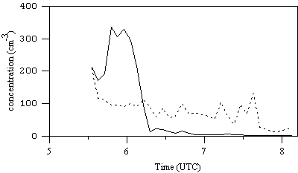

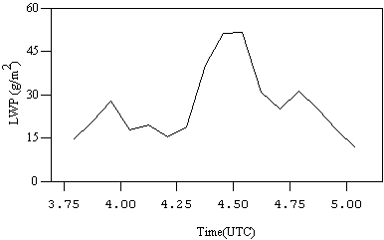
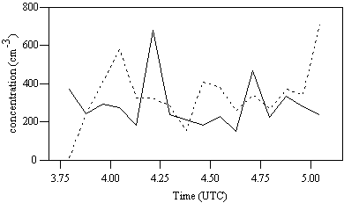
Figure 1. (a) Radar measurement of a stratocumulus cloud performed during the Clare'98 campaign (15 October 1998), with the 35 GHz radar 'RABELAIS'. (b) Liquid water path obtained from a microwave radiometer. (c) Retrievals of droplet concentration from the Frisch-method (solid line) and the Boers-method (dashed line).

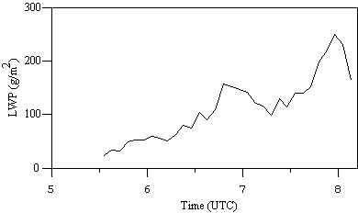

Figure 2. (a) Radar measurement of a drizzling cloud performed during the Clare'98 campaign (20 October 1998), with the 35 GHz radar 'RABELAIS'. (b) Liquid water path obtained from a microwave radiometer. (c) Retrievals of droplet concentration from the Frisch-method (solid line) and the Boers-method (dashed line).

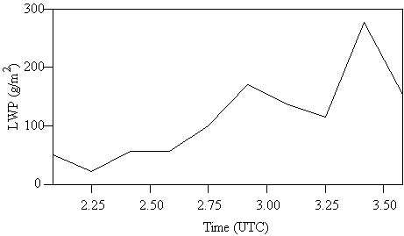

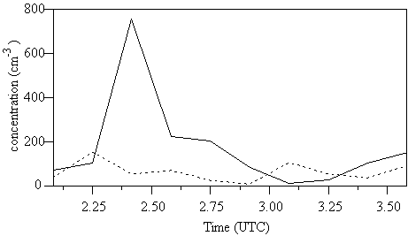

Figure 3. The top panel shows the 35 GHz radar measurement of a stratocumulus cloud performed on 13 October 1998. The middle panel shows the liquid water path for the same period and the bottom panel the concentrations estimated with the Frisch-method (solid line) and the Boers-method (dashed line).

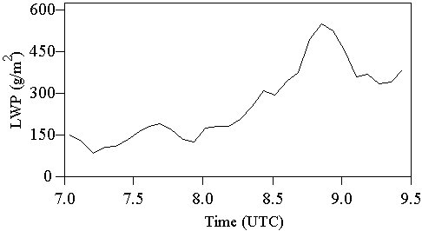

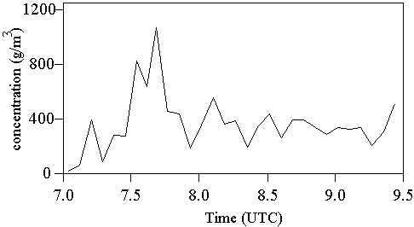

Figure 4. The top panel shows the 35 GHz radar measurement of a stratocumulus cloud performed on 22 October 1998. The middle panel shows the liquid water path for the same period and the bottom panel the concentrations estimated with the Boers-method.

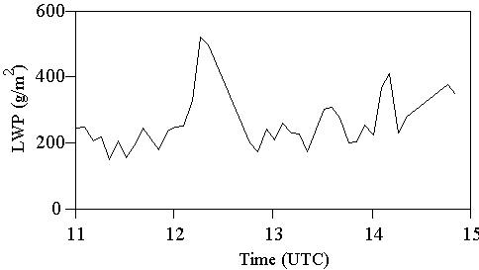

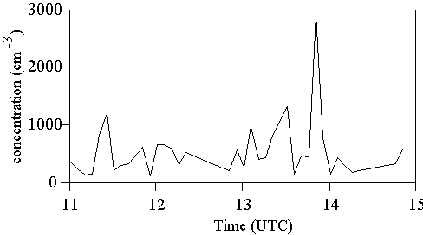

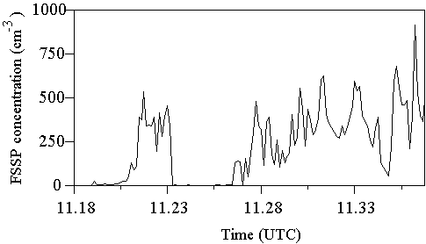
Figure 5. (a) About 4 hours of 95 GHz 'MIRACLE' radar data on 22 October 1998. (b) Liquid water path. (c) Droplet concentrations obtained with the Boers-method. (d) Concentrations from corrected FSSP-data, collected when the aircraft was close to the ground-based measurement location.

Figure 6. Histograms of liquid water content and effective radius obtained from the Boers-method and FSSP+JW-probe, respectively.

the two retrieval methods described above. The continuous line shows the concentration estimated with the Frisch-method, the dotted line the concentration given by the Boers-method. For both methods it has been assumed that the value of the logarithmic width β is equal to 0.35. The values that are obtained are reasonable. Unfortunately, no in-situ measurements are available for this case to validate the results, but a comparison with in-situ data could be made for 22 October, see figures 5 and 6. The average value of the droplet concentration found with the Boers-method is 338 per cm³, and the mean is 287 per cm³ for the Frisch-method. An error in the assumed logarithmic width has a different influence on the concentrations found with each method. This can be seen from eqs. (5) and (6). If a value is used for β that is too low (high), then the estimates of droplet concentration from the Frisch-method will tend to be lower (higher) than those obtained with the Boers-method. The average values of the concentrations would become equal when β=0.39 is taken. Of course, the differences in the concentrations found could also originate from other error sources. Some of these will be discussed briefly in the next section.
The top panel in figure 2 shows a measurement of a cloud which starts to precipitate. This measurement was performed on 20 October 1998 with the 35 GHz radar as well. The middle panel shows the liquid water path. The retrievals of droplet concentration from the Frisch- and Boers-methods are the solid line and dashed lines shown in the bottom panel, respectively.
The Frisch-method is much more affected by the presence of drizzle, because the radar reflectivity is dominated by the largest drizzle droplets, while the liquid water content is determined by the smaller cloud droplets. In that case, the radar reflectivity and the liquid water content will almost be unrelated [14], [15]. It may be possible to distinguish between cases with and without drizzle by setting an threshold on the reflectivity or velocity [1]. Another method uses the effective radius estimated from radar and lidar [15].
Figures 3 and 4 show the results for two other cases on 13 October and 22 October. The Frisch-method could not be applied for the latter case, because the radar measured only part of the reflectivity profile.
Figure 5 shows the results of the Boers-method for a different period on 22 October. The top panel shows the radar reflectivity measured by the 95 GHz 'Miracle' radar. It is a concatenation of 11 periods of about 20 minutes each, with some gaps in between. The second and third panel show liquid water path and retrieved concentration, respectively. In-situ data has been collected during this period. The bottom panel shows the concentrations derived from the probes carried by the 'Hercules' aircraft, during run 11, when the aircraft was flying at an altitude of about 1 km. (The concentrations shown are from the FSSP, corrected such that the total liquid water content equals that of the Johnson-Williams probe.) The average value of the logarithmic width parameter for this data was 0.37. The average concentration obtained with the Boers-method is 495 cm⁻³. The average concentration for the in-situ data, when only values are taken into account for which the liquid water content as measured by the Johnson-Williams probe exceeds 0.01 g/m³, is 267 per cm³. The difference may be partly caused by the fact that the aircraft was flying near the base of the cloud layer, and did not stay in the clouds all the time, so the lower values found at the cloud edges may decrease the average concentration in the FSSP spectra.
The Boers-method models the liquid water profile as a straight line, the slope of which is calculated from cloud thickness and liquid water path. A profile of effective radius can be calculated from the retrieved concentration and this liquid water profile. Figure 6 shows histograms of liquid water contents and effective radii obtained this way, and also histograms of those quantities calculated from the corrected FSSP spectra. The ranges of values agree quite well with each other. Similar values of liquid water content have been found from the difference in attenuation between ground-based 35 and 94 GHz radars [3].

4. DISCUSSION

In this section, the most important sources of error in the retrieval methods will be discussed. In eq. (8) the dependency of concentration, effective radius and liquid water content on β and the measured quantities is shown for the Frisch-method:

(8)

where Z_{I} is the square of the height integral of the square root of the radar reflectivity factor:
(9)

The corresponding expressions for the Boers-method are:

(10)

The expressions show that radar calibration does not influence the estimate of liquid water content for the Frisch-method, and that β has no influence on liquid water content for both methods. It is also clear that errors in the measured quantities have the largest impact on the concentration, and less on effective radius and liquid water content.
Both the Frisch- and the Boers-method make the assumption that the width parameter is constant with height and known (the value of 0.35 has been assumed here). The assumption of a constant value is questionable. For example, Gerber [16] finds values of β between 0.10 and 0.41 in marine stratocumulus clouds during ASTEX, and also a decrease with cloud height. FSSP measurements during the CLARA campaigns in 1996, in the Netherlands, show values between 0.19 and 0.44. This latter range of values would imply errors up to ± 60% for the concentration obtained with the Frisch-method (if β=0.37 is used) and up to ± 23% for the Boers-method (for β=0.35). The resulting errors in the effective radius are smaller (about 16% for both methods).
Both methods depend on the square of the Liquid Water Path (LWP). The LWP's are obtained with a non-linear algorithm called Matched Atmosphere Algorithm, developed at Eindhoven University of Technology [17]. The algorithm is a so-called profile algorithm: profiles of temperature, pressure, humidity and liquid water content are modeled. The humidity and liquid water profiles are changed until the brightness temperatures predicted by radiative transfer calculations match the measured ones. The tuning parameters are the cloud thickness and the slope of the liquid water profile. For this type of algorithm, the rms errors in derived LWP are of the order 10% - 20% [18] (but the errors are not less than about 10 g/m² for small amounts of liquid water). An error of 10% in LWP will cause errors of about 20% in concentration and 10% in liquid water content. The errors in effective radius will be about 10% for the Boers-method and 3% for the Frisch-method.
A calibration error in the radar reflectivity would influence the retrievals of concentration and effective radius for the Frisch-method, but not the estimates of liquid water content. A calibration error of 1 dB leads to an error of about 25% in the concentration and about 4% in effective radius.
For the Boers-method, it is very important to make an accurate estimation of the cloud thickness since the retrieval of the concentration depends on H⁴. Some of the clouds in the examples presented were not very thick (thickness about 300 m) and the resolution of the radars used was rather coarse (about 75 m), so an error of half a radar resolution cell would lead to errors in the order of 50%.
Errors in the derived lidar extinction will also contribute significantly to errors in the concentration. The Klett-algorithm [10] was used to infer the extinction profiles, which convergence increases with the optical thickness of the cloud. For the clouds studied here, convergence is probably not a problem. An error of 10% in extinction would cause an error of about 30% in concentration.
There are also a number of errors that are harder to quantify. Drizzle could seriously affect the perfor-mance of the Frisch-method, for example. If the drizzle contains a significant amount of liquid water, then the Boers-method will also be affected. Also, the accuracy of the assumptions of a concentration constant with height and a linearly increasing liquid water content profile is unknown at present. Such assumptions should be validated with in-situ measurements. The cloud thickness is calculated from the radar cloud top and the lidar cloud base. Even if cloud thickness is estimated accurately, an error in cloud height would still influence the retrievals, because eq. (7) does not include an offset in the liquid water profile. It is possible to fit cloud base as well, if there are a sufficient number of points on the extinction profile [2], but that has not been done in this paper.
For very thin clouds, the mentioned errors and uncertainties may be so large that the retrievals become too unreliable to be of much practical value.

5. CONCLUDING REMARKS

Two methods to retrieve droplet concentration have been compared, the method of Frisch et al. [1] and the method of Boers et al. [2]. The concentrations obtained with the Frisch-method are more sensitive to errors in the assumed value of the width parameter than those from the Boers-method. For the latter method to work properly, however, an accurate determination of the cloud thickness and part of the extinction profile is necessary. The Frisch-method will not work when a cloud is drizzling, because the radar reflectivity will then be dominated by the drizzle drops while the liquid water path may still be dominated by the small cloud droplets. The Boers-method is less affected by drizzle.
More accurate results could be obtained, for example, by improving the retrievals of liquid water path. This may be done by providing the used profile algorithm with more information on atmospheric profiles and cloud height and temperature [19]. Using a radar with a finer height resolution can improve the accuracy of the measurements of cloud thickness.

ACKNOWLEDGMENTS

We thank John Goddard and Charles Wrench of the Radiocommunications Research Unit, Rutherford Appleton Laboratories, Chilton, United Kingdom for the ceilometer data, we are grateful to Henri Sauvageot and Nicolas Gaussiat of the "Laboratoire d'Aérologie, Université Paul Sabatier", Toulouse, France for providing the 35 GHz 'Rabelais' radar data, Olof Danne of GKSS, Germany kindly provided us with the 95 GHz 'Miracle' data, and we owe Robin Hogan of the Department of Meteorology, University of Reading, United Kingdom for doing the processing of the CLARE'98 data.

REFERENCES

[1] Frisch, A.S., C.W. Fairall, and J.B. Snider, "Measurement of stratus cloud and drizzle parameters in ASTEX with a K_{α}-band radar and a microwave radiometer," J. Atmos. Sci., Vol. 52, pp. 2788-2799, 1995.
[2] Boers, R., H. Russchenberg, J. Erkelens, V. Venema, A. van Lammeren, A. Apituley, and S. Jongen, "Ground-based remote sensing of stratocumulus properties during CLARA-1996," Accepted for J. Appl. Met., 1999.
[3] Hogan, R.J., A.J. Illingworth, and H. Sauvageot, "Cloud characteristics from dual wavelength millimetre-wave radar," Proc. 29th Conf. Radar Met., Montreal, Canada, pp. 457-459, 1999.
[4] Guyot, A., F. Baudin, S. Haimov, P. Laborie, D. Leon, A. Pazmany, J. Pelon, J. Testud, V. Trouillet, and G. Vali, "Dual beam cloud radar and backscattering lidar on the same airborne platform: first results," Proc. 29th Conf. Radar Met., Montreal, Canada, pp. 469-471, 1999.
[5] Donovan, D., A. van Lammeren, and H. Russchenberg, "Cloud effective radius and water contents inferred from combined lidar and radar observations druing CLARA," ," Proc. symp. Remote Sensing of Cloud Parameters, Delft, The Netherlands, October 1999.
[6] Erkelens, J.S., S. Jongen, H. Russchenberg, and M. Herben, "Estimation of cloud droplet concentration from radar, lidar and microwave radiometer measurements," Proc. symp. Remote Sensing of Cloud Parameters, Delft, The Netherlands, 21-22 October 1999.
[7] Quante, M., O. Danne, E. Raschke, and M. Chandra, "The GKSS 95 GHz cloud radar: system description, measurement examples, and calibration concepts," European Trans. Telecom., in press.
[8] Slingo, A., S. Nicholls, and J. Schmetz, "Aircraft observations of marine stratocumulus during JASIN," Quart. J. R. Met. Soc., Vol. 108, pp. 833-838, 1982.
[9] Martin, G.M., D.W. Johnson, and A. Spice, "The measurement and parameterization of effective radius of droplets in warm stratocumulus clouds," J. Atm. Sci., Vol. 51, No. 13, pp. 1823-1842, 1994.
[10] Klett, J.D., "Stable analytical inversion solution for processing lidar returns," Appl. Optics, Vol. 20, No. 2, pp. 211-220, 1981.
[11] Venema, V., H. Russchenberg, A. Apituley, A. van Lammeren, and L. Ligthart, "Cloud boundary height measurements using lidar and radar," accepted for Phys. Chem. Earth, 1999.
[12] Clothiaux, E.E., T.P. Ackerman, G.G. Mace, K.P. Moran, R.T. Marchand, M.A. Miller, and B.E. Martner, "Objective determination of cloud heights and radar reflectivities using a combination of active remote sensing sensors at the ARM CART sites," accepted for J. Appl. Met., 1999.
[13] Sassen, K., G.G. Mace, Z. Wang, M.R. Poellot, S.M. Sekelsky, and R.E. McIntosh, "Continental stratus clouds: a case study using coordinated remote sensing and aircraft measurements," J. Atm. Sci., pp. 2345-2358, 1999.
[14] Fox, N.I., and A.J. Illingworth, "The potential of a spaceborne radar for the detection of stratocumulus clouds," J. Appl. Met., Vol. 36, No. 6, pp. 676-687, 1997.
[15] de Wit, J.J.M., R.J.P. Baedi, J.S. Erkelens, H.W.J. Russchenberg, and J.P.V. Poiares Baptista, "Development of retrieval algorithms of cloud parameters from radar and lidar based on the CLARE data set," Proc. symp. Remote Sensing of Cloud Parameters, Delft, The Netherlands, 21-22 October 1999.
[16] Gerber, H. "Microphysics of marine strato-cumulus clouds with two drizzle modes," J. Atm. Sci., Vol. 53, No. 12, pp. 1649-1662, 1996.
[17] Jongen, S., M. Herben, H. Russchenberg, and A. van Lammeren, "On the accuracy of water vapor and liquid water retrieval with the Matched Atmosphere Algorithm," Proc. USNC/URSI National Science Meeting, Boulder, USA, p. 71, January 1998.
[18] Peter, R. and H. Kämpfer, "Radiometric determination of water vapor and liquid water and its validation with other techniques," J. Geophys. Res., Vol. 97, No. D16, pp. 18,173-18,183, November 1992.
[19] Erkelens, J.S., H.W.J. Russchenberg, S.C.H.M. Jongen, and M.H.A.J. Herben, "Cloud liquid water profile estimation combining radar and radiometer," Proc. 8th URSI-F Symposium on Wave Prop. & Remote Sensing, Aveiro, Portugal, pp. 167-170, 1998.

